

LIFE LESSONS BY J. PAUL SELTZER

Stories prompted by the relationships and life experiences of J. Paul Seltzer

You can reach the author at jpaulseltzer@gmail.com

Published by Seltzer Books
established in 1974, as B&R Samizdat Express
offering over 14,000 books
feedback welcome: seltzer@seltzerbooks.com

PREFACE

Within these 73 Life Lessons of ordinary events and relationships since the 1930's will be found the unique experiences of Paul Seltzer. Here, the human spirit of curiosity, wonder and spontaneous delight are tested and flourish. There are dark nights and bright dawns that spark ruminations about life and humanity. With clarity, humor, and poignancy, these original life stories provide a vehicle to let us live into the gamut of our own humanity.

From a child's delight in spinning Ivory soap into a tub full of suds, to an adult diving into a mountain of leaves; from the shock at the mysteries of death as a youngster squeezes life out of a guinea pig, to an oldster reflecting on the devastation of a tornado. In this array of tales, we come to see the forces at work in our own minds and what we can do about them. We see love and heartbreak with their consequences. There is chaos and serenity. There are values and choices. There are surprises and sameness. There is determination and resilience. There is the craziness and comic lacing it all. In exploring Life Lessons we understand that in our ordinariness we sense a higher purpose and universality. It is not about the fringe or the edges, but about us now.

HOUSE HOLDINGS

JAILBREAK

MAESTRO...PLEASE

CANNED PEACHES

THE QUITTER

SHADOWS

FURNITURE STORE... AND MORE

FAMOUS NO NAME

HOOKY HOLIDAZE

DOWN FRONT

SNIFFING EASTER

BUSY BEE CLUB

BREAKFAST PLANS

SUDS

CABIN FEVER

POOR PASSAGES

LONG BEFORE

A CHRISTMAS MIX

HOLY HAUNTS

A WAR STORY

THE BIGGEST FIRE I EVER SAW

CALOPHEN'S CONSEQUENCE

ELMER AND ELSIE

SMILE SOURCE

WALLFLOWERS ANONYMOUS

A PIANO RECITAL

DEMON DEALING

TROMBONE TRAILS

WATER MUSIC

STARS ETCETERA

LIFE BEGINS

SHOWBOAT

THE PROMISE OF TEA LIGHTS

HORIZONS

GLORY POSTPONED

PITS AND PEAKS

GROWING PAINS

A BAILIFF BIRTHING

CHOICES

IMAGINE JACOB

THANKS FOR THE CHANGE

FUNERAL FARE

DANCING WITH CONVERTIBLES

MISSY MOMENTS

SOULCIOLOGY

SIDES OF BACON

TIMEPIECE

SALES BONUS

YOU'RE NUTS YOU KNOW?

THE CHICKEN LITTLE CAKE

A CATERING CAPER

JUST ONE MORE DAY

LEAF IT TO ME

SNAPSHOTS 1

SNAPSHOTS 2

MISTER BIG

A SELTZER SAMPLER

A BROTHER'S BIRTHDAY PARADE

THE GIGGLE GIFT

HERMAN AND HELOISE

ODE TO A MIRROR

MUSIC MAGIC

MOOD MAKER

A SUNSET DIARY

SATURDAY'S RABBITS

TAX SALE

MINING GOLD

AT LEAST…

BEER

CANDY

A PONDER POND

A JANE DAY

JETHRO'S PARADE

EXTRAS

A HYMN FOR EARTH DAY -- SHINE MYSTERY!

HEAVEN POSTPONED

ALBUM OF SELTZER FAMILY PHOTOS

MUSIC AND POEMS WRITTEN FOR SPECIAL OCCASIONS

SELTZER GENEALOGY

INTRODUCTION TO LIFE LESSONS

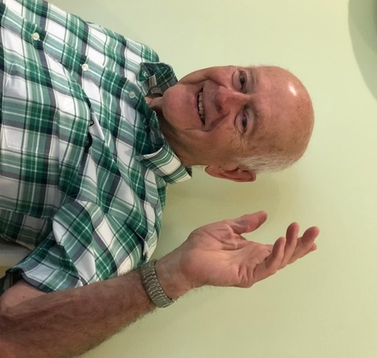

Obituaries don't tell our whole story. They usually summarize our accomplishments, awards, jobs, relations, connections, with the essential dates. Much is left to our imaginations to fill in the details and make appropriate assumptions about a person we have known.

How often we have lamented about a loved one, "I wish I had gotten their stories on tape, or they had written them down. It's all gone now."

My grandfather died before I was born. He was a man of letters. He kept meticulous accounting records. He wrote lengthy treatises on diverse topics. He kept a fact diary of his Conestoga wagon trip to Kansas Indian country. In all of his writings, little is revealed about his human feelings, dreams, and disappointments. I would like to know that.

My father read multiple books at a time. He wrote weekly factual letters to his brother Charles in Philadelphia. He had some favorite stories he repeated through the years. I would have appreciated more insights into his humanness.

My mother had some life stories she verbally repeated. I would like to have known more about her internals.

This shared desire to respond to this frequent lament is what led fifteen people to convene a Life Writing Group at the Mahone Bay Center in Nova Scotia in 2009. We began 'mining the gold' of our life experiences with the expectation that these glimpses would reveal some of the flavor of what we had savored in life.

It had the immediate benefit for us of digging deeply into the memory bank and cherishing the richness of our 'gold dust.' We discovered wisdom in the fun, feelings, and foibles of our past. We hoped all of that might connect with others in our writing. We came to know that everything is a vessel for the heart story.

Life Lessons is one expression of that. Some stories are embellished where memory limits. I have added some original songs and verse inspired by special people and events.

I am deeply grateful for the treasury of persons and events inhabiting my journey and exhibited in Life Lessons, and for my fellow writers for their critiquing of the tales.

Most especially I appreciate my nephew, Richard Seltzer, a notable author in his own right, for his encouragements and ongoing assistance in assembling this material and navigating me through the jungle of devious devices.

My wish is that Life Lessons will be engaging and entertaining for you. May it also be a catalyst to 'mine your own gold,' re-live your own hidden memories, and savor your own flavor.

HOUSE HOLDINGS

When a house holds 'heart,' it becomes a home. For Warren and Lillian Seltzer, it starts when they are talking in 1926. Warren says "I've been thinking about that ad in the paper about that development way out in the Silver Spring farmland. It's a new idea for a planned subdivision. I like it. They're calling it Woodside Park. I can design our own home, maybe a cottage."

Lillian responds, "It would be a long way from here, probably ten miles. It sounds isolated. We'd be leaving all of our friends and family here on 5th Street, but it does sound exciting. Why don't we take a look?"

That weekend they drive the black Essex sedan from downtown Washington, D.C. to just beyond the trolley line on Georgia Avenue in Silver Spring. It is here, where Mr. Hopkins, the developer, has built two stone gate shelters to frame the entrance of the graveled Highland Drive into his real estate venture of Woodside Park.

It is rolling farmland, divided into quarter and half acre plots, with sewer and water and electric services in place. Warren and Lillian spend all day Saturday traipsing over the property possibilities, being guided by Mr. Hopkins. They stop for a picnic lunch at one of their favorite spots, on what will be called Pinecrest Circle.

Their dream machines are engaged. Warren already has a design for their new house in mind. He has won an award from the Architectural Design magazine for it. It is an English Tudor Cottage. Lillian loves it as well. They might be able to afford it. He has carefully planned it for attractiveness, simplicity, and efficiency. It has sloping slate roofs with a beige stucco exterior, accented with splotches of pink stucco, stone corner pieces, and traditional dark tudor beams. It will be a lovely little house for their growing family.

They can make it into a home that will last them fifty years. Their dreams are flowing for the next month as they excitedly try to mix in the practicalities of how much they can afford, and how far they wlll have to travel everyday to downtown D.C. for work, church activities, family and friends. The adventure of it trumps other realities. In May of 1928, #4 Pinecrest Circle becomes one of the first new homes in Woodside Park, with its graceful fields of waist high barley and weeds.

I am introduced to this scene of newly seeded grass and young trees in November of 1932. I can take any space inside or outside of that house and tell you how the 'heart' of its people, and their experiences together, morph the cinder blocks, stucco, and timbers into a home.

Let me try with just the living room. Coming through the front door you see the fresh concept of a large, open space for combined living room and dining room. It is surrounded with vividly grained dark chestnut paneling. The flooring is random width oak planks. An eight-foot fenestra picture window points your eyes to the fish pond and gardens outside, and bathes the room in bright southern sunshine.

The inside wall is dominated by an imposing stone fireplace at the center of the house with a cozy cubicle and its fire watching benches tucked in. The furnishings of the living room include a baby grand piano in one corner, an 1815 grandfather's clock standing very tall next to the front door, a spindled sofa bed facing the fireplace, a well-worn rocking chair accompanied by a cigar stand at its side, hot water radiators on each wall, a varied colored carpet with a block design, just right for playing 'town' with tootsie toy cars and trucks. There is a cabinet radio, dining room table and cabinets, assorted chairs, benches and lamps. A double French door leads to the stone back porch.

This is the look of the 'hard house stuff.' The feel of the 'soft home stuff' is personalized. It evolves over my eighteen years of living there with family and friends.

Beyond the sight of it, how does the chestnut paneling wrap around you with its 'heart?' Perhaps as a silent container for all of the comings and goings, conversations and music, flowing there through our lives every day.

How about the plank oak floor? Perhaps it takes on 'heart' as we vacuum it, wax it, and polish it on our hands and knees, to please the eyes of the party dancers. Or maybe it was because it supports the rumblings of my tricycle racing around the hallways and living room. The oak floor holds the Christmas trees and trains and frames the carpet where childhood pretendings spend hours moving the little cars and trucks and garages and houses around its 'streets.' The floor is a space separated from the adult world where I can lie on my back and imagine and imagine. It is space where I am by myself, or with my brother and friends, to play or argue. It is here that I giggle or pout when I need to. There are lots of 'heart' seeds sown on this carpet, on this oak floor, in this living room.

How about the big picture window? 'Heart' grows there by helping me connect with the natural beauties just outside. I can run my fingers across the frosted panes, making crude shapes and sounds. I feel the heat of the sun or the cold of the ice crystals. I see the goldfish darting around the water lilies in the pond. I stare at the iris gardens and the cherry tree blossoms. There are the repetitions from Mrs. Parker's upright piano of a Tchaikovsky Piano Concerto, which often resonate from her house next door. I perch myself on the arm of the couch and play truck driver with my pot lid as a steering wheel, or as a cowboy riding his horse in pursuit of something imaginary. All the while the inviting outdoor scene is in my view.

The fireplace is a natural for developing 'heart.' Roaring flames from the applewood I helped to saw up warms my body. The flickering firelight transports my thoughts to distant places, people, and possibilities. It happens up close in the cubicle benches, or on the couch from across the room on a Sunday afternoon while listening to the New York Philharmonic Orchestra on the radio. Or maybe it is Milton Cross commenting on the latest offering of the Metropolitan Opera on a Saturday afternoon, as I try to figure out what all the shouting and singing is about.

The baby grand piano, draped with its silken gold and tasseled coverlet, involves every family member on a daily basis. Mother often awakens us in the mornings with her hymn playing or accompanies my father on his violin in the evenings. Each of the four sons practice on it, or with it, on their trumpet, violin, saxophone, trombone or clarinet. The combined family orchestra squeaks out its melodies on Sunday evenings with lots of spontaneous laughter. You can count on having the piano back up the frequent solos and singalongs whenever friends drop in.

The vintage grandfather's clock sounds its unmistakable clanging throughout the house every hour, including during our sleeping times. There are the primitive movements of the moon faces painted at the top of the clock to indicate the position of the moon at this time. My father cranks the heavy cables and weights that power the clock every few days. All of this feeds the 'heart' issues of regularity, order, and connections with a history of ancestors long gone.

The spindled sofa folds out into a sleeper and holds the many guests who visit our home and share so many of their life views, enriching our perspectives with warmth.

The dining room table is reserved for holidays and special event meals with others. The culinary pleasures etch 'heart' memories in our senses. The mouth-watering aromas of cooking turkey, chicken, ham or beef waft through the rooms of the house into our 'heart' places.

The Philco radio and new automatic record changer provide the stimulus for the story world of our 'heart.' We gather around the cabinet, parents in their chairs, boys cross-legged on the floor. We absorb the likes of "The Great Gildersleeve," "Fibber Magee and Molly," "I Love a Mystery," "Gangbusters," "Henry Aldrich," "It Pays to be Ignorant," "The Phantom," and many others, including lots of musical offerings. We have a little bowl of pretzels, or Cheez-Its, or popcorn, with some Coke or ginger ale to keep us company as we carefully use our fingers to dust the various angles of the wooden grillwork on the front of the speaker.

The rocking chair is a favorite of my father. With his cigar stand at his side, he can read his many books and newspapers, and puff away. Sometimes I climb on his lap, there to stroke the stubble on his cheeks and chin and absorb his faint smile of satisfaction.

The 'heart' of our living room has its share of laughter, arguments, Chinese checkers, Monopoly and finally, some of "I Remember Mama" and "The Ed Sullivan Show" when TV is introduced to us in the 1950's.

So it is that the 1928 'heart' dreams of my parents are transformed at first into the physical components of a house. Then every room and space takes on its own 'heart' life as we live in them. These accumulating energies are held and nourished in this house at 1234 Pinecrest Circle, Silver Spring, Maryland. Such 'heart' moments make it into my home, affirming the old adage, "Home is where the heart is."

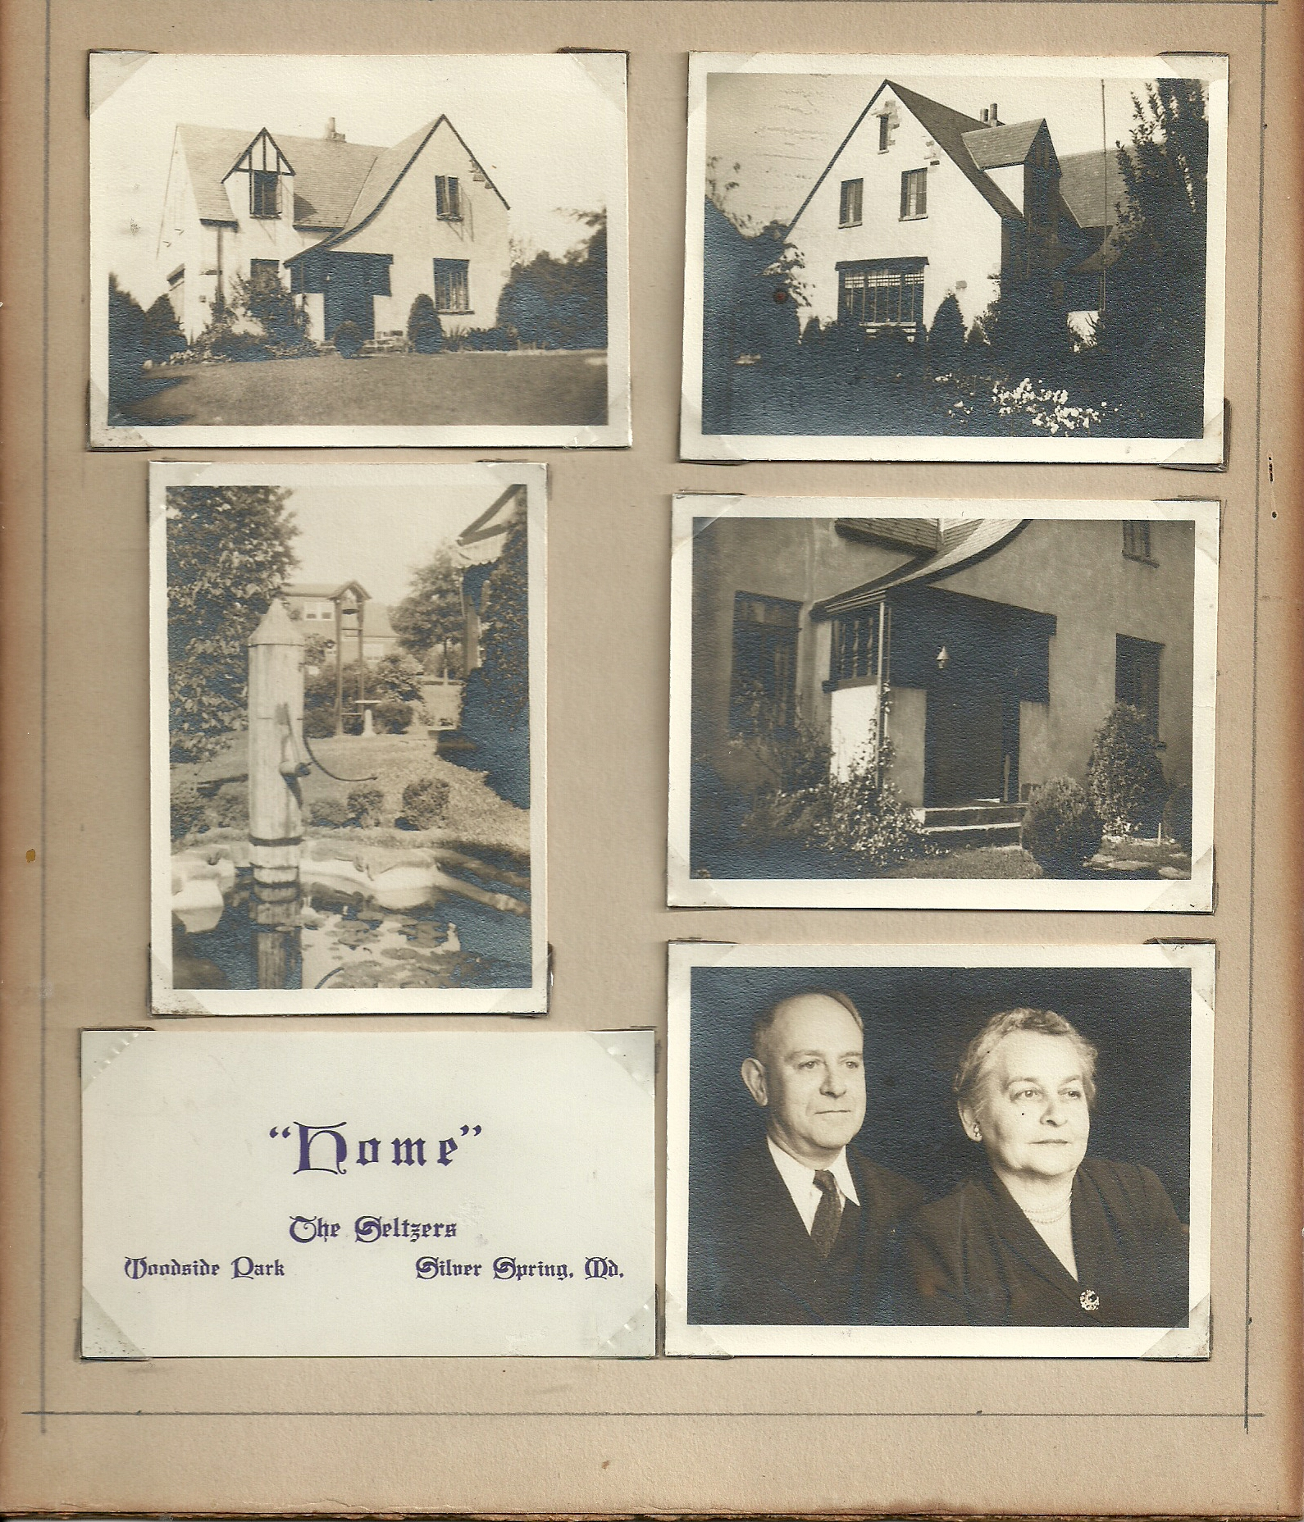

1234 Pinecrest Circle, December 1949. The house was gutted by new owners around 2000. Exterior looks similar. Interior totally different.

JAILBREAK
(Earliest memory)

If I hadn't learned better later, I might have thought I was in jail.

I peer out through the white bars, whose paint had worn so thin, so that only bare steel
meets my eyes. The rumpled and frayed blanket lays twisted under me. A half empty bottle
is at my side. A mixed aroma of old urine and old powder fill my nostrils.

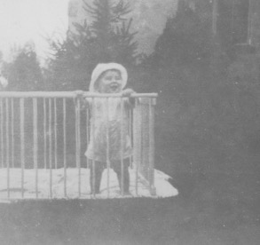

I cast my eyes outward through the steel bars into dark nothingness. I think about what will await me on the other side should I manage to break free. Is there reason to be afraid? Or should I assume that freedom will bring that for which I hunger?

I have plenty of time to ponder the answer. There is no way out. The bars are rigid and secure. I can only wait and see what the next moment, or maybe a lifetime of waiting behind bars, might bring. Perhaps it will bring infinite darkness. Or maybe a glimmer of light. Or even a reassuring voice to allay my fearful wonderings.

For now, it is enough to know that while these steel bars seem to imprison me, they may also be protecting me from unimagined dangers.

But then, these are only the musings of a diaper clad, twelve-month old boy, from his crib.

MAESTRO...PLEASE

Kindergarten 1937 is a wondrous time for me at Woodside Elementary School. A brand-new world is expanding for me in so many directions.

I am meeting intriguing teachers and students. I am building trains out of orange crates. I am imprinting my little hand in a plaster of Paris mold for posterity. I am loving the milk and graham cracker breaks. I look forward to the naps on the floor with my homemade pad. I overcome my misgivings about stripping down in front of others to get my "Schick test" inoculation. I love making little "rooms" out of raked leaves during recesses. I enjoy the field trip to see a weathervane in action. And there are always new songs to learn and stories to hear.

But most of all I love being selected to be the leader of the kindergarten band. We practice for weeks with our tambourines, triangles, rhythm blocks, drums, and xylophones to Mrs. Lyons' piano accompaniment. I learn to be rather flamboyant with the baton, and being the announcer of our two pieces for the school assembly, which is attended by parents and students from all six grades. My teacher, parents, and fellow kindergartners are very encouraging. I am ready to make my debut on the musical stage of my little world.

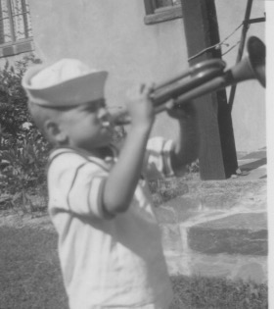

Showtime arrives. I am properly scrubbed, in a starched shirt, with baton in hand. The assembly hall is jammed with teachers, students, and their families. The kindergarten band is the first to perform. The plan is for me to announce our two musical selections and then turn and direct the tambourines, triangles, drums, blocks and xylophones, with Mrs. Lyons accompanying us on the piano.

Except I don't. The band is all in place. I walk onto the stage with baton in hand. The stage lights are blinding. I can only see the cavern of darkness in front of me, with silhouettes of bodies lining the back windows of the assembly hall. Everyone is hushed. All eyes are on me.
I freeze. All of the rehearsing of previous weeks is not helping. I am paralyzed. I stare into the darkness. Mrs. Lyons is stage whispering the song titles to me from her place at the piano. It doesn't help. Nothing moves in my body or brain. Only silence, fright, and paralysis. I hear Mrs. Lyons call to Mary Lou Forni to step out and announce the music to the crowd. She does. I don't. The music begins. I remain frozen, staring into the darkness.

My debut is humiliating. I leave the stage with the others when it's over. No one says anything. Not the students. Not Mrs. Lyons. Not my parents. At least I'm not aware of anything anyone says or does. I am alone in my purgatory. I can hardly imagine that there are any knowing smiles on any faces in the crowd right now, but surely, there must be others who know about the devastation of their world crumbling.

My insides are wrenching as I play on the floor that evening at home with my 'tootsie toys.'

My parents do manage to break the silence with, "You really disappointed us today."

Ugh! A hug would be better. Or, words like "Don't fret about it. We love you. It happens to lots of people. You'll do better next time. It must have been frightening up there all alone, looking out into the darkness. We know you're upset with yourself, but we love you..etc. etc. etc." A lot words could be better.

This early message tells me that love has some conditions. Conditions of performing well, and making parents and others feel better. I don't meet those conditions. Over the years I tell several psychiatrists about this early life shaping experience. It isn't so much about stage fright as it is about empathy and love withheld. It is a catalyst lesson that hopefully helps to turn my life in fresh directions. In fact, I come to see it as a positive event because it shows me what I do not want, and reactions I do not like. Therefore, I can use it all as a contrast for future experiences and choices of what I do want. Thank you, maestro.

CANNED PEACHES

I should never eat canned peaches while laughing.

On this Saturday I have been invited to lunch at Ann Parker's, next door. Her mother has prepared a lovely lunch for is two eight-year-olds . There are baloney sandwiches, potato chips, chocolate milk, with Oreo's and canned peaches for dessert.

We are seated properly at Ann's youth sized table and chairs. A tablecloth and cloth napkins make it seem special. Ann and I always get along well, often laughing without much provocation.

On this day, just as we are beginning the dessert course of Oreo's and canned peaches, we get into an uncontrollable giggling session. We are bent over with laughter and tears, but we never cease to ingest the peaches. I have my first dramatic awareness of my alimentary canal.
With minimal chewing, I am swallowing the canned peaches, and engulfed in laughter at the same time. All of a sudden the peaches come shooting up from my throat, through my nose and splatting onto my plate. Surprise is quickly overtaken with more raucous laughter bursts from Ann and me.

I should probably never eat canned peaches while laughing, but then I will miss a lot of fun.

THE QUITTER

I start smoking early, at age six. I see the movies. Everyone is smoking, especially my favorite cowboys, like Deadwood Dick. I look through magazines. Every other page shows men and women with cigarettes in hand. I stand behind the curtains at adult parties, and the ash trays are usually full of cigarette butts. I see the billboards along the highway flashing that the good life includes cigarettes, even for doctors. But not for kids, just adults.

That little rule does not daunt Jimmy Meserly or me. He is a fellow first grader who lives across from a vacant lot that has an assortment of large boulders. His older brother, Jack, smokes the popular Lucky Strike brand. Jimmy and I conspire for him to steal a couple of "Luckies" from a pack that Jack usually leaves on top of his dresser.

Jimmy and I meet under the big boulder across the street from his home on Highland Drive ... It is a warm fall afternoon after school. He has the two cigarettes. The moment is pregnant. We are following the directions we have learned for the good life, but we are also disobeying the rules for little kids. We're hiding under a rock, hoping not to be caught. This will give us a head start on adulthood ... at six.



We each light a match. We bring to mind how Deadwood Dick does it in last Saturday's movie matinee at the Seco theatre. Cigarette in the corner of the mouth. Match between two fingers. Breathe in strongly to get a sure light. So far, so good. For a second.

Then, simultaneously all hell breaks loose in our breathing apparatus. Choking! Gasping! Coughing! Hawking! It is an assault on our taste buds. Jimmy and I look at each other through our stinging eyes, and wave off the clouds of smoke. We try to re-gain our composure and appear cool, as 'they' do it. Maybe we don't get it right on the first try. Maybe another drag. Same thing.

We pause longer between puffs. We want to get the rest right. Holding the cig between the forefinger and the thumb. There are some options here. We need to keep the medius available to flick the ashes just when the cigarette need to be rid of the ash. No one is here to instruct us properly. We just follow how we remember the way Deadwood Dick and brother Jack do it.

When the cigarettes burn down far enough, we toss them to the ground and rub them out and into the dirt with the tip of our shoes, just the way 'you know who' does it. Then we we go off to meet our friends to play some ball.

This scene repeats itself everyday after school for the next two weeks, while the weather holds. Then there is rain. So for several days there is no smoking. We never say anything out loud to each other, but there are probably some private inner conversations going on. "This tastes awful and it doesn't go away for days. What is so cool about choking, and stinging eyes, and smelly fingers, and having to hide under a rock?"

Jimmy says his brother isn't leaving the Luckies on the dresser any more. "Oh that's really tough luck," we both affirm...but there is an inner sigh of relief that now we can get on with some more pleasing diversions.

We are quitters. There is some satisfaction at having succeeded at some level. After all, we haven't been caught for either stealing or smoking the cigarettes. Without outside pressure we have experimented without too much harm being done. We have learned some lessons and made new choices with resolve. We can become very satisfied with just rolling up glued paper labels to look like cigarettes, and then let them hang out of the corner of our mouths. Maybe Deadwood Dick won't notice ... or care. We can taste our food again, and see straight, and breathe in some of the sweet fragrances of the mimosa blossoms outside my bedroom window. I stop smoking early, at age six. I am now among the quitters, and breathing easily.

A postscript. I have a couple more tries at smoking as a teenager, and my father includes me when he offers cigars to the males at holiday dinners. But none of the distasteful elements change for me. I have almost become a crusader against smoke-filled cars, and parties, movies, and study halls.

Knowing my preferences, the girl I first marry agrees to quit smoking when we are engaged, and then resumes soon after the wedding ceremony. In my passive resistance mode to her change of heart I often leave water in the ash trays around our apartment. Even more exasperating to her is when I take the time to weave a needle and thread through a pack of her cigarettes so that the cigarettes tear apart as she pulls them out. This marriage doesn't last. My cigarette crusade may be a contributor. I guess that's what quitters often do.

SHADOWS

"How could you? What were you thinking? Don't you know it's wrong to steal? What have you learned in Sunday School? Please tell me why you did this?"

I am seven years old as I lie in bed, staring into the dark but starry night outside my window.
I am tearily rehearsing these scary questions and admonitions that have come from my mother moments before. She has confronted me with the handful of boxed medicines that she has discovered behind the socks in my dresser drawer.

I have been caught stealing. My young mind is working overtime to come up with answers that might make sense. It isn't easy. The back up lies are even harder to keep consistent and rational. It isn't working. Internally, I am plummeting into the black waters of confusion, humiliation, and silence.

To the questions: "What are these? Where did they come from?"

I attempt, "I don't know what they are. I can't read labels. I found them in Mr. Packett's garage. He said I could have them. ( Oops, my thoughts stumble, that can be checked! It is.)

She goes on, "Why would Mr. Packett give you these?" Mr. Packett is a neighbor and a pharmacist. He owns a drug store in town.

In answering my mother's phone call questions about these boxes of medicines she has discovered in my dresser, Mr. Packett replies, "No, he had not given Paul any of them. No, he didn't know what was missing. No, there was probably nothing dangerous among them. Yes, he would like them back. No, he wouldn't punish Paul. He would leave that up to her."

I am standing next to my mother as this phone call develops, disclosing the painful details and cover-up lies, and condemning me to the worst hell I have known in my seven years.

My face is crimson from embarrassment. Beads of sweat drip from my forehead and cheeks. All of my energies focus on what to do with the panic of having been caught. I am in free fall. I'm thinking, "There's no rhyme nor reason for the stealing. I don't need them. I don't even know what they are. I can't read the labels. There are lots of them in that garage. Boxes and boxes. Stacks and stacks, all over the place. A few won't be missed. I'll just tuck a few in my coat pocket. The Packett's aren't home. They have left their garage door open. I just wander in. I don't know what I will do with the boxes and tubes. Maybe I can store them in behind my socks in my dresser drawer. I can look at them now and then, until I get things figured out."

After my mother's discovery, the questions, the phone call to Mr. Packett, and more questions, there comes the pounding of my psyche with pronouncements from my parents of: "What a disappointment I have been, how hurtful it is for them, how it will reflect negatively on the family, and how people will be suspicious of me from now on."

I burst into uncontrollable tears and a jerking body, bawling as I promise to "March them all back to Mr. Packett, tell him how sorry I am, and never do anything like this again."

All the high drama is done. My mother and father are talking, while rocking in their chairs in front of the fireplace. My father is puffing and re-lighting his pipe. My mother is knitting. They are trying to understand what could have gotten into their cute and loving fourth son. They ask, "Who is he playing with these days? Where could he get such ideas?" They look into expert's books for the possible meanings and causes of kleptomania. They find that there is no particular cause and no cure. Only some of the symptoms fit their son.

They question themselves, "Was he doing it to get revenge, or to get attention? What have they done wrong? Is there a chemical imbalance in his brain? Is this just the beginning of something more serious? How can they nip it in the bud?" Answers are not forthcoming. They decide the best they can do is to keep loving him as best they know how, and to keep their eyes on him and his playmates for any indicators that might help them.

Meanwhile, I am painfully rehearsing the parts of the events in all their detail. Still trembling, I lie in my bed, looking forward to neither sleep nor the next day. I am thoroughly confused about my actions, and their why's and wherefore's. However, I am very clear about the feelings of the emotional snakepit of remorse, humiliation, and anger at myself. These are murky waters. The shadows of my behavior certainly give me a contrasting and definitive picture of who I do NOT want to be. The unarticulated shadows point me to the kind of person I would rather be. But it is just a start.

There will be other incidents hinting of kleptomania. My mother and father will never know of them. It is not a matter of an ongoing and everpresent compulsion. It is rather a few rare moments that contain similar elements and produce the painful shadows and murky emotions. My expectation is that my clarity about it all would expand. I know any change had to come from more than fear of being caught or following one of the Ten Commandments. I look to increasingly know the aspect of the divine at my core, and then acting accordingly in response to the life questions: "Is this who I really am, and is this who I really want to be?" " Shadows, point the way, or be gone."

FURNITURE STORE... AND MORE

Our family always visits relatives for its summer vacations.

This year it is the Arnold's in Manheim, Pa. They are jolly cousins. Laughter is plentiful.
I am seven. I haven't met them before. They have a family furniture business which they run from their spacious front room. On this evening my family and I are greeted with hugs and humor. Inside, the array of cushy sofas and chairs are close companions with the mattresses, dining sets, and lamps. I trail the adults going back into the living area. On the way I notice an unusual piece of furniture. It is a long, half open, wooden box. A spotlight above highlights the soft and dimpled pink satin cloth around the sides of the box. I am awestruck by the man taking a nap in the box. The man is all dressed up in a navy-blue suit, shirt and striped tie. He is apparently not being disturbed at all by the raucous group of adults passing by.
I am thinking "He's taking a nap, right? After all there is a fancy sign on the box announcing: 'Man at Rest'."

I stare at the man for some time, waiting to see when he moves. But the man must really be worn out. He doesn't move a muscle. My mother calls me to the living room where the adults are laughing. After lingering in this mystery a bit longer, I meander back to where the cousins are, while keeping an eye on the man sleeping in the box.

When with the adults, I venture a quiet question to my mother, "Why is that man taking a nap in that box out there?"

My mother ties her first impulse of amusement from my question, with her desire to be sensitive to my honest, but halting query. The other adults grow silent as they realize that something more serious has entered the scene. My mother's quiet answer is heard by everyone, and spontaneous giggles erupt among them.

She cuddles me as she explains in hushed tones, "Well, he's not really taking a nap. He has died. That box is called a casket. Our cousins also run a funeral business from their home. They both sell the furniture you see out there, and they help families who have had someone die by providing a place for friends to come and see the dead person at peace, and to tell them how sorry they are for the person to have died, and how he will be missed. After that they have a funeral service at the church, and then the man will be buried in the ground at the cemetery."

The adult's giggles have changed to understanding smiles and stares as they wait to see how I will receive all of this new information. I notice that I am now the center of attention, and not really comfortable with that infrequent experience. My head points down and my eyes quickly glance around the room. I tug at my mother's arm and want to shrink into my own quiet places to process all of this new experience. I am allowed to do that. The adults resume their former spirited conversations. I keep my own vigil by peeking back into the front room and the "Man at Rest." It is my first encounter with a dead person.

In one sense it is just one more life experience for me in what was to be a never-ending series of death connections. In another sense, it comes to stand out, and be a defining moment for what is to follow in my life.

After that summer evening in Manheim, Pa, I often think about the "Man at Rest." I also ponder and have dreams of my own father being in that casket. And my mother. And my uncles and aunts. And my brothers. And my friends. And my pets. And myself. All dead! The questions it stirs last a lifetime in the reading it stimulates, in the living of life that it evokes, in the choices it determines.

As a young teenager, I look to the Ouija Board for specific answers. As a seminary student, pursuing my thesis on "Death and the New Testament Faith." As a hospital chaplain intern, choosing to work on the terminal ward. As a pastor, focusing on suffering, death and bereavement as primary teaching moments for all involved. As a chaplain, re-living the near-death experiences with patients. As a hospice employee, being a part of the freedom it produces.

Seeing my first dead person is the beginning of the story. It continues.

FAMOUS NO NAME

Ryland Packett starts it all. Life has been simple and sweet before he wanders into my backyard. When he leaves, I have to begin dealing with a whole new world.

It seems like a perfect summer day. Warm enough to wear shorts and T-shirts. Enough clouds to soften the sun. A gentle breeze to fend off beads of sweat. I am a seven-year-old, comfortably growing up at 1234 Pinecrest Circle in Silver Spring, Maryland. We have a yard filled with fruit trees and grapevines, supported by a carpet of green crab grass. I can wander around at will and let my imagination and 'pretends' take me most anywhere.

I can always lie on my stomach at the edge of the fish pond, and talk with the goldfish as they repeat their aimless wanderings.

Today is especially exciting. We have three new guinea pigs to play with, and to care for. Word has spread around the neighborhood about our new acquisition of the cuddly critters.
I am in the backyard getting acquainted with them. I take them in and out of their cage and box, replace the paper strips and wood chips under them, replenish their water and food. I am entranced by their scurrying about with their nervous noses, soft fur, and searching black eyes. I can just lie here and watch them, consider their needs, and feel the friendship growing.

I think about, "What about night-time, where will they sleep? In a box in my room, maybe."

My mother is saying, "How about the basement? Then they won't disturb you and the smell will be out of the way."

I am thinking, "I wouldn't be disturbed by them. I'd love to have them close by to keep me company. I'd hardly notice the smell."

I muse, "I have to think of names for each of them." I hold each one several times and let them run across my chest and stomach, wherever they want to go. "I can always pull them back if they go too far in the wrong direction," I think.

And more, "I just love their fur. It's so soft and warm. They're so friendly. I think I could probably talk to them about most anything and they'd understand and give me a supportive sniff and wiggle. This all feels really good. I can lie here and look up at the white clouds and blue sky or look down at my three new guinea pig friends."

Ryland Packett lives three houses down from me on Pinecrest Circle. He is only five, so we aren't regular playmates. He has heard about the new guinea pigs, and wants to have a look firsthand. He doesn't know anything about guinea pigs. His world is expanding. His curiosity has led him to my backyard. He kneels down beside me and we watch the guinea pigs at their play. He touches the fur of one and smiles, "Oooh, soft." He lets them sniff his fingers and offers them some food.

We play with them for some time. They run up and down our little make-shift ramps, and in and out of the cage, and around on the grass. Ryland is delighted. The guinea pigs are delighted. I am delighted. It is a perfect day of childhood bliss.

To make it even better, my mother calls out from the kitchen, asking if we would like some lemonade and cookies. We both shout back gleefully, "Yes mam!" I jump up and run inside for the lemonade. I wait as she gets the lemonade from the fridge and cookies from the box. She pours two little glasses full of the pale-yellow drink. The glasses are the usual ones, about the four-ounce size, decorated with little red tulips on the outside. They are the kind of glasses that flavored cream cheese is sold in. We have accumulated an abundance of them, and they are always used to portion out our drinks of soda, orange juice, milk, or lemonade.

I say, "Thank you," as I happily put four ginger snaps in my pockets, pick up the glasses of lemonade, and make my way to the back porch, pausing to take a couple of sips from my glass on the way. I push open the screen door with my backside and set Ryland's lemonade on the porch table .

I call to him, "Here you go Ryland, it's on the porch table." I am ready to sit some more on the grass and play with the guinea pigs.

Ryland's back is to me. His head is looking down. He says nothing. I move over in front of him and say again, "Your lemonade and cookies are on the table over there."

Then....I see what he is staring at. His eyes are frozen in place, wide with fright and disbelief. In his two hands he holds the black guinea pig. It isn't moving. No nervous nose twitching. Black eyes wide open. I put down my lemonade and hold my face in my hands.

"What happened? What have you done?" I yell. I grab the guinea pig from his hands and tried to make it move...or wake up...or sniff...or wiggle its little clawed feet ... something ... anything!

Ryland keeps staring at it.

I yell again, "It's not waking up. It's dead. You killed it. What did you do?" I say, trying to stifle the anger rushing up from my chest, hoping for a shred of explanation. Ryland just keeps staring at the guinea pig, tears welling up in his eyes, as he tries to comprehend the mystery and tragedy that is devouring his young brain and heart.

He finally weakly stammers from his quivering lips that, "I was holding him...he was wiggling and squirming and trying to get away...I held him tighter... he wiggled really hard...and I held him tighter and squeezed him so he wouldn't get away...until he stopped squirming..."

I yell at him, "Oh no, you stupid kid. You've killed him. You've squeezed him to death. What an idiot!"

My anger and anguish is now a torrent. I continue yelling, "You're such a mean brat. Get out of here. Go home. I don't want to see you again." Ryland runs off towards his home, wailing.

I cry. I hold and stroke the warm fur of this nameless and lifeless creature.

The perfect summer's day of child's play is gone. It becomes a learning day, a famous day for stepping into another world of reality. It is a day to begin the barrage of life's questions, emotions, and just mystery without questions. Life. Death. Anger. Grief. Guilt. Sadness. All of it. I have not been close to the death of anything before. Here one minute. Gone the next. A lively body. A still and stiffening body. A warm body and then a cold body. I have not felt this measure of anger before or lashed out like this before.

My mother tries to comfort me with some welcome hugs and kind words. She also asks if I had told Ryland about how to be careful when handling the guinea pigs. She says, "Maybe he just didn't know enough about how to care for them, and not squeeze them to keep them from squirming…"

"No", I admit. "I didn't tell him anything like that, or even show him, I didn't even think about it." So I am partly responsible as well. After all what does a five-year-old know? This is added to the mix of my thoughts about his being a mean brat.

I assume that the perfect summer day also becomes a famous learning day for Ryland, although we never speak of it again to each other. He spends the rest of his childhood in the background of my life, growing up with neighborhood kids his own age.

I have to decide what to do next. My mother suggests burying the dead little black guinea pig in the backyard near the fence, so the lawnmower will miss him. I sadly agree. I find an old Red Goose shoe box in my bedroom closet. I wrap him in a soft cloth. I get the spade from the garage and dig a hole just big enough for the box. I cross out the Red Goose shoe label on the box with a black crayon. Before putting the box in the ground, I want to print his name on the box. But he is so new, and with us such a short time, that I haven't given him a name.

I have been thinking about names for all three when we are playing on the grass, but I hadn't decided. So, with another measure of sadness for this 'perfect day,' I print in my best seven-year-old's lettering, "NO NAME" on the Red Goose shoe box. Then with the tears of a seven-year old, new to the death reality, and the finality of separating from such a brief friendship, I fill the hole with dirt and tamp it down. "No-name" is always in the background of my playtimes with the other guinea pigs, who I quickly name, Fred and Charlie.

Without being knowledgeable about the easy ways of guinea pig reproduction we soon have ten guinea pigs to cuddle with. In hindsight, it would have been more appropriate to have named the first two Fred and Charlotte, instead of Fred and Charlie.

This summer day, and its changing from perfect to somber to enlightening, becomes a template for much of my life to follow.

HOOKY HOLIDAZE

Crime can be titillating. At least at first. Somewhere in the psychic recesses you think a particular course of action will somehow make life better. Distorted logic engages the excited ideas. Adrenalin starts pumping overtime. Deception seems like fun. Deceptive judgements. Secretive plans. Slippery implementation. Crime at the third-grade level of elementary school almost seems sweet. At least cute. But the basic stuff of it is all there. To cover inhibitions, we can say to ourselves that no one will notice or care.

So it is that Bert Johnson and I, students of Miss Clark's third grade class at Woodside Elementary School, commence our early ways of crime.

"Whaddya think, Bert?" It is another beautiful fall day with a warm sun dancing with us at our lunch recess playtime. The air is so fresh with its early fragrances of crunched leaves wafting through our nostrils. Our eyes are glancing at the little yellow fall flowers scattered at the edge of the playground as we run to and fro. We don't really need our sweaters to keep warm, so we take them off and tie the arms around our waists during our play.

After the lunch recess there are a couple more hours or so of classwork inside. Bert and I are surveying the situation as we have done on and off for the last three weeks, weighing the possibilities … hmmmm.

"Well, it's another really nice day," Bert says. "

"Yep," I say. "It's almost too nice to be inside."

Bert says. "Yep," I say. "It's been working so far,"

"Yep."

Our eyes dart around the playground as our fellow students are running, jumping, laughing, kicking the balls. "Who's going to know?" I ask.

Miss Clark is our third-grade teacher. She has also been our first-grade teacher. She is sweet, chubby, and lethargic. She yawns a lot. Bert and I have observed that her frequent mode of operation is to give the class an assignment after the lunch break, and then she puts her head down on her hands at her desk and takes a nap. We watch this pattern for a long time. Our conclusion is that she will never notice or care if we were in the room or not. This shared observation is enough to stimulate the crime juices in us to dream up ways to test its validity.

We make our move. The lunch recess is winding down, Bert and I gradually move ourselves away from our playmates toward the trees and bushes at the edge of the playground. We keep our eyes alert. No one notices us. The school bell clangs, ending the recess. All the others immediately turn and run toward the white school doors.
While they pointe in that direction, Bert and I dart into the cover of the bushes and trees nearby. We stand motionless as we screen the landscape of the school yard for any slow movers. There is none. We look at each other. The adrenalin rush brings smiles. In a burst of new energy we take off through the woods, leaping over fallen logs, swinging from branches, crunching the sweet leaves underfoot, half squealing, half laughing. It is another successful escape into freedom. We come to a familiar field of weeds. The beige strands come up to our shoulders and we trample our way to a quiet spot about a dozen yards from the path that everyone uses on their walk home from school. We settle ourselves in. We each pluck a long straw weed, lie down in the soft patch, and roll up our sweaters for pillows under our heads. We triumphantly use the picked weed as a very long toothpick. We smile and gaze up at the azure blue sky. Our pride is overflowing. There are musings about how everyone else is still stuck in that stuffy classroom, probably laboring over a penmanship exercise while Miss Clark has her post lunch doze. Here we are. Free as birds to enjoy the sweet nectar of freedom, surrounded by nature's gifts. Ah, how clever we have been! Life is good!

We lie on our backs, passing the time with stories and occasional peeks above the weeds to see if anyone is coming down the path on their way home from school. I suppose that inside we might be feeling a bit bored. We have gone through this process off and on, when the weather has cooperated, for three weeks. Our purpose is elusive. We never let on.

Soon a stream of school kids makes its way along the path and we surreptitiously slip out of the weeds to join them on the rest of their walk. We all help in making the plans for after school activities.

One more sunny afternoon arrives. I suppose that it is cocky over confidence that finally does us in. Our surveillance has gotten sloppy. We probably think we are invincible, as we manage to pull off the perfect third grade crime, with no negative consequences.

Robert Preston must be the one. He must have squealed on us. For three weeks no one has noticed. No one knows. Not Miss Clark. Not our parents. None of the other students. Robert has been running around the playground with Bert and me during lunch recess. We are having a great time re-enacting last Saturday's matinee cowboy film. It is another gorgeous day.

Bert and I have given each other the signal to implement our familiar plan. In our play we try to occasionally distance ourselves from Robert. He has none of it. He is a faster runner, and he can manage a more realistic fall after being 'shot.' Bert and I are working our way toward the trees at the edge of the playground. The school bell clangs. Everyone starts toward the white doors as usual, including Robert. Except he looked around on his run in. He sees Bert and I standing still.

He stops. "Are you coming?," he yells. Bert and I freeze nervously. We do not have a plan for this eventuality. Bert and I glance awkwardly at each other.

I yell back, "We'll be along in a minute. We have to check out something."

Bert confirms it , "Yeah, you go on in, we'll be coming." Robert glanced back a couple of times on his way in and then stops at the white doors. He takes a long look at us still frozen in our positions.

We haven't made the needed adjustment in our plans that this new situation calls for. The old pattern has been working for three weeks. No one has noticed. It is another beautiful day. We wave Robert on in through the doors

This unexpected turn unnerves us a bit. We are a little less exuberant in our run through the woods and fields to our established observation point. Breathing heavily, we lie back, pluck a long weed with which to pick our teeth, and gaze at the passing white clouds on a warm fall day. It takes some effort to overcome our tense moments with Robert. Should we have barged ahead with our hooky habit...or not?

Bert and I don't say much that afternoon. Soon we hear the familiar chatter of classmates making their way down the path homeward. We slip in among them unnoticed and begin the usual planning for the rest of the afternoon. Everything is copacetic.

Except it isn't. I quickly realize that the sky has just fallen. I open the side door of my house. I am taking my folded wax paper and paper lunch bag from my back pocket to put on the kitchen counter for tomorrow's lunch. My mother appears in the kitchen doorway. Tears are streaming down her cheeks. My mind flashes into stress mode.

Thoughts are darting to and fro, like lightning bolts in my head. Is she in pain? Has my dog died? Did my father lose his job?" Her question, through the tears, clears it up. "Where were you this afternoon?" she pleads. My jaw drops. I stammer. She continues--which fortunately keeps me from digging a deeper hole of lies for myself.

"What?!... Why?!", she cries. I haven't analyzed the "why's,"

"I don't know," is all I can manage through my penitent tears.

She volunteers a semi escape route for me..."It's that Bert Johnson. He's a bad influence. It must have been his idea. I don't want you playing with him."

I don't object to her judgements of Bert. This can at least deflect some of the blame. I think about Bert. He is probably going through the same grilling from his mother right now. She is probably pointing her finger at that Paul Seltzer, and how he is a bad influence on her sweet Bert. He probably hadn't objected either. The tactic could lighten the burden for both of us.

Bert and I both know the reality that both of us are at fault. The same excitement. The same feeding of each other's willful ideas. And now, the same fears and regrets. We now know what it is like to be caught at wrongdoing. Ugh!

The only thing that lessens the severity of the three-week hooky crime is that as far as I know, the accusations are only addressing one afternoon of AWOL rather than the actual three weeks of afternoons. Whew! I just have to hope that Bert has had enough cool through his tears to keep the extent of the crime to one day as well.

Some lessons learned. Some lessons not learned from our hooky 'holidaze.'

DOWN FRONT

The beauty of early dawn comes over me. I wonder who and what my heart will reach toward today. This is the first morning of my family's annual summer vacation at the Daly Cottage on the shores of the Potomac River at Colonial Beach, Virginia.

All is still and quiet inside the cottage. As a ten-year-old boy, I have the privilege of awakening to the big orange and red sunburst rising from its own sleepy bed on the horizon of the river, and filling the window next to my bed. There is no traffic or voices outside, just the cadenced "coo, coo" of the morning doves calling to each other. I can inhale the mix of salt water and drying seaweed from the beach across the street, as it is topped with the delicate aromas from the powder puff blossoms of the mimosa tree next to the porch. I feel snug and secure with the musty cotton spread wrapped around me. I can just gaze in silent awe as the huge new sun spreads its brilliance into this new day. I can daydream.

The air is pregnant with possibilities for the day. The inventory of abundant and delightful memories from years past flood my mind. Our regular family gatherings usually last a week or two, and often include an extended family of cousins, aunts and uncles, as bed space allows. These remembered good times shared in the humid heat of summer warm our holidays together in winter.

Here it is. A brand new vacation at bucolic Colonial Beach. And here I am, with my chin resting on my folded arms, gazing at another sunrise, and feeding my anticipated delights with the memories that might be repeated or added to. How shall I prioritize my wish list? What would I most want to do today?

Memories serve. I can let my imagination once again have a field day in the storage space under the cottage where family artifacts of furnishings, tools, clothing, pictures, AND… Uncle Adolph's World War I leftovers of uniforms, hats, holsters, boots , maps, and stereopticons from Egypt, are kept in trunks and under wraps.

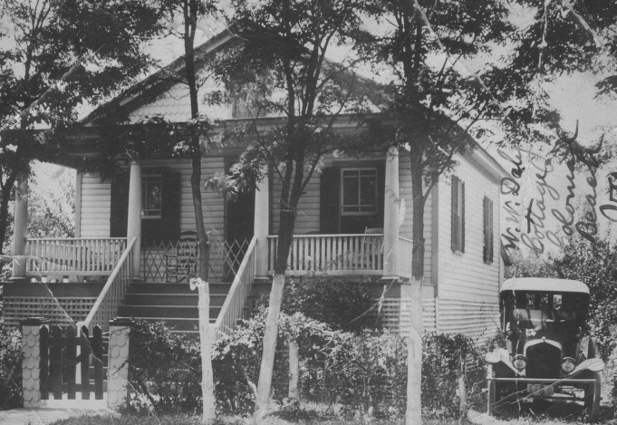

Or... I can join others in hauling the old Daly behemoth of a rowboat from the shed to the water's edge to see if it will float, or need more caulking, or just be allowed to sink and soak until the board seams swell. Or...how about grabbing a crab net and a basket, then hiking around to the Monroe Bay piers to snatch a crab chewing on the barnacles? Of course, there are always plenty of chores and cottage improvement projects needing attention. I can try to get the barley grass under control with a scythe or the clanky reel mower, or white washing the fruit tree trunks as pest control. Lots of fruit trees, pears, plums, apricots, apples here. All planted by my grandfather years before, and now bearing abundant fruits that need daily picking up from the ground.

Or... I might be called to help when the ice man or vegetable hucksters stop at our place on their rounds. I can dare a pat or two on the tired horses or mules with the iron weights around their necks holding them in place. Or ... if it rains, I can open up the old mahogany Victrola in the hall and listen to some of the favorite recordings from yesteryear like "Uncle Josh at the Dentist".

There are so many options for pretending. On the beach, with sand castles and skipping stones, climbing over gates, exploring paths, watching the naval patrol boat and men in the lookout tower, where for all the World War 2 years they patrol the river, and measure where the newest artillery shells, being tested at Dahlgren Proving Grounds, will land. There are so many places to roam or hide out, even behind the cottage outhouse at the end of the property with the pungent combinations of sticky fly paper and lime, plus assorted sweetnesses.
r
When the patrol boats leave, we can venture out front for swimming and splashing and 'chicken fights.' To get to the desired sand bars about fifty yards from shore we have to sludge through the ankle-deep mud and clinging seaweed, then tiptoe over oyster shells while avoiding the jelly fish floating by. Alternative transport might be the Daly rowboat, or a tire tube to keep us above the muck. After swimming we can likely rest up and dry off while sipping a cool sarsaparilla from the well house.

Soon we can expect aromas from the kitchen to take over the odors of the kerosene stove, and whet our taste buds with fried chicken, corn on the cob, crab cakes, or fish, cantaloupe, watermelon...mmmmm...all in the shade of the pear tree just outside the screened dining room overlooking the river in the distance. The dinner cleanup will be fun with everyone joining in some singing or laughing as we swish the little wire basket with the leftover soap pieces to make the suds in the soft slippery water, and then take turns drying off the plates and glasses.

If this year lives up to my expectations, I can look forward to the day being topped off with my favorite family vacation ritual.... going 'Down Front' in the evening. There are some bargaining chips from my mother: "If you want to go Down Front, you need to take a nap. Or,"You have to put on a clean tee shirt and shorts, and comb your hair, before we go Down Front." Or, " Make sure you get all those pears picked up, so we can go 'Down Front' tonight."

The trip "Down Front" is an almost daily event at twilight, after some porch sitting, watching the fishing boats gliding by, playing some games, and planning for what the evening 'Down Front' might include.

There is the application of citronella oil and lighting of punk sticks to fend off mosquitos on our long walk. Then, in a jolly mode, we start our family adventure for the evening. 'Down Front, takes us along the sidewalks, in front of cottages, and parallel to the river waters. There are greetings to neighbors and relatives along the way. The walk always seems long, probably a mile or so, but enthusiastic anticipation provides the needed energy.

'Down Front' is four blocks of a wide concrete sidewalk along the waterfront of Colonial Beach. At one end is the Wolcott Hotel with its lineup of emerald green rattan rocking chairs on the porch. (Aunt Mabel and Uncle Irving met and romanced here). Just across the street is the expansive town pier, large enough to receive fishing boats and the tour boat from Washington, D.C. Lots of people walk here and watch the waves. Other folks climb into the speedboats or sightseeing boats for a twilight cruise. At the other end is the historic Colonial Beach Hotel and its sprawling green lawns. It was originally the home of "Light Horse" Harry Lee, brother of civil war general Robert E. Lee. Lots of history here. In between, there is a diverse assortment of shacks. They house eateries, beer joints, dance halls, and carnival-like amusements, all framed with bright white and colored lights. The sidewalk is lined with benches for relaxing and people watching. Behind them is the public beach with its sand, seaweed and netted swimming area. The foam of the gentle waves reflects the bright lights of 'Down Front.'

There is so much to encourage my wild-eyed excitement. I get to choose one treat, so I take a couple of trips up and down the four-block strip to see the options for the evening. To start with there can be an ice cream cone from the drugstore. Strawberry is a favorite. Then, let's see. I am thinking, "A flavored snowball. I like root beer best. Maybe a 'pig-in-the-blanket' (corn dog) with lots of mustard. There are deviled crabs. But no thanks, too hot. Maybe a big orange drink since it is very hot and humid. Am I ready for a candied apple or saltwater taffy? Ah, but it will be hard to pass up a favorite that I'm smelling right now. Hot buttered popcorn! Nothing like it.
It's fun to watch 'Popeye,' the ebullient old man with the bald head and captain's hat, tilt the cooker lid, sprinkle in the hot butter and scoop those tender morsels into the bags. He's been here ever since I can remember.

"I also get to choose one amusement. Let's see. There's the 'whip' ride, or miniature golf, or shooting gallery, or ring toss, or a boat ride. Maybe I'll just watch the adults do their thing, like bowling or roller skating or dancing."

All the sights and sounds and smells keep stretching my little world. I hear the hawkers for the boat rides, and announcers at the dance hall, and the clanging bells in the background, ringing for winners of something, and babies crying or laughing.

There are angry words and fighting, and the town policeman with his billy stick through the belt of an unruly drunk, hustling him out of the public eye to the town jail. There are the young couples with arms around each other, dreamily laughing and sauntering along the sidewalk, unaware of anyone or anything else in their blossoming world. There is the greasy smoke from the fried fish and clams and potatoes. There are the juke boxes and shots ringing from the shooting gallery. Lots of world to take in. It's fun. I'm tired.

It's time for the long walk home along the dimly lit sidewalks. Someone agrees to pick up a stick and be the leader of our family line to break up the yukky threads of cobwebs that have formed across the sidewalk during the evening along our walkway. We sing and laugh and recount some of the eventful evening delights. Once home, it's time to get a half a glassful of water and go out to the backyard to brush our teeth, along with an outhouse visit.

Then we gather on the rocking chairs of the front porch of the cottage, listen to the lapping of the waves on the beach across the street, get another dose of citronella and light up the punk sticks to do more battle with the mosquitos . My father lights up a cigar. There is some singing and story telling. My eyelids start drooping. Finally, the willing trip to bed, closing the screen door quickly to prevent mosquitos from entering and buzzing and biting through the night. It's been a great day. The remembering. The dreaming. The planning. The doing. And especially, 'Down Front.'

SNIFFING EASTER

Memories of Easter excite my senses. The anticipation of my ninth one is stimulated with the purchase of a brand-new tan, wool suit. Anything new is cause for exhilaration in our house during those waning days of the Great Depression. Our household motto is the directive to "save, re-use, and re-cycle…everything." Hand-me-down clothes, toys, and sports equipment from my three older brothers are my eagerly awaited prospects.

But this 1941 Easter is my turn for a new Sunday suit. Of course, my parents' usual constraints of conservation are in play. The expected echo from my mother, "Remember Paul, this suit has to last a long time. It is too large now, I know, but you will grow into it. The pants and coat sleeves are too long, but I will turn them up and put cuffs on them. They can be hanging in your closet and on your body for a very long time." Any embarrassment from me about these obvious adjustments have to be swallowed for the 'cause.'

No matter, it is still rare to have a new item just for me. It smells new. It is Easter. There is also included a brand-new white shirt to be excited about. Of course, it's sleeves are also tucked for later extension. I know my new suit is important because my parents have a professional photographer come to our home to take pictures of me. He sends us five poses, including the cuffing, with "proof" stamped in black across them. They become our permanent record. No actual prints are ever ordered. We save money.

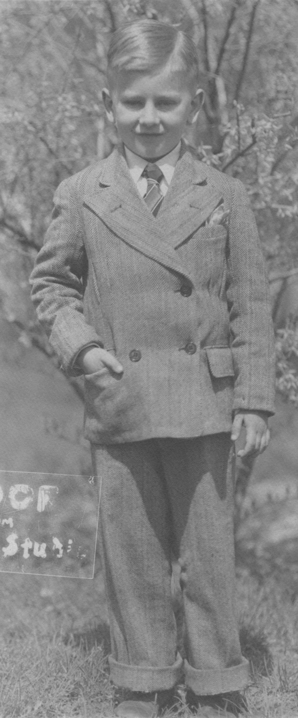

Bounding down the stairs on that sunny Easter morning my nose signals to me lots of other things to be excited about. On the kitchen floor there is a flat brown cardboard box with three dozen little chicks chirping and scratching the saw dust and grains inside… with an odor all their own. In the living room are the regal bugled white blooms of the three-foot Easter lily. Its sweet fragrances have been wafting through the house for days.

On the dining table are gathered the assortment of Easter goodies. I gingerly finger the separate baskets with their soft green cushions of cellophane grass holding the brightly decorated hard boiled eggs that we prepared yesterday. I move my head closer to my purple basket. With short breaths I separate the unique spices wafting from the little piles of red, yellow, green, black, and orange jelly beans, along with the assorted Hershey 'kisses' wrapped in their foil blankets, with the little paper tabs to help in their opening. In the middle of the table is a box with four large chocolate bunny rabbits. Each is a different size for the four boys. Mine is the smallest. My oldest brother's is the largest. "Oh boy! I think. All chocolate! I can't wait to get into that…just smell that…"

Next to my basket is a soft and puffy white velvet rabbit. Also new! With its store aromas.
All of these table gifts are just to be looked at for now. Consumption time will be later… after breakfast… after singing some Easter hymns together around the piano…after shining my shoes and dressing for the big day at church.

Our family of six piles into our gray 1936 Lafayette auto for the ten-mile drive to the Keller Memorial Lutheran Church at 9th and Maryland Avenue in downtown Washington, D.C. The excitement and stimuli keep growing.

The rows of white lilies are lined up around the church sanctuary and Sunday school rooms with their prominent olfactory sensations. Everyone proudly sports their new clothes. Children eagerly spy the stacks of Easter candy boxes that will be distributed at the end of the ceremonies. The choirs and organ can be heard practicing in the distance.

I make my way through the bustling crowd with its assorted aromas to my place at the table in the Junior Department, where my Aunt Ruth is the superintendent. As usual she leads the 150 students through the Sunday morning rituals of singing some Easter hymns, helping us recite from our memory work cards The Apostles Creed, Lord's Prayer, Ten Commandments, Twenty-third Psalm, The Beatitudes, and the love chapter from First Corinthians 13. … "though I speak with the tongues of men and angels…but have not love, my speech is like a noisy gong…"

As we go through the rituals and begin our weekly lessons at our tables, the boxes of Hershey kisses are always in view. The sweet chocolate aromas they emanate make their way to our nostrils. We have done our usual share of giggling and shoving as we transition to our table lesson. Mr. Frolic is our teacher. We each have in front of us our little teaching pamphlet. It includes a lovely full color cover of the Easter scene of the empty tomb with its calming angel and the story inside. There are also printed exercises and questions for discussion.

I have my eye on Barbara Mumper, the pastor's daughter. For some time, I have thought she was quite attractive with her long blond curls, cheerful personality, and freshly starched and pressed clothes.

Today she is different. She is not joining in our fourth-grade antics. She sits at the other end of the table with her head resting in her cupped hands. Her usual bright smiles and laughter have been replaced with quiet frowns. Even her lovely new outfit cannot disguise her grayish appearance. Her face is pale. Her eyes stare straight out as if there is a deep puzzlement for her to figure out.

She doesn't open her pamphlet like the rest of us, when Mr. Frolic has instructed us to begin our lesson. The rest of us at the table get busy looking at the colorful lesson paper, and of course we keep our eyes on the stack of Hershey kisses boxes waiting for us next to Mr. Frolic's clipboard.

What we don't see is what is coming. From a befuddled Barbara gushes out an enormous blast of vomit. It splashes across the whole table in front of us. It oozes over every pamphlet and Bible. It drips over the table edges onto our new pants and dresses. There are two more throaty surges. They are received with gasps and screams as we scramble away from the table.

Mr. Frolic jumps up and goes to Barbara, wiping her mouth with his handkerchief, and mumbling. "Oh, dear girl. I'm so sorry. Here, let me help you. Come with me. We'll get you to your mother upstairs." He escorts her from the room. As he is leaving, he calls to my Aunt Ruth across the room, "Mrs. Seltzer send someone to get the janitor to come to help clean this up quickly."

The whole Junior Department is in upheaval and abuzz. This is a first for most of us. We are wide-eyed and stunned. Another teacher brings out wet dishcloths and towels from the kitchen and starts rubbing our new garments, trying to reduce the damage. They finally march all of us into the adjacent church kitchen where there is more water and towels for the cleanup. Barbara finds her mother in the adult Sunday school class and is taken home.

Our eyes share the upset we are feeling and smelling. The stink penetrates our noses and takes over our olfactory awareness. Everything reeks of vomit. Its stench blocks the abundant fragrances of the perfumed lilies surrounding us. The former sweetness of the awaiting Hershey chocolates has disappeared ... but we will accept them anyway. Our new clothes…will they ever be the same?

We have stories to tell our parents on the way home. They don't have to be told about the malodorous part. We all agree to keep the car windows open all the way home. We feel sorry for Barbara. We feel sorry for ourselves. We can't wait to get out of our new Easter clothes. The acrid pungency follows us everywhere that day, even after we have showered.

Life does return to normal eventually. Barbara smiles again. Chocolates and jellybeans please the palates again. Soft bunnies and chirping chicks fulfill their expected roles. Pants cuffs and sleeve tucks are finally let out. I grow. I especially remember with smiles the sniffing of that Easter 1941.

BUSY BEE CLUB

It's Tuesday afternoon and time for the Busy Bee Club meeting. You are welcome to join us. We are a group of eleven-year-olds in Woodside Park, Silver Spring, Maryland.

Mrs. Lillian Seltzer, my mom, put out the invitation last year. She is an affable, rotund organizer who plants ideas, and can stir up a giggle fest. She gaily begins most days at the piano accompanying her finely tuned contralto voice.

She comes up with the name and format for the weekly after school program. There's lots to do in our hour and half session.

After Mrs. Seltzer's jolly welcoming, she accompanies us on the piano as we start off singing some songs. She picks one. We pick two. Her choice today is "The Band Played On." Our choices are "Daisy," and "Reuben And Rachel" with the usual boy-girl divisions.

After singing we nestle into the combination of wooden and cushioned chairs arranged in a circle in the Seltzer's living room. Beverly Woofall is the president for this month. She is fair skinned, has a red-haired page boy cut, and wears pink framed glasses meant to adjust her crossed eyes. Mrs. Seltzer prompts her to ask for the minutes of the meeting last week to be read. They remind us of our assignments, plans, and provide the content for the club newspaper.

Beverly pushes her glasses back up her nose to see better. She asks the secretary and editor for the month, Ann Parker, to read what she has for the newspaper this month. Ann, an only child, lives next door to me. We have been good friends since we were three, which is when we venture our "I'll show you mine if you show me yours," intimacies.

Following the news items Mrs. Seltzer takes over saying, "Thank you, Ann. It's fun to remember all of the exciting things we have in store for ourselves. Let's get to the first order of business."

We all share our squirms from prior experience, knowing that the first item in our Busy Bee meeting is always to go around the circle as each of us repeats a Bible verse that we have memorized during the week. It is a required step along the path to the hot cocoa and cupcakes at the end. The rule is that we can't repeat another member's choice. Strangely enough we have figured out that if we go first, we can get off easily by reciting the shortest verse in the Bible, "Jesus wept."

Until Mrs. Seltzer catches on to the strategy, she is pleased that so many of us want to go first. We are sheepishly snickering among ourselves about this and thinking about what the backup verse will be if we can't go first. It's a mix of anticipation and angst … a small price to pay to belong to the Busy Bee Club.

Once the Bible recitation routine is completed, we are to share a newspaper clipping of community or world news that is of interest to us. I pull out my page from the Sunday papers' supplement that has a picture and article about my older cousin, Al Dieffenbach, who is a bombardier on a B-17 aircraft during World War II. He has received a Purple Heart Medal after having been shot during a bombing mission in Europe. I pass the article around the circle.

After everyone gives their news reviews, the treasurer for the month, John Thompson, gives his report. We each bring a dime to every meeting to put in the basket and then decide where and when to donate the money.

He reports, "Well, we have $3.80 in our treasury. I'd like to suggest that we donate it to Alfred, who is the son of Marie, our family's maid. I know you don't know Alfred even though he is our age. He lives with his mom in Monkey Hollow (the black community) and never gets over this way. Alfred loves comic books. We could take a dollar from the fund and at ten cents each get him a bunch…ten actually…different ones like, maybe…"Batman," "Flash Gordon," "Dick Tracey," and something funny like "Blondie. Whaddaya think?"

Richard Petzold, with his curly blond hair and usually restrained participation, surprises everyone as he pipes up with, "Sure, a good idea."

I am is thinking there may be a sensitivity connection between Richard's benevolent reaction to Alfred's being black and feeling left out, and what happens at Richard's own home where his mom is confined to a wheel chair and is also feeling left out and disconnected from the world outside. Everyone raises a "yes" hand to the idea. John says he will buy the comic books and get them to Alfred.

Richard's unusual vocal response to the donation idea isn't the only thing that draws extra attention to him today. Judy Anderson and Joan Membert are sitting on each side of Richard. They are both prim and proper with freshly washed and starched dresses and neatly arranged hair. Agitated, they turn away from Richard as they look at each other and roll their eyes.

The wordless upset spreads around the circle until Mrs. Seltzer joins in and addresses the "elephant in the room." It isn't actually an elephant, but it could have been, given the stench emanating from Richard's right shoe. There it is. Dog poop, mixed with grass and gravel firmly stuck between the heel and sole of his shoe. A mix of gagging, giggling, and groans fills the room. Richard's white skin turns crimson. He is immobilized, mortified with embarrassment.

Mrs. Seltzer moves to his aid, "Here, Richard, take my hand. Come with me. We'll get this cleaned up. It's too bad, but don't worry. It could happen to any of us. You didn't know. Paul, you come with me. The rest of you…Ronnie…Jimmy…grab some paper towels from the kitchen and look around the halls and carpets to see if there are any poop tracks to be cleaned up."

Mrs. Seltzer, Richard, and I go to the side entry of the house to remove the problem shoe. I take it outside to clean off the worst of it with a stick and then run it under the hose, using an old brush, until it's clean.

Richard is is sitting on the steps inside the entrance, bewildered, speechless, staring straight ahead, and still very red. She says to him again, "Don't worry. It's okay. It happens to all of us one time or another. I'll bet you walked here today through the Thompson's yard. They have two dogs you know. No doubt it would be very hard not to step in one of their droppings scattered around the grass. Richard gradually calms down and we return to the group where she repeats the same explanation.

Mrs. Seltzer then diverts our attention further with her demonstration for the day. She lifts her canary cage with Cheeky inside to the floor in front of her. She begins talking about her pet canary, his care, likes, and dislikes. She encourages Cheeky to sing as she carefully has him jump to her finger and close to her lips while she talks with him. We are entranced with this exposure to life with Cheeky.

There are two more things on the agenda for today's meeting … actually three, if you include refreshments.

Ronnie McDevitt, the only Catholic in our WASP neighborhood, is to report to us on a hobby or new discovery of his. He has brought his new crystal radio set that his mom has given him.

He shows everyone, "Here, see this. There's this five inch square wooden block. It has a nickel size metal disc with a pea size crystal in the center. Then I have this copper whisker arched over the crystal. I can move it around with my finger like this. You can see these two jacks going out from this block. One is attached to a copper wire which goes out my bedroom window to a tree in the backyard. The other jack holds a cord for the earphones that go on my head.
I gently move the whisker around the crystal, and I can hear radio stations from all over…D.C., New York, Wheeling. It's amazing…all these sounds going on out there and you can't see a thing! Come over to my house sometime and try it. It's wild!"

The last thing they do before refreshments is to plan their next Busy Bee outing. A couple of ideas are tossed out. Jimmy offers, "How about a hike along the Sligo Creek woods with a picnic and dodge ball at the end?"

Beverly comes up with "taking a trolley car from the district line to downtown D.C. to see the new Smithsonian Museum displays and then to White Tower for burgers?"

Liz Cave and Marjorie Hardee volunteer to bring back more details to next week's meeting.

Finally, we move our wooden chairs around the dining table and add a couple of sitting stools. It's hot chocolate and cupcakes as promised for today's refreshments. There is free-wheeling chatter and laughter now. Even Richard has managed a smile about his "poop problem." He finds some new connections with his friends as he haltingly relates his story.

"Man, this is so bad. I mean I keep smelling this awful stuff. I never dream it is me. Then I see Judy and Joan moving away from me and rolling their eyes. I don't know what is going on…"

Everyone is now giggling about it, but not about him. We all know we could have been the ones crossing through Thompson' s yard and…"yuk!" We squeal and squirm and laugh.

Another Busy Bee meeting is done. We pull on our jackets, say our thank you's and goodbyes.

With today's gentle nudging our little world's have expanded and been enriched. No doubt larger versions of the Busy Bees will continue to merge.

BREAKFAST PLANS

"How about a fish feast?" My brother James is asking me. It is our summer vacation at Colonial Beach, Va. on the Potomac River. The available weeks of summer at the Daly cottage are divided up between my mother and her sibling's families. During our turn, there is usually one morning that we have a fish feast for breakfast. Our mother fries up a 'mess' of Perch fish caught the day before. It is a simple but tasty treat. There are the welcome additions of home fried potatoes and onions, succulent sliced tomatoes, sweetly ripened wedges of cantaloupe. It is a meal to be savored longer than the usual breakfast fare because the butter fried morsels of Perch are laced with lots of little bones that have to be extricated by hand or mouth before swallowing.

On this particular day, James, my fourteen-year-old elder brother and I conjure up a plan for the for the traditional fish feast breakfast. This year, it will be different. This year, my brother suggests, "We can surprise everyone. We'll be the ones to catch the mess of fish."

I ask him, "How is that going to be a surprise?" He answers, "Well, nobody has caught any fish yet this week. We can be the ones to supply the string of fish. It will be our secret. Without anyone knowing, we can get up really early, before sunrise, before anyone else is awake, and row out front on the river, catch a mess of fish, and be back in time to clean them, get them to mom, and surprise everyone with our fried fish breakfast. Whaddaya think?"

The idea stirs my imagination. I think, "Hmmm. I'm only nine years old. Big brother wanting to include me in an activity is cool enough. Add to that, having an adventure like getting up before dawn and sneaking out with no parental advice or admonitions to dampen the dream stream. Taking on the Potomac River by ourselves. Wrestling with the heavy, old, hand-made Daly family rowboat. Showing our stuff in lessons learned about cleaning the fish properly by ourselves. Surprising everyone. Wouldn't that be a hoot?!"

My controlled enthusiasm blurts out a simple, "Yeah, man."

We spend the rest of that day piecing together the breakfast plan and thoroughly enjoying its unfolding and anticipated happy conclusion. Before drifting off to sleep at night, in the musty double bed we share, we whisper a few more details. The aroma of citronella oil fills the room and sends its message to any hopeful mosquitos that they are not welcome.

It is a wakeful night even without the mosquito's buzzing. We are both anticipating the morning adventure with our personalized scenarios of how it will all play out. We don't want to miss it by oversleeping. There is no alarm clock. We have to rely on our activated inner juices to awaken us before the dawn.

This means frequent false wake ups in the dark, each of us listening and wondering, "Is he awake? Is it time yet?" Then another turn in bed, pulling the sheet over our heads, and a determination to get back to sleep before 'H-hour.'

Finally, there is a hint of light in the dark eastern sky, and the first wistful "Coo, coo" of the distant morning dove. We nudge each other at the same time in acknowledgement that this is 'it.' We push back the covers in the dark and slip quietly out of bed. We find our tee shirts, shorts and shoes where we have carefully placed them the night before. Being quieter than usual, and in measured pace, we imitate each other in our dressing routine. We slowly open the bedroom door. Fortunately, no squeaks.

We tiptoe down the back hallway, reaching out in the darkness for familiar objects, like the old Victrola, or the horse hair couch, or the old family portraits that line the walls. The main door is still open to let in fresh air during the night. There is only the hook on the screen door left to deal with. My brother deftly uses both hands to pull the door toward his body to release the tension, and then he nudges the hook out of its hole to its freedom, and ours. The door spring and its stretching "twange" is engaged so slowly we can barely hear it. Carefully we move through the doorway and gently close the screen door.

We are free of the house proper and holding hands as we inch across the porch and down the steps in the dark. Small beads of sweat now ring our brows as we make our escape. Our nostrils welcome the early dawn sweetness of the mimosa tree blossoms as we brush by them on the way to outside the back door of the kitchen where we have stored our gear for the trip: The can with worms and their soil, an old tomato can for bailing the boat, our fishing lines and weights and hooks, a line to hold the caught fish, a fishing knife, and our box of Cheez-Its for snacking.

The dew from the wet grass curls over our sneakers as we walk to the garage to pick up the oars for rowing the old Daly boat. Our eyes are getting accustomed to the darkness and the eastern sky. We are also moving toward more light. We can make out each other's shape well as objects along the way.

The rhythmic waves of the Potomac River are pounding the beach, louder than usual. There is the familiar smell mixing salt water and seaweed as we approach the riverbank, crushing the pine needles along the way with each step. We find the usual spot for negotiating our way down the bank to the water. The roots and rocks are spaced just right for easy steps down to the loose mix of sand and gravel which sounds its 'crunch, crunch' with every step.

We set down our gear and oars as we look toward the horizon and relish the fulfilling of our breakfast plans via our adventure on the high seas. Actually, the seas are indeed quite a bit higher than expected. Usually, the Potomac is a lethargic estuary showing nothing much more than a frothy ripple slithering across the shore's shells and sand.

This morning it is different. There is no storm, but there is rough water. White capped waves are rolling in and crashing on the beach. The foam is almost rolling to the bank. James and I can now see each other plainly, and we are taken aback with this unfamiliar scene. But our stores of enthusiasm for the benefits of providing the surprise string of Perch for our fish feast trump any inklings of trepidation that might be close to surfacing. It is going to be more of a challenge than we have planned. Our adrenalin is ready for it. Wide eyed, our dream is enlarging in front of us.

We move to the post and rope by which we would reel in the Daly rowboat from its protected mooring about thirty yards from shore. The boat is bobbing up and down with each wave slapping its sides and sending huge splashes over its sides. It will need both of us to reel in the rope and get it to shore quickly. All the way in the boat is being pushed and slammed in different directions. By the time we get it to the beach several inches of water have accumulated on the bottom of the boat and needs to be bailed out before we can start our trip. James uses the fish bucket and I use the old tomato can to feverishly get the water out. It goes pretty fast. We secure the oars in their locks and stow the gear under the seats.

The bow is on the shore. The stern is taking hits and more water from the back. We have to get the boat out and turned around so the bow will face out and we can row away from shore. The boat is heavy and the bow stubbornly sinks into the shore's gravel and sand. Finally, an incoming wave coincides with my push. The extra lift is enough to get it unstuck. I push out some more until the water is up to my knees. I try to pull the boat around as James pulls hard on the right oar. During the turn-around effort another big wave hits the other side of the boat. It knocks me over. I pull my drenched body up and push even harder to get the boat around. Together, we get the bow pointed out and James yells for me, "Jump in, quick!".

Once I am in the boat, he is pulling on the oars but not making much progress as each new wave is pushing us back to shore. He calls, "Come here. You take the other oar and pull hard with me. We've got to get out of here. If we can get out a bit farther the waves won't be so bad. Pull hard."

We are together on this, leaning way forward, bracing our legs on the seat in front of us, digging the oars deeply, pulling hard and leaning way back to get maximum benefit from each stroke, so we can get away from the churning waters at the shoreline. Over and over. It is working.

We gradually make our way to deeper waters. The bow continues its wild thrust up and out of the water as we crest the waves. Then with a loud "schwock!" we slam into the trough, and the spray splatters across our backs. The water rising in the bottom of the boat sloshes over our shoes. We are soaked. The sun is not up yet. We are shivering. This is the adventure and its reality.

This the way I have heard that they do it on the high seas. Pull hard together. Meet whatever challenges show up. We have the rhythm: Feet braced. Lean way forward. Get the oars raised and planted in the water behind us. Pull hard. Repeat and repeat.

The boat heaves uuup and dooown over the crests and into the troughs. My hands grip the oar tightly. Soon I am feeling the painful effects of the repeated friction on my palms. We are now a couple of hundred yards from shore.

I am relieved when James says, "I guess this is far enough out. Go to the bow and throw the anchor overboard. I'll try to keep the bow headed into the waves."

I give him my oar, turn, and scramble to the bow to toss the anchor overboard. In less than a minute it catches on the river bottom. The line is taut, keeping us steadily headed into the oncoming waves. The rolling and heaving up and down keeps up. We bail out the several inches of water, now soaking our shoes.

We manage to get our hand lines baited and dropped into the churning Potomac waters. We are both tired as we eye each other with silent satisfaction at having overcome the first challenge of our mission together. We survey our situation. The sky is fair and the full light of the big orange ball now rising from the eastern horizon promises us some warmth.

The water-logged Cheez-Its are thrown overboard. We'll have to wait for snacks. We stow the oars. With the lines out, we settle in, look around and back at shore. We begin the wait for the first strike for our expected string of fish for the breakfast feast. Our imaginations let us savor the fish frying, along with the home fried potatoes and onions, and all the rest. Especially pleasant to look forward to is the delight and praise of parents and family for pulling off such a welcome surprise for everyone.

It isn't long before the nylon line, draped over my fore finger for early detection, reaching into the murky Potomac, gives its familiar stutter. Somewhere, down under, a sweet Perch was checking out a wrinkled worm for his breakfast.

A couple more nibbles for a taste test, a chomp from him and a yank from me. He has discovered the sharp hook waiting for him behind the tempting wriggling worm.

"I've got one," I yell.

"Good going. About fifteen more of these and we'll have our quota for the surprise breakfast." James said.

He watches as I try to get a proper hold on the flapping Perch. It is about nine inches long. "Not bad," I think. I proudly cup my hand over him on the floor of the boat and hold back the sharp fins, twist the hook out of his mouth, and maneuver the metal end of my fish stringer through his pulsing gills.

I secure the string to a rib of the boat and toss the line overboard so he can stay alive while we capture some more. I re-bait the hook and drop it back into the water, draped again over my fore finger for early detection of the next catch. All the while I am bracing myself from the now familiar rolling and smacking of the boat up and down, up and down.

In a few minutes I hear James yelp, "Whoa. I've got one. Something big!"

We aren't used to 'big' so the curiosity and adrenalin rachet up. His hand line is wildly coursing back and forth in the water. This is more than another Perch. Clearly his excitement includes the pain to his hand as he tightens the pull in. The line jerks and runs through the water over and over. Finally he brings it up tight to the boat.

"Oh no." he shouts. It is not a fish.

He wrestled the squirming creature into the boat. "Holy cow," I'm thinking. "It's three feet long".

"It's a snake," I blurt out. Wide eyed, I watch James as he tries to get control of it. It whips and slaps around his end of the boat.

"No," he says, "it's not a snake, it's an eel." I have never heard of, or seen, an eel. It is olive green, two inches thick and looks mean to me.

James finally gets his foot over the writhing creature from out of the deep. He has heard about eels. What he has heard is about to come to the present tense of reality for him in living color.

He tells me that, "The thing about eels is that when they take the hook they swallow it. Other fish chomp on the bait and the hook snags their lip or gill. Not so with the eel. He takes the hook by gulping it and it doesn't grab his flesh until way into his gullet. This means that if you want to retrieve your hook you have to cut the eel on the spot down its middle until you find it."

James has never done this procedure before. He starts in. With his foot still holding the eel in place, he reaches for the fish knife in the bucket. He cuts off the eel's head. At least that stops the wild whipping. He then continues the slicing of the eel's mid-section, laying it open to find the hook. It becomes a very stomach-turning scene on the boat's floor, with the eel's blood and guts strewn all over. Added to that is the continuing heaving of the boat up and down, up and down.

I am having no more bites so I stare at James' surgical process and begin to notice that as he searches for the elusive and embedded hook, his own countenance is changing to shades of grayish green.

As he is cutting away, I hear him mumble, "Oh man. Oh man..."

He swallows hard a couple of times and wipes the accumulating sweat from his brow with his forearm. He looks to one side and then the other, over the side of the boat. He is breathing heavily and gripping the stern seat of the boat as we continue our rolling response to the oncoming waves.

He looks at me painfully, and says, "Man, I can't do this anymore. I'm sick. We gotta go in. Haul up the anchor and see if you can row by yourself for awhile." This has not been a part of the breakfast plan. Clearly, we have to abort the mission.

I quickly pull in my line hand over hand and throw it on the floor. I scramble to the bow and tug at the anchor rope until it releases. I stow it in the bow. I yank up my lone fish and slip him free back into the water. When I turn toward the oars my brother has turned in the stern seat and is leaning over the back of the boat, vomiting what was left of last night's supper, and any other juices his retching can bring up. There are groans in between. I take hold of the oars by myself and start the long trek to shore.

He looks awful, but the greenish gray hues gradually give way to normal pinks as the blood rushes to his face during his dry heaves. As he is resting up from his ordeal, he tries to get back to normal by bracing his outstretched arms on the stern backrest. He breathes deep gulps of the fresh air in and out of his lungs.

He scrapes together the pile of dismembered eel parts from the floor of the boat and tosses them over the side in disgust. He uses his foot to slosh the unbailed water over the eel remnants in a half-hearted attempt to be done with it all. It is a long, quiet row for me back to shore, although I am often assisted by a new wave coming under the boat and carrying us with it at its faster pace.

By the time we reach shore James is still queasy from the ups and downs of the ride but in much better shape. His normal color is back. We have started talking and rehearsing the eel event and getting our minds around the disappointment.

"I'm sorry man," he offers.

"It's okay," I say. "I'm just glad you're better. You looked and sounded terrible."

"Well," he volunteers, "at least it was a secret surprise. Nobody is expecting anything, so they won't be disappointed. We just won't say anything, right?"

"Right," I answer.

Even though it has turned out to be a misadventure, it has its plusses. A dream has been shared and we have given it our best shot. Circumstances have intervened. We have another memory together.

On shore, we pull our gear out of the boat, attach the rope of the boat to the pulley and reel the boat out to where it had been two hours earlier. We sneak back into the cottage and change out of our wet clothes. Apparently, no one has noticed our absence. We hear some movement from other bedrooms. We sponge off the salt and dirt with water from the basin stand in the bedroom. (There are no inside bathrooms in the cottage.)

We can smell bacon frying and coffee brewing, coming from the attached kitchen. We empty the basin into the slop jar and carry it to the outhouse, just like any other morning. On our way back we hear our mother busily preparing the breakfast she has planned.
She calls out, "Good morning, boys. What a beautiful day, isn't it? I need you to set the table and cut the cantaloupe. I'm going to make corn fritters for breakfast. You can cut the corn off of the cobs from last night's dinner for me, and then I'll fry them up. How does that plan sound?"

We reply in unison, "Sounds great!"

While we are cutting the cooked corn off the cobs for the fritters, she says. "You know, sometime this week someone needs to go fishing so we can have a fish feast for breakfast, like we do every year. Can we plan on that?" Without looking up, James and I half glance our eyes toward each other, and murmured our "Uh huh" assents.

SUDS

Saturday night is bath night at our house in the 1930's. The tradition of a thorough scrubbing of the body from a week's worth of grime before Sunday's church activities is well established. It is often a fun time. Being in the midst of the Great Depression means that conservation measures are in place at every turn. It is a way of life, accepted, and seldom complained about. Our bath water is no exception. We are limited to about eight inches of hot water in the bottom of the tub. These same directives mean that I have to share the bath water and tub space with my older brother, James.

Saturday night becomes 'suds' night for us. We look forward to the freshness that comes from a good scrubbing. The skin can show off its true pinkish hues and make us feel tingly all over. We use Ivory Soap, the floating soap, for our baths, so it can easily be retrieved when dropped. For some reason, Ivory Soap is not on our conservation list. We can use up as much of the bar as we want and get as clean as we want. Ivory Soap can be easily be coaxed into a large mound of bubbles. My brother and I learn to maximize its possibilities.

We are both small enough at the time so that we each take up less than half of the tub. We can scrub each others' backs. We cover our hands and washcloths with the soft, melting soap bar. We feel the slippery stimulant oozing and bubbling all over our bodies. We then vigorously splash the milky water onto each other. That is just the beginning of the fun.

We then each start spinning our cross-legged bodies around in the tub as fast as we can go. The mass of foam begins to build. The more we spin around and splash, the higher and higher the pile of suds grows. After many repetitions of this play, the mountain of froth reaches the top of the tub. We are enveloped in Ivory foam. With each spin of our bodies and with new suds being produced each time, we laugh and squeal and try to go faster. With suds covering our heads and spilling over the sides of the tub we laugh and shout at the top of our lungs, "High's Ice Cream!
High's Ice Cream!"

If you live in Silver Spring, a suburb of Washington, D.C., you will understand. High's Ice Cream is a popular local, and low-priced ice cream. Our parents joke about it because it apparently has been whipped a lot to increase its volume. It seems to be mostly filled with air, not unlike our Ivory Soap suds. James and I pick up on that little ongoing family joke in our bathtub antics of spinning around and around and squealing the announcement, "High's Ice Cream!" It delights our parents as they poke their heads into the bathroom to share in the fun.

It is a win, win situation. My older brother doesn't mind having me around, at least for the moment. In fact, he puts aside his usual, "Don't keep following me around, find your own friends," admonitions. We are caught up together, and bonding through this playful, frothy exercise. My parents think us clever for turning the Saturday night routine into such a happy time. In fact, our mother seriously considers sending the idea, and maybe some pictures of us, to the Ivory Soap Company to use for their advertisements. The mounds of suds also mean that there will not be as much of a dirty rim at the water line of the tub to clean when we're done with the bath. We go to bed still chuckling at our shared frolic in the tub, and feeling squeaky clean, inside and out. We are ready to start another week of school, work, and play.

Ivory Soap is still available. However, my brother now lives elsewhere. I can no longer cross my legs and spin around in the tub to help bubbles grow. High's Ice Cream is not sold where I live. Nonetheless, I can still bathe in the memory of those sudsy Saturday nights, and smile at the simple family delights shared along the way.

CABIN FEVER

Outside, the wind is whipping ice pellets onto the windowpanes. It is a dark, frigid February evening. My brother James is aged fourteen. I am nine. We are feeling safe and secure inside our home at 1234 Pinecrest Circle.

We sit across from each other on the benches of the cubicle that frame the large stone fireplace. The blazing fire warms us with its concentrated blasts of heat. The rest of the living room is dark. Afternoon has slipped into early evening. No lights have been turned on. It is better this way. It makes for a smaller, insulated world where our imaginations can take flight. It feels good. We have helped to cut up the apple wood that crackles and pops in front of us. The leaping flames sends flickering light to dance the shadows across our faces as we stare into the fire.

The sounds coming from our new cabinet sized Philco radio and record changer are familiar. They bring Cesar Franck's Symphony in D Minor from the grooves of the six double sided 78 rpm records. It is the only set of symphony records we have. We hear it often.

From the kitchen, the aroma of our mother's homemade vegetable soup in the making wafts around our nostrils. It all feels good. Warm, secure, music, food on the way. Little brother sharing cherished moments with big brother. We are sheltered from the wintery sounds and not thinking right now about the four and a half years separating us. This is the usual reason given for James to keep me at a distance when he wants to play with friends his own age. But not now. No one is around. It is just the two of us together. We are both relaxed and can allow our dream machines to be engaged.

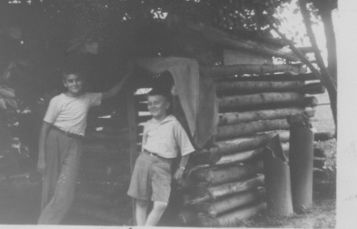

Stoking the fire, James says to me, "You know what? We could build a log cabin in the back yard this spring. Whaddaya think?"

My head turns from the fire and meets James' eyes with an excited, "Sure!" I don't really know what will be involved, but my older brother is inviting me to join him. Whatever it might entail, it will be ours to share.

My brain brings to mind images of a log cabin from my having had many hours playing with my Lincoln Logs set. "Yeah, that sounds neat," I say happily. As if to say, "Let's get started on it. Say more. What will it take to make this brother cabin happen?"

James likes the feel of his leadership role. And so, on that evening a special chapter in our growing up years in Silver Spring is born.

Idea after idea keeps surfacing and providing ready fuel for the embers igniting inside our minds and hearts. We will need a plan, a drawing of some sort, a floor plan, to show what it might look like. Our father is an architect. We have both stood next to his drawing table and watched him develop his plans. He deftly moves the slide rulers, triangles, compasses, finely sharpened pencils, erasers, and other tools of his trade, around the drawing board. We will imitate. After supper, we are at the drawing table with ruler, paper and pencils, starting to bring our ideas to life. Such fun!.

Ideas come together: "A simple design and dimensions. Four walls. A door. No window — too complicated, too much extra work, and there could be mistakes. We will use a curtain for the door. We can get logs from among the dead trees in the Sligo Creek woods. Lots of them. We can transport them to our back yard on our little green wagon. We'll have to trim off the branches with a hatchet or small saw, and use our two man saw to cut the eight foot lengths.The cabin will be six feet tall. That will mean twelve, six-inch diameter logs per side. It will be eight feet square. That's four times twelve …about 48 logs in all. Then the roof. Leftover boards stored in our garage attic will do. There is also tar paper and nails in the garage. We can build it under the cherry tree in the back yard. That way we can climb up on the cabin roof and have an easier pick of the ripe cherries in June." We proudly concur..

"When do we start?," I ask.

James replies, "As soon as winter's over and the snow's gone. We can hike down to Sligo woods tomorrow actually and spot the dead trees we want to use."

"Great!", I exclaim.

This can really happen. From now on our dream time, day and night, at school, and during chores, is focused on our joint adventure. Our parent's approval and support further stimulates us. We have cabin fever.

Winter's signs finally subside. For several days, James and I make our forays into the Sligo Creek woods, spotting the dead trees that can provide the eight foot lengths of straight logs. With stakes and string, we lay out the right spot in the back yard under the cherry tree for the cabin. We have told our separate groups of curious friends about the plan. All of them want to help. James and I tell we them we will take care of the building process. They can join in later for the fun when the cabin is finished.

It is late March before we can get started. We mark the dead trees we want. Each day after school and house chores, we pull our little green wagon toward the woods, carrying our two man saw and hatchet.

Once we sight the right sized logs, we trim off the branches and the saw them into three, eight-foot lengths. That's all we can fit on the wagon at one time. We tie the logs to the wagon to keep them from rolling off. We make our bumpy way through, and out of the woods. Rocks and fallen brush don't make it an easy trip. We are pleased to reach the paved road before the long hike home. All the way it is no small task to keep the logs from rolling off of the wagon. We have to re-tie them several times.

Once home James instructs me on the placement of the logs. We both share in the notching of the logs at the ends to get a tighter fit. Three logs per day is about our limit. A few more on Saturdays. Nothing on Sundays. There is Sunday school and church... and rules.

James and I are persistent and eager as we work together and watch our cabin gradually take shape. As we make the long trip from Sligo woods, tugging and pushing the shifting loads, the ideas for what the cabin will look like, and what we will do in it, keep flowing. One idea always spawns another.

Thoughts are plentiful. We can pretend and play out last Saturday's double feature cowboy movies from the Seco Theatre. Deadwood Dick competes with the Lone Ranger and Tonto for pretend times. We can have a secret club with a password, and maybe tattoo-like markings on the backs of our hands to prove membership. We imagine war scenes played out with our real German and USA Army helmets, and other army equipment from our Uncle Adolph's World War I days. We can sleep out overnight in the cabin. There can be a table and stools and a little orange crate to store our food and equipment. We see ourselves with our cowboy hats and holsters, rolling up some paper labels to look like cigarettes. They'll droop from the corners of our mouths as we play cards in the shadows around our candle lit table, and drink cola from our tin cups. Maybe we'll also have some chips or pretzels to keep up our strength. It is going to be so neat! Cabin fever.

After three months of our arduous labor, the day finally arrives when the last nail fastens the tar paper to the roof boards. The curtain is up at the door. The table, stools, lantern, orange crate, and candles are all in place. The dirt floor has been brushed clean of wood chips and nails.

Friends gather and climb all over. As planned, the cabin roof gives easy access to the juicy ripened cherries waiting to be plucked, and savored. The cherry seeds then provide the small missiles for our little spitting battles. A secret society is formed with passwords for entry and the obscure pen markings on the back of the hand showing membership. A proper written document spelling out the rules and conditions is signed by all and hidden under the orange crate. Cabin fever.

The dream is accomplished. Excitement, imagination, hard work, brothers bonding, parents approving, friends joining in, have all been a part of the delight-filled mix of cabin fever. The dream machine, and its wonderland world will not be long dormant. There will be more wintery evenings, gazing at the blazing fire, listening to Franck's Symphony in D Minor, and more of brothers glancing at each other, exploring the universe of thought and feeling, sometimes by themselves, and sometimes with each other.

POOR PASSAGES

It often happens that people and circumstances beyond our control make decisions for us. It's especially true when we're young. The older world, and the outer world, decide what our life will look like.

An early example of this for me is in April 1941. I am in the fifth grade at Woodside Elementary School in Silver Spring, Maryland. Mrs. Chiswell is my teacher. It is time to choose which boys will become the school patrol for the next year. It is an honored, and much sought after responsibility. Many boys volunteer to care for the safety of the younger school children at critical street crossings before and after school. I am among the volunteers.

If chosen I get to wear the white belt and silver badge designating my honor and responsibility.
I can be tardy for school in the morning and allowed to leave class fifteen minutes early at the end of the day to attend to my post. Both of these are daily reminders to others that I am someone special.

It is an exciting moment when Mrs. Chiswell calls me to her desk to announce, "Paul, I'm pleased to let you know that you are among those chosen to be a safety patrol for next year at Woodside School."

I was pumped and proud, although I'm sure that my slight smile and quiet, "Thank you" don't reveal the extent of my true feelings.

As I turn to go back to my desk she takes hold of my arm to keep me attentive. She says, "I've also nominated you to be either captain or lieutenant of the whole patrol."

"Wow!," I thought, trying to process the growing significance of this juncture of my life.

"Would you like to do that?", she asks.

The measure of my pleasure now breaks through my polite restraints. My face lights up, my smile widens, my eyes beam. "Would I ever!," I exclaim.

My imagination quickly kicks in and I am aware of the admiration I have for this year's officers. I can see myself cycling from crossing to crossing with my red lieutenant's badge, or maybe even the blue captain's badge. It will remind the patrol on duty of my authority and responsibility to make sure we are doing our job according to the book, so that the children would be safe. I am also thinking that I probably need to dress up my bike with some new chrome fenders and handlebars.

"That's wonderful, Paul, I'm sure you'll do a good job," she says as she pats me on the shoulder in affirmation. "And to help you be a good officer next year, you will go for a week of officer's training this summer at Camp Roosevelt."

"Holy cow," I thought, "this keeps getting better, getting chosen to be an officer and then a week away this summer at Camp Roosevelt. I can't wait! Summer is going to be great this year. I'll have to get Johnny Thompson to deliver my papers that week. It's all falling into place. Life is good. All is well!"

Mrs. Chiswell says, "So we'll look forward to this, Paul. I'll call your parents tonight to tell them about your being chosen, and about the camp this summer."

"Great", I say, as I spin around on my heels and make my way back to my desk. I am bathing in the mix of emotions bolstering my self-esteem to the highest I can remember. Not unnoticed I'm sure is my raised forearm and clenched fist, and an audible "Yes!" as I sit down. This is all I can think about for the rest of the day at school, at play, when delivering my papers, and as I drift off to sleep. My dream machine is fully engaged.

I bounce from bed the next morning still relishing what is going on. I pay special attention to what I might wear today to help celebrate it all. I excitedly enjoy my usual large breakfast. My mother is quiet as she alternates between serving the family our breakfasts and preparing the lineup of sandwiches for all of us.

I leave the breakfast table and go through my morning duties in the bathroom. They include scraping the remaining toothpaste onto my brush from the tube that has been cut open to take advantage of whatever paste could be salvaged after no more can be squeezed through the top. I also gargle with Listerine as usual, to fend off the germs. I march to the kitchen to pick up my lunch for school.

My mother is quiet and thoughtful. She says, "Sit down Paul, I have something to talk over with you." I obey with a gulp because this is an unusual process. The question marks are streaming from my eyes.

"Mrs. Chiswell phoned last evening. She told us of your honor in being chosen to be a school patrol next year. We are very pleased for you. She also told us about your being nominated to be either captain or lieutenant. That's also very nice. Then she told us that in order for you qualify to be an officer you would go to Camp Roosevelt for a week of training this summer, and that will cost $25."

I am on the edge of my chair. Storm clouds seem to be gathering on what had been a very sunny day. I sense something ominous impending. I can't imagine what could ever prevent the unfolding of my dream.

"Your father and I talked it over for a long-time last night. You know money is very tight for us these days. Your father has managed to keep his job, for which we are grateful. But there's always the threat of him losing his job. Then we would be without income, and maybe have to give up living here. We're always trying to find ways to save money and cut our spending. You know that of course. You always get hand me downs from your brothers. We buy your shirts and pants too large and then take in the sleeves, or turn up the cuffs, so you can grow into them. You fold your lunch bags and waxed paper every day so they will last a week. We get your old shoes re-soled. And lots of other things.

What this all means is that as much as your father and I would like to send you school patrol camp this summer for training, we can't afford it. $25 is just out of the question. We're very sorry but that's the way things are, and you'll have to be satisfied with being a regular patrol. You'll have to tell Mrs. Chiswell this when you get to school this morning."

There is silence after that pronouncement and explanation. It's impact punches me in the stomach. Its pressures spread throughout my body bursting through my eyes in a flood of tears, and cries of desperation. Life is not good. All is not well. My mother cannot comfort me. I stomp out of the kitchen wailing and pound on the wall.

My thoughts are in a downward spiral. "Had the world ever known such suffering? Honor is gone. Esteem is gone. How can I face Mrs. Chiswell with this news? What will the other kids think? Why do we have to be so poor? I don't mind the hand me downs or saving my lunch bags and waxed paper. But this, this is too much! "

My mother calls, "I'm sorry Paul, but you'll have to pull yourself together and get to school. It's time. Mr. Thompson is going to give you kids a ride to school this morning. So hurry up. Dry your eyes, put on your jacket, and get going."

I am in the bathroom, washing my face. The mirror highlights my watery, blood shot eyes. "Geez?", I thought, "how am I going to explain this? Maybe no one will notice or say anything. I'll just try to keep my head turned away and keep the talk on something light."

The four neighborhood kids are piling into Mr. Thompson's 1941 black Ford sedan. He cheerily says, "Good morning everyone," as he is climbing into the driver's seat. He quickly glances at us all, and then does a double take at me. I am pleading in my mind, "Please, Mr. Thompson, don't say anything!." It is not to be.

"What happened to your eyes Paul, have you been crying?" he asks gently. My mind goes into overdrive. "Oh no," I thought, " What can I say? Quick, something." Lies can be quickly manufactured.

I finally said, "Oh, no sir, I just accidentally spilled some Listerine in my eyes when I was gargling." He says no more, but the slight twist at the corners of his lips stifling a smile send me the message that he doesn't buy that little lie for a second. It also says that he understands something about how life can be raw and biting in its hurts. He knows I need to be alone with it for now.

Mrs. Chiswell tells me, "Well, I'm disappointed of course. You would make a good officer. But I understand when money is tight. You certainly will be a fine safety patrol."

After the storm and its stream of realities, the clouds disperse. I am able to file the experience under the 'what's so' category. I then have to move into the 'so what' dimension. What is left for me to decide? I can control what my attitude and emotions and perspectives are to be for what shows up from now on.

I remember that during my sixth grade I enjoy being a regular patrol at the corner of Highland Drive and Georgia Avenue. I take pride in shining my silver badge and scrubbing my white belt every week. I like the daily contact with the younger children in my care.

Other responsibilities and honors come my way in sixth grade. I get an important part in the Christmas play. I am in charge of the War Stamp campaign. We raise enough money to buy a jeep for the army. An army sergeant parades me and the jeep around the school playground. I become a Boy Scout and pay for my uniform with money I earn by delivering newspapers.

Ah, yes, I learn that life can be good again, even when something else, or someone else, is making decisions for me. Of course, as a fifth grader I can't comprehend much of anything outside of my dark little tunnel. However, I learn that life, and its lights to enjoy, seems to keep showing up in fresh ways, with new people and places.

LONG BEFORE

Long before the marvels of Facebook or Twitter or emails, or iPods, or iPhones, or Skype, or computers, or CD's, or DVD's, or cassettes, or transistors, or Walkman's, or stereos, ... there is the marvel of crystal sets.

With my eyes open wide in amazement and excitement I have just constructed my own crystal set kit. It lifts my awareness to the invisible and mysterious presence of the radio waves in which we live and move and have our being.

It isn't complicated, even in 1945. Anyone can easily put the components together. There is a little 5"x5" wooden platform. In the center is a nickel sized metal cylinder with room for a pea sized crystal in its center. Attached, and above the crystal is an arch shaped wire bristle which can be manually moved about the surface of the exposed crystal. There are two terminals on the little wooden platform. One is for the shiny insulated copper wire coming in through my bedroom window. Outside, it is attached to the backyard bell tower. The other is for the headphones.

Everything is attached and ready to go on my bedstand next to the window. I am told that crystal sets work best at night. I follow the advice and put the headphones over my ears. I gingerly start moving the bristle over the little crystal, not knowing what to expect, touching here and there, testing what might work best. All of a sudden, at one touch, I heard an announcer's voice. It is Arch MacDonald, clear as a bell, from WWDC radio station in Washington, D.C. He announces, "The score is now seven to seven in the seventh inning of this Washington Senators and New York Yankees baseball game." Wow! No static.

After a while of listening in wonder, I try randomly moving the bristle wire across the crystal again. This time I hear music, country music, from Wheeling, West Virginia, filling my ears with sound and my brain with wonder.

Another move, and I am listening to a WOR newscast in New York City. Such magic! Such a thrill! From out of nowhere, through these thin copper wires, over that tiny crystal, and into my ears, I can hear voices and music from hundreds of miles away.

My bedroom is small, but my little world is now made massive. Who knows how big? Always reliable. Nothing to wear out or burn out. Who can imagine this? How far can it take us? For the moment, the awe and pleasure are more than enough.

A CHRISTMAS MIX

It's Christmas time. It's wartime. It's 1942 in Washington, D.C. I'm ten years old. The mix of the big world realities envelope and shape my little world. I play at Christmas. I play at war.

It is my best Christmas yet for presents. Growing up during the Great Depression, my brothers and I are used to receiving one present each from our parents. A package from Uncle Charlie and Aunt Edith in Philadelphia can also be counted on to provide a new white shirt and tie for each of us. Other relatives provide an assortment of smaller items like, socks, candies, or toys.

This year is different. Second cousin, Grace Behm, (I call her "aunt") and her daughter, Patty, are living with us. They are among the thousands of wartime government employees who have swarmed into Washington, D.C., with no place to live. They are an added delight in our home, expanding the laughter, music and warmth.

They are also an added source of two more presents for me. It turns out to be a bonanza year for me. Three big ones! My parents give me a toy xylophone on a wooden stand. It has twelve chimes, two red hammers, and a bright purple banner to wrap around the base. The banner spells out "xylophone" in big white letters. This results on my being the first ten-year-old kid in the neighborhood to know how to spell it. I play on it and treasure it for years. It also provides me a beginning place in our little family orchestra. But the xylophone and the predictable shirt and tie from Uncle Charlie and Aunt Edith aren't the end of the presents in 1942.

Aunt Grace hands me a big box wrapped with dancing reindeer on the paper. According to family protocol, I carefully peel back the tape at the ends, and remove the paper without tearing it. I fold it so it will be ready for use again next Christmas. I remove the top of the box. Under the layer of white tissue paper a uniform of the Royal Canadian Mounted Police appears. I gasp as I unfold the bright red coat, and blue jodhpurs with a yellow stripe on the seams. There is also a holster and cap pistol, a broad brimmed Mountie hat, and puttees. My eyes bug out. This is everything I need to feed my imagination for RCMP adventures forever.

There is more. Cousin Patty presents me with another big box wrapped with green and red Christmas trees on the paper. Again, I follow the unwrapping procedure. That done, I pull off the top and squeal as I find another full city policeman's outfit. It includes the policeman's hat with a black visor, the blue jacket and pants, handcuffs, a billy club, another holster and cap gun. What a Christmas! I am so happy! I shout my "thank you's" and spread my hugs all around.

I spend these holidays playing out one "pretend" after another. Sometimes by myself, all over the house...attic, basement, bedroom. I pop the cap gun chasing outlaws up and down the stairs, taking the stairs two at a time and sliding down the bannister, or into the darkened basement hiding places. Sometimes an adult joins in. I put the cuffs on Patty when she doesn't eat her cranberry sauce. I wear one of the police uniforms all the time, even when we go visiting friends.

It is a Christmas plus. It is music. It is looking at our twelve colored lights around the outside of the front door for five minutes each night. It is lying on the living room floor close to the tree and watching our silver Burlington Zephyr train speed around the track spewing its aroma of hot oil as it breezes by. It is doing battle with the formations of lead soldiers and tanks lined up. It is playing "town" and moving the "tootsie toys" around the square designs of the living room carpet. It is helping to set the dinner table and fill the salt cellars and slicing an extra piece of cranberry sauce to go with my turkey drumstick. It is joining in the singing during clean up around the dishpan and dipping my finger in the bowl of left over mashed potatoes for a final taste, when no one is looking. It is gazing into the blazing fireplace fire and dreaming dreams when the guests have departed. And ...always in uniform. The best of times.

But these best of times are surrounded by the dark shadow of World War II. It is not going well. I see the daily newspaper headlines. Germany and Italy have conquered all of Europe and are advancing through North Africa. Japan has swallowed most of the Pacific Islands and much of China.

I see my parents cry as my two older brothers leave home in the early morning hours to join the army. We have our two-star service flag hanging in our front window to show that our patriotism trumps our fears for their future. Gathered relatives share worried stories of cousins and friends who have already been wounded or killed. The hugs are abundant.

We cover our windows at night with black cloth so that potential enemy bombers can't see any targets. We hear the shrill whistles from the neighborhood wardens, patrolling the dark night in their white helmets. We have our victory gardens to raise vegetables. We raise chickens for meat and eggs. We have our neighborhood "victory bins" to gather scrap metal, paper, old tires, and anything that might be used in the war machine. We have ration stamps for lots of things...gasoline, sugar, shoes, butter, etc. We have a peek at one unpatriotic neighbor's three car garage filled with brand new black market refrigerators. We hear lots of war news, and watch propaganda movies, and sing lots of patriotic songs. I walk the mile to the grocery store with my little green wagon for supplies. We children save our money to buy ten cent war stamps at school. They will be recorded every day until we reach $18.75 to exchange for a war bond that will mature in ten years for $25.

We practice air raids at school. Sometimes they are in the basement of the school, and sometimes in the basement of a neighboring home. I'm lucky to be assigned to Winship Green's house. He keeps a three-foot high stash of comic books for us to enjoy. We keep metal ID tags hanging around our necks. We are drilled in marching and military formations every Thursday by the uniformed visiting high school students. We doodle caricatures in our notebooks of the axis of the evil enemy, Hitler, Mussolini, and Hirohito. We play at war, becoming heroes in our imaginations.

War's dark shadows are pervasive. Mixed and conflicting messages are being assimilated. Around the piano we sing with equal gusto, choruses of "Silent Night" and "Praise the Lord and Pass the Ammunition." I am learning the ways of war and its ravages even as I gaze at the serene creche and its sleeping baby Jesus. I am becoming accustomed to the inherited ancient culture of fear and revenge with my cap pistol and imagination close at hand, even as I memorize the Twenty-third Psalm and Jesus' Beatitudes. Humanity's age-old laments intersect with its age-old longings and find a place in my psyche. As it is with those who have gone before, I can hear the whispered echo of hope that someday a better way will prevail.

HOLY HAUNTS

"I gotta tell ya, that house is haunted." All of us at Woodside Elementary School are saying it.
The old Wilson house is just across from Woodside's playground on Georgia Avenue. It is in our face every day at recess time. We have to walk past it going to and from school. When we walk to downtown Silver Spring, the best we can do to avoid it is to walk on the opposite side.
Just to look at it gives us the 'willies.' It is an imposing three story structure, with a gabled moss-covered roof with its gaping holes. It had probably originally been yellow, but most of the paint is in the last stages of peeling off. A few window shutters remain, with most hanging by only one hinge, as is the remaining front door. Assorted vines and brambles gnarl around the porch posts and sagging roof. Slats in the front porch floor are missing and can easily trip up an adventurer.

Overgrown weeds and thistles fight with each other to obstruct any pathway to the porch. Any attempt to sneak a view through a window is met with blackness and putrid smells of dusty and musty everything, left over spoiled food, urine. maybe even something dead or dying. It all
fits the vivid repulsive caricatures of haunted houses we have stared at in our comic books and horror movies. But here it is. Right in front of us, right now, in terrifying full color.

The story is …that it is part of the expansive Wilson estate that has been diminished in stages over the years since its glory days in the mid 1800's. Montgomery Blair and Abraham Lincoln used to bring their horses and buggies out to the Maryland countryside for Sunday afternoon picnics. Its sprawling acres have been reduced to this two-acre plot of weeds and debris.

It is now surrounded by an expanding subdivision of new homes and manicured lawns in Woodside Park. There is another twelve-acre piece remaining, adjacent to the haunted house. It is used as a golf driving range. With the decaying house in our side view, we sixth graders can earn five cents or a big orange Nehi soda as payment for picking up a bucket of golf balls or a can of golf tees for Mr. Wilson. He is something of a grumbling grinch. We are never sure if he is connected with the original Wilson family. His personality seems to be in sync with the unapproachable ghost domain next door to his golf course.

It is a fear filled scene, almost terror. Whether we are peering out of our classroom windows, running relays on the playground outside, or speeding down Georgia Avenue on a bike, the Wilson Haunted House is a spine-tingling threat for us. It spawns our wide-eyed imaginations to envision and feel the increasingly horrible possibilities of what awaits us should we ever venture through the thorns to the evils lurking in the blackness of that house.

The catalogue of creepy stories is always expanding, being embellished and reinforced with ever eerier possibilities to induce our nightmares. We are huddled just across the street on the playground after school one day when my buddy, Winship Green, excitedly volunteers, "Man, I saw it last night, just like Dickie Fitch saw it last weekend. It was like a blue glowing light moving from one window to another on the third floor, probably the attic, right? It went on for half an hour or so and then just faded out. No noises. Nothing like that. Just that blue light, not a flashlight, just bobbing up and down, from window to window. Scary, man! Whaddaya think? Check it out some night when you're going by."

As usual, this spurs the unfolding chain of hair-raising dreads. Jack Prettyman chimes in with a chilling report of his daunting adventure to the Wilson porch.

Jack says, "On a dare from Charles Wickery and Fred Stedman, I had worked my way through the thicket and the scurrying …rats, I guess they were. Yeah, that's right, rats, I'm sure. Lots bigger than any mouse. I get to the front porch. It is still daylight. No way I'm going near there at night. Well, that porch sags, you know. Up and down. I crawled up on it, trying to miss the places that didn't have any boards. I didn't touch the front door. It's hanging by only one hinge, y'know. I went to the front window, no glass of course. I looked in but couldn't see a thing. It was just black. All black, man. But it did smell something awful. I don't know what it was. Just really bad, man.

Then I heard a loud 'WHACK!' I don't know what it is Boards or somethin'. I musta jumped a foot. I am scared stiff. I feel like I am going to puke. Could be a raccoon, or maybe one of those tramps they talk about who sleep there sometimes. But I'm thinkin' it's probably a ghost of some sort. I don't stick around to look or listen anymore. I jump off the porch quick as I can and hightail it home, tremblin' all the way. Wouldn't cha know I woke up twice dreaming' and sweatin' about it all. Man, stay away from there!"

Once the bloodcurdling stories get going, there is be no stopping us whether we gather in the school yard before and after classes, or when two or more of us are hanging around a streetlight, or sipping a phosphate at Crofton's Drug store soda fountain. The spookiness of the haunted house consumes our ghoulish thinking and telling.

Bert Johnson gets it going with, "You won't believe this but when I was going by there the other night before Scouts, I heard moans and groans comin' outta there. I mean it. Like somebody's sick or dying or already dead, and their ghosts are doin' the moaning for 'em. I'll tell you I was doin' some quakin' and quiverin' for real, man. Bein' home never felt so good!"

We don't really know what to do about all this stuff that makes our flesh creep. A place inside of us panics at the grim and ghastly paralysis these stories stir up. Yet there is a level of camaraderie in our shared stupification and horror. The stories and the emotions they generate are our own and stay with us. Our parents don't know what we know about the house being spooked. To them it is just an eyesore and blight on the manicured suburban neighborhood.

One day when my dad and I are walking home from Silver Spring, going by the ghostly Wilson house, my father complains, "Just look at that place. What a mess, and in this neighborhood! Somebody's going to have tear it down or put a match to it sometime soon."

He is an architect and has an appreciation for the beauty of its original design. "I'll bet it was a gem in its prime. Look at it. It's stately. The gables are majestic. Even in its deteriorated condition the iron work is exquisite. I can just imagine it being on an elegant estate of a couple hundred acres and the envy of the other landowners in its day."

My father's musings prompt me to open up about the situation of the house from the standpoint of my friends and me. I say, "You know what's really happening here dad? It's haunted. It's scary as all get out. I mean it. My friends all talk about it. There's strange lights going around the attic at night. There are frightening sounds coming out of there. I think it's more than just squirrels or raccoons. There are groans and moans. There are awful smells. Some of the guys think the tramps use it. Maybe someone has died. You can get a whiff at the windows. Really."

My father asks me, "Have you ever been inside?"

My reply: "No way, no sir! A couple of guys have gotten close on dares, but never inside. The smells and sounds and ghostly lights at night…no way. None of us. We don't have to go inside. Imagine what would happen to us! No way."

The two of us keep peering at the house. I peer apprehensively. My father peers with smiles.
l wonder what there is to smile about. "Here, Paul, give me your hand. Let's have a look for ourselves," my dad says confidently.

I am wide-eyed, shuddering inside, "Oh no. Are we really doing this? I wonder if I'll be around to tell the guys about it." I allow my hand to be firmly gripped by my father as we pick our way through the bramble and vines to get to the front porch. "Just like Jack Prettyman did," I thought. "Next will come the strange loud clacking noises and foul smells and moans and groans…and ghosts! Jeez!"

We climb onto the porch. It does sag and bounce, with not much to support it. My dad maneuvers over the missing porch floorboards to the front door with the one hinge left to hold it.

He carefully pulls it open and walks it around to rest against the siding. I am still shaking. I think, "Oh, holy cow, yep, just smell that. Yuk. Double yuk. And its so dark." The light from the open door brings some things into view.

My father still holds my hand tightly as we carefully step into the musty and debris filled front hall. Strangely this hand holding is making a difference for me. I am in a state of observing and thinking, "If something is going to jump out at us, I guess dad can handle it. He doesn't seem to be afraid. He looks like he's curious and not wanting to breath in too much of this dust we are stirring up. So far there are no dead bodies showing up. Two squirrels are playing on the broken stairway and knocking off some loose debris…making some loud bangs in the process. Oh, look ..that must have been the old dining room. Lots of old tin cans and newspapers. Looks like someone sleeps here. Each room has its piles of garbage and pukey smells. Whew! There's enough light coming in from the windows for us step over these broken stairs and look in all those rooms and then up to the attic. No signs of ghosts or blue lights so far."

My father stops every so often, with his hand over his mouth in admiration. I think he is picturing what it must have looked like in its day. He fancies the grandeur of the spiral staircase with its intricate carvings on the solid oak wood. It is an adventure of a different sort for him. Seeing through the present deterioration to its original glory.

I still hold my father's hand, but now lightly, once my original trembling has dissipated. My confidence is building. I am knowing that my father can handle any of the fearful unknown goblins. It is turning out to be a lesson of looking at the realities of the ghoulish specter up close and letting the quaking shift into smiles of curiosity and discovery.

I am wondering how the story of my newfound freedom with my father in this scary and decrepit building will go down with my buddies. Will they even believe me about the haunted house… and how 'cool' it really is, once I feel safe and fears disappear. What If they look closely? What if they become curious about it? What if they discover its inherent beauty? Will my experience entice them to try it out? Or will the old scary stories still have their attractions?
Holy stuff…holy haunts…actually.

A WAR STORY

War. War. War. In 1943 all eyes are on World War II. All energies are being poured into the war effort. Reminders are everywhere. It is pervasive. Billboards and posters with Uncle Sam pointing his finger and saying, "I Want You!" The radio blares patriotic songs like "Praise the Lord and Pass the Ammunition!"

Every neighborhood has its own 'victory' garden and its collection bins for scrap metal, rubber, paper, and most everything. Every neighborhood has its own white helmeted warden who patrols the streets every night at "blackout" time to make sure no light is showing from any window to be seen by enemy aircraft.

Every family has their share of ration books for so many things, from sugar to shoes to gasoline. Families huddle around their radios for the evening news. The newspapers, magazines, and movie newsreels keep everyone posted on the most recent battles in Europe and the South Pacific.

Our family home boasts its two sons serving in the army with a two-star flag in the front window. We have our own a 'victory' garden for raising vegetables and have built a chicken house in our suburban backyard for eggs and meat from our Rhode Island Reds. We have put up a pen for Elmer and Elsie, our twin Toggenburg goats. There is talk that Elsie will provide us with milk, but that never happens for some reason I wasn't told. We raise some rabbits, but we could never eat them because we have given them all names and they are just too cute to kill. We have our shoes re-soled and re-heeled. I spend many Saturday mornings with other Boy Scouts gathering and bundling used newspapers and magazines to help the salvage effort.

At our Woodside Elementary School we have our own version of the high school's 'youth army.' The uniformed eleventh graders come to our school on Tuesdays and Thursdays to teach and inspire us in marching drills. No uniforms for us.

We have regular air raid drills at school where we quickly move in groups to the basements of neighboring homes. I am lucky enough to be assigned to Winship Green's house where a three foot stack of comic books awaits us for study during the drill. My school papers and books often include my doodling of the caricatured axis of evil of Hitler, Mussolini, and Hirohito, reminding me again and again of what this war is all about.

Everything is wrapped in the war's blanket. Decisions are measured as to how they might help or hinder the war effort.

Into this heady time of excitement and unified purpose an opportunity presents itself for me to have my "day in the sun". There is no congressional medal of honor, mind you, but there are rewards....and consequences.

As a sixth grader at Woodside Elementary, I am at the top of the heap. Our principal, Bess Young, is a rotund single lady with an appropriate mix of smiles and frowns. She approaches me one day.

She says, "Paul, as you know, the war effort is so important. It requires the best from all of us. The government has asked our school to raise enough money to buy a jeep to help the army fight its battles." (I could feel Uncle Sam's "I Want You" finger starting to point at me.)

"It costs lots of money," she said. "We can't do it with war bonds because they cost $18 each. But we can do it through war stamps at ten cents each. I want you to be in charge of getting every pupil to fill a book of war stamps, so that Woodside School can buy a jeep for the army." My eyes widen into a 'tell me more' mode.

She continues, "It means that every day at lunch time you collect all the ten cents that are gathered from the students of each class, give them the war stamps for their books, and then you bring the money to my office, count it, put it into coin wrappers, tally the results for each class, and post them on the bulletin board."

"Uh, huh," I say, as if the seriousness of the task is understood.

"Will you do that for us as part of our war effort?" she asks.

"Yes ma'am," I reply.

"Wonderful," she says. "We'll start next month and distribute the books at an assembly. And oh, that will mean you will have to miss your class session after lunch to do the counting. I will let Mr. Johnson know."

"Bingo!" I thought. Mr. Johnson's class after lunch is MATH! Not only have I been singled out for this special honor to represent our school in this war effort, but also, the icing on the cake, is this hallelujah moment that quickly consumes my consciousness, " NO MATH CLASS!"

"YES MA'AM!", I exclaim, in what I hope are muted tones so as not to to reveal the extent of my enthusiasm which might arouse some suspicions of something being awry.

So it is that Miss Young presents the school's mission to an assembly of the students. I am announced to be the one in charge. The daily routine is spelled out. Everyone is encouraged to bring their dimes everyday to receive their war stamps, to fill their books, so that we can buy the jeep that will help the army fight its battles in Europe and the South Pacific.

It is an ecstatic moment for me. An army sergeant brings a sample jeep to a school assembly so that everyone can see and understand how important the objective of our mission is. I get to sit in the jeep. Pictures are taken. Posters are put on the doors and in the hallways. "All this," I thought, "AND no math classes!"

I start into the routine the following Monday. I quickly finish up my sandwich and milk, saving my cookies and apple for later. I get into the task of gathering, counting, and tallying. I feel like everyone is looking up to me, being enthusiastic and responsive, and making me feel pride for the school and myself.

As the aromas of lunch fade and the hallways quiet, I seclude myself in Miss Young's small, sunny office, crowded with its filing cabinets, bookshelves, piles of papers on her desk, a couple of chairs. A small table is against the wall where she makes room for my work. She shows me how to stack the pennies into piles for the fifty-cent wrapper, nickels into piles for the two-dollar wrapper and dimes into piles for the five-dollar wrapper. Then I am to put a finger at the bottom of the wrapper and stuff in the coins. She watches and works with me for several days until I have it straight. Then for the best part of the school term I am left alone to do my job ... for the war effort...AND to cluck a bit each day thinking about not having to endure the math exercises going on in Mr. Johnson's room at that hour. It is a perfect combination, noble service to help us win the war...AND freedom from the "concentration camp" of long division and fractions.

Woodside saves enough war stamps to buy a jeep for the army. They reward us with another visit from a sergeant and the jeep that we have bought. It is displayed on the playground at another assembly for both students and their parents. I get to sit in the jeep again. This time we take a ride around the playground. Everyone cheers. Such rewards for service to your country!

The consequences of spending the hours after lunch counting money for the jeep don't start to emerge until seventh grade. I am now at junior high school. The war is still going on. Our jeep is out there somewhere helping the soldiers. My moment of glory is short lived and now fades.

I face a new reality. I have missed almost a whole year of mathematic learnings. It feels like I am in a foreign country. I can't speak the math language. I can't read the signs. I recognize my fellow students but I can't play their games. I have avoided the mathematics 'concentration camp' of last year only to find myself in a new one with no help. Panic sets in. I start realizing what I have missed. The foundation blocks upon which the next levels of math learning are to be built: geometry, algebra, trigonometry, calculus, are absent .

Cockiness has turned to contrition. How can I play catch up? I am crippled from my war efforts. I am slipping into a victim mode. I won't be able to follow my father and become an architect. I'll need a lot of math for that. I won't be able to become a doctor like my grandfather. I'll need a lot of math for that.

It will mean a lifetime of struggle trying to insert some of those missing building blocks into the structure of my education. The blocks never fit easily. They are too big or too small or out of sequence...and always irritating.

At least we win the war. Maybe our jeep is on display in a museum somewhere. And now... I have a calculator. All is well!

THE BIGGEST FIRE I EVER SAW

I am only twelve. Everything seems big. It is midnight on July Fourth.

I am awakened by screams from the Thompson's house. It's just behind ours in Woodside Park.

Mrs. Thompson is yelling to anyone within earshot, "Get out, get out through the window. Get the children down the stairs. I'm going out through this window. The fire's coming up the basement stairs. I can't go through the doorway!"

Wide eyed, I look out of my bedroom window. I can see smoke belching out of the windows and the flickering lights at the Thompson's house. Her sons, John, Bill, and Jim are yelling in response to their parents' frantic directions. They hurry downstairs and safely out of the back of the house from their bedrooms. An orange, smoky glow fills the house.

There are screams to call the fire department. I am quickly pulling on my jeans and trying to straighten out my shirt. I carry my shoes in one hand as I rush down the stairs of my house towards the Thompson's.

It seems like an interminable wait before we can hear the distant sirens of fire engines approaching. We helplessly aim water from the garden hose into the flames roaring from the basement. Neighbors are running toward us in their night clothes.

Mrs. Thompson is not to be consoled, panicking, "Where is the fire department? Do they even know where we are? Can they find Crosby Road?"

I run down Crosby Road to its intersection with Woodside Parkway. I see the flashing red lights coming over the hill. As the trucks slow down, probably looking for some directions, I wave them on toward 9111 Crosby Road, now fully involved with flames.

After an hour or so of water pouring in through the windows and doors, the flames subside. Once everyone's safety is assured, the biggest worry is that the living room floor has been severely compromised with the flames leaping up from the basement The fear is that it might collapse and the two grand pianos would crash into the basement rubble. The floors hold.

As the firefighters are rolling up their hoses and retrieving their equipment, the crowd of neighbors who have been witnessing the fiery drama from afar stay into the wee morning hours and traipse through the halls and rooms of the Thompson's home. The leftover water is dripping from the ceilings. The acrid smells of burned furniture, walls, and carpet fill their nostrils as they make their way through the shadows and emit their sympathetic comments. The neighbors become especially close that night. The enormous task of cleaning and months of rebuilding begin.

CALOPHEN'S CONSEQUENCE

Calophen is a very small pink pill. It has a very large and frequent impact on my family during my growing up years in Woodside Park. Calophen is a laxative recommended by our family physician, Dr. Atkinson. His formula for continuing good family health includes a weekly dose of Calophen and a morning gargle of Listerine before trotting off to school or work. My parents follow his advice to the letter. It must have some merit because our family of six avoids almost all of the usual childhood diseases. Whenever the subject is broached, it is only in hushed tones and confined to our immediate family. Bodily functions are private and not acceptable for mealtime conversations.
Our little family ritual goes like this. Friday night before bed we are each given our allotment of Calophen. Being twelve years old, I am the youngest, and the little pill is cut in half for me. It is still far more than I want. I hate even the half pill. I haven't learned to swallow a pill without chewing. The slightest contact of the pill with my tongue or taste buds trigger my gag response, which continues because I can't get rid of the little pill, up or down, in or out. It just bobs from one part of my mouth to another. The gagging repeats itself.

I recover from each episode only after a flood of water carries it down my throat assisted by my mother's anxious coaxing to, "Swallow it quickly. Don't chew it. Let the water push it down. Here, drink some more. It'll help with the after taste. This is so good for you, just like Dr. Atkinson says."

We all do it. My mother eventually thinks to deal with the unpleasantness for me by wrapping the pill in a little wad of bread or cake, or in with a spoonful butterscotch pudding. Later I learn of other laxative options like cherry-flavored Castoria or chocolaty Exlax. I wonder why we don't switch products. Friday night is the first stage of the weekly Calophen laxative event.
The second Calophen stage is on the following Saturday morning. We have our usual hearty breakfast of fruits, cereals, eggs or cornmeal mush and sausage with syrup and a glass of milk. We then check my father's desk in the library where he leaves a separate list for each of us of household chores that need our attention today. I am proud to have my role to play. Once done with the chores and lunch we get our twenty-five cents for a double feature at the Seco Theatre and an ice cream cone.
However, before receiving these rewards, during the morning chores, the Calophen purge sets in, with three or four toilet trips for each of us. Fortunately, my father, being an architect, has designed three bathrooms into our home, so overcrowding is not a problem for the six of us. The whole laxative event is usually over by lunchtime, allowing us freedom for our Saturday afternoons.
My plan for his particular afternoon is to hold onto a couple of pockets of carrot sticks from lunch for a snack later on. Then go sledding with Johnny and Billy Thompson for a couple of hours, before making my deliveries of the Washington Evening Star Newspaper. I'll have to make my rounds with my sled today, because my bike won't do well on the snow and slush.
All goes according to plan, so far. I meet Johnny and Billy. We happily make our way to the long hill at Dale Drive, chatting about the various tricks we would be trying with our sleds on the slides down. I take my delivery bag along so that after sledding I can just go to the pickup point for my papers. I can roll them up, stuff them in my bag, make my deliveries, and be done and home before dark. It is a lovely February afternoon. The subtle sweetness of newly fallen snow fills the nostrils, and the familiar crunch of snow and slush is underfoot. Cardinals dance from bush to bush for a leftover berry or two. The trees shadows from a late winter sun are cast all around my path. It is a welcome and serene quietness.
About halfway through my deliveries, I start to feel like is is Saturday morning all over again. The Calophen purge is urgently wanting to repeat itself. I say to myself, "But that's all done. At least it usually is by this late in the afternoon, Good grief! What to do? The urge is growing and has to be reckoned with. I really have to go! What are my options? The Sligo woods are two blocks away. I'll never make it, even if I run. I don't have my bike for a quick sprint to home. I'm too embarrassed to ask Mr. Gruver to use his bathroom even though he is closest and I just tossed his paper onto his porch."

Cold sweat is forming on my forehead. I am panicking, thinking,"No bushes are close by. What if someone drives by and sees me? I'm afraid Calophen is going to have the last word here. Nothing like this has ever happened before." I can only stand still, staring straight ahead into the gathering sunset clouds. Nothing more is to be said or thought. Only the strange feelings of how Calophen is radically changing my day,
There is a warm rush down my right leg, spilling over into my boots. After the surge I pull up my pants leg to see the steam coming up from the befouled carrots on the snow. All I can think next is, "My parents are going to kill me."

I have to get my thoughts together. "Now what do I do? I can't go home. It's too far. It'll be dark before I can get back here. I still have half of my route to deliver, up and down Live Oak and Red Oak Drives. I can't explain this to anybody. I have to keep going."

I forge ahead as fast as I can with the squishing in my right boot, hoping to keep Calophen's foul fragrances behind me, with the bag of papers on the sled, and hoping I won't meet anyone along the way. I keep thinking, "What a mess! How can I deal with it and clean up and cover up the whole affair?"
Fortunately, I meet no one along the rest of my paper route as I half jog, half hop, between the houses, and on the road to home. Upon arriving, I am relieved to see the garage door open and the family car gone. No lights are on. No one is home. I have to move quickly. I don't know how soon they will return. I prop my sled against the porch post and hang my paper bag on a nail on the cellar stairs. I turn on the lights and rush to the wash tubs in the basement.
Frantically I stick the plugs in the drain holes on both sides of the tub. I turn the hot water on full blast on one side. I dump in the laundry detergent and swish it into a thick foam. While the tub is filling, I pull off my boots, pants, underwear and socks.
Yuk! I dunk them into the foaming suds and rub them over the ribbed washboard as best I can. I do the same with my underwear and socks in the other side of the tub. The water is really hot. I leave everything to soak while I run upstairs to clean my body, keeping an eye out for any lights coming in the driveway.
I turn on the bathroom shower, even though there is no shower curtain, because we only used the tub to bathe. But I don't want to wait for the tub to get full enough to wash, and I don't want to sit in the dirty water. So, the shower water sprays onto the bathroom floor. "Too bad," I thought, "I'll take care of that later if I have the chance." I grab the red bar of Lifebuoy soap and run it over and over my right leg and foot. Then I use the washcloth to finish that side of me. I don't have time to do the rest of my body. That will have to come later with my regular Saturday night bath. I dry off as quickly as I can and run the towel over the watery mess on the bathroom floor. I run to my room and grab clean pants and shoes. There is no time for underwear and socks.
I then charge down the three flights of stairs two and three at a time while holding and sliding with the bannister. I scrub the clothes again as best I can. I run fresh hot water into the tubs. A few more rinsing swishes and then I crank the clothes through the hand wringer mounted on the centre of the sink.
I am perspiring profusely as I listen for my parents' car in the driveway. I know I can't hang the clothes on the winter clothes lines crisscrossing the basement ceiling without drawing attention to what has happened. So I drain the tubs, look feverishly around for anything I might have overlooked, and then race up the stairs again, two at a time, to my bedroom. I quickly hang the corduroy trousers on a hanger in the rear of my closet, hidden behind other clothes. I tuck the underwear, socks, and shoes behind the radiator for a quicker dry.
As I see the flickering shadows from the headlights of my parents car going into the garage, I do another quick wipe of the bathroom floor and run a comb through my hair.

I do my best to sound casual when my mother comes through the side door exclaiming, "Paul, we're home."

I reply, "Hi. I'll be down in a minute. Where have you all been?"

She calls up the stairs, "We were just over visiting Aunt Margaret. You know she's still getting over her operation. We thought we might see you on your paper route from her place on Dale Drive."

I called back, "No, well I got through my paper route a little sooner than I had expected. I've been home awhile."
"Phew," I think I've pulled it off. I'll check the cellar after supper to see if I missed any telltale signs." I have supper. We clean up. We play a round of Chinese checkers. I take my usual Saturday night bath, with a bit more scrubbing and soap than usual. Next Friday I will confront Calephon once again, maybe a little wiser.
I have escaped shame and embarrassment. It has been a solitary event. Never before. Never after. The secret remains mine alone, until now. I never tell family, friends or therapists about it. The only creatures in the know are my pet black and white goats, Elmer and Elsie. I usually tell them everything. I know it will go no further. There will be no ridicule or judgement from them. They always just listen intently, as they munch on their oats and corn, looking me right in the eye, and licking my ear every once in a while. So, for seventy years Calophen's Consequence has been locked in my bank of memories, now revealed, for the sake of a smile.

ELMER AND ELSIE

Goats are not to be seen in Woodside Park. It is a cozy subdivision nestled outside of Washington, D.C. You can find lots of the usual pets like dogs and cats. I have tried having dogs. None has worked out. One had suffered from long term mange and required regular applications of a very pungent and purple medicine. One had to be put down because of distemper. One was killed by a car. Another bit the mailman. Two just ran away.

So my parents think we might try goats. Black and white, Toggenburg, twin baby goats. New possibilities emerge. Goats might just prove to be very interesting and lovable. They come to serve many useful functions for me at my sensitive age of twelve. We name them Elmer and Elsie.

They are playful. We find that out on the Sunday morning after they had arrive. They are in their fenced pen in the backyard. Our family is at the breakfast table, excitedly talking about the new members of our family outside. In between bites, we all pause at the repeated sound of "shwock", pause, "shwock", coming from the yard. We gather at the window to see Elmer and Elsie, rearing up on their hind legs and then slamming down to knock their heads together right where their horns would grow. Our first thought is that they were fighting.

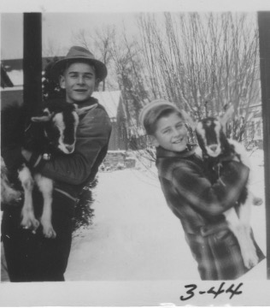

Oh dear," my mother says, "What if they don't get along? What if they hurt each other? Will we have to put them in separate pens? We haven't bargained for this."

I say, "I can put Elmer in the stall in the garage and leave Elsie outside." They continue to rear back, slam down, rear back, slam down, with a loud "shwock" each time. It goes on for about fifteen minutes. Then they just stop, sniff each other, and start munching on the vegetables in the bucket we have left for them. It turns out that they go through this routine frequently. It also turns out that this is a very natural and playful way of being together. No fighting. Just fun. Knocking their heads together and enjoying it.

Elmer and Elsie do more than play. As their primary caregiver I soon realize their significant role in my soon-to-be teenager life. They became listener, confidant, and friend. When I come home after a hard day of trying to be "cool" at school, I seek out Elmer and Elsie in their garage stall at the back of our garage. I freshen their water bucket and pour a mix of corn and oats into their food pail. They are eager to eat and drink of course. But they also have time to listen to my tales of woe and wishing. I know they are listening intently because every time they lift their heads from the food bucket, they look straight at me —as they continue to chew. I feel that they surely understand me as I pull their heads close to mine. I am talking. They are munching. I absorb that aromatic mix of crunched corn, goat saliva, barnyard breath, and the not too distant fragrance of slightly befouled straw under their hooves. How sweet they are. On occasion, they lick my ear as if they can hear my every thought. I know I can say whatever is on my mind and in my heart. They will never betray my confidence. True friends. Just what I need at age twelve.

I share Elmer and Elsie with the neighborhood. They function well as grounds keepers for our ball field. They receive the gratitude and adulation of my buddies. Before leaving for school I chain Elmer and Elsie to a heavy plank that I have dragged into the field of weeds behind my home. Upon returning from school all the kids are delighted to see two wide swaths of meticulously cut grass. Within a couple of days of this process, Elmer and Elsie have prepared a perfectly manicured ball field for us to play on. It is a win, win. We get a lovely place to play, and they get a belly full of healthy weeds and grass, plus some extra treats from the gang. Elmer and Elsie were are quite mellow as they lay next to the ball field watching us play. They re-live \their day's harvest as they belch and chew their cud.

Elmer and Elsie also are the cause of my learning some new vocabulary. There is one time when I have left them chained to the plank in the field to take care of their grass cutting chores. I was off playing at Mrs. Button's house with her children and the gang. Mrs. Button called to me in the backyard, exclaiming that my mother had just phoned. I must come home as quickly as possible because the goats are bleeding and need my help. I frantically jump on my bike and speed home with visions of my pet goats dying in a pool of blood.

My mother points me up to the field where I had left them. What I find is not a pool of blood from their bleeding but their heads wrapped with their chains and holding them tightly to the plank. They are down on their knees, pulling desperately to free themselves. They have, over the course of the afternoon, moved around and around in ever smaller circles, and they never look up from chewing the grass. The chain catches under the plank and keeps getting shorter and shorter until they cannot move, and they panic. As I find out from my mother, their frenzied bellows for help is called 'bleating'---not 'bleeding.' It is a little piece of learning that stays with me.

In my early days with Elmer and Elsie I have expectations that I can hook them up to the front of my child sized covered wagon. They can prance me around the neighborhood. I can do some real cowboy and Indian stuff. The wagon has an authentic look with its canvas cover, and even a yoke I can attach to the goats. With no preparation or training,

I am using only my imagination to guide me. Elsie is a bit more dainty and feminine. Elmer is stronger and more aggressive. I tie Elmer into the yoke and begin to lead him around, with the plan that once I get him going I'll jump into the driver's seat and we'll be off on our first ride---just the way they do it in the movies. Not so. Elmer spooks once he is tied in and hears the wheels of the wagon clattering and banging on the gravel behind him. His eyes bulge. His tongue turns purple. He lurches. He is scared and not to be comforted. He never gets near that thing again. My covered wagon dreams are history.

There are other uneducated plans for Elmer and Elsie. I have thought that they could help out with the wartime food shortages by providing us with milk and cheese. My father never enlightens me on the finer points of animal husbandry. I never know it is unlikely for twins to produce offspring. I never know that the only way to get milk from Elsie isfor her to have a baby goat first. I never know what having Elmer castrated is all about, other than making him whimper for a week.

On a parting positive note, Elmer and Elsie gives us a regular and plentiful supply of fertilizer for our vegetable garden after my brother or I cleanse their stall every week. They make me feel proud and unique when I put them on a leash to join my friends as we walk our pets around the neighborhood. I notice the neighbor's heads turn as they make some humorous asides about the pet parade passing by.

The signal for Elmer and Elsie to exit my life comes one afternoon as my mother is transferring them from the garage stall to the yard pen. She has hold of them by their collars. Elmer, now two years old, and grown quite strong, lurches around a corner with my mother still holding on and trying to regain control. He is too powerful for her. She falls and is dragged across the yard before she can free herself.

The word at dinner from my mother is: "This is it. The goats have to go."

We find a new home for them on the Lindsey's farm. It is a sad day for me. Old friends separate. Two years done. But I don't know how much of the sadness is shared by Elmer and Elsie. One day on a visit to the Lindsey's I see them happily grazing and then gazing contentedly at the green meadow that awaited their attentions, once they complete their immediate session of cud chewing.

Elmer and Elsie became a very special chapter in my life's book. My life is richly expanded and enlivened because of our friendship.

SMILE SOURCE

It brings a smile. My first date. Yours probably does as well. Awkwardness. Embarrassment. Outside the comfort zone. Emotional turbulence. Hormones. Tongue tied. There is some good stuff too. A marker moment. A passage. A silent sense of pride for having taken enough initiative to overcome the obstacles. New horizons.

All of this is here for me. Joan Membert and I have grown up together in Woodside Park. This means we have shared the birthday parties through the years, as well as the informal gatherings for hide and seek, or Monopoly, or Simon Says, on a summer's eve with the lightning bugs to chase. We create a little drama and circus to perform in Thompson's basement for the neighborhood parents. We go on hikes and picnics with the twenty other kids our age in our neighborhood. We have our bike posse racing over the gravel roads and dirt mounds of the new houses. We practice our pianos to get ready for Mrs. Thompson's big recitals. We walk to school and play baseball and football and ping pong and badminton. We are loving it.

There comes a time when something inside of me is saying that I should be making some moves toward being an adult, which, being translated, means I should be having a date. I am in the seventh grade. Some say it is early for a date. I am not deterred. Joan and I have been pals for years. She helps me deliver the Evening Star newspaper almost every day. She is in the sixth grade. She can run faster than I. She is two inches taller than I. This gives me pause in the date asking phase. But I have to deal with my shortness at every other turn as well. So, I think about the possibility of asking my bike buddy for a movie date. I think about it a lot. I talk to my male buddies about it a lot. Finally, the thinking and the talking about it move me to action.

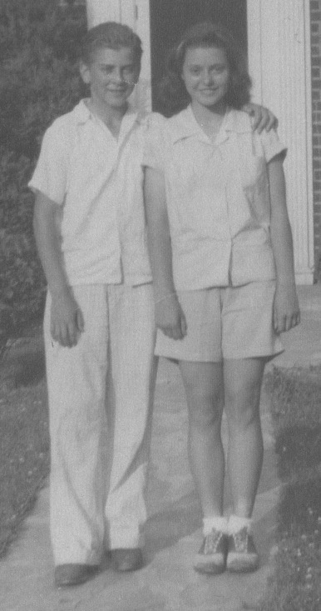

With adolescent verve and juices flowing, I do the proper thing. One day, after we have delivered the papers, I go home, and I call her on the phone. I politely invite her to go with me to the Silver Theater Saturday afternoon. She also changes persona for the phone conversation and politely accepts.

Early that next Saturday afternoon, she helps me, as usual, in my newspaper deliveries. We are careening around on our bikes in this process, talking and joking incessantly, as is our custom. When the deliveries are over, we both go home to get ready for our official first date together.

Somehow, the carefree is replaced with nervousness and angst. I get myself 'gussied up' for the occasion. Shower, hair slicked down with Brylcreem, starched shirt, freshly shined shoes.

I leave my racing bike with the curved handlebars and big wire basket for the newspapers, in the garage. I walk the two blocks to her cozy white, and neatly landscaped home. Going up the driveway, I am met by Bonnie, the Membert's black cocker spaniel, who knows me well. She spends extra time sniffing and checking me out, sensing that something is different.

I properly knock on Joan's front door. Her mother answers, with her huge smile, and welcomes me into the living room where Joan's grandmother and other bridge playing friends are sitting at their card tables. They all turn and give me their best 'isn't he cute' smiles and hello's. My face, now crimson, attempts a return smile. I enter into the nervous small talk as best I can until Joan shows up. This is one piece of the first date experience I have not anticipated. It seems to last a very long time.

Joan finally appears, also 'gussied up'. Her hair is properly curled. Her dress is starched and shoes are shiny. The ladies all turn their 'isn't she cute' attentions to Joan. I can relax ever so slightly. I'm not prepared for what is needed for an exit move from this well-meant gushing from the ladies. Fortunately, Joan's mother has sensitivity to what we might be feeling.

She graciously moved us toward the door with, "I know you don't want to be late for the afternoon movie at the Silver, so you'd better get a move on. Have a good time. We'll see you when you get back."

A flash of panic momentarily penetrated my brain, "Not if I can help it. Enough of 'aren't they cute.' "

We are the same kids who minutes before have been wheeling up and down Highland Drive, Pinecrest Circle, Crosby Road, and the rest. But now we are different. For the moment at least, there is a shift taking place, a marker being laid, a passage being made. I'm not remembering exactly what I say. I only know that I am out of my comfort zone, and whatever comes out is probably stupid or inappropriate. Joan's family and guests smilingly absorb my awkwardness and accept these signs of change with their 'aren't they cute' smiles and well wishes.

Joan and I start the walk to the bus stop at Highland Drive and Georgia Avenue. We are trying to cope with this newness in our relationship with small talk that doesn't seem to fit. Things like, "It's a lot hotter than it was earlier." Or, "I hope the bus is on time and not too full." Or, "Have you ever seen the Marx Brothers in a movie before?"

It will be so much easier when we are back on our bikes and in other clothes. But we persevere. This is the way dating adults seem to do it. We ride the bus the mile to downtown Silver Spring, watch the Marx Brothers movie, with popcorn, to keep our hands occupied.

After the movie we walk to the soda fountain at People's Drugstore for a chocolate milkshake. I feel some accomplishment at having earned enough money from my newspaper route to afford these amenities. We catch the bus back to Highland Drive, with its stone gate shelter inviting us to walk under the arched pink and white dogwoods, framed by the bright orange, pink, and fuchsia azalea borders on the way back to her home. It all has unidentified romantic overtones for us youngsters.

Joan's parents are waiting at their front door with more 'aren't they cute' smiles. She says to me, a proper, "Thank you. I had a nice time."

I say properly, "You're welcome. Me too."

I go home, take off my date clothes, put on my play clothes, and ponder just a bit about what has happened. Then I get my bike out of the garage, race up to Joan's house. She mounts her bike. We both join the neighborhood gang. The summer evening is spent in the usual fashion with our bike posse, racing, laughing, and yacking about all sorts of things, very much at ease again in our comfort zones of Woodside Park.

Joan and I date hundreds of times, off and on, over the junior and senior high school years. There is also lots of dating with others in our neighborhood group as well. But this first date is the one that most quickly brings the smiles.

WALLFLOWERS ANONYMOUS

I am short and shy at thirteen. Grade eight is coming up in September of 1945 at Montgomery Hills Junior High School, in Silver Spring, Maryland. As a part of the socialization efforts of the school, Miss Nixon, the music teacher, and Mr. Hitchcock, the vice principal, gather students for an afternoon dance once a month. The dances are a catalyst for the blossoming emotions, stirring and mixing them with the untested fantasies and hormones of young teens.

I am no exception. Since grade four I have been admiring and dreaming about married life possibilities with several lovelies...Patricia Crabtree, Luanne Johnson, Joan Membert, Liz Cave, and lots of others in between, who pass my mother's frequent admonition to me to "make sure you marry someone of good stock."

However, I am shorter that all of them, and wondering if I will ever grow. So I never venture far beyond polite conversational exchanges with any of them, stifling any evidence of my dreams or wishes or fantasies.

I watch them all at the monthly dance, where, with the other boys---taller boys--outgoing boys-- laughing boys--, they are be cavorting and tripping the light fantastic around the dance floor.

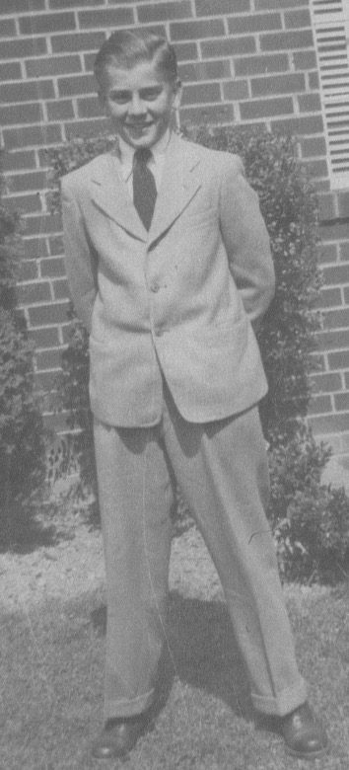

Embarrassed, I am glued to the wall with my hands in my pockets, head down, some half smiles, with frequent glances to the dance floor, trying to give some semblance of being "cool" along with the other wallflowers. There are the weak jokes, with maybe a little kick or shove thrown in.

Then I feel the blood rush to my face when Miss Nixon tries to peel us from the wall with her cajoling to "get out there on the floor and dance with the girls!" In silence I shout back, "BUT I DON'T HOW TO DANCE THE WAY THEY DO, AND I AM TOO SHORT AND TOO SHY!"

Of course I want to get out there with Pat, Luanne, Joan and Liz, and the rest of them, with bodies touching, gliding around the dance floor, BUT, at that moment, what I want more, is a hole in the floor into which I can disappear, or at least a way to ease myself out into the hall.

That's the way it goes for all of the monthly dances of the seventh grade! (Moan) As the new summer begins, I think, "Good grief, I have two more years of these scheduled junior high dances NOT to look forward to. And, perish the thought, three years of high school dances, and then four more years of college dances. What a dismal prospect! If I don't grow, if I don't learn how to make conversation comfortably, IF I DON'T LEARN TO DANCE...I might as well become a hermit, or just hang it all up. Something has to change!"

My teenage analysis goes like this:

1. I can't do much about growing up physically, except to believe my parents' assurances that it would happen sooner or later. (Probably later for me!)

2. I can follow up on an advertisement in a comic book which heralds a product, The Art of Conversation, as the road to social ease. (Maybe I'm not the only one feeling that way after all.) I order it. The ten red booklets arrive the first of July.

3. Then an ad in the Sunday Star classified section catches my eye:
"Don Martini Dance Studio - Special this summer. Ten dance lessons for $10. Learn the fox trot and jitterbug. Be a wallflower no longer."

I show the ad to my neighbor friend Derby Sussman - also short, also shy, and also thirteen. We agree to try it. We phone. For ten Saturday afternoons in the summer of 1945 we make the trek from Silver Spring to Don Martini's Dance Studio on Connecticut Avenue in Washington, D.C. It is an hour's bus trip each way with three transfers. We are creating our future.

On our first visit for the lesson, we meet Ginny, our attractive instructor. She wears very high heels, a tight black dress, lots of makeup and perfume, and her black hair is in a tight bun at the back of her head. Anticipation, excitement, and wonderment is heightened when she puts my hand, arms, and legs in place for the first instruction, AND my short frame positioned my bulging eyes to stare straight into her generous bosom. I think I had on a bright red shirt that day. It matched the crimson of my hot, flushed face.

We begin the dance lesson in spite of the distraction. She has me look at and follow her feet...her FEET. (Whew, that helps!) We then move together as we practice the first of the twenty dance steps I am to learn. Ten foxtrot. Ten jitterbug. I practice them with diligence this summer. My life is changing, starting with lesson number one, "The Right Waltz Turn" step. Derby and I alternate learning each new step with "Buxom Ginny". "Sleepy Time Gal" is the tune for jitterbug lessons.

At the end of the ten-week dance course, and with my practicing, my confidence is blossoming. It is even competing in attention with what confronts my eyes when facing "Buxom Ginny" every Saturday at 2:00 p.m.

Along with digesting the instructions offered in The Art of Conversation booklets, my dance lessons ready me for September, and the beginning of grade eight. The first school dance is announced to be at the end of September.

I eagerly anticipate the opportunity to demonstrate that I am catching up and qualifying to be among those who have the smarts to be at ease on the dance floor. A wallflower no more! Hallelujah! Miss Nixon doesn't have to say another word to pry me loose from the sidelines.

TO MY SURPRISE, and hidden delight, as I dance with girl after girl, and observe more closely the moves of the other boys, who in earlier days seemed so cool and superior, I realize that NO ONE ELSE KNOWS HOW TO DANCE!!

At least they don't know any of the steps I have learned. All along they have just been rocking back and forth in the "pumping for oil" motion, shuffling as best they can, and enjoying it. There I am, with my new "right waltz turns" and "double dips" and "roll ups" and seventeen other "cool" steps. I learn to lead the girls with a nudge here or a twist here and there, encouraging them "Not to worry, we'll get it better next time." In quiet times, away from the dance floor, you can even find me encouraging some of the guys and coaching them on what an actual dance step looks like.

I feel like I have grown about twelve inches this summer. This caterpillar has morphed into a butterfly. After that, there are two more years of the monthly junior high school dances, three years of high school dances, four years of college dances, and sixty plus years of enjoyment on the dance floor, using those same twenty fox trot and jitterbug steps. In the summer of 1945 I join Wallflowers Anonymous. Thank you, Ginny!

A PIANO RECITAL

Recital day is finally here. Evelyn Thompson's fourteen Woodside Park students are seated in order, two by two on the carpeted stairs leading up from her crowded living room. It includes two grand pianos and a large Hammond organ, leaving space for only one needlepointed wing chair in the corner. A massive 7' x 9' spotlighted painting of a forest covers the wall over a fireplace.

Mrs. Thompson sits in the chair and announces the recital pieces. The forty-some parents and friends are packed together into the screened side porch off the living room and then into the entrance way, hallways, and dining room.

It is 4:00 p.m. on a warm September Saturday afternoon. Windows and doors are all propped open, allowing a welcome breeze. Mrs. Thompson greets everyone with her ready wit and charm. All is then hushed as the students and parents settle in for the next hour or so of piano renditions from the assembled assortment of aspiring musicians. It is a time of ordeal or opportunity for both students and guests, depending on their perspective at a given moment.

The engraved program shows James Seltzer, the oldest of the young pianists, to be the first recitalist, playing Brahm's Waltz in A Flat. Gentle smiles and eyes are upon him as he makes his way from the lowest stair to the piano bench with no turns of his head or eyes. He sits. He pulls the piano bench forward a couple of inches. He clears his throat. He cracks his knuckles. He rubs his hands up and down his trousers. He stares at the Steinway keyboard. His hands are raised. Is this little preparatory ritual telling us something?

He makes his first move with his second right-hand finger in proper hammer-like formation. He strikes the "G" firmly. Just one note. There is a momentary pregnant silence that seems like an hour to most of us. James keeps his head down, staring at the keyboard. A crimson hue ascends from his neck to flush his face.

No doubt his brain is shouting a mix of messages through his body: "Wrong note!! You just played the wrong note! Brahms Waltz in A Flat does not begin on 'G'. You idiot! You have been practicing this piece for three months. It has never started with a 'G'. What are you going to do about it? Whatever it is, it had better be quick."

The tide of crimson countenances is spreading. First is Mrs. Thompson. Then the gathered guests. Then the other students from their stairway perches. All awkward. Embarrassing. Everyone's sympathetic mechanisms are engaged. In that millisecond, thoughts are racing within them: "Is this the first of many more goofs to fill the afternoon?" "Has he practiced enough?" "He must feel awful." "Poor dear." "I know how his parents must be feeling." "Should I say or do something?"

And from the stairs: "Is this how it might be for me too?" "What is my first note?" "What if I mess up? What then?"

Finally, James looks up, and slowly turns his head to the right. He announces, with a wry, red-faced smile, "That was the wrong note. This is the right note." With relieved giggles echoing from the stairs, and smiles from Mrs. Thompson and the gathered parents, James starts with a "C" this time. He proceeds as practiced through the waltz, with flaws that only Brahms would notice. At its conclusion he is roundly applauded not only for his commendable performance, but also for his bravado in responding to the initial wrong note. With aplomb he has quickly rallied his resources and smoothed the mistake with a smile, to help everyone move on.

This is how the recital day begins. Fears have been triggered. Sweaty palms are evident among the remaining thirteen performers. Our starched shirts and skirts, and scrubbed fragrances still dominate appearances in the stair gallery.

Each of us has our unique family history and baggage that brings us to this place and time. For me it has been from my beginning a daily bathing in music of every sort and source. Parents, brothers, cousins, aunts, uncles, friends, neighbors, all embracing me with their inspiration and aspiration toward choruses, choirs, solos, duets, bands, ensembles, and instruments. Music is everywhere to listen to and to experiment with.

The Thompson household is one more happy example of music's abundant place in my life. They live directly behind us at 9111 Crosby Road. As professionally trained musicians they offer us daily reminders of their gifts with solos and duets lofting through their windows to the whole neighborhood. Mr. Thompson has a brilliant tenor voice and his solos, combined with the sing-alongs at their frequent parties, add to my family's enjoyment. All of which is enough to move me to forego some afternoons of football and baseball in favor of the laborious repetitions of the scales, Hanon exercises, arpeggios and the rest needed to memorize each classical piece measure by measure, line by line, page by page.

During eighth grade summer, Mrs. Thompson somehow cons some of us students to compete for how many hours we can practice each day.

We often check in with each other, "How long did you practice today?"

"Two hours? I beat you. I did two and a half."

Of course, we experience the level of improvement that accelerated discipline produces.

I can only imagine what giving a piano lesson is like for her.. She has to be very motivated to inspire us as she listens day after day to her struggling students. We try to plunk out the first notes of a new piece three months before the recital.

I can hear her repeat: "That's it. That's the right note. Good. Now, the left hand. Keep your fingers in the hammer position. Concentrate. Let's try that again. Use your third finger on that one, and cross under with your thumb the way you do it when you practice the scales. Good. Now let's move onto the next line and try to read it. Take it slowly. Remember the F A C E is for the spaces and the E G B D F is for the lines. Here, let me write out the fingering for you. Now, let's try it again."

So it goes, over and over again, lesson after lesson. Such is the scene. She sits beside me on her piano bench, sharpened pencil in hand. Her rotund body is well corseted. She frequently inserts her encouragements and humor. 'Buffburger,' their cuddly family dog blend of spitz and cocker spaniel, is parked on a carpet under the piano sounding board. He chimes in with his howls during the lesson whenever the sounds combine to move him. These are the weekly lessons leading up to recital day.

Now is the recital day. It has had a shaky start with my brother James'—"This is the wrong note. This is the right note,"— experience. This triggers the adrenalin glands in the rest of us to use all of our resources to get our notes right the first time.

Mrs. Thompson and the parents are no doubt wondering how will it be for their own: Judith Anderson, Elizabeth Cave, Joan Membert, Ann Parker, Bert Johnson, John, Bill, and Jim Thompson, Lillian Longley, Kathleen Tyrell, Katie Brunstetter, Ryland Packet, and myself.

Not to worry. We all make it through without incident, including my rendering of Edvard Grieg's, To Spring, and a simplified version of his Concerto in A Minor . None of us performs perfectly, but we're all passable, and we enjoy the polite parental applause.

Finally, comes the musical desserts from the masters among us. We can all relax, enjoy, and be inspired. Mrs. Thompson wows us with her rendition of Defalla's Ritual Fire Dance. Then Mr. Thompson's tenor solo lifts our spirits with Malotte's Lord's Prayer.

Glen and Ruth Carow, professionals Mrs.Thompson brings in from Washington, D.C., move us to amazement with their piano duet of Tchaikovsky's Second Piano Concerto. What a treat! The dual Steinway's are awakened to a brilliant level. It seems that the Carow's do it still. They employ all the keys through all the varieties of runs, arpeggios, ten fingered chordings. Their duets interplay the loud, soft, and sustaining pedals, four hands, twenty fingers, pianissimos, and sforzandos. Some passages are slow and blissful. Others are ripping like a storm with the Carow's hands moving so fast they appear only as a blur. Beads of perspiration trickle from their foreheads. Their four eyes are intensely focused and darting their attention from right hand to left hand.. Their bodies rise up and down on the piano benches for emphatic passages. We are all engrossed, wide eyed, with jaw dropping awe. We wonder inside, "Can I ever be like that?"

Recital day is capped with the delights of a pineapple punch, tea sandwiches, and assorted cakes. All of us students are lathered up with the congratulations of the adults. The prior two-hour crisis of nerves is quickly forgotten.

This recital day joins dozens of others that follow it over the years. The rewards of all the practice, discipline, and mistakes are mixed with the resulting habits, vibrant rhythms, and melodious harmonies to provide a cumulative musical legacy. This legacy is ever close at hand to delight and lift the human spirit, especially mine.

DEMON DEALING

The signs read: "See Yourself in Woodside Park
A Brand New Concept in Suburban Living
Silver Spring, Maryland
(A Restricted Community)"

A planned housing subdivision is a new idea in 1928. All the roads, sewer, water, and electric services are already in place. The buyer has only to pick out his favorite lot, and get approval for his house plans from Mr. Hopkins, the developer. It tickles the fancy of folks wanting to move out of the downtown crunch of row houses in nearby Washington, D.C. In the months of free flowing cash prior to the economic crash of 1929 it is easy to get the dream machines engaged for building a new home in the midst of the apple orchards and barley crested fields of Silver Spring. There are already pansied gardens and sheltered stone entrances to the main roads of Highland Drive, Noyes Drive, and Woodside Parkway, lined with arches of dogwoods and azaleas.

The 'demon dealing' initially finds fertile ground in the last line of the advertisement:
"A Restricted Community". It triggers the lower human instincts of separateness, prestige, and fear. Translated, it means that the real estate salesmen on hand for the Woodside Park development would tactfully reject anyone who was not a White Anglo-Saxon Protestant. W.A.S.P. for short. Blacks, Jews, or Catholics cannot be a part of Woodside Park.

The word is clear from the developer: "Keep your eyes and ears open. Be discreet and polite, but firm and definitive, they will not be allowed to live here."

My parents qualify. They buy and build on a quarter acre plot at #4 Pinecrest Circle in 1928. My father, an architect with the U.S. government, has won an award from Architecture Magazine for his design of an English Tudor cottage. It quickly becomes his dream home.

I am born into this home, and this "restricted" neighborhood in 1932, unaware of the invisible demons at work. It is just the way things are. No one questions it, as far as I know. I grow up not knowing any blacks, or "coloreds" as my relatives call them. Excepting Marie, the Thompson neighbor's black domestic, who comes and goes every day from her home in "Monkey Hollow", two miles out Georgia Avenue.

No Catholics and no Jews. There are two exceptions that somehow slip past the watchful eyes of the salesmen. There are the Catholics, Ronnie McDevitt and his mom, on Dale Drive, and the Jews, Derbie Sussman, his brother Arnie, and their parents who live in the enormous gray stone house sitting diagonally at the corner of Crosby Road and Woodside Parkway. Both families are generally accepted by the neighbors, as far as I know. Although, the handles of "the Catholics" or "the Jews" are often included with the mention of their names in conversations. Ronnie, Derbie, and Arnie fit in with our neighborhood posse of twenty kids as we tear around the gravel roads and dirt paths on our bikes and have softball games on the vacant lots. We fill our playful days together.

The demon surfaces each time Ronnie visits my home. We play with the array of 'tootsie toys' on the living room rug. After Ronnie leaves to go home, my mother cautions me to count my tootsie toys to see if any are missing after Ronnie's visit.

She says, "He seems a nice enough boy. He laughs, and is polite, and you have a good time together, but you know, he IS a Catholic. I think you'd be smart to see if the cars and trucks are all there."

I listen to my mother, but with my boyish furrowed brow reveal the confusion cast by this shadow on my good friend and playmate. "Why would he do something like that?" I wonder, along with the other unformed questions, like, "Are Catholics told to steal by their priests or parents?" "Is there some mysterious evil lurking inside of them?" "Are they real people?" But the questions are tucked away for another time, in favor of enjoying a friend and playtime.

The "restricted neighborhood" demon also shows up with my Jewish friends, Derbie and Arnie Sussman. With them, it is not "better count your toys when they leave" advice from parents, or other WASP neighbors. It is offhanded slurs about Jews being loud and pushy money grabbers. Their big stone house on the corner is more pretentious than any other, with its three garages, spiral staircases, circular driveway, and an excess of large rooms.

Remarks are dropped in front of us kids, like, "You do wonder where he gets all the money to build a house like that. We don't even know what kind of job he has, other than he says he's in real estate. He's away most of the time. You could fit three of our houses inside his. It is really out of place. But that's how THEY are." These comments are also stored away for another time in favor of playtime and friendships.

But all that which has been insulated in the psyche is bound to surface again. It can't stay simple.

Complications occur for me one warm fall afternoon on my way home after delivering The Evening Star newspaper to my 45 customers. Coasting down the Dale Drive hill with my large bike basket now empty of papers, and enjoying the free cooling breeze on my sweaty cheeks, I spot Ronnie with his red wagon at the bottom of the hill. He has finished his paper delivery route for The Shopping News, a free weekly distribution of 150 copies. Ronnie is looking up from the storm drain culvert that runs under Dale Drive. I drop my bike on the gravel shoulder and skid down the embankment on my heels so I can talk with Ronnie.

When I reach the bottom I look over to where Ronnie is standing. Beside and behind Ronnie are stacks of old Shopping Newspapers. The sopping piles back up into the smelly, wet culvert. I am trying to take it all in. What am I seeing?

"What's happening, man? What's all this?" I ask, as my eyes try to connect with my brain. Ronnie, is embarrassed by my unexpected appearance on the scene, and my quizzical look.

He sits down in the red wagon and tries to help us both figure it all out by saying, "Yeah, I know, I know, it's a mess."

l plop down on the driest stack of Shopping News across from Ronnie, and plead, "What are you doing, anyway?"

Ronnie twists his baseball cap in his hands as he explains, "Nobody knows. Nobody has found out. Nobody sees this mess from the road. The paper is free, so nobody misses it, or is getting ripped off. Man, 150 papers is just too much. Even though it's only once a week, it takes me almost three hours to deliver all of them, so for the last month I only delivered half of them and I dumped the other half down here. Nobody complains if they don't get it, so my manager doesn't know either."

"Geez, Ronnie!" I exclaim as I stare at a month's worth of non-deliveries in the culvert and try to process the whole scene. I'm comparing own situation of having to deliver The Star seven days a week...of course my customers are all paying and expecting their paper...they would let me and my manager know if they didn't get their papers...and I am making some money at it...so dropping half of my papers in the drain is not an option for me...but even if it was?.

"Wow", is about all I can muster for a response and then I clamber up the bank crunching through the fallen red and yellow leaves, where I picked up my bike and pushed off for the pensive ride home.

Some of those hidden questions about Catholics pop into my head. Had my mother been right? Was Ronnie doing this because he was Catholic? Cheating? Stealing? Bending the truth? Lazy? Dishonest? Doing whatever he wants as long as he doesn't get caught? My mind is churning. Ronnie's undelivered papers are feeding the old suspicions. It will be harder after that to stifle those uncomfortable wonderings.

Next are the Sussman's. There are the demons of the Jewish stereotypes and prejudices about them.

It is a summer night in 1943 when the world is at war. In the United States practically everything is rationed, or just not available at all. The Woodside kids are in our nighttime game mode of hiding and seeking. I have partnered with Johnny Thompson. We run behind the Sussman's house to hide. We position ourselves next to the partially open back garage door of the Sussman's house. The garage lights are ablaze. While waiting to be found, we glance into the garage. There are no cars. There are new refrigerators. Lots of new refrigerators, filling the garage. It is at a time when no one can buy a new refrigerator. Johnny and I know this. Strict rationing rules and their effects, are often the centerpiece of adult conversations

. We gasp, "How come the Sussman's have a garage full of them?" "Blackmarket!," is our conclusion. We don't know for sure what Derbie's dad does for a living. Obviously, black-market dealings, and potentially big money, is part of it. Our minds are spinning. Suspicions about the stereotypes are being nourished. The thoughts are here. Are they doing this because they're Jews? Greedy? Cheating? It will be harder to put away these uncomfortable wonderings.

That is not quite the end of it. The questions about stereotypes, prejudices, the superiority of W.A.S. P.'s, and the inherent inferiority of Catholics and Jews continue to rumble through my consciousness for years.

One day I see things differently.

I painfully recall when I, a W.A.S.P. thoroughbred, at ten years old, have been cruising the aisles of Murphy's 5&10 store and stop at the toy table. I eye an appealing yellow dump truck. I have no money, but really like that truck. Anybody around, I wonder? After a quick glance around to get the 'all clear,' I slide my hand into the glass section containing the truck. I pick up the truck, and am about to deposit it in my coat pocket, when my one last rapid scan around abruptly catches the stare of Mrs. Clement, my fifth grade substitute teacher that day, at the end of the aisle. Her piercing glare of 'gotcha' sends my insides churning. I drop the truck back into its counter cube, turn my crimson face toward the floor, and move like a rabbit out of the side door of the store. She never mentions the incident. Neither do I. But it has been deeply implanted in my brain. My lesson has been learned.

I remember that day in Murphy's 5&10 and realize that I have my own human demon. This puts me right in bed with the human demons that judge Ronnie McDevitt and the Sussman's. I am a W.A.S.P. They are Catholics and Jews. Beyond those labels we are humans. We are one, not separate. We are connected by both the fears that lead to the greed, stealing, and cheating, as well as the aspirations that can lead to higher moral ground. Moses would have pointed the Sussman's beyond their hoarding of refrigerators. St. Francis would have guided Ronnie to deliver all of his Shopping News. Martin Luther would have advised me to think about the store owner and to pay for the yellow truck.

I never heard what Ronnie, Derbie, or Arnie might have experienced or learned from those days. But it is a life lesson for me. I realize who we all really are. The ground is level. These demons can be let go.

TROMBONE TRAILS

My trombone has been a frequent companion on my life's journey. So many shaping relationships and events include my trombone and its tunes. I have been primed for it by being surrounded by music and musicians in my family and neighborhood from birth. Seeds are sown early. My first definitive move toward the trombone comes at age fifteen. New notes are coming into my life.

When I reach the tenth grade at Montgomery Blair High School in Silver Spring Md., the principal wants to form a band. As a rural high school, he has just hired the first music teacher, Mr. Messerole. He is eager to start a band and sets about recruiting members. He approaches me with a specific request to play trombone. I have no instrument. He says he can get me a loaner from the county storehouse. I won't have to shell out for one of my own until I am sure I want to stay with it.

It is good timing. I talk it over with my parents. I know I am too small to try out for football at high school. There is excitement at Blair about having a band. A lot of kids are talking about it. Our family orchestra can also use a trombone. I say, "Yes." The first lessons will be from Mr. Messerole.

Mr. Messerole has the loaner waiting for me in time for the first practice the next week. I have visions of a shiny brass version to show off and get started. This expectation is quickly shattered. He hands me a battered black case with a broken handle, scrapes, and mildew fuzz all over it. I think, "Where has this been kept in the county storeroom? Are all the instruments looking this bad?"

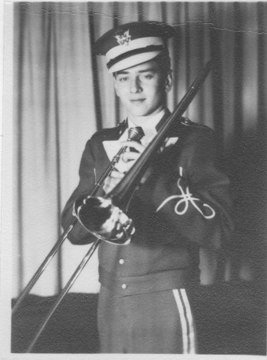

Somewhat crestfallen, I cautiously open the latches and lift the lid. It gets worse. It reeks of a pungent and penetrating odor which I later learn is camphor. I wonder, "Is this some kind of special storage chemical? Yuk!"

Gazing at the trombone parts clamped to the frayed velvet interior do not boost my spirits one bit. Instead of a shiny golden brass metal, it is a dull and smudged silver color. Already, second thoughts are churning in my heard, "Do I even want to take this thing out of the case and hold it? Who's going to envy me this contraption?"

The condition of the other instruments from the storage unit is similar. Disappointment is palpable among us new students. Mr. Messerole doesn't give us time to chew on our negative impressions.

He quickly tells us how to release the pieces from the case. He describes the slide's inner and outer sleeves and movements, and how they attach to the bell section. Then he tells us how and where to attach the mouthpiece. I'm thinking, "Do I have to put that to my lips? Doesn't look clean to me. Who's been playing it? I gotta at least wash it off."

He shows us how to hold the trombone in the left hand, rest the shaft on our left shoulder, and use the right arm to move the slide. "Yikes,' I say, "I can't even move the slide. It's stuck." He helps to get it started. I keep trying to make it move more easily. Someone must have used a thick lubricant like Vaseline. In trying to move it back and forth, it bangs the mouthpiece against my lips every time. He says, "We'll have to get some proper oil for that slide and clean that old stuff off. "

Mr. Messerole gives us our introductory lesson on how to get sound out of the trombone. He says, "Purse your lips like this, and make a buzzing sound like bee." We practice this awhile and then put the mouthpiece to our lips. Sure enough, a sound comes out…like a sick cow, or a tired car horn. Not a pleasant sound, just a sound.

He then shows us how moving the slide out from us changes the sound. He says, "Do that every three inches until the slide is all the way out. It's seven different positions and you get seven different notes. Then, by loosening or tightening your lips at each of those seven positions you can add five notes at each position. Just keep practicing that again and again every day for half an hour. We'll get together next week. Pretty soon we'll have a band!"

My parents are also underwhelmed by the sad condition of my loaner trombone. My Dad says, "Let's try to get it cleaned up a bit and set that case out in the sun to get rid of the smell."

After two months of my using the loaner my parents see that I am staying with it enough to warrant looking into getting a brand-new one, with shiny brass this time. We will split the cost. I have saved money from delivering newspapers for four years. We are ready for the next stage of beginning my trombone journey.

We go to our usual supplier of most everything, Sears and Roebuck. Its catalogue is always handy. Yes, they picture a lovely trombone. We order it. It arrives three weeks later. How I anticipate this moment. No more camphor odor. No more sluggish slides and swollen lips. No more shoe polish to cover the blemishes on the case. My very own shiny brass trombone in a case lined with red velvet.

I proudly remove the packaging and put the slide and bell sections in place. We all say, "Isn't it lovely!" We mingle our other comments: "You bet. It's great … Except. Wait a second. Look at the shaft. That upper part of the bell section. Look at it. It's bent! It's in such a prominent place too. It's cockeyed. It must have been damaged in shipping. We can't keep this. We'll have to send it back and have them send a new one."

Disappointed, I go through the return process. Sears doesn't respond to any of the details of my return explanation. They are prompt in sending a replacement. This buoys my spirits. NOW I can get a proper start on my trombone trail. The family gathers around for this second opening, sharing my enthusiasm. I pop the latches open. My eye goes directly to the shaft of the bell section that had been bent on the first one.

"Oh no," I yell, "They've done it again. Look, this shaft is bent too! I wonder if they really sent me a new one. Maybe they just re-sent the first one. I mean, how likely is it that a second one would get damaged in exactly the same place?"

We suspect that Sears and Roebuck had tried to pull a fast one on us. Exasperated, my father says, "We will not have any of it. We send this back, get our refund, and look elsewhere. We'll go to a proper music store like Moss Music, downtown D.C. They'll have them on display, and we can be sure it isn't damaged, and get what we want...with no bent shafts." It is returned to Sears.

The next Saturday afternoon my father and I go to Moss Music at 13th and F Streets in downtown D.C. My father says, 'Look, there in the window, three trombones are on display, like I said. We'll probably have to pay more here than at Sears, but at least it won't be damaged." I am pleased that this part of my trombone journey is finally being accomplished.

But ... oops … a closer look at all three trombones in the display window…they ALL have cockeyed shafts! A question to the salesman inside exposes my ignorance. He tells us, "All trombones have a little bend in the shaft. They are not damaged. It's there for a reason. It accommodates the trombone to the shape of the player's neck for his comfort."

Inwardly, I lament, "Those two that I returned to Sears were fine after all. They hadn't pulled a fast one on us. But if I can afford one of these I'm not going through the aggravation of re-ordering from Sears." I buy a Conn brand, Pan American Model trombone at Moss Music that day. It has soft red velvet lining inside the brown speckled case with a proper shiny brass bell, slide, and mouthpiece that will last me through many relationships and life experiences for twenty-five years. Those stories have yet to be told. Lessons are learned. New notes in my life are forthcoming on my trombone trail.

WATER MUSIC

For most people "water music" conjures up royal images of July 17, 1717 when King George 1 and friends are lounging and partying on the cushioned thrones of the royal barge. It is a calm summer evening on the River Thames. The barge is festooned with gold and red fabrics and furnishings. Flags displaying the royal seal are positioned at six-foot intervals above the rowers around the gunnels, and flap gently in the breeze. Flaming torches are secure between the flags, and their glow casts flickering shadows on the King and his party. They also bring into view the thousands of the King's subjects lining the banks of the Thames, excitedly straining for a closer look at him. There are the cheers, "Long live the King!" There are parents prompting their children's attention with, "There he is. There he is. See him? Right in the middle there, with the bright red vest and gold chains. You can tell your friends that you saw the King today!"

Close behind the royal barge is another brightly decorated vessel. It also has the gold and the reds with more flags and torches. This time the flames reveal the Royal Symphony seated, in their formal attire, with their instruments, ready to please the King. The music is grand. It is majestic, and aptly named "Water Music."

The oars dip rhythmically in and out of the water as the barges slowly course through the waters of the River Thames. King George 1 has planned it all. He has commissioned George Frideric Handel to compose music for just such an occasion to show off the King, and how wonderful it is to live under his reign. The King loves it. The people along the banks love it. It is often talked about. It is often repeated.

Fast forward 232 years to July 17, 1949. "Water music" takes on another meaning. The scene is Colonial Beach, Virginia, on the Potomac River. You will see the big white Daly cottage. It is a simple four room structure set on stilts. White lattice surrounds the open storage area underneath. It has an expansive front porch, a screened dining room and enclosed kitchen attached at the rear. The lime fumigated outhouse lies at the end of a grapevine lined path behind the cottage. There are whitewashed fruit trees scattered among the shade trees of the yard with a white fence. Close to the cottage there is a small icehouse for food storage and a water spigot for unheated outside showers, and the nightly toothbrushing ritual.

Across the front road, Irving Avenue, there is an open deck nestled in the grove of pine trees for sitting close to the water's edge and pebbled beach. Close by is an eight by eight, forty-foot high U.S. Navy lookout tower secured on metal pipes. After wartime needs end, it is still used to test and measure distances of artillery shells fired from the Dahlgren Navy Base. The Naval patrol boat keeps river craft clear of the danger zone from 10 to 2 on practice days.

On this particular day, you will find small groups of neighbors huddled along the shore and in front of the Daly's white fence. Bert and Sara Stutz are climbing the metal pipes under the naval tower and peering out into the river.

Mr. Monk and Mr. Stutz are busy attaching their outboard motors to their eighteen-foot fishing boats for a possible rescue mission on the river. You can see the Bergmans, the Edwards, the Seltzers, the Berrys, the Monks, the Foxes, the Stutz's, and others chatting and moving between each grouping, with consternation and wonderment wrinkling their brows. The groupings are large enough to draw the attention of the only police car in town, with its officer, Beauregard, called "Bo" for short. The folks direct his attention, along with theirs, outward to the river. Bo reaches inside his '41 Ford police cruiser for his binoculars.

What is attracting their attention and bringing them together are the strange sounds wafting into shore for the last twenty minutes. They can't see anything. They are guessing what it might be. Maybe it's an animal, or a human bellowing in distress. Is it someone who has turned up their loudspeakers to full volume? Is it the patrol boat sounding a warning for a trespassing watercraft?

They listen more intently with Bo there, while looking at him for guidance. They continue their guessing. Sometimes it sounds almost like a human voice. Sometimes not. But what is it? Bo keeps peering out through his binoculars.

Bert and Sara report from the tower, "We can't see anything from here." Someone from the Seltzer clan volunteers that Paul and the family rowboat are missing. Can he be the source of the distress call?

His father says, "He doesn't usually row or go fishing out of sight of land."

Mrs. Bergman replies, " Maybe he's in trouble and we ought at least go out in that direction and see if we can locate him... or whatever it is that's still making that noise."

Mr. Monk pulls the starter rope on his outboard Mercury 25 and calls from the beach, "I'll go out and see what I can find."

Frank Stutz has his little boat tied up next to the Monk's, and he calls out, "I'll follow you."

He unties his boat and yanks on the starter cord. As the two boats speed in the direction of the noise in the river a speck finally appears to them on the horizon. They wave to each other, pointing toward the speck. It gradually expands in size. Yes, it is a small rowboat. Yes, someone is standing in the middle of it. But there are no waving arms beckoning for help. It gradually comes into full view. Yes, it is the Seltzer rowboat with "lil" painted on the bow, having been named for Paul's mother, Lillian. Yes, it is me.

I wave and smile as the Monk and Stutz boats come alongside.

They call out, "Are you okay? We thought we heard you yelling for help, like maybe you had lost an oar or something."

I smile broadly and sheepishly admit, "I was just singing, very loudly, I guess. I thought I was alone out here. I didn't know anyone would hear me."

Frank smiles and replies, "Sound really carries over water. Everyone on shore thought there was trouble, and then they realized that you weren't around, your boat was gone, and thought you might be fishing and out of sight. Quite a group has gathered, and Bo is there too. They'll all be glad you're okay, and probably laugh a lot once they know that it was you singing and not a distress call from a bull moose."

I shake my head in embarrassment. I say, "So sorry you had to come all the way out here for me."

"That's okay. Don't worry about it," they shout, "just glad you're all right." With that, they spin their boats around and shove their throttles wide open for the trip to shore to share the news.

I sit down on the center seat of the boat, grab the oars and plant them in the water for the long row home. I have plenty of time for the rush of thoughts to play through my mind many times. With embarrassment pervading my mind, I remember my penchant for music, and my frequent fantasy performances. It is my habit, whenever I think I am alone, I pretend I am more than an amateur, and move into the role of a pro. It can be in my living room at home, with walnut baton in hand, gyrating like the conductor, Toscanini, to the energized strains of Tchaikovsky's "Capriccio Italien." Or it can be in the shower bellowing like Gordon McRae to "Oh What a Beautiful Morning," or Frankie Lane with "That Lucky Old Sun." Or just like this afternoon on the Potomac River, with vocal cords at their full emotional tilt, belting out my favorite aria of Canio the clown, in the opera, "Pagliacci." Inwardly, I congratulate myself, "Now THIS is 'water music'." There are no royal barges or flags or symphony to support my efforts. It is just raw enthusiasm, with willing, but untrained, lungs and vocal cords.

Finally, the half hour long row back to shore is over. The big white Daly cottage is in full view. The neighbors and family and Bo are still clustered, but now without furrowed brows of worry. It is all eager waves and laughter and sarcastic remarks filling the air as they share their takes on the afternoon's entertainment on the Potomac.

I smile modestly and express my apologies, "I had no idea you were hearing me. When the fish didn't bite I just thought it was me out there, with the blanket of jelly fish bobbing up and down around the boat. What better time to sing out to the cosmos with some of my favorite opera. The jellyfish didn't seem to mind."

It isn't like the 'water music' on the Thames in 1717, but I am feeling some connections. Unlike Handel's version, it is never repeated.

STARS ETCETERA

The stars are clear and close on this July night in 1949. I lay on the damp grass looking up and feeling a deep connection with the vastness of the night sky and the brilliant diamonds sprinkled above me. It is as if each blink of the distant dots is sending out a message in code for whomever might have the eyes to catch it. I am in wonder. What might be there for me?

I'm not alone. I am with a half dozen other high school juniors who are spending most of the summer as counselors at Camp Nawakwa, a Lutheran church camp, located in the apple orchard hills near Gettysburg, Pa. Each of us shepherd the ten boys of our cabins through the camp activities of morning religious classes, afternoon swimming, games, and crafts, evening rituals of competitions, camp fires, entertainment and worship at the Upper Temple mountain overlooking the beautiful stretches of farmland and apple orchards. We help them ready our cabins for inspections. We teach them the camp songs and traditions. We hold the hands of the homesick. It is fun and rewarding.

However, it becomes somewhat routine and predictable after several weeks. We need some more excitement. Some diversion. On an afternoon trip to the town of Gettysburg we get into kidding about whatever comes up.

Doug Carlyle suggests, "You know what? We ought to plan to sneak away from the cabins at night after the campers are asleep."

Charlie Wertz chimed in, "Yeah, we could go up on the Upper Temple mountain and have a party." Macho swagger is kicking in and ideas are flowing from the six of us.

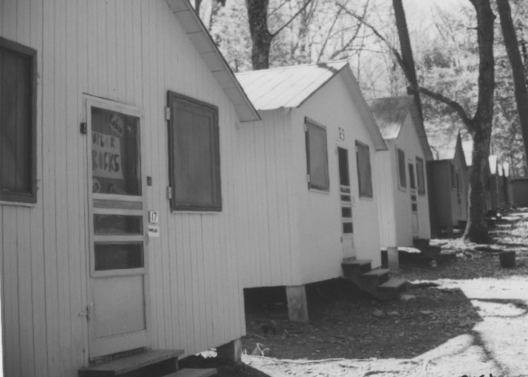

Someone else offers, "Yeah, you know what? We ought to try out the stuff in those Benzedrex inhalers. It's supposed to be really cool."

"You ever tried it?"

No, but I hear it's great."

"What do you do? What happens?"

"What are you talking about, anyway?"

"Well, you know those inhalers you use when you have a cold and your nose is stopped up? Inside those inhalers, if you break them open, are a couple of yellow strips of this concentrated stuff that unstops your nose when you breathe it in. I think the idea is that you take one of these strips, roll it up and swallow it. After a while, it's makes you feel real good."

More talk. More questions. More joking around. It continues as we moved into the drugstore. We locate the Benzedrex inhalers. Our joking around about the possible non-nasal usage of them catches the ear of the druggist. He scolds us for this kind of irresponsible talk. He refuses to sell us any.

We are somewhat taken aback with this encounter. It gives an additional naughtiness to what we are considering. We have to be secretive about it. It feeds the excitement and group camaraderie. We are more careful and calculating at the next drug store. We are able to purchase the inhalers here, as we stifle our laughter and bravado.

We make the plan. There is plenty of peer pressure to go along with the whole scheme. Two nights later we give the campers time to go to sleep, maybe an hour. We meet at the swimming pool at eleven. We won't try walking the usual trail through the woods up the mountain to Upper Temple. Too dark. We will quietly walk the long way around, using the country dirt roads. We can pick some apples from the trees along the way, take some soda and snacks along. Maybe we can even catch the sunrise.

It is a lark. Very dark until our eyes get used to it. Eventually we can make out the trees and the apples and the ruts in the road. The view from the top at Upper Temple is always awesome. We look at the lights of Gettysburg in the distance.

We realize we don't have to be whispering any more. So, the party begins. We sing. I have my harmonica. We open the soda and snacks and crunch the apples. We venture all over the grassy knoll in our bare feet. We absorb the gifts of fresh night air tinged with hints of newly mown hay and fallen apples from the fields close by.

Finally, the moment of initiation into what we thought might be a world of altered consciousness, is at hand. We sit on the damp grass. No doubt each of us is having his own inner conversation, trying to sort out the various feelings in play. "Is this wrong? It seems exciting and fun, especially with these guys, but I'm not sure. I guess I'll go along. Too late to turn back now. What would that look like? What would they think? How would they treat me? It's no big deal I guess. I hope we don't get caught. Well, here we go."

We break open the inhalers with our heels. The plastic covers are torn off and there is our first look at the innards. Sure enough, even in the darkness, we can make out the yellow strips, emitting their pungent and penetrating fumes. We pull out the strips and roll them up. There are quick glances and nervous smiles shared as we pop the strips on our tongues and take a swallow of soda to wash them down.

We cast our eyes around the circle of six. There are some moments of quiet anticipation. Nothing happens. We finally lie down on the grass realizing it might take some time for the effects to kick in. A few more swigs of soda and some more chips.

We are quiet with our personal observations and thoughts of the constellations of heavenly bodies hovering overhead. In about ten minutes I feel my heart begin to speed up and beat heavily. It becomes an alarming moment for me lying quietly on my back, gazing at stars, to feel my heart rapidly firing and pounding inside my chest. There are no feelings of euphoria or even a buzz. Just my heart, going a mile a minute.

I am scared. I don't hear anything from anyone else, my heart is making too much noise. I am thinking, "Oh jeez, what's going on? What have I done? How stupid of me! Am I going to die like this? How long is this going to last? Oh, stars, are you looking at me? What are you thinking? I wish I hadn't gotten myself into this. What's happening with the others?"

I ask them if they are having the same reactions. They are. The laughter and youthful swagger are muted now. Each of us is wondering how it will all turn out.

I am making my inner personal pledge. "If I live through this, I will NEVER try anything like it again. I don't care what anyone thinks!" So my personal drug war is short-lived. My first experience is to be my last.

The rapid pounding keeps up in spite of my pledge. It lasts... twenty minutes? half an hour? .... an hour? ... too long! Streams of hot perspiration roll from my head and face to join the tears from my eyes as I bathe in this stinging little moment of reality.

Gradually my heart slows. The pounding recedes and the perspiration dries. I gaze again at the stars capturing my field of vision. No one is saying anything.

The stillness and darkness is broken by the rumbling of a car motor in the distance. This is soon followed by the appearance of dust clouds, penetrated by two headlights bouncing our way over the rutted dirt road.

"Who could this be?", we wonder. "The farmers are surely asleep at this midnight hour." A familiar Chevy station wagon turns onto the path to Upper Temple. The headlights have us in full view. The side door opens.

"Do you know what you're doing?" It is the bull horn voice of Dr. Reginald Deitz bellowing at us. He is a seminary professor who serves as the camp director in the summer months.

Apparently, we have not been as secretive about our adventure as we had supposed. A short scolding for our irresponsibility ensues. "The six of you have left sixty fifth graders unattended. What if one of them had awakened and needed you? What if their parents heard of it? They depend on us to look out for them, and to be there if needed. What's going on here?"

Carlyle meekly answers that we are having a party. Nothing is said about trying out the Benzedrex inhalers, etc. Dr. Deitz is rightfully angry that we have let him, and the campers, and their parents, down. The purging adds fuel to the already heavy weight of regrets for our drug testing party(?).

He tells us to start jogging down the dirt road back to camp. He follows us with his station wagon. No words are uttered on the long jog. All that can be heard is the staggered thumping of twelve shoes meeting the ground. The headlights from behind show up the puffs of dust as each foot meets the dirt road.

All the campers are still asleep when I pull back the screen door of my cabin with its squeaky spring. I tiptoe to my bunk. Through the window above my head I can still see the bright stars blinking above. In the mix of thoughts and feelings rushing around inside of me before sleep takes over is a keen awareness of my immaturity, the resolve of my pledge.... and the sight of one star in particular that seemed to be winking some wisdom my way.

LIFE BEGINS

There's an adage: "Life begins at the end of your comfort zone." A major stretch for me

comes with my 1948 summer job in Silver Spring, Maryland.

Before then I have experienced an assortment of work situations since the fourth grade. I start out selling the Saturday Evening Post and Ladies Home Journal every Wednesday afternoon to about thirty of my neighbors. I go on to earn money for my various causes by delivering morning and afternoon newspapers for the Washington Post and Evening Star or cutting grass and raking leaves for neighbors who want my help. I also have been a soda jerk at Forsythe's Drug Store, and a counselor at Camp Nawakwa. They are all jobs in a protected environment of neighbors and friends.

1948 is to be different. After my junior year at Blair High School I find summer employment at the Coca Cola Bottling Plant at sixty-five cents an hour.

The summer heat means a surge in the thirst of the public and therefore the need to produce more beverages. They hire three of us as bottle washers. Each of us is placed behind a 8' x 30' shiny gray giant washing machine. We stand on an unforgiving concrete floor. Behind us are hundreds of racks and stacks of wooden flats filled with soiled six-ounce Coke bottles. Some are dirtier than others, caked with mud or grease, and often filled with cigarette butts, or dead bugs, mice, or even concrete. Some of the necks are broken, leaving jagged glass edges to avoid. All of them reek of souring Coke syrup.

Our job is primarily to reach behind us for a case of empties, slam it on the metal shelf in front of us, grab four bottles at a time - two in each hand with a bottle between the first and second fingers and another between the third and fourth fingers. Initially, this produces blisters and sores, but with repetition, large callouses grow between the fingers.

The metal spines on the rack in front of us calls for twenty-four bottles at a time. It keeps moving relentlessly. There is no stopping it. Whenever a case of bottles has a bottle or two that is stuck or broken, we have to quickly throw it aside and grab a fresh one to fill all of the empty spaces as the machine rattles and swallows the bottles into its gaping throat behind the rubber flaps. There can be no empty slots showing up at the other end of the machine or we will be called to task. There is no time to stop and blow your nose or wipe the sweat from your brow. The clacking, clanking machine has to be fed its continuing diet of dirty bottles.

And so it goes. Lift the crates. Grab the bottles. Swing them into the open slots. Pile the empty cases to the side. Then hurry to start it all over again. And over. And over. Some days during the peak heat of July and August we keep up the monotonous routine for thirteen hours a day, with just a half hour break for lunch. Bill, the assistant manager, does spell us for a five-minute washroom break when we signal him.

Occasionally, the machine's thirty-minute bottle ride, which includes repeated scrubbings and washings with detergents and caustic solutions, will shut down. Mr. Sutton, the sullen plant manager, with a bull horn voice, can be heard all over the plant floor, "Bill! Bill! Get over here!" Bill comes running and tries to discover the cause of the shutdown. He unlocks some levers, turns some bolts, opens some doors, bangs on metal parts, climbs over and under the machinery. He is resourceful and always remedies the problem.

These moments of repair mean a welcome relief for the bottle washer operator. When it happens to my machine, I am internally cheering "Yes! Yes!" and smile smugly at my cohorts. Now I have some time to run to the washroom, get a drink of water, wipe the sweat from my forehead and re-arrange my endless stacks of bottle crates.

Breakdowns are cherished. After a couple of weeks of the unending drudgery we learn how to assist in the frequency of the breakdowns. It is discovered by accident. In the rush to keep up with the rapid movement of the machine I unwittingly drop a bottle into its slot upside down. About ten minutes later we hear a 'pop' from the belly of the machine. All goes quiet. No more of the jostling and rumbling din. Within seconds Mr. Sutton is bellowing again, "Bill. Bill. Get over here!" Soon Bill discovers that the shutdown is caused by a broken bottle. Only we, the operators, know that the real source is the upsidedown bottle originating at our end. This remedy for our factory fatigue is tested and proven many more times that summer without detection. Necessity is the mother of invention once again.

Sometimes I am called away from my bottle washing machine to other tasks. There are the fifty-gallon drums of the secret formula Coca Cola syrup just arriving from Atlanta to be unloaded from the tractor trailer. They are very heavy and there is a trick to rolling them to the mixing room with their rims at just the right angle. There is the carrying of the fifty-pound bags of sugar and mixes for the orange and grape and ginger ale drinks. There is helping the truck drivers unload the empty cases and re-load their trucks with fresh ones. It has to be done quickly because only four trucks can fit inside the plant at one time for the loading process.

Another time I am sent up to the front of the plant to fill in for a female bottle inspector who is off on sick leave. Her job is to check the bottles coming out of the washer and rattling by on a conveyor with bright lights behind, shining through the familiar aquamarine Coke glass. The bottles have to be sparklingly clean before they are re-filled and sent out to customers. No dirt, no cigarette butts, no critters.

I don't last long at this watching job. Being seated, and being very tired, I doze off. The supervisor confronts me with a bottle holding a dead mouse in it. It has been caught by a second inspector down the line. I am dressed down and returned to the washing end of the machine.

Our thirty-minute lunch breaks are usually outside, at the large acorn shaped shelter covering the original silver spring of the town. The story is that the spring had been discovered almost one hundred years earlier by Montgomery Blair, the Postmaster General of Abraham Lincoln's cabinet. He had traveled with his family in a horse and buggy to the farmland outside of Washington, D.C. for a family picnic, and discovered this sparkling and bubbling spring. We are continuing the tradition of eating by the mica reflections in the spring waters. We spend much of our time here commiserating about our working conditions.

Out of sight, and unbeknown to corporate officials, we are often joined by a dedicated union organizer who wants us to strike and make corporate Coca Cola respond with better pay, hours, and working conditions. It will not be of much benefit to me since I will be going back to school in the fall. I am inspired by this dedicated and vigorous union man, struggling with grass roots folks, taking risks, and taking stands on issues of social justice.

Even more than that, I am much concerned about Bill, our assistant manager. He is tall, lanky, with a full head of disheveled black hair. His eyes are deeply set and surrounded by tired and darkened circles. At twenty-eight, his shoulders are already bent over and he tends to shuffle, except when he hears Mr. Sutton bellow for help. Bill is in his late twenties, making eighty-five cents an hour. He has little prospect of doing any better at Coca Cola. He laments his situation but feels trapped.

I still hear myself pleading with him. "Bill, you're a smart guy. You know all about these machines. Mr. Sutton and the whole plant would be lost without you. But you've been here ten years and still only make eighty-five cents a hour. Any promotions? Any increases in pay? You've got a wife and four kids. You're young enough to do something different. Something that will help you to better support your family. I know about a night school. You could learn to be an auto mechanic, or a carpenter or a plumber. Think about it."

He makes me think about and be moved by the plight of all the "Bill's" of the world, trapped in poverty and dead ends at age twenty-eight.

There are some pleasantries with this different kind of work life. I am warmed by the basic human qualities that surface in some disguises of connectedness and generosity. One example is evidenced by the truck drivers. On some Fridays after work, they invite the summer help to join them for a beer at Crisfield's Oyster Bar. It is a way of thanking us for helping them with unloading and loading their trucks. I have my first draft beer and follow their example of adding some salt to make it foam. A pickled hard-boiled egg is the protein for the late afternoon.

Another example is with my fellow bottle washers who are my age but have dropped out of school. They are more attuned to the ways of the world, still new to me. They invite me to go with them to the visiting carnival in town. They have met a couple of girls who are now in the back seat of their car, giggling with each other, and enticingly slipping their skirts up their thighs. My buddies expect the girls to be sexually cooperative later on. They are. I'm a bit too far outside of my comfort zone at this point. I make myself scarce.

I even have some understanding for Mr. Sutton, the plant supervisor, and I suppose for all the others in authority, whom I have not encountered. His frequently angry countenance and furrowed brow have been creased by decades of trying to survive in the corporate jungle.

My job at Coca Cola ends. I go back for my senior year in high school. I have indeed been at the end of my comfort zone. Life has changed. My perspectives have been stretched. My eyes have been opened. I had previously been sheltered from knowing how life is lived by many others. I now have a taste of what life is like for factory workers with interminable, repetitious movements and low pay. I have been wearied and somewhat frightened by it. I can look at the callouses between my fingers that have grown into knobs by summer's end as reminders of lessons learned. I come to know what I do NOT want my life to look or feel like. I am strongly motivated to get as much education and training for a career as possible. My new awareness of
life has begun.

SHOWBOAT

It is spring 1950 at Montgomery Blair High School in Silver Spring, Md. It is time for its annual Variety Show, "Showboat." The show has a long tradition of being a main event at the school and in the community. Students spend much of the year leading up to it, putting their talents together into performances to try out for the April show. It is a time, especially for seniors, to show their stuff and enjoy the recognition it offers.

Donald Lindsey and I are among the senior dreamers. We are friends and have been playing our trombones in the two-year-old Blair Band.

I approach Don, "Hey Don, want to do something on our trombones for the Variety Show?"
Don goes along with the idea. We decide to make a run for the big Variety Show auditions in late February with a trombone duet of "Londonderry Air." We think, "Surely, a rendition of 'Danny Boy' will be a crowd pleaser."

For two weeks before tryouts Donald makes the early trip to school from his farm, before classes start. I carry my trombone the mile and a half from home to school. The two of us practice diligently, without coaching, in the band room.

The excitement of the upcoming tryout day keeps growing. We think we are sounding pretty good. If nervousness from being in front of the faculty advisors doesn't sabotage us, we should be a shoo-in for the show.

Tryout day arrives. Don and I are on the try out schedule for 3:45 p.m. We audition from the gymnasium stage. The faculty advisors --and deciders-- are at a table fifty feet out from the stage. They include Miss Stickley, a sweet and jolly librarian, and the eldest faculty member, along with Mrs. Worthington, the English teacher; Miss Libby, the phys ed teacher; and Mr. Meserole, the music instructor. He is the who calls out, "Okay boys let's get started."

Without piano accompaniment, "Danny Boy" echoes from our trombones around the gym walls. There is some nervousness. But at least there are no sour notes. We are thanked by the faculty and told that the results will be posted on the bulletin board the next week. Don and I smile to ourselves, feeling pretty satisfied with our audition. We nourish our performance dreams to the point of considering what outfits we might wear for the show.

No need. Our names are not on the bulletin board list of talent to be included in the big Variety Show. We are looking at the list together. Silence at first. Then a searching look at the names of those who have made it. Perhaps an oversight? No. We glance at each other. Hopes are dashed. We make a brief attempt at analyzing possible reasons for the rejection, and a comparison with other acts that have been accepted. It is a dejected moment. We wander into the cafeteria to chew on something more appealing. It is Donald's only audition attempt. He is through.

I, however, have tried out for two other possibilities, and even offer to help out as a stagehand so at least I can have some part in this last hurrah of my senior year in high school.

My ultimate dream role for the "Showboat Variety Show" is to be to be named the master of ceremonies 'captain.' Six others are trying out for this top spot in the three-night extravaganza.
I audition for it as a long shot. I lose out...again! Percy Goode is the choice to be the showboat 'captain.' For this set back I have no Don with whom to commiserate. I swallow it alone.

My final try was to join with five other guys, dressing up in female chorus costumes with wigs, et al, and do a 'can-can' for laughs. We call our act, "Legs". There are lots of laughs for us all along the way of rehearsing and auditioning. "Legs" makes the list. I settle into enjoying this lesser role of dancing with all the boys in our panty hose and curly blond wigs. I also pursue the stage hand assistance role, which means I have to be involved in all the rehearsals to help move the sets and props. I get well acquainted with the performers and their acts through the many hours of practicing together for the big weekend show. It is fun.

One afternoon, a week before the show is to open, another rehearsal is about to commence.
Mrs. Worthington approaches me to say that Percy is home sick that day. "Would you just fill in for Percy today where you can, just give a short introduction for each of the performances?"
I immediately say, "Sure, I can do that today." My adrenalin starts to kick in.

I have been watching and listening to all of them for weeks. It is just be a matter of putting my observations into some order and invite an audience to expect some enjoyment from all of the talent. I study the program line up and in five minutes the rehearsal is under way. (My memory of my kindergarten band stage fright experience is nowhere to be seen or felt.)

The best of me rises to the occasion from my inner recesses. I provide a string of flamboyant verbiage and humor that surprises everyone, including myself. Enthusiasm from fellow performers is very vocal and persistent. The faculty asks me to fill in for Percy for two more days on a temporary basis, until Percy is well and has returned. In those next two days of subbing I hone my newly discovered craft.

A groundswell of affirmation is coming from the students. It is acknowledged by the faculty directors. It is decided that even when Percy returns, I will be a better choice for 'captain' of Showboat 1950. It is a conundrum for the faculty, as it is for me. I am admittedly enjoying the kudos, but I also like Percy and don't want to see him cast aside. Percy does recover and return to rehearsals. The faculty comes up with a compromise that has Percy as the master of ceremonies for Thursday night, and I will do it on Friday and Saturday nights. It seems to work amicably for everyone.

I am able to borrow a real US Navy captain's uniform from my pastor who had been a chaplain in World War II. All goes well during the performances. Everyone agrees that the 1950 Variety Show is a huge success and lots of fun.

I emerge from what I feel are the faceless shadows of non-recognition in my high school days.
I become a local celebrity for those last three months before graduation. There is the immediate applause, the autographs, the compliments written on the programs by the performers and teachers, the cast parties, the special "Hi Paul,", from football players, cheerleaders, majorettes, in the school hallways. The notoriety continues at all of the closing events of the twelfth grade, like the proms, beach parties and graduation ceremonies. It is a heady time. I feel like I have finally arrived--at least for this limited, high school awareness of 'success.' Yes!

Of course, once in college the whole process has to start over.

THE PROMISE OF TEA LIGHTS

We actually meet at the punchbowl. I have known who Sydney Hepler is, but from a
distance. I see her, and even say some hello's, during group activities at Blair High School. I am in the band. She is a majorette. She is often with her covey of girlfriends, kidding and laughing. She is also a performer in this year's traditionally important Variety Show at Blair. Being an accomplished pianist, she wows the crowds with her beautiful rendition of "Bewitched, Bothered and Bewildered."

It is at the Variety Show cast party in the spring of 1950 that we chance to meet at the punch bowl, with its array of tea lights floating on top. My gathering and offering her some refreshment from in between the tea lights prompts a stream of jokes, puns, and laughter. It is a sparkling mix that adds up to the delightful excitement of a fresh discovery of mutuality. The conversation continues for quite a while, moving in and out of topics, but always generously seasoned with stimulating repartee. "What fun!" I think. "This relationship has possibilities. This is a connection worth pursuing." I invited her to join me for the class picnic the next day.

The juices of excitement are activated. It is mutual. We are off on a long round of dates for the plethora of springtime senior year events. There are parties, dinners, proms, double dates, hikes, beach parties, park play time, games, sitting together into the wee morning hours, even falling asleep in the car, as we talked about every possible life event and relationship, and of course, making out , with its happy explorations.

I have her over to my home for dinner to meet my parents. We play some badminton. She amazes my parents with her talents on the grand piano. Other similar interactions with my parents later on lead my mother to surprise me with, "Why don't you and Sydney think about getting married!?" I have never heard that one before from my mother. She has always emphasized the importance of a mate coming from "good stock" and having strong religious foundations. We don't know much about Sydney's 'stock.'

Her father is in the Philippines on assignment from the U.S. Government's Agriculture Department. Her mother is a sweet person, attending with care to her only child.

Sydney has very loose religious connections, if at all. Her musical gifts are her trump card with my mother. That's what I think until I made the deduction that there is another motivation for my mother's suggestion. The Korean War has just begun. The U.S. Army is drafting high school graduates like me. You can get a deferment if you are married. Aha! I imagine my mother's thoughts go something like, "I've had three other sons serve in the army for many years. I've spent those years with its emotional stresses. I want to be spared having more. Sydney is a nice enough girl. Why not marriage, so Paul won't be drafted?" Her advocacy for marriage serves to stimulate the ongoing question I have had with every female relationship since second grade, "What kind of a wife will she be?"

There is more than fun and games with Sydney. Another side of her surfaces at our Senior Prom. For some unknown reason, I am upset and sulking in a corner. Sydney comes to me to find out what is the matter, listen, and encourage me to consider a different perspective, and other options for dealing with the now forgotten issue. We return to the crowd considerably closer for having worked it through together.

After graduation, there is a summer filled with all kinds of picnics, boat trips, water skiing, miniature golf, movies, walks and talks with plans for our future together. The time comes for Sydney to leave. She and her mother are going to the Philippines to join her father for the last year of his tour of duty there. We know this time of goodbye is coming. We promise a year of separation filled with letter writing. We will build on what has been blossoming between us. We will fan the flames from afar.

The day arrives when I drive her to the train station in Silver Spring. Holding hands. Stifling tears. Trying to keep that wrenching moment of goodbye at bay. Silence is pervasive and pregnant. There is only occasional small talk to ease the pressures of the emotional cascade that probably would erupt. We go through the necessary motions of gathering and carrying the baggage towards the waiting train. The train greets us with its familiar odors of hot metal and oil, and bursts of steam from its undercarriage. Sydney and I hug and kiss amidst the flood of tears streaming from our eyes. Our friend, Aimee Lou, who is here with us to share the pain says, "I wish I was the one leaving, instead." We all smile knowingly.

The train whistle screeches. There is a shudder that ripples from car to car along the tracks. No more words now. Just a final clutching and letting go. She climbs the steps into the train. There is one last teary glance back toward Aimee Lou and me. We wave gently. The conductor waves his flag to the engine ahead, lifts the stepping stool, steps into the train and closes the door. The train jerks, lurches, clanks and gradually turns its wheels on the tracks moving from the station.

I drive Aimee Lou home, still with tears in my eyes. There is not much talk, other than her reassurances as to how quickly the year of separation would pass, and some reminders of all the good times we have shared through the summer months.

Sydney and I exchange lots of long letters. Five or six pages every day or so. They gradually shorten and became less frequent. But we still rehearse our love for each other, and our plans for when she returns.

She come back on schedule a year later. We hug. We kiss. She sits on the sofa in my home. I sit in the chair opposite. We talk of her trip back. We talk of her time in the Philippines, and what life was like there. I tell her what I have been up to in my freshman year at college.

Something is starting to churn inside of me. What is it? Something is out of sync here. We are not connecting the way I had expected. What is going on? I have to keep up the flow of conversation on the outside, and at the same time try to identify the emotions swirling in my gut. I am thinking... "She does look somewhat different. But it is more than the extra make up. Certainly, the cigarette smoking is new, and not pleasant for me. But there is such a mix. The laughs aren't here. The old shared feelings and dreams aren't surfacing. Her countenance has changed. There are the stories of her new friends. There are the plans her parents have for her to enroll at Kansas State University. It is all seeming very different, distant, and empty.

My mind is racing, "How can I jump start that old engine? How can I re-light the brilliance of that old flame." It seems like our brief love history is being dragged into the quicksand of extinction. Our polite small talk is accelerating the process. My head and heart are choking with this unwanted turn of events. I can't be transparent and talk about this elephant in the room.

That's the way it ends. There are kindly, but mechanical gestures and conversations to try and bridge the chasm. All of the earlier promises and intentions have been yanked from us. Our inner emotions are telling us the truth. It is too much reality to handle with honesty and transparence. So we part with: "Hey, it's really good to see you again", "Glad you had such a great year," "I hope everything goes well for you in Kansas" ... "Keep in touch" ... "Bye".

The tea light has shone on us and in us. Its delicate flickering has dispelled some shadows of growing up. It has given its share of brilliance and warmth for its time. Now it is done. The remnant of its luster brightens the treasury chest of memories. I do not hear from, or about, Sydney after that last goodbye, that time without tears, just wonderment.

HORIZONS

My summer job at Dupont Circle in 1950 has some life lessons for me. It is again time to grow up. Fresh from my high school graduation, I secure a job as a timekeeper with Morauer & Hartzell, an excavating company in Washington, D.C.

They have landed a $2,000,000 contract, their biggest job ever. They are to dig a very large hole, five stories deep, for a very large apartment house at Dupont Circle. They prepare to meet the challenge of this project by buying lots of new equipment. There are thirty new dump trucks to add to their fleet. There are also new steam shovels, graders, loaders, and tampers. They hire lots of new workers. I am among them.

The job as a timekeeper is to check the dump trucks in and out, noting the time it takes for each driver to make the trip to and from the dump site. The excavation has to be finished by the end of August. The foreman wants to keep a steady stream of trucks moving the dirt out of that ever-deepening hole in the ground. He wants to know if any driver is missing, or late, or stuck in a traffic jam, or maybe taking too long for a coffee break.

New dirt ramps for the trucks are fashioned each day by the dozers and loaders, as gradually the cavity is carved out of this block long stretch of real estate. With three foot plywood paddles, I help to tamp the loose dirt on the back of the trucks as they left the site. This will prevent dirt spilling onto city streets during transit.

In time I get to know the fifty truck drivers by name and countenance. There are the jokesters, kidders, fast talkers, non-talkers, smilers, and grumps. We have a good time together, with few problems. Occasionally, a driver might test the system by taking longer than normal for his dump run. When I call him on it, we have our moment of truth, or half-truth, or lies. When they see the foreman looking over my time sheet, they know it is serious business. Compliance is the general practice.

Being positioned curbside to monitor the truck movement, I have conversations with lots of curious onlookers passing by who are wondering what is going on. One questioner is an attractive woman, probably in her thirties.

She comes by several times a week. She reveals that she lives in the apartment across from our dig. She is probably among the sunbathers often noticed by the work crew during the day, accompanied by their testosterone inspired comments. Her name is Joanne. She has long, curly brown hair. I remember her blue cotton skirt and off the shoulder white blouse best. She has a sparkly smile. We often exchange pleasantries about the day and the project's progress.

At one point she asks, " Do you know if they're hiring anyone new? I have a friend who is looking for work."

I reply, " Well, I don't really know, but I will ask the foreman when I have a chance."

She concludes, "Well thanks, I'll check back another time." It seems a very normal question and exchange.

Joanne comes back several times, leaving me her phone number and address.

I have informed her, "Richie, the foreman, says that they don't need anyone right now, but might later on."

She is passing by on another day. We are talking again about the usual, when I notice several of the truck drivers gathered around the water cooler for a drink. They are bent over laughing. They are also looking at me, and Joanne. I am trying to process what is going on.

She is a friendly, interesting person. I am trying to be a friendly, interesting person. I wonder,
"What's so funny about that?" She goes on her way again with the parting comment, "I'll check back with you again soon to see if anything turns up for my friend."

I say, "Okay, see ya. I'll keep my eyes open."

It is then that the guffawing truck drivers move toward me.

One of them, fairly choking with laughter, blurts out, "Hey man, she's a pretty one. Did she tell you where she lives?"

"Well, yeah," I said, "she lives in those apartments across from the dig."

"And is she one of the topless sunbathers we see over there on the balconies?", he asks.

The others chime in, poking each other, "And did she invite you over? Ha, ha."

I half smile and say, "Well, no, but she gave me her address and phone number to contact her if any work becomes available for her friend."

They all roar with laughter, and poke each other again. Charlie gets a little more serious and said, " Hey man, don't you know what's going on here? She's a hooker."

"A what?" I ask.

He replies, "A hooker, a prostitute. She's looking for some business with you for herself. Forget about her friend needing a job. She wants a job with you, man!" They all chime in with more "ha, ha, ha's".

"Yeah?", I question them. "She seems so nice, so normal. Are you guys sure?"

Charlie says, "Oh yeah, we're sure. We've seen her around here before. She's just playing a little game to get you interested. Trust me. But she's not a bad looker. Pretty nice, in fact. Gonna give her a try?" My brain is churning at this point.

I look down at my time sheet and muse, "Man, I don't know." They smile and leave me with a friendly poke and slap on the back as they hop into their dump trucks. They know they have introduced the naive timekeeper, fresh out of high school, to one more of life's realities.

I am thinking intensely, "But Joanne is so nice, so friendly, so easy to talk with, so sincere, so normal. Do those guys really know what they're talking about? Of course ... she is quite comely. The off the shoulder blouse does 3reveal a little extra cleavage, I guess. ... And the breeze does press her blue skirt around the shape of her legs ... And ... I wonder if she really is one of the topless sunbathers on those apartment balconies across the way. I wonder... Teenage testosterone is starting to color my consciousness. What to do with all of this! I'll have to pretend to be very cool, unnerved, and knowledgeable about all of this. Someday dreams, maybe ... to myself.

Oops, there's the roar of another truck groaning up the dirt ramp out of the hole, enveloped in its own dust cloud. The familiar truck smells of hot engines, grease, and gasoline waft through my nostrils and into my brain. Instinctively, I'm back on duty, tamping the dirt on the back of the truck and then jotting 11:33 on the time sheet for truck #35, Wilson. Charlie Wilson, my most recent teacher.

* * * * * * * * * * * * *

Dupont Circle Addenda...

Another life lesson of summer 1950 while working with the excavation business of Morauer and Hartzell, is being introduced to my first real interaction with a black man. Actually, with many black men. I have grown up in the suburban Washingon, D.C, WASP neighborhood of Woodside Park. The only black person I have known is Marie Washington, the jolly, rotund domestic for the Thompson family, who live behind us. She takes the bus in the evening to her home in what is called, 'Monkey Hollow'. There have been no black classmates in any of my schools. My parents and relatives all recounted stories of pleasant experiences with blacks while living in downtown Washngton, D.C., before moving to the suburbs. They have fond memories of 'Arthur, on E Street' and others. They refer to them, without derision, as 'darkies' or the 'coloreds.'

At the Dupont Circle dig there is a mix of blacks and whites employed. Heavy equipment operators are white. Truck drivers are both white and black. Laborers in the hole with the picks, shovels, and tampers are all black. This summer for me is a rich initiation into what I later realize is a cultural racial divide. This summer, we eat lunch together, drink from the same water ladle, laugh, joke, and tell stories about our families, our weekend parties, and growing up days together. We work side by side, and mix our sweat and smells while shoveling, tamping dirt, moving tarps, sweeping streets, and patting the dump trucks. I experience a oneness that lasts a lifetime.

* * * * * * * * * *
The reality of fear is also a new learning for me during this summer. Not fear that I experience, but fear that was very present for some others I meet.

On a normal workday I ride the bus to work down 16th Street to three blocks away from the excavation at Dupont Circle. I walk those three remaining blocks.

It turns out that my appearance is scary for some. I wear surplus army fatigues for my work clothes. They often have their share of the dusty remnants of the prior day's work. My combat boots are encrusted with left over mud. Not a pretty sight by any measure. I am not in my dancing clothes when I approach an older woman to ask the time of day. She shrieks, throws up her hands, and runs away in retreat. I am stunned. I guess I assume that my pleasant countenance trumps the dirty work clothes. It takes a second occurrence of a similar situation to educate me to the realities of street fears and strangers, and probable dangers. Men dressed in work clothes, asking for the time of day, can be a frightening threat.

Summer ends. I enter the university for learning to continue, through a different pipeline.

GLORY POSTPONED

"Try out for football."

"Try out for football?!" Am I daft? But, "Try out for football," is at the top of the list in my older brother Richard's six-page letter advising me how to get the most out of my college experience.

It is kind of him to take the time to write this to me, and to want this for me. I admire and respect him and his advice. He had graduated from the University of Maryland years before I arrive on the scene. He knows his way around. I appreciate his sensitivity to my nervousness and intimidation as a freshman facing a student body of 20,000, and hundreds of buildings on a strange campus of several hundred acres.

After football the advice is: get involved in the marching band, the campus theater group, a fraternity, the Daydodgers Club (for commuters), the Lutheran Student Association, etc. The list seems long. I can't remember them all. At the end is, "Oh, yes, and pay close attention to your studies."

But at the front of the list is, "Try out for football." Being a state school, they have to allow 'walk-ons' to try out. So here I am, taking the dive, in my new sweats, walking very self-consciously, with my head down, hardly noticing the fresh fall breezes or the bright blue afternoon. As I get closer, my nostrils absorb the aromas of crushed grass mixed with the stale body odors coming from the used equipment, and the practice uniforms of the veteran players already on the scene. There are whistles screeching from several parts of the practice field. There are the shouts from various coaches, "Go, go, go! Move it, move it."

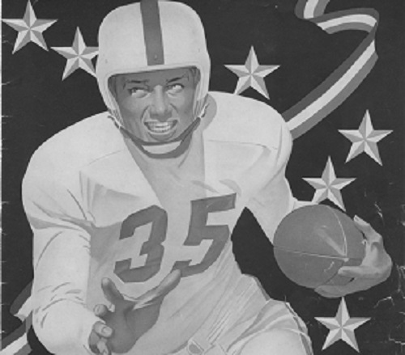

There are a few other apparent 'walk-ons' like me with no uniforms, just their own sweats. We all seem to be making our way toward an older man with a clipboard and pen. "New guys? Walk-ons? Get over here." He takes our names and looks at us with what I imagine is an inner shake of his head, saying, "You've got to be kidding!" But he is the one who is to get us started and put us into action.

We follow him as he walks through the several practice formations already in place toward what is to be our spot on the field. I glance at the suited players on our little walk.

"Holy cow!" I'm thinking, "They are so big. I am so small. They must be West Virginia coal miners, 280 - to 300 pounds, 6'5". Look at them! I can't tell where their shoulders stop and their heads begin. They're missing teeth. They've got tape and splints on their arms and legs, and blood stains on their jerseys! "

I'm thinking, "Hey, Bro, why am I here? What did you say about me enjoying my college experience? Would you notice what is petrifying me right now? I am 155 pounds, 5'9. I never played anything more than neighborhood pick up football. Nothing in high school. I was too small THEN . And incidentally, I'm just coming from my ROTC class where the instructor asked if I am going to be celebrating my fourteenth birthday anytime soon?!"

I am trying to shift my focus. If by some miracle I can get on this team with these giants, maybe as a kicker, or even assistant manager, or water boy, or ball boy, it would mean I was part of a college team contending for the number one spot in the nation, with Jim Tatum as head coach, going to bowl games, on national broadcasts, on the covers of national magazines. There must be some kind of glory in there for me.

So, I trudge on and follow the older man with the clip board. "Grab one of those canvas blocking dummies from the pile and follow me, " he shouts.

I'm pulling one out and trying to lift it. Can't do it. I'll have to drag it if it's going to move at all. Half of the others drag theirs as well.

He yells and gives a screech from his whistle, "Line up here, along the white line. Hold the dummy firmly in front of you. Press your body against it. Dig your feet in as hard as you can. Your job is to hold that dummy while the guys who are the tackles and guards come at you and practice hitting the dummy high or low, and moving it out of the way to make a path for the runners and blocking backs. Now get set. Here they come."

I think I feel the ground tremble as six of those huge coal miners line up in front of us in a crouched sprint position, with their fists planted on the ground in front of them, and their heads up and their steely eyes peering menacingly through the battered helmets at the dummies. I don't think they are noticing what might be behind the dummies.

Then the din, combining the whistle signaling the start, amidst the shouts of "Go, go, go, move it, move it, move it."

I'm not looking at what's coming. I'm dug in. I'm firm against the back of the dummy. My face is a part of the brace at the back of the dummy. My nose is squashed against the canvas. I can smell the mix of years of use ... sweat, grass, dirt, old.

Then, WWHHOOMFF! I see stars. I'm on my back. I can't quite get my breath. My face hurts. My body hurts. I struggle to get back up as quickly as I can when the whistle blows. I'm now ten yards back from where I started.

"Set 'em up" yells the old man at us. "Get set," he yells at the giants who are good naturedly punching at each other as they stoop down to do it all over again. I think, "They're probably enjoying this, seeing the walk-ons peeling themselves off the ground after their first attack."

Legs dug in again. Body and face firmly against the smelly canvas again. Whistle again ... WWHHOOMMFF, again. Ten more yards or so back from where we started. Body hurts again. Face hurts again. Need some more breath, again. This time though I get a good whiff of freshly crunched grass as I brush it from my nose and off of my face. This time on top of me is the canvas dummy, and on top of the dummy is the toothless smile of the 290-pound coal miner from West Virginia. My crushed 155 pounds can't quite call him a friend yet, but his face and hulk of a body are becoming very familiar. I'm knowing what to expect when I hear the shrill whistle and the coaches shouts.

It's going this way for most of the practice time. I keep rehearsing my brother's kind advice in my mind, "Get the most out of your college years, try out for football!"

I go home and take a hot bath and look over my scrapes and bruises. I think, "Maybe tomorrow will be different, be better. Maybe we'll do something else to make walk-ons fit in. Maybe today was like hazing. Give us the worst first, and the rest will be a piece of cake."

At least on the second day I'm looking more seasoned. My sweats are dirty and grass stained from yesterday. There is some joking and shared complaints among the 'walk-ons' as we hear the whistle and line up with our canvas companions once more.

Today is like yesterday. My West Virginia 'friend' is still the one coming at me. Everything smells and sounds the same. And more importantly, feels the same as the WWHHOOMMFFS! continue. The third day is the same as the first two. What might the future hold? Any other possibilities?

The only difference in today is that one time when trying to get my breath back, and get back on my feet, I'm hearing some band music. It seems to be coming from another practice field. It sounds pretty good, certainly more pleasant than the shrill whistle blasts of this football field.

I look over that way before my next pounding and start thinking, "Maybe I can enjoy my college years more from over there, rather than here. Maybe my brother's next suggestion on his list would have its own glory. After all I do know how to play the trombone. I can still go to the bowl games with the football team. I can be marching right behind the majorettes in every band formation. It's looking better... Also, my body might stay together a little longer. It might even grow a bit taller if given the chance, without being pummeled for three hours every day."

If you don't mind Brother Rich, I think I'll postpone football's glories, and see what the marching band might have in store for me to maximize my college experience.

PITS AND PEAKS

There are major pits, and no apparent peaks, for me in the winter of 1952. Almost everything is looking bleak. I am feeling sullen and ill-tempered.

It is my second year at the University of Maryland but I can hardly qualify as a sophomore. My short college career is teetering. It is my own fault. My freshman year has been a false start. I join several clubs, party too much, and study too little. My focus is blurred. After my first theater audition I am given a prominent role as old Mr. Cherry in the University Theatre production of "The Silver Whistle." On the surface it is quite an achievement for a newcomer, especially one such as myself who looks to be not quite fourteen years old.

I am catapulted into notoriety on this campus of 20,000 students. For the two weeks of the show time I am recognized around campus by my powdered white hair, and I relish the complimentary newspaper reviews. Upperclassmen call out to me as we hustle down the sidewalks between classes, "Hey Paul, great job. Hollywood's next!" I am on cloud nine in my narrow world, and I am thinking, "This college life is pretty cool."

I soon find out that this part of it is all fluff, and that such glory is fleeting. I neglect schoolwork while riding this cloud and almost flunk out of college with a report card of two "C's," two "D's" and two "F's." My study habits and diversions follow me into my second year, to the dismay of my parents and myself. John Veidt is a friend from high school days. He is also a daily commuter for the six miles from Silver Spring to College Park. We lunch together every day at the Dairy of the university. We commiserate over the miserable state of affairs we share with our academic records, and hopeless attitudes about life at the college.

Our back up plan usually has us solving everything by putting college behind us and going to see the Air Force recruiter. We can join up to help the Korean War efforts of the USA. Nothing seems to be going right. We are lost in this vast university. But we hang on and keep going through the motions of college life without ever joining up. I am adrift and in the doldrums in the winter of 1952.

While on Christmas break from college, I am at home and there is another deep pit. It seems especially bleak this Christmas. During the holidays I work as a "temporary hire" for the post office to help them deal with the surge of packages and cards for the season. I make $350, enough to pay a semester's tuition at school. I drive a postal delivery truck, sort letters, and climb over the twelve-foot mountains of packages, sometimes for eighteen hours a day.

When I come home in the evenings during the holidays, and many days thereafter, I hear my father walking up the driveway on his way home from work. He is sick. He is retching violently. He continues his painful dry heaves in the library by himself, until the spell subsides. I sit in the darkened living room listening to him, and to another replay of Cesar Franck's Symphony in D Minor. It is our only six-sided classical record collection.

My father's episodes are repeated many times during the prolonged and exhaustive medical investigations this winter. Doctors are trying to figure out what is going on. It comes to a head when after a couple of months of inconclusive doctoring he falls unconscious at while at work. It turns out to be a diabetic shock. Hospitalizations and surgeries later reveal that a bleeding stomach ulcer has become cancerous. The stomach has to be removed. The pancreas is dysfunctional because it has become encrusted by the acids seeping down from the ulcerated stomach. The old stomach is removed and a new one is created by attaching the esophagus to the duodenum. Over time, and with eating only baby foods at first, it will expand and function as the stomach.

The intervening weeks and months of 1952's winter present one crisis after another. My mother is left with despairing questions.

She would say, "What will become of me and our family if he dies? It's not looking good."
Dr. Stein visits my father's bedside, trying to give my father some comfort. I give my father alcohol back rubs which he says help some. The mood through it all is somber, combining faint hopes with resignation.

Finally, by early May my father is recuperating from the winter's ordeal of stomach cancer and surgery, and diabetes. He feels well enough to accompany my brother James on a weekend trip to Colonial Beach, Va. where they can open up the family cottage for the summer season. It can provide a needed change of scenery for him and help him mark the road to recovery.

'Pit' number three of 1952 also occurs this same weekend. I am probably also looking for a change of scene and mood after the long dark winter of my father's illness and my continuing decline in the college student department.

My ATO fraternity is holding its annual spring prom at a rustic resort outside of Annapolis, Md. I am late in securing a date, but Joan Appleby is available. She is the very funny and attractive senior I have come to know briefly when she applies my make up during the play the year before. We are decked out in prom attire. She, with a lovely flowered blue dress, and I, with my white tux jacket and accessories. It is a roaring good party with lots of dancing, singing, and laughing. I even played Malaguena on the upright piano in the corner.

Champagne is the drink of the evening. As we leave the dance for the forty-mile ride home, it is pouring rain, horizontal rain. Two other couples need rides. They join Joan and me in my father's 1948, two toned green, Nash auto.

We reach the town of Annapolis. In the drenching rain I make some wrong turns and get lost. Soon flashing red lights show up in my rearview mirror.

"Oh, Oh," I shout to the others, "Hide that champagne and those buckets somewhere, it's the cops!" It is raining so hard that the officer doesn't want to deal with us on the spot. He motions for me to follow him to the station. During the ride, the buckets with the champagne are dumped out the back doors into the street. At the station the six of us stand in front of the desk. The officer announces that we had been going the wrong way on both a one street and a one-way circle. I try to explain that it was raining so hard I couldn't see any signs, and that we had gotten lost. He is sympathetic but he still hands me two citations.

We make it out of town and settle in for the long drive home by way of the dark, empty, and very wet country roads. It is now 2:00 a.m. Everyone is tired and soon asleep on each other's shoulders. I can feel myself nodding off. I roll down the window to get some fresh air to stay awake.

No one knows my plight, so when the rain and wind whips in on them they call out, "Hey man, we're getting all wet back here, close the window." I do so.

It isn't many minutes later when I am startled awake by the rough clatter of my car's wheels on gravel, and then, 'Whack. Thud.' I have dozed off and drifted across the road, over the narrow shoulder and into a shallow ditch, before slamming and splitting a utility pole.

Seconds later, I look out to see and hear a Sunoco gasoline truck barreling down the road from the opposite direction. My immediate thought is, "Oh no! It just missed us by seconds. We could have crashed into that instead of the pole, and by now we would be toasted in a ball of gasoline fire!"

There is a quick sigh of relief at that, but there is still the damage to quickly assess. I have broken the steering wheel as my face rammed into it. My nose is crushed to one side of my face. Blood is running down onto my white tux jacket. Joan is climbing up from the front floorboard where she has been thrown after hitting the dashboard. No seat belts in these days.

From the back seat comes muffled screams, "I'm blind. I'm blind, Help me!" As the dust is settling, the backseat riders are scrambling in the darkness to find out what is happening, and who is screaming, and from where. It turns out that Don Wilson had at impact been thrust forward and then plunged quickly into the trunk of the Nash.

It is a car model that can be converted into a bed. This is how works: The back rest of the back seat is loose at the bottom. It can be suspended and held with side straps to hooks in the ceiling. The bottom of the rear seat is then shifted forward. Its place taken by a cushioned section that drops into place from the trunk. In the split seconds of the crash impact everyone surges forward. The backrest flies open and upward. Don is thrown headfirst into the trunk before the back rest comes back down. From inside the blackness of the trunk, blindness is Don's frenzied conclusion. We get Don extricated and everyone has a relieved and nervous laugh. There are no serious bodily injuries.

However, the car won't start. It can't be moved. Steam is hissing from the crushed radiator. The hood is waving in the breeze. The front end has hit the pole dead center and all the front parts are tightly wrapped around the base of the pole. The upper part of the severed utility pole is swaying back and forth, weighing heavily on the wires secured at other distant poles.

Here we are at 3:00 a.m., stranded on a country road in pouring rain. No police. No tow truck. No house in sight. No way to get home. We decide the best we can do is to wait for the light of dawn and then make a decision. In about twenty minutes a fraternity brother from the dance comes along. We pile into his car and he drives us to our separate homes in Silver Spring.

It is now 5:00 a.m. The dawn light is emerging. My distraught and incredulous mother meets me at the door. She sees me. She sees no car. "Oh no!" she cries, "What's happened? Where's the car? Look at you. Your father will be so upset when he gets home, you have destroyed his car. After all he's been through, after all we've been through this winter. Now this. What if he has a relapse? You were drinking, weren't you? I know these fraternity parties. How many times have I told you not to? This is awful!"

I make my way to my bedroom, nursing not only my crushed nose, but also my hurt feelings that my mother is more concerned about the wrecked car than my condition.

After a few hours of sleep my frat brother returns to take me to the hospital to see what can be done about my apparently broken nose and disfigurements. The nose isn't broken. It is only the cartilage that has suffered. The doctor pushes the swollen mess painfully to the opposite side of my face, holding it there awhile before trying to reposition it properly.

I leave the hospital and get a tow truck to take me back to the accident scene. We find the car, but it has been broken into by someone. There are no signs of police being aware of the accident. I don't report it. I get the car towed back to the Nash dealers parking lot in Silver Spring for damage assessment. I don't relish the thoughts of my father's reaction to it all when he returns Sunday afternoon from his beach trip. He is, of course, very upset, and gives me a repeat of my mother's earlier lacing and lecture. The repair estimate is $385. I am told, and agree, to work the summer to pay it off. Insurance is not involved.

Some icing on the "pit" cake of that year comes one afternoon in mid-June. I am working off my debt by painting the family home and have enrolled in summer school classes to try and get my academics on track. A knock comes at our front door. My mother answers. It is a Maryland state trooper with an arrest warrant for me. He wants to take me to Annapolis to face charges. I am listening and gulping in the next room.

My mother frantically asked for some explanation, "Why? What did he do now?" The trooper told her that there are two unpaid traffic citations from the Annapolis Police Department for going the wrong way on a one-way street and a one-way circle back in early May 1952. Aghast, she persuades him to not take me with him, but to let her pay the fines. He agrees. I'm cringing in the background, waiting for the fall out when he leaves.

This is brand new bad news for my mother, I have not told her about that part of the party night. I thought it had been settled, and there was no need to deepen the problem pit. Howie, another frat brother, had come to my aide after the dismal night, saying that his father was the mayor of Annapolis. He was sure that his father would take care of the tickets for me, given the specifics of the heavy rain and all. I hand over the citations to Howie, much relieved that additional transgressions have been put to rest. So I am now mortified when the trooper appears and stirs it all up again. I later call Howie to ask why his father had not fixed my tickets. He casually replies, "Oh he must have forgotten. Too bad."

The 'pits' of 1952 are about done. A corner is about to be turned. I am ready for some 'peaks.' I pay off the auto damage debt. I have done a careful job painting the house. My father gradually regains his former robust health to live and work another twenty-six years.

I sign on for two major summer school courses to help make up for my lost academic ground. Amazingly, I blossom in this new atmosphere of concentrating on two subjects for six weeks instead of the normal semester system of six courses for twelve weeks. I love the saturation opportunities with Human Anatomy and Physiology, and the History of the Civil War. I come to know and memorize all the muscles and bones and workings of the body. I can rehearse all the battles and strategies and human feelings of the Civil War. I ace both courses. I love the sweet ecstasies from getting my first two "A's" in college. It spurs me on. It lifts me from the morose pit of self pity and starts me on a new path with a new perspective. Something in the mix of uselessness and depression has given me the push I needed.

Returning as a junior to classes that fall, I make the necessary changes to no longer be a daily commuter. I prefer not having to juggle both home and school issues. I rent a room in one of the converted army barracks, now serving as temporary dorms at the edge of campus. I can the handle the $12.50 monthly rent. I also work as a houseboy at the Tri Delta Sorority house and get all my meals as compensation. I can pay for my $350 college tuition from my summer and holiday work. I can pick up $10 now and then for pocket money and a few extras, by playing trombone in a campus dance band.

I vividly remember walking jauntily down College Avenue in my not-so-white, white buck shoes and hand creased khakis, breathing the crisp fall air. My pockets are empty. No money to jingle. Yet I have a lasting 'peak' feeling that life is good. With my basic needs covered, I require nothing more to enjoy the moment.

The image of that moment returns often and reminds me, in the midst of new difficulties, that survival and happiness can be had with very little money. The universe is teaching me that "There is enough!" I can ask myself the worst-case scenario question in the midst of new dark prospects, "What's the worst thing that could happen? Can I live with it? " The picture and feeling of that day on College Avenue flashes before me and I can utter a resounding, "Sure!" Now that's a 'peak.'

GROWING PAINS

It isn't easy getting from ten to twenty. At least for me. Probably for most. It always seems a hectic mix of fun and frolic, with a heavy dose of fear and uncertainty. It is something like trying to walk up the down escalator. It doesn't quit. At every turn of relationship and circumstance there is a challenge to change something again and stretch me out of my comfort zone.

This day in February 1952 is no different. I am settling in for another session of Philosophy 101 at the University of Maryland. It is my sophomore elective. I have hustled over the frigid wind swept path from my zoology lab. There are the ritual sounds of another class beginning filling the room. Sixty of us are shuffling toward a vacant desk, clunking our snow laden boots along with us. The ripping sounds of zippers being pulled apart, and the pops of snaps opening our winter, down filled coats pepper the air. We drape our coats over the backs of our chairs, stuffing our scarves and hats in the sleeves. We flip open our boots and inhale the aroma of snow on rubber. We clap our book bags on the desktops and pull out our philosophy notebooks. We click our pens ready for action. Behind me someone crunches a first bite of an apple. In the midst of the clamor eyes dart around to see if there are any familiar faces and some signs of recognition. This class has its share of World War II veterans who are getting their free education under the GI Bill. I feel inside like my fourteen-year old appearance on the outside, and welcome any sign of friendliness.

The noisy bustle quickly hushes as Professor Bradley comes through the door, moves to the podium, opens his black leather notebook, flips a couple of pages, and reaches into his vest pocket for his reading glasses. He looks up and around at the gathered students. This commences what is to become my big event.

He begins, "Today, we continue our exploration and comparison of various philosophies and religions, and what they offer for giving a belief system and direction for life. Let me get into it today with a question. How many of you would say that you were brought up with a religious background and influence? How many had parents, and other authority figures in your life who influenced you, trained you, raised you, by making sure you got to Sunday school and church and other things, like reading a Bible, listening to religious music, having you memorize church creeds and dogma, pray before meals or before you went to bed, or were sick or in trouble? Did they send you to church summer camps, have you join church youth groups, read and follow the rules from the Bible or church documents? Did they teach you about rewards and punishments, heaven and hell and things like that? Anybody raised like that?"

Quite a few hands go up, including mine. If I had known what was coming, I would have nailed my hands to the desktop. I am in the third row.

He singles me out. "Okay, just for an example, you there, young man. Your name?"

"Seltzer," I meekly respond, knowing that eyes and ears are now trained on me, vets and all. I am thinking, "This is going to be bad. There's no escape." My cheeks quickly turn crimson. I clear my throat and smile nervously. I look down at my notebook to avoid eye contact. I start clicking my pen point in and out.

He continues, as he walks from behind his podium toward me with the thumbs of both his hands tucked into his vest pockets, leaving the other fingers to flap up and down to give emphasis as he makes his points.

"Okay Mr. Seltzer, tell me what it was like for you, and what good you think your religious upbringing has done for you. What do you think about all of that?"

My mind races to find something coherent to reply, I feel the embarrassment that brings the cold beads of sweat to join my crimson countenance. The seconds of silence from me seem like hours as my ears pick up the muffled chuckles from others in the room, fueled no doubt by their relief that they had not been called upon.

I am finally able to manage a response. "Well, all these things you listed are true for me. My family, the church, the Bible, praying, -- all of it."

He jumps in, "Did you ever question any of it? Or did you just swallow it?"

I reply, "I remember I asked a few questions of my Sunday school teachers and my parents along the way, but mostly I probably thought, 'Well, these people, these adults, pastors, teachers and friends, these authorities, are all loving, caring, thoughtful people with me. If they are believing and following it all, trying to live by it, then it must be okay. If it's good enough for them, then it's good enough for me. I guess I'll just follow their example.'"

I am surprised that so many words have gushed out. They make some sense to me even though I haven't thought much about it before.

Professor Bradley replies, "I can understand that much. But what do YOU believe, what do you know for yourself, not just 'hand me down's' from others. What is God for you? How does your loving God allow so much horrible suffering and evil in his world? How do you even prove his existence? What about all of the conflicts in the Bible stories? Is every part of it equal in its authority? Do you really follow all of those rules in Leviticus? Why would a loving God damn his creatures to an eternal hell? What happens to people who don't believe as you do or follow the same rules? What about all of the atrocities perpetrated in the name of religion over the centuries? How come good people do bad things? Why are there so many different religions?"

The flurry of questions and issues continues. They are probably meant to overwhelm me. They do. I'm not sure of the professor's motivation for all of it. Whether it is to prove the rightness of his atheism, or to put enough of a bomb under me to get me, and the rest of the class, moving toward thinking more seriously about life's questions, and maturing from simple to complex. Either way, at that moment I am crushed. The adrenalin of humiliation is pumping through my veins. There is no resolution of his questions or charges to me. By the time the class hour is over I just want to exit as fast as possible without making any eye contact. So, without looking up, I pack my book bag, snap my boots closed, grab my coat and rush to the nearest door.

My secure and safe little religious cocoon has received a broadside attack and been splintered. I have been shaken by the professor's apparent meanness ---and rightness. He is right, after all. At least about my naiveté and ignorance of such an essential part of life as a belief system. In trying to re-group and resolve the quandaries he opens up in me I go to see my pastor who both supports me in my desperation, and also agrees that a long process of thinking and feeling and questing is necessary for me.

So it is, this February philosophy class becomes a marker event which nudges me out of my twenties to turn from my pre-med and pre-teacher preparations toward a thorough going spiritual overhaul. This comes by way of a seminary education. It is to be followed by a lifetime of shared questing to know and experience with ever greater clarity some answers to Professor Bradley's questions, as well as the host of new ones show up to excite me and stimulate my evolution.

A BAILIFF BIRTHING

If dreams have their way in the summer of 1954, I will be a bus driver.

I have just graduated from the University of Maryland and need money to start graduate studies in the fall at Gettysburg Seminary. I have responded to a Trailways Bus Company newspaper advertisement for new bus drivers to handle the summer vacation travelers, with the likelihood of driving weekend charter trips throughout the year. My dream machine is engaged.

I see myself excited about being away from home for the two-week bus driver training in Richmond, Va. Then I will be ready to be wheeling one of those powerful, shiny passenger buses all around the country. I will get to see new vacation destinations and meet a wide assortment of humanity. I'll make enough money to support my education for the next year and probably even earn extra dollars with the football trips and weekend excursions.

I send in my application to Trailways with my best personal references...a bank president, a physician, a couple of Washington, D.C. government officials. They are all enthusiastically supportive. It all looks perfect. All I have to do is wait for the acceptance call. I did wait, and wait, and wait, for three weeks.

The pleasant dreams are gradually being replaced.

This process goes from reasoning that: "they are a big company, it probably takes a long time to deal with the influx of hundreds of applications", to "I wonder if they have even seen my application yet, or checked my references", to "I wonder if I should call someone to check on the status of the application," to "I guess I need to be more realistic about my prospects." to " my parents aren't keen on me being down in Richmond with who knows who being there..," to " I guess I'd better not count on it and think about applying somewhere else. Summer is almost here and I need a job!"

With the bus driver dream fading, I start looking at the newspaper ads again. My mother, not one to stand idly by, decides to make a move in my behalf by calling our congressman, Dewitt Hyde, to see if there can be any patronage jobs available for me. She has been a loyal supporter of his for a long time. I am still waiting for the possible Trailways call. Two days later Mr. Hyde's office calls back. They want me to go for an interview tomorrow with Mrs. Callahan, head clerk at the criminal court of the District of Columbia.

The job will be as a bailiff. "Wow, that is quick," I thought. I also thought, "Just what does a bailiff do anyway?"

I have watched Perry Mason on TV. The court scenes have a man with a badge delivering a glass of water to the judge from time to time and telling everyone to stand up and sit down. I venture that I can probably handle that much. But I wonder, "What else?" It certainly doesn't fit with my bus driver dreams. Those dreams will evidently have to shift gears. I have no idea what might be in store for me at the court.

I have the interview. I am accepted for the job on the spot. I can start the following Monday by reporting to Mrs. Callahan's office and undergoing training and introductions. I accept on the spot with a mix of relief for having secured any kind of job for the summer, and a barrel of internal questions as to what was ahead.

Upon arriving home, I report the sequence of events to my parents with considerable excitement, which they share. They also share that Mr. Robinson from Trailways Bus Company has called that afternoon to say that he is very impressed with my line up of references, and that he is offering me a job as a Trailways bus driver, and to please give him a phone call.

"Oh, no!" my mind and mouth shout. The questions race through my head, "How can I get out of the bailiff thing that I have just accepted? How will that look? How will that make my parents look? How will that make congressman Hyde look? How will it look to my references for the bus job? That's the job I really wanted. Why didn't they call a week earlier, or even a day earlier. Oh, man, what a quandary".

My parents favor the bailiff patronage job because of the 'low life's' I might meet up with driving a bus, and because of their loyalty to the congressman. I have a two-day internal struggle and then make my apologetic phone call to Mr. Robinson to announce my dilemma, and prior commitment to another job just the day he had called. He is understanding, and also apologetic for his tardiness in getting back to me, occasioned by his having been on vacation for two weeks. He wishes me well. I sigh heavily. For the next two days I can be seen kicking up some dust and pounding my fist for the missed opportunity and dashed dreams.

Finally, Monday arrives. It is time to start my new job as bailiff at the District of Columbia Criminal Court, and to leave the bus driving to someone else, or maybe another time. Answers to my line up of questions about all the people, situations, and humanity's ways I might face quickly become evident and instructive for me.

I will wear a badge but no special uniform, just my personal suits and ties. I will carry no weapons. I will deliver the paperwork for the daily cases from the administrative office to the clerk in the courtroom. Then I'm to go to the judge's chambers.

He is the first among the fascinating assortment of people with whom I interact and expand my awareness. I am assigned to Judge Thomas Scalley. As we began our day, we exchange pleasantries. I help him don his courtly robe and escort him to one of ten courtrooms housed in the stately granite stone courthouse.

Judge Scalley is always pleasant with me, but he has a fierce look about him. He is of recent Irish heritage, and looks the part, with his full head of snow-white hair flowing in the breeze as he walks. His bright red countenance suggests he is often into the sauce, but I never witness it. He carries his black horned rimmed glasses in one hand. In the other hand is a thin leather satchel holding his legal pads, pencils and a folder or two. I am not to allow anyone in the hallways to approach the judge, even if the judge knows them.

Then there is the judge's clerk, Bob Ernst. A thin, cheery, and efficient recent graduate from Georgetown Law School, now learning the ways of the law from the inside out. He has an excellent tenor voice, singing in several groups, and still takes lessons along with more graduate law courses at night.

Next is Mr. Flynn. He is the bond clerk and manages a steady stream of bondsmen who quietly leave him little gifts of liquor or cigars to gain his favor to be inclined to send them more business. Flynn takes a liking to me and often offers advice on how things 'really work' at the court. He is also something of a lech.

With a sparkle in his eye and chewing on his ever-present unlit cigar, he opens the bottom drawer of his desk to show me his prize. It is an animal bone and joint which obviously resemble a large human penis and scrotum. He delights in its shock value to a viewer. He is always wanting to 'talk' with my girlfriend. She sometimes stops in at the close of the day. Incidentally, she has just won the Miss National Press Photographer beauty contest and been pictured with Vice President Richard Nixon.

For me, there are also the daily conversations with the police officers who are in court to give testimony regarding the arrests they have made. Often times, they have to be present on their days off which produces many complaints. Many times, during the long waits for their cases to come up I also hear much of what their lives are about on the job, and at home.

Lawyers are everywhere. Many are looking for some favor from me to get their case expedited or to find out details. Others have been legitimately hired and are doing their best for their clients. I label some lawyers as 'court vultures,' as they keep a keen eye out for a weeping family, clearly unfamiliar and traumatized with the ways of a court, jails, fines, and possible prison terms. Once these vulture lawyers spot them, they rush in on them, appear caring, engage the distraught family, to find out who and what the trouble is about.

I can hear a typical conversation, "Oh my, you say he was arrested for drunkenness and disorderly conduct. That is very serious indeed. He could be sentenced anywhere from sixty to ninety days in prison. Very serious. That could mean he can lose his job, right? You certainly need me to help you."

I watch in dismay as they offer their services, establishing their supposed credentials, and very soon asking to see the bank book of the family. Thereupon they establish their prepaid fees and promise their attention to do their best to get the best deal from the judge in court. They defer the case if possible until someone in the family can rush out to the bank to get the lawyer's retainer fee.

The reality I know is that every first-time offender is released. Always. No prison time. The vulture lawyers also know this but paint a very dire picture for a vulnerable family. The family is so appreciative of the lawyer's efforts on their behalf to get the offender released, even though they have actually been taken to the cleaners. I am soon motivated to also be on the lookout for panicked relatives of first-time offenders. I quickly move in ahead the vultures to tell the family the real court story and 'not to worry.'

I have frequent conversations with the prisoners as we move through the court processes together. Many are repeaters. For some it has become a way of life. They serve their sentences at the Occoquan, Va. correctional facility, making license plates for the District of Columbia. It becomes a community of a sort. Everybody knows each other: the prisoners, the guards, the bus drivers, the clerks, the bailiffs, even the judges know the regulars. Within a week of being released from Occoquan they are back in court and expecting to do it all over again.

Their pattern is that a few days after release from Occoquan Jail they often get a loaf of white bread and a pint of pure alcohol. They filter the alcohol by pouring it through the length of the bread. They call it "Smoke." It a favorite drink. It's also a sure path to drunkenness, the court, and back to Occoquan.

The oft repeated weak defense of a drunkenness charge is, "But your honor, I only had two beers!" No defendant, no matter how drunken his behavior, ever admits to having consumed more than two beers. Such defense always brings smiles to court employees.

A memorable sight of my court experience is the reunion of a just released prisoner and his common law partner after being separated by a ninety-day jail term. They can't wait to celebrate. Going to my lunch break through the back door of the court I am smilingly surprised by their copulatory activity just behind the bushes next to the court building.

There are so many lives encountered, so many life stories from which I learn, from both sides of the jail walls.

I also learn from my daily routine at the court. It looks something like this.

With the judge just behind me, I open the heavy oak courtroom door and bellow, "All rise. Hear ye, hear ye, all persons having business before the Municipal Criminal Court of of the District of Columbia draw nigh and give attention. The court is now in session. The Honorable Judge Thomas Scalley presiding."

Once the judge is seated, I announce that everyone else can be seated. The judge and his clerk briefly discuss the upcoming cases. They look over the criminal records for repeaters. I go to the holding room outside the courtroom to escort the first ten handcuffed prisoners into the courtroom chairs. They wait for the clerk to call up their case, naming the charges. Prisoners new to the court system are frightened and look anxiously into the courtroom for a familiar face that might offer some kind of support for this traumatic moment. I escort each prisoner to stand in front of the judge where he is asked if he has a lawyer to represent him.

It is a busy courtroom. After a weekend, the dark blue Department of Corrections buses with the heavy metal grill work covering the windows, pick up prisoners from police precincts throughout Washington, D.C. Often, they have accumulated an assortment of 200 arrests. They are mostly drunk and disorderly offenses, with a few assault and battery or DUI's mixed in. Occasionally, the vice squad presents prostitution or homosexual offenders. All of these detainees are dropped off early in the mornings at the courthouse cell block, located in the basement.

That cellblock is a seamy scene. My nostrils are assaulted with the acrid combination of stale alcohol, cigarettes, vomit, and other bodily odors. The noise is deafening with the crowd of bellicose men and women, separated by iron bars but yelling their invectives as if this is their last gasp of control in their lives.

There are also the silent ones. They are scared and morose about the turn of events in their lives. They curl up in the corners to avoid any fights. If a case has not come up by noon a lunch is passed to them. It consists of two slices of white bread with mustard and a slice of baloney in between, and water.

We bailiff's take turns arranging the hand cuffed prisoners in groups of ten according to names on the case list. We then have them join us on the elevator that takes us from the cell block to the holding room outside the courtroom.

One morning, as court is ready to begin, there are no prisoners in the holding room to be brought out into the courtroom. Not knowing what might have happened I go over to the elevator door and hear muffled screams and shouts coming from the elevator shaft. The elevator has jammed between floors. No one has noticed for a long time. The elevator is filled with panicking female prisoners. The mechanical problem is resolved. The functioning elevator delivers ten very frightened ladies and their ashen faced bailiff escort.

When our court case load is complete for the day bailiffs have some freedom. Some seek out an empty court room for a nap. I usually sit in on other court sessions dealing with crimes varying considerably from my usual diet of the drunk and disorderly. It enhances my understanding of the law and the legal tactics employed to gain from it.

It doesn't take much reflection to realize the richness of this summer experience. The parade of people, with their diverse range of life experiences and emotions serve to stretch my awareness and understanding beyond my wildest dreams. Oh sure, the bus driver dreams are appealing. But another part of me, and its dreams, intervene and call the shots. Just what I need at the time!

CHOICES

Inga Johannnson and Esther Bartlett are both residents at The Home For Incurables in Washington, D.C. In 1956, as a chaplain intern for the Lutheran Inner Mission Society, I visit with them regularly for a year. Inga and Esther both have choices as they face their incurable conditions. Their responses are miles apart. The contrast gifts me with permanent life lessons.

Room 203 is called by the staff, "The Bitch Box." It is Esther's room. She provides the staff and visitors with a steady stream of reasons to support the naming. Esther is six years into her permanent confinement to a wheelchair. This gives her mobility in her room and through the hallways. She chooses to use this mobility to spread her doom and gloom whenever the opportunity arises. She is avoided by everyone at every opportunity. True enough, the institutional green covering the walls is drab indeed. The pungent odors of lingering urine mixed with pine floor cleaners and alcohol are ever present. The dimly lit halls mean more shadowed corners. The very name of the institution does little to inspire the moment. Esther has plenty of negative stimuli to justify her sour countenance.

She can move her hands and arms, so the front locks of her hair have had a brush through them, but the rest of her hair is like an oily rat's nest with no signs of attention. A thread bare lavender wool shawl covers her black and spotted dress. Frayed slippers hold her twisted feet. The rest of the room is dark and stark. No pictures. No family remembrances or knickknacks. Just the standard bed coverings with a pink chenille bathrobe hanging over the foot rail. Large black and white checked linoleum tiles cover the floor.

In this severe setting I have deep feelings of sadness for Esther and her plight. Her aloneness. Her anger. Her depression. Her expanding isolation. My mind races, searching for some questions, or words of comfort and encouragement that might move her toward a different perspective, to let in a bit of light. I look for something that might open her inner hurts to some kind of healing. I have a measure of human caring just waiting to get behind her "bitch box" label.

I hold her hand as we pray. It all sounds and feels pretty limp and ineffectual to me, probably to her as well. She is making an indelible impression on my understandings of human nature and the choices available in the presence of enormous odds. I don't like what I am experiencing from Esther's choices. As with the other staff, I welcome the opportunity to move on from "the bitch box", and to consider its lifetime effects at another time.

Fortunately, right next door, in Room 205, at The Home for Incurables, resides another Lutheran. I am to visit Inga Johannson. Inga is a first-generation Swede, still with a heavy accent. In contrast to Esther, Inga's room has been nicknamed, "Angel Alley" by the staff, with good reason. Inga has been in that same room, and in that same bed, for eighteen years, paralyzed from the neck down. The range of her sight is limited to how far her eyeballs can take her side to side, or up and down, excepting when she is lifted or turned to change the bed clothes or help her avoid bed sores.

Inga's room has the same institutional green paint on the walls, the same black and white checked linoleum flooring, the same dim light on the high ceiling, the same unpleasant smells drifting in from the hallway. Like Esther, she has no visits or remembrances from family in the room. But there the similarity stops. In "Angel Alley" the walls are covered almost top to bottom with various sizes of colored paper and pictures with writing on them.

If I had been an invisible presence in Room 205 I might have heard something like this exchange between Inga and Charlotte, one of the health care staff.

"Hi Inga, it's good to see you smiling again this morning. I've come to change your sheets. You know the routine, I'm sure. You ready? I'll get James and Charlie in here to lift you while I change the covers. It should only take a couple of minutes."

Inga looks directly at Charlotte with her dancing eyes, sparkling with the full force of those delicate muscles playing together. These are the delicate muscles around her eyes. Muscles that move are scarce in her paralyzed body. She makes these combine with her wrinkles into an infectious broad smile.

She kiddingly replies, "What Charlotte wants, Charlotte gets. Charlotte is a sweetie. What would a morning be without Charlotte in here doing something. Everyone is watching, you know. The bed sheets, bedpans, brooms, mops, washcloths, soap and powder, combs and lotions, the little massages. They all see you. Even Sam, my squirrel friend out there on the maple tree limb, perched on his haunches, grinding his teeth away on that hazelnut, has a front row seat. He's hardly aware of the two caterpillars crawling around the branch at his feet or the blue jay bouncing on the twig above him. It's quite an audience you've got here Charlotte. Who knows how things look from where they sit. I'll bet it's something you'd like to hear about. When we're done here this morning I'll think about it some more, and try to put together a poem about it.
Come back after lunch and I'll tell you what I've come up with. Maybe you will want to put it on paper."

"Oh yes Inga," Charlotte replies, "I'll write it down and paste another picture on it with my name, and we'll see if we can find a spot somewhere on the wall for another of your famous poems. Now let's get these sheets changed."

There are exchanges like this with other staff and scores of visitors, who experience the unique inspiration of Inga's presence through her smiles and vibrant countenance from the neck up.

Inga's visitors over the years record the words of inspiration flowing from her heart. Her simple, humorous, and profound thoughts, often in poetic verse, and with Swedish accent, are born from her keen observations of the lone maple tree limb that diagonally crosses the single window next to her bed. Day and night, month after month, year after year, through the imperfections of the dust and frost, she comes to see the extent of life available in the apparent stillness of that maple tree. Its constant companions of insects and animal life, busy through the steady changing of the seasons, with the brilliance of the sun, and the subtleties of the moon and stars as a backdrop, enhance it all.

Those of us who come to her room to change bed pans, administer medicines, and offer words and prayers of encouragement for Inga, leave her side blown away. We are instilled with Inga's unique brand of healing and power. She is the giver. We are the grateful receivers. We cover her walls with the words that come through her light to show us life in a new perspective. We sign our names and add our pictures or symbols or speechless thoughts of gratitude, for having had the rare privilege of being in her "Angel Alley" just when we needed it.

She never wants us to close her door as we leave Room 205. Even that admonition is symbolic and instructive. I always remember Inga as a model of the expanding power of her choices in the face of a lifetime of insurmountable adversity. I'd also like to think that somehow Inga's life-giving energies eventually penetrate through the wall to Room 203, where Esther is... waiting.

IMAGINE JACOB

His mother calls him Jacob. His wife calls him Jacob. His students call him Dr. Heikkenen.
He is professor of New Testament at the Lutheran Theological Seminary in Gettysburg, Pa.
He has known hard times during World War 2 in Finland. You will love him, as do his students.

He has some tell-tale signs of being a professor. Imagine a well-worn baggy tweed suit, with a black tie and white shirt. Imagine his head full of black, bushy hair. Imagine his glasses with thick lenses, so you never get a clear definition of his eyes, other than their sparkle to match his ready smiles.

His home has loaded bookshelves in most every room. Stacks of periodicals prevent dust from accumulating on the tables. He has authored many professional articles. He is respected and called on as a learned authority in his field of New Testament studies.

Dr. Heikkenen's countenance is endearing, gentle, and exudes an ethereal exuberance, as if at every moment he is having a vision or insight emerging from the distant horizon. You can often find the New Testament majors gathered in his living room, engaging with him on current issues, as they munch on snacks together. He politely addresses every student as 'mister' or 'miss.' You can probably imagine most of this.

You can also probably picture his vintage bicycle. It is a very vintage bicycle. It does move, but without some of the usual niceties. The originally dark green fenders are now mostly rust laden. There are no gears to shift. The brakes engage by a back pedaling movement of his legs. There is no shield over the chain, so he wears clamps on his trousers to keep them from being entangled. There is no basket, so he slips his ever-present briefcase over the rusty handlebars. It is how Jacob always moves around the campus.

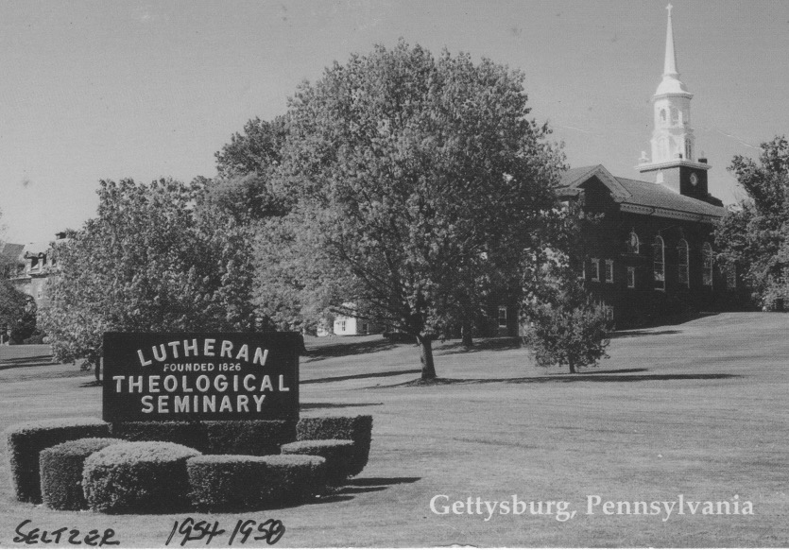

The first little bicycle moment happens one day when he is peddling along the seminary sidewalk, next to a bushy hedge. Looking straight ahead to keep-his eyes focused, he hears students across the road call a cheery, "Hi, Dr. Heikkenen!' He quickly turns his head and waves with his left hand. It is a momentary distraction, but long enough to throw him off his course and into the hedge. The students rush to his aid. He isn't hurt, just embarrassed. They all laugh it away.

There is a second incident with his not-so-trusty bike. Students are gathered in front of the refectory before dinner on a spring evening. Professors take turns dining with the students. On this day Jacob arrives as usual on his old bike. He is smiling broadly as he swiftly pedals across the street toward them in anticipation of some pleasant conversations. Abruptly, his smile turns to panic. He looks down at his feet and yells to the students, "Look out, I can't stop!" As he plows into the group several of them grab him and the bike before they collide with the brick building. The brakes have failed. Amid the inspections of the bike there are more laughs, courtesy of Dr. Heikkenen.

Imagine one of his non-professional entertainments. It is the day for the final exam to be held in the classroom of the imposing administration building, built in 1829. There are intricately carved oak stairwells and railings with vaulted ceilings. The doors are classically inscribed thick oak, nine feet feet tall.

Students have been cramming for their finals. Stress levels are high and need release, a perfect recipe for shenanigans. Before Dr. Heikkenen arrives, some students conspire to test him by locking the two giant doors to the classroom with an old fashioned skeleton key that matches.

The minute hands of the clock creep toward the 10 a.m. class starting time. Everyone falls silent, except for some devilish giggles. They wait for Dr. Heikkenen to approach and try to open the doors. He is always punctual, as he is on this day. The students are all in their places. He is not. They listen and watch. Finally, the door handle twists…several times. Then the same thing for the second door. Another twist …a bump…a shake. Then silence…more silence.

The students whisper, "Does he know where to find another skeleton key that fits? Maybe the administration office?" The students wonder about him, but they also become a bit concerned that, "Maybe we've stepped over the line, gone too far? Maybe no more smiles? Maybe 'F's' for everyone?"

They wait and whisper, "Should we open it?" They are frozen. Time goes by. Lots of time … five, ten, fifteen minutes. They listen for any sound to give them a clue.

Suddenly, a key is in the lock the handle turns. The door bursts open. Dr. Heikkenen charges in, yelling, "Hands up!" He is dressed in a 'Columbpo' style trench coat with its collar turned up around his neck, and a wrinkled fedora pulled down over his ears. He swings his son's toy machine gun into action with rapid fire clackety, clack, clacks, cutting a wide swath back and forth so that everyone will be dropped.

We students are bent over with shrieks of surprise and laughter. We have met our match. Jacob's eyes sparkle through his thick glasses. He removes his coat and hat, then quietly distributes the test papers. Everyone stays an extra twenty minutes after the usual class time to finish.

You might find it harder to imagine Jacob's next memorable adventure. He and his wife love concerts and the theater. Sometimes they ride the train from Harrisburg to New York City for a show.

One Monday morning waiting students are informed that Dr. Heikkenen will not be meeting his classes. He has to go to Harrisburg to meet the train from New York City. His wife will be on it.

The details of the announcement are sketchy. They attend a show together Saturday afternoon. There is no disagreement between them, but for some reason he leaves the theater during the intermission. Something quite apart from the show consumes his attentions. Mrs. Heikkenen is left still seated in the theater. It is a long wait. In the meantime Jacob has made the train trip back to Harrisburg without her. Images of an unbelievably absent-minded professor grow with the students. There are gasps, 'Holy cow…good grief…are you serious? … Can you imagine?" Apparently, with a mix of panic and anger, his wife phones their home late Saturday night to find out what has happened. She can't imagine. Neither can he.

This is Jacob: lovable, laughable…and unimaginable.

THANKS FOR THE CHANGE

I will be changing. There are two impacting influences for me in 1957. The first has to do with my spending a year away from my seminary theological studies.

I am participating in a clinical training program at The Washington, D.C. General Hospital as a chaplain intern. During this year, five of us meet twice a day with our chaplain supervisor, Herb Hillebrand. He is a quiet-spoken, gentle, but incisive counselor of Reformed Church origin. He smiles easily and listens thoughtfully, as he leans back in his swivel desk chair.

The process is that each of us interns is assigned a different hospital ward for three months on a rotating basis. We meet with various patients on the ward for a couple of hours in the morning. Then we spend a couple of hours writing down the conversations as close to verbatim as possible. In the afternoon we take turns reporting our interactions with the patients to the group.

Then we move into our own form of surgery. Through questions from Herb and to each other, we try to get behind our words and actions to the motivations, meanings, feelings, and belief systems that are in play. We pry and probe, peeling back layer after layer. It is often an intense, penetrating, unnerving, and insightful exercise, both welcomed and feared, for what it might reveal about who we are inside.

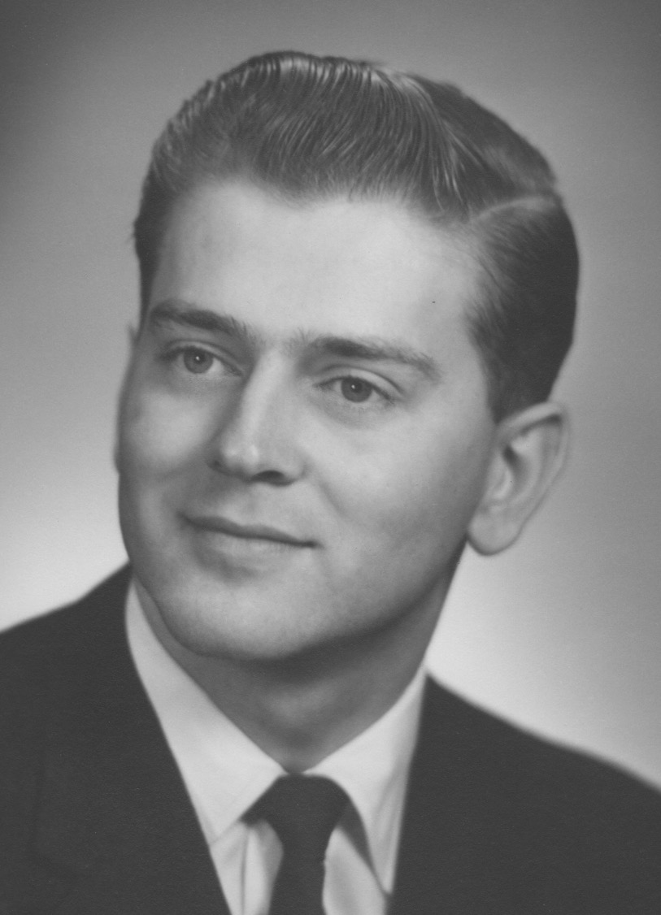

In our verbatim reports we include descriptions of body language and patient responses. What appears at first as a simple greeting or exchange, when dissected, can open a can of emotional worms.

Questions like, "What thoughts popped into your head when you saw the tears dripping from the corners of his eyes? What did you say? What did you do? What were you feeling? Inadequate? Helpless? Tense? Hopeless? Calling on religious clichés? Playing a role? What was his body language telling you? Quick, say a prayer? What might have been done differently? Were you judging him or yourself? Let me out of here! Transparency here? If you had been in his place, what would have helped you? Honestly, now. Think about it? Write it out. Say it."

Progressively, through the year, our sensitivities are sharpened, observations and insights developed, and compassion deepened for those of us sharing in the group remembering, as well as the patients in our pastoral care. A year of daily interactions like these serve to re-shape my core values and personality alignments.

The second major change comes through my exposure to one other chaplain intern in particular. He is a 6'2" blond, handsome, bachelor Presbyterian from Princeton Seminary. His name is Sinclair Van Tipton. He has a thoroughly ivy league background. He is charming and articulate. He has brought his own sailboat from Massachusetts and moored it at the Potomac Marina for weekend outings. Sinclair is the object of adoration by the nursing staff, and often sought after. From all of the outer trappings he is a major "catch" for any of them, even if for just a weekend sailing excursion. Sinclair is pleasant and engaging with all of them.

However, he gives most of his attentions to lunchtime conversations and weekend dates with the most physically unattractive student nurse available. She is diminutive, shy, short, thin, has a bulbous nose, close set eyes, and an acne covered face. She has a sweet smile and twinkle in her eyes. Her name is Angie.

Apparently, Sinclair has the maturity to discern the angel in Angie. They engage in extended conversations over lunch, focused on the insights and laughter they share. It frustrates the more attractive nurses hovering about. Angie's insights that Sinclair shares with our chaplain group are enviable to my ears.

The maturity and awareness of important realities the two of them evidenced brings me up short. It is in stark contrast to my own and is frequently referenced by me as the years go by. I realize that I have been focused on the surface stuff and fluff of approval needs, I represent a college fraternity culture that repeatedly tells me that good looks and other appearance issues are the most important.

I have been influenced by it enough to seek out and marry a beauty queen, the magazine cover starlet, the daughter of a banker. We dance well together. She is sweet enough. She agrees with almost everything I say. We are the Hollywood couple. We are on national TV. There are five hundred people at our wedding, providing us with a houseful of sterling silver gifts. It is not the stuff of permanence or stability. We don't last.

I don't know what happened to Sinclair and Angie after the year at D.C. General Hospital. Maybe they pursue their relationship to marriage, or maybe they just experience the joys of simply living more maturely without the encumbrances of surface values and judgments for those sweet moments in 1957.

The memories of them, and the intensity of the intern group, both serve as major change agents in my life. They continue to be reference points for meaning and value in my life. I am changed.

FUNERAL FARE

Funerals are a mixed bag for me. On the one hand, I love them. It is when I feel closest to people. I feel most useful. I feel most rewarded sharing the pain with the people. They are most open to a comforting presence, a hug, a word, a look. It is often a teaching moment for everyone, including me. It is a time when deep calls to deep, and inspiration often answers. Words of holy writ that on any other day will receive little more than a complacent nod, now carry ancient wisdom to sensitive ears. Music from an organ or hymn singers sweep stored emotions into the river of tears. Laughter is serendipitous from fresh stories about the loved one. The gathered support of friends and family point to nourishing connections. So often, funerals are awash with love. I will reflect, "This is such a gift, such a privilege. This is what it's all about, without the fluff."

On the other hand, and at the same time, there is the dance with the shadows of a funeral.
There are the family fences that have not been mended, connections that have not been made.
Feelings of separation are made even more raw in the presence of holy things happening. The contrast is often bitter, if not numbing. Somehow, I always hope that a word spoken, or a song sung, would be a catalyst for positive change. Sometimes they are. Often, not.

Also, on the other hand, and at the same time, is my long-term inner grumbling with the funeral practices themselves, and the businesses that generate them. There are small things like the carnations flavoring the hallways and clothing of the directors. It can't be avoided. There are what seem to be the outrageous and unnecessarily high costs. I hear a funeral director playing on the guilt feelings of the bereaved.

Things like, "You would want your father to have the best, wouldn't you, after all he sacrificed for you for a lifetime?" Or, "Your mother will look so beautiful with this polished oak casket and its pink satin softness next to her kindly face."

I have taken on a number of personal pastoral crusades as I accompany especially vulnerable families through the casket choosing process. There are the expensive, sleek, solid cherry caskets always carefully lighted at the beginning of the display, and the modest gray felt covered boxes hiding in the dark shadows at the back of the room.

Then there are the conversations about the many choices which, under pressure of time, condense a lifetime of competing dialogues and meanings. Topics like: how best to preserve and protect the body...maybe an extra concrete vault, hermetically sealed, so no vermin or water can get in. It is a long list. Embalming practices. Cremation. Donation of body parts. "Who will be in the grave next to mine?" "Which way will mother be facing?" Mausoleums. Columbaria. All are mixed in with Judgement Day, Resurrection Day, Heaven, Hell, and variations of Purgatory...and oh yes, "How much will that cost?" Sometimes protests from new relatives weigh in and distort realism even further.

Most of the funeral directors themselves know their role. They are personable, polite and pleasant. They are solicitous, solacing, and dignified, no matter what, genuine or not. Their creed is to maintain proper decorum and to be flexible in their persuasion, allowing for many weird special requests. There is always propriety, decorum, and tradition to be considered, even while everything is swimming in syrup and baked in phoniness. All of it is necessary in order to make a living and improve the image.

The list of funeral negatives is large, growing, and ever present in both my conscious and subconscious mind. It is there even as I can bask in the glories of a particular funeral service. There doesn't seem to be much I can do about the negatives. Oh, here and there, I can offer a word, a question, or a counsel. Being with a family to keep them from being pressured or gouged in their decisions helps. Suggesting ways of reconciling distraught relatives helps. Just being present in supportive silence helps.

My rebel and maverick voice sometimes surfaces and makes itself heard. How can I challenge a harmful tradition of the culture? How can I register protest, and maybe even change a practice for the better? It isn't like I am going to be carrying a sign in an anti-war rally or locking arms with Martin Luther King marching across a bridge in Selma. It is just my little corner, my little way. It is probably on my mind enough to make it surface into some kind of action, without even thinking it through.

For an instance. It is early in my ministry at Atonement Lutheran Church in Syracuse, N.Y.
It is eleven o'clock on a bright, balmy, breezy September morning. A funeral is being held in honor of David Bruce, a longtime, hardworking, and beloved member of the church. The choir turns out on a weekday to honor David in song, and the organist gives stirring fervor to her rendition of Widor's Toccata in F ... nothing quiet and weepy for David. The pews are full. Everyone sings the hymns with gusto and greets each other with hugs, which helps in sharing the pangs of separation. It is an inspiring time together.

Bill Lunsford is the new owner of Ballweeg and Lunsford Funeral Home in the Valley
neighborhood. He is a 6'2" slender man in his '50's, with a tuft of blond hair in the center front of his otherwise balding head. He is sedate, with shoulders slightly stooped in introverted fashion. His smile is present but scarce. After the service, he is attentive to his role of helping everything to move smoothly. He properly gives dignified deference to the family as they make their way to the freshly polished black limousines waiting along the sidewalk. He and his assistants properly dismiss pews of guests and guide them to their cars, asking them to turn on their lights for the trip to the cemetery.

He guides the six pallbearers as they lift the flower covered casket from its carriage and carry it to the rear of the shiny black hearse. Knowing eyes are on him, he opens the rear
door of the hearse in measured fashion and instructs the pallbearers as they carefully insert the casket into the hearse. He then directs them to their waiting black limo.

The proper order for the funeral procession is for Bill to be in the lead limo with the pastor in the back seat as the only passenger. This is to be followed by the hearse, the limo with the pallbearers, the family's limos, and then the lineup of guest cars.

However, on this day I need to visit patients at the hospital, after the ceremonies.

I tell Bill, "I'll drive my own car to the cemetery so that I can go to the hospital directly from the graveside. It will save time and unnecessary travel." He winces a bit. This is diverting from the proper and traditional protocol. At first, hoping to find a better option, he says that he can drop me off at the hospital. But then he realizes that won't work. It would mean that he would have to wait for me or come back to pick me up. After some head scratching toward finding an option for me not to drive, he finally tells me, "Okay then, follow right behind me, and in front of the hearse." I agree and hurry back into the church to drop off my robes and pick up my car from the parking lot.

What I neglect to mention to Bill -- accidentally or on purpose -- is that my car happens to be a brilliant red Buick convertible, and the top is down! If he had known that earlier, it probably would have evoked more than just a wince and raised eyebrows when I announced that I would drive.

There I am, driving out of the church parking lot, in a bright red convertible, with the top down, slowly passing the lineup of funeral cars with their lights on. I am perched in the driver's seat, left elbow leaning over the door, the other arm guiding the steering wheel. My hair is flowing in the breeze. Solemn looking, I am not. Once beyond the shiny black limos and hearse I pull into the open space behind Bill. He has been watching out for me.

Once in my spot, I think I see Bill with his forehead down, turning from side to side in anguish, and pressed against the rim of the steering wheel. I am smiling a lot on the inside, and even some on the outside. We sit there for quite a while before moving. The folks watching the procession along the way would no doubt notice the contrast as they hold their hands or hats over their hearts, as is the old custom when funeral processions pass by. They will see the big black limo, then the smaller bright red convertible with the top down, with a pastor at the wheel, and then the black hearse and more black limos.

I can only imagine what is going through Bill's head as he bangs it against the steering wheel rim. "Oh, no! What a mess! This is a prominent funeral, proper and dignified in every respect, except for this young bimbo of a pastor, who apparently has no regard for the sensitivities of the family, my reputation, or my business prospects. Who does he think he is?
I'm trying my best, and he makes this procession look silly. Well, it's not silly, and it's not a circus I'm running. He needs to be told the rules and the importance of what's going on....
But I guess I won't tell him. What good would it do? He's making a fool of himself as much as me ... This too will probably pass ... Get over it, and get this procession moving."

Bill lifts his head from the steering wheel rim, turns on his directional signal and pulls out. I turn on my lights and follow. At the graveside he appears collected and his usual calm self, showing the pallbearers where to place the casket on the steel frame above the hole. He leads people to their chairs and standing positions. He gives me the signal to start my part. He gives the grave diggers the signal to start their part.

It is after the graveside ceremony, on my way to the hospital that I realize some of what has surfaced from my inner rebellious grumblings. I realize that I have been in my passive- aggressive mode. For a brief few minutes, I have challenged what I perceived as phoniness and wrongs. I experience these moments with satisfaction, victory, and maybe even some nobility. It is only a slightly disguised way of asserting my responses to grievances that have bothered me for a long time.

I also realize my selfishness and insensitivity to the family and memory of Dave Bruce. I question the worth of it, and my motivation. It doesn't really change anything, or anybody.
This isn't just about me. It hasn't been a well thought out strategy. It is a wimpy gesture at best.

At the next funeral with Bill, when once again I announce that I need to drive, instead of riding with him, so that I can make hospital calls, I notice his body stiffening. I offer a compromise in light of my lesson learned. I say, "Why don't you just lead with your car, as usual, and I'll fall in at the end of the line with my car and follow from there?" With a smile between us, I add, " The top is up, and my lights are off.

DANCING WITH CONVERTIBLES

My dance with convertible cars spends a long time in the dreaming stage. Years of dreams. Years of imaginings, focusing on what life with a convertible will be like. I bathe in the magazine advertisements. My dreams turn my head toward the the used car lots and auto dealers' showrooms as I ride by.

I ask in silence, "Are there any convertibles in there, any tops down?" An affirmative answer prompts a slowing down or turning around for a closer look, and a triggering of my convertible dream buttons.

It starts when I am eight. My older brothers, Rich and Phil, are eyeing a 1934 purple Ford touring car in a used car lot in Silver Spring, Maryland. As students, they are needing commuter transportation to the University of Maryland. They have both saved money for several years from their summer nursery jobs and will go in together to buy their used car.

I am with them on one of their return trips to the used car lot. They have excitedly settled on that purple convertible now glistening under the strands of light bulbs criss- crossing above the used car lot onto the lineup of available cars. It is okay for me to sit in the back seat and be thrilled me with their promise, "You can be our regular passenger."

It is settled. We all go home feeling almost giddy that night. The plan is to get their money from the bank the next day and pick up the car Friday night after work. I am day-dreaming all day about my prospects with the purple convertible, even pretending to be the driver when my brothers might leave it in the driveway.

I have to be in bed before they will bring the purple chariot home. I awaken Saturday morning and spring to my bedroom window to get my first look at the convertible in the driveway that will nourish my dream. I look outside excitedly and see--- not a purple convertible, but a black 1937 Ford sedan!

"Oh no!", I gasp. What had happened? I am so upset and go running to the kitchen where my brothers are having breakfast to find out. They tell me, "Well, when we took our money to the lot to pick up the convertible we wanted, it was gone. Someone else had been there just before us and bought it. We were really upset too. But we needed a car for school right away, so we chose this one." They take me for a ride in it. No big thrill here. My dreams are dashed. This part of the dance is done.

There are more convertible dances in store for me. Bill Allen is an older neighbor friend of my brothers. He has a 1930 Ford Model A convertible coupe. It delights me when he asks me and my friend, Johnny Thompson, "Hey guys, you want to help me deliver my newspapers? You can each stand on the running boards while I drive my route. You can run the papers up to the doors of the houses." We do it. What a thrill it is bouncing along the rutted dirt and gravel roads of Woodside Park. "Man," I think, "I can't wait until I can have one of these cars!"

Then there is Walter Tanner. He rents a room at the Hardee's, next door. He owns a big maroon convertible. I especially remember the August night in 1945 when all the neighborhood kids pile into his convertible and we join the dozens of other cars driving around town honking their horns, banging on pots and pans, shrieking our euphoria over the Japanese surrender, ending this part of World War II. Wonderful convertibles! The blue sky and clouds at your fingertips. The wind whistling around your flapping shirt sleeves. You can stand up and shout. No restrictions. Freedom! More!

When in high school, a neighbor friend, John Wolfe, gets a used Model A Ford coupe convertible. His parents are well off. He is an only child. His Model A is often the source of transportation for our large neighborhood crowd of kids. One time fourteen of us cram in. We fill the rumble seat, stand on the running board, and stack ourselves in the front seat as we gleefully wheel around the streets of Woodside Park.

One Halloween night a half dozen of us are positioned in John's coupe with a surplus World War II water fire extinguisher that has a hand pump. We are playfully, and naughtily, pulling up alongside cars at stop signs in downtown Silver Spring, and spraying them with water, and then speeding away. One time we unwittingly spray through the open window of Jimmy Turner's car and onto his gang of toughs from high school. They then pursue us, yelling angrily, and promising to "bash our heads in" when they catch us. The chase and escape over hill and dale is both frightening and exhilarating. We appreciate the stillness of the clump of bushes in an obscure field where we spend the rest of Halloween night hiding from them.

George Kennebeck has a Chevy coupe convertible. He lives two blocks away from me on Dale Drive. He often offers me a welcomed ride to high school. I have to carry both my trombone and my book bag for the mile and a half walk to Blair High School. It is too much to carry while trying to ride riding my bike. As we prepare for our drive, George often has to use the crank to get the car started, and then quickly jump into the driver's seat to rev the motor before it conks out. His Chevy needs work. There is a perpetual oil smell, and blue smoke pours from the exhaust pipe. We can see the pavement through the rusting floor boards as we chug our way to school. There is an occasional "Auuugah", sounding from the horn, under the hood. I think, "Maybe someday I can have one of these neat roadsters."

When in college I am house boy for Tri Delta Sorority. A fellow houseboy, Jim Pace, a war veteran, owns a beautiful Oldsmobile green convertible. We often ride the hills around College Park with the top down, feeling the envy and attraction of the coeds on the sidewalks, and loving it all. Jim offers to sell me the car. I would so like to have it. It is a dream. But where am I going to find $900? My college transportation is to be via my Uncle Adolph's 1936 Buick hand-me-down and our family's 1948 Nash.

In 1962 my turn finally comes to dance up close with my own convertible. I am driving by the Buick dealership in Hyattsville, Maryland. A side glance focuses on a shiny red convertible with the top down in their showroom. It presses the energy button in my brain. I check the display floor again on my way home from work. It is still there. This routine goes on for days as I ride by in my rather drab and dumpy gray Triumph sedan. Each day my appetite for the red convertible grows. I eventually stop, go in, look it over very closely, and ask the questions to see if it is within the reach of my pocketbook.

I think, "Maybe if I get a stripped down, basic version with no white walled tires, rubber mats instead of carpeting, a manual instead of an automatic top, no automatic transmission or steering, no cushy bucket seats. It could still be red, and with the top down would satisfy my dreams..."

But then, how about those rational arguments against convertibles? It is said that convertibles are not safe in an accident. They can be easily broken into. And then, as a young pastor, I am thinking, "Some people will probably say that it is inappropriate for a pastor to drive a red convertible, especially with the top down. Too sporty. Too secular. Would my career be jeopardized? He's immature, a smart aleck, upstart, show off, drawing attention to himself."

But the dance juices, churning for so many years, trump the reservations. I order and finance the basic version. When it arrives, I drive it from the showroom, and all over town with the top down for an hour before going home. I am thinking, "What a thrill! What excitement!" The billowy white clouds drifting about the azure blue sky are now so freely available to my overhead gaze, and the rushing wind whipping my hair and drying my eyes. Freedom! Delight!

Realities are also there. There is Bill Lunsford, the funeral director, trying diplomatically to persuade me to not lead the funeral procession from the church to the cemetery with my top down red convertible.

He pleads, "Why don't you ride with me in the lead limousine? Your car will be safe here in the parking lot until we get back." Or maybe he would say, "If you really need to drive to the cemetery, you could follow at the rear of the procession and you won't have to turn on your lights."

My mind races through the arguments and reasonings: "Am I being too much of a rebel, or just loving the feel of this kind of freedom with the fresh air and sky? Can I put my needs on the back burner for a moment and think a little more about how a top down red convertible might be appear as a unnecessary distraction to a grieving family?"

Then, of course, not everyone thrills at the prospect of a long evening drive in a top down convertible. My parents are among them. On a chilly night I can put up the side windows, turn up the heater, and be cozily comfortable in the front seat, while they are being frosted in the rear seat, wrapping their scarfs around their necks and pulling their hats tightly over their heads. They plead, shouting into the wind, "Can you get some heat back here, we're freezing."

When this red Buick Sunbeam has rusted out in ten years it is followed by a cushier Buick Skylark convertible. This is followed by a 1975 used luxury Buick LeSabre convertible. Its four horns under the hood sound impressive train-like blasts to announce me. Its rumbling and powerful engine and the super soft, gliding ride in the white leather bucket seats complete the satisfying experience of bringing the glories of nature to sit with me in my serendipitous chariot rides.

More of life's realities bring my dancing with convertibles to an end. I sell the LeSabre convertible when my wife and I start a catering business in 1982. We need a van or truck to transport our food and equipment.

So this dance is done. It is a delight filled dance. It nourishes the beckonings of my psyche for much of my life.

"Whoa! What was that car that just went by? A lemon-yellow Miata convertible? Very nice indeed. Hmmmm."

MISSY MOMENTS

The sign reads: "Free Puppies". It is in front of a house on Valley Drive in Syracuse, N.Y. Seven-year-old Cherie, her mom, and I have driven by it several times this week. Each time I have slowed down a bit. It is becoming obvious that its message is penetrating our psychic recesses and starting to stir our individual imaginings. We each test out the thoughts as they come.

Once, I announce, "Oh look, free puppies there. I wonder what kind they are?"

Cherie immediately slides over to the backseat side window to have a look and starts with her pleading: "Oh, I want a puppy. I want one of them. Can I please, huh, can we get one?"

Her mother and I exchange knowing smiles. She cautions, "Well, you know they can be a lot of work, and sometimes trouble."

I piggyback on that with "That's true. They're fun and lovable for sure but...."

Cherie chimes in with, "Oh please, Colleen and Fran have dogs and they have lots of fun with them."

I continue with my 'buts' as we proceed on our drive to Green Hills Market.

I say, "I know they can be cute, cuddly, playful, and lovable, and all that. But they have to be fed and cleaned up after, and when you go away, you have to find someone to look after them. You have to train them not to poop and pee inside the house, and to not jump up on people, or bark incessantly, or chase after cars, and to stay close to home. They can cost lots of money for vets if they get sick or need shots. And then of course there's the food and treats. Someone has to look after them. And then you get so attached to them, you're devastated when they die because they've become like family."

It is a frequently rehearsed list I had also heard from my parents throughout childhood, apparently passed on from one generation to the next. As in past generations, once the list of potential negatives has been recited, the pleading and positives invade the thought processes and discussion.

From different quarters you can hear, "They are wonderful companions." " She doesn't have any brothers or sisters." "They can be so lovable and so much fun and company." "I suppose it wouldn't hurt to stop and have a look."

With each pass down Valley Drive to the market this week the same scene of thought and conversation repeats itself in one form or another.

One final pleading from Cherie, "Oh please, can we go see them?"

The slowing down of the car becomes a stop. Cherie bounds along the path, past the "free puppies" sign to the front door. I try to keep a lid on my own anticipation. The owner greets us and ushers us into her kitchen. There the make-shift cardboard pen holds shredded newspapers, an old blanket, and a momma dog nursing her puppies. It is a scene inviting a warm response.

"Oh, aren't they adorable," we all exclaim.

There they are, six buff-colored pups, thoroughly engaged in their new life adventure.

"They're a mix," the owner announces. "Part lab, part golden. Six weeks old. Three are spoken for. These three are still available," as she points them out.

"One male, two females. Jessie, their momma, is friendly, has a sweet disposition. We're not sure who the father is, but Jessie is part lab and part golden Retriever. The pups look a lot like her."

We watch them eating and climbing over each other.

To break the silence, I say, "Well, what do you think? Want to talk about it awhile and come back, or ..."

The owner chimes in, "They can be ready to be picked up next week if you're interested. Some other folks are coming this evening to have look."

The negative reservations fade in the presence of these cuddly creatures. The positive emotions and imaginings accelerate.

Cherie gives a tug on my sport coat with a "Oh please!" to push us over the top with our shared glances.

I say, "Well I think we'd probably like that female in front, right? We'll need to talk it over some more, but we will call to confirm today or tomorrow, so you'll know for sure. What's your phone number? What vet do you go to? She'll probably need some shots soon."

"I go to Valley Vet on South Salina Street," she replies. A few more pleasantries and we leave for our car and the ride home.

It's dog talk all the way. "What will we name her?" "Where will she sleep?" " Can she stay in my room next to the bed?" "We need to get a puppy collar and leash and find out what's the best food for a puppy."

Cherie exclaims, "Oh, I'm so excited. I can't wait to tell Colleen and Fran. What will she do while I'm at school?"

I say, "She'll probably sleep a lot, but she'll be ready to play with you when you get home. It'll be fun."

Through our evening dinner we are into the naming process. "Missy" keeps re-appearing in the brainstorming. Cherie likes Missy best. Missy it is. With repeated references to what Missy might need or like or do, it is quickly established as the permanent name for our new pup.
I make the confirmation call. A week later Missy is in the back seat of our car, nestling into the warmth of Cherie's lap and loving caresses, on the way to her new home.

We gather all of the needed dog paraphernalia. "Missy Moments" with us has begun. We watch admiringly as she waddles around our kitchen floor, sniffing every object in her path. We laugh at her antics. She does all of the usual: consuming puppy food; puddling on the rug just beyond the newspaper spread out before her; whining at night when left alone and confined to her box. Our calls to assure her we are close, the ticking clock under her blanket, a toy or two for company do not satisfy her loneliness. Her fatigue finally puts her to sleep.

Her life, and our lives are now very different. Over the ensuing months she gets her shots, comes to know her way around our home, inside and out. She recognizes the voices and caresses of her caretakers and friends. After repeated accidents and reprimands with the newspapers, and rapid trips outside, the housebreaking routine is finally engrained. She can stand by the front door to signal it is 'time,'

Walks and play time with Cherie and her friends are a natural part of the daily routine. I pursue the directives of the training manual for teaching Missy to "sit, stay, come, heel and down." The leash is accepted reluctantly, at least as a concession to accompany a pleasant walk adventure with the 'master.'

We all relish the quiet moments lying in front of the fire in the living room or watching TV. Missy dozes off. Cherie nestles in close, relishing the warmth of Missy's tummy. She alternates scratching her back or fondling her floppy ears. Sometimes I doze off only to be awakened by a curious and attentive Missy licking on my face. She is always present and alert for a Sunday evening pizza moment. She places her drooling jowls on my freshly ironed trousers. Her eyes are fixed on the bite I have just taken from the pizza in my hand. Then her pleading eyes switch to what remains in my hand.

She is probably thinking, "That smells and looks so good. I can't stand it. Am I going to get any of it, even a morsel, or is he going to be his selfish self again, and tease me, tempt me, taunt me, and leave me to starve? I'll give him my most needful, loving stare. How could you possibly turn me down? Don't my drooling jowls tell you something about my intense need for some of that pizza. If you ever set it down and look away for a second, it will disappear. I promise."

There are those delightful Missy Moments when riding in the car on a beautiful spring day. Missy is sitting in the back seat with Cherie. The windows are down. Missy props her head on the ledge, her head just outside enough to get the full effect of the brisk breeze against her face, her eyes blinking and ears flapping. She is probably thinking, "This is really living. I hope it never ends!"

But end it does. Early one afternoon, while Cherie is still in school. Jane Kilmer, a neighbor, comes running to our door, yelling, "Paul, Missy's been hit by a car at the corner of Comstock and Thayer. She's alive but she's down and badly hurt I think."

I race on foot to the scene, a block away. Missy is lying on the grass between the sidewalk and the street, whimpering.

The alarmed driver of the car says to me as I approach, "I'm so sorry. She's such a pretty dog. She just darted out in front of me at the last second. I had no time to stop before I hit her. I'm so sorry. How can I help?"

I tell the lady I understand, and that Missy has run after cars before.

I go to Missy and bend over her. She is breathing erratically and foaming at the mouth. Her eyes are fixed straight ahead. When I touch her, she yelps.

Realizing the gravity of her condition I say, "I have to get her to the vet to see if we can help her. Stay here a minute if you can. I'll be right back."

I run back home and get a 3'x4' piece of plywood from the garage to serve as a stretcher for Missy's forty pounds of hurting flesh. I put it in the trunk of the car and drive back to the accident scene.

Other people have stopped and are looking at Missy's labored breathing, and talking it over. I ask one bystander to help me shove the plywood close to Missy so we can slide her onto it without doing more damage. Missy is still breathing and doesn't resist or yelp. We gingerly place Missy's stretcher into the open car trunk.

I drive away quickly toward the vets two miles away. I carefully negotiate the curves, corners, and hills to the vet on South Salina Street. I look at her briefly to see that she is still breathing as I rush in to get the vet to help me carry her in. We take her out of the car and are making our way through his double doors. He is eyeing her condition as we are briskly walking in. He solemnly announces, "I think she's gone. Just now she stopped breathing. I'll check."

Without taking her off the plywood, we set it on his operating table. Looking for signs of life, he says again, "No, I'm afraid she died just as we were coming through the door. She is really badly damaged. I'm sorry."

The rush of adrenalin to respond to Missy in that last half hour finally culminates with my burst of tears as I sink into a chair. Images of her brief life with us flash through my mind. Emotions are churning. I am thinking, "Poor Missy. I'm sorry I couldn't get you help in time. Why couldn't you learn to not chase cars? We had some wonderful times together. You gifted our lives with your bubbly presence. You were such a cuddly bundle of beige fur just two years ago. How shall I tell Cherie and her mom about this?"

The vet breaks into my thinking and says, "I can take care her remains for you, if you wish."

"I would appreciate that. Thanks very much," I respond.

We slide Missy off the plywood. I give her still warm body one final caress. I go back to my car, all the while rehearsing the events of her last hour, and our two years of companionship. I drive home slowly, taking another look at the parks and paths that have been part of Missy's adventures. I drive by Kilmer's house to let Jane know Missy has died.

When Cherie comes skipping home from school with Colleen and Fran, I call her inside, sit her down, put my arm around her and tell her the details of what has happened. She cries and asks questions. Then we start the remembering and celebrating the many special "Missy Moments" we had been privileged to enjoy. This goes on for a long time.

SOULCIOLOGY

Tim has always been a stutterer. Kathy has always cowered at life. I have has always followed the book.

This week all that will change. Life lived at the core has a look all its own.

"Tim here. This is my third year of the Confirmation Camp of Atonement Lutheran Church, Syracuse, NY. Something rather amazing is taking place".

"Confirmation Camp is held during the last week of August. Each junior high age student attends for three years. Fifty or sixty young people spend the mornings studying the meanings of Martin Luther's Small Catechism, (Apostle's Creed, Ten Commandments, Lord's Prayer, Baptism, and Holy Communion) which are to have been memorized. This is all in preparation for our Confirmation ceremony, a ritual and rite of passage to an adult religious belief system".

"After morning studies our camp schedule includes familiar camp activity like sports, competitions, hikes, campfires, swim fests, all with lots of laughing and singing. It also includes what has turned out to be catalysts for looking at and experiencing life differently. Nightly, 'Talk It Over Groups,' are where we share, and intentionally look at each other with accepting, and forgiving encouragement. We can drop the many defenses and needs to 'be cool,' ax is normal in our junior high agendas. Fresh ways of relating with each other are experienced and relished."

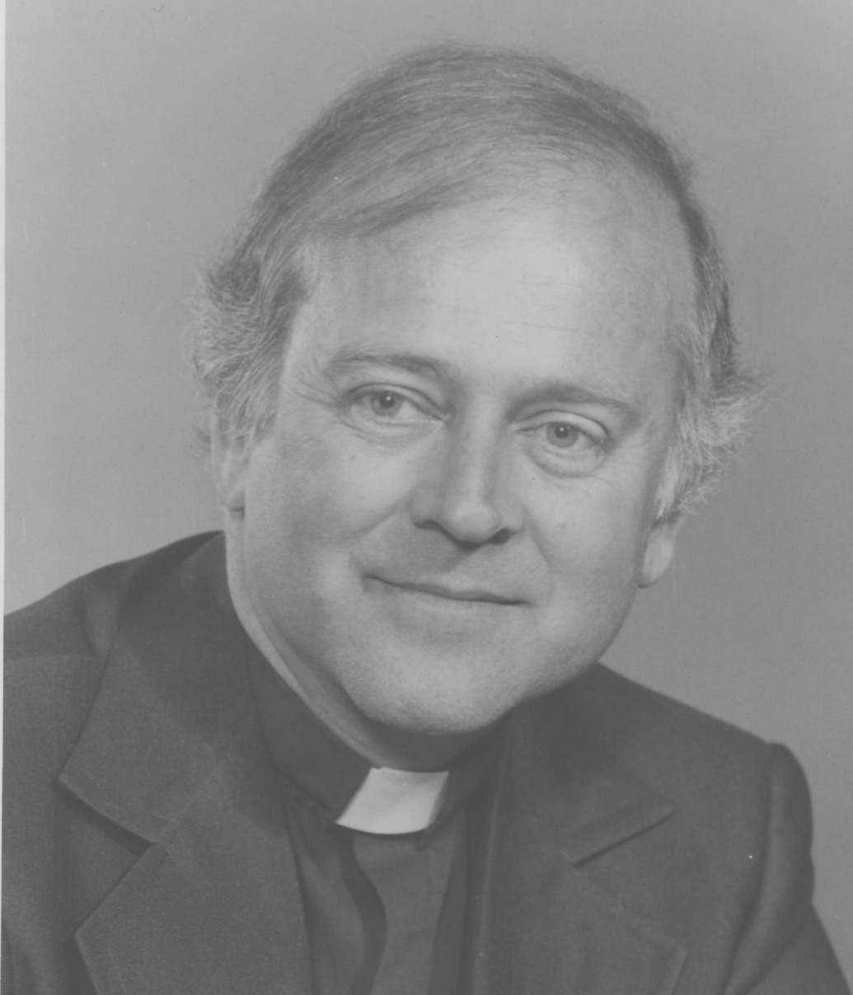

"It is in this atmosphere of freedom and non-judgment that something revolutionary is occurring for me. Through the years of my growing up I have been a stutterer. It is ever present. I have spent many hours with speech therapists and psychotherapists, trying to remedy the problem. It has been to no avail. Nothing really ever changes much. My family and I have learned to live with my liability, all the while keeping our eyes open for something new to try".

"This particular week at Confirmation Camp everything is changing. By Thursday I am noticing less and less stuttering. In the 'Talk It Over Groups' I am getting to finish several sentences without a stutter or hesitation. Excitement and wonder become my focus. What is going on? Others begin to notice but they don't say a word about it".

"The full impact of the change is when my parents are driving my brothers and me home from camp. They are asking the usual 'how was camp?' kinds of questions. After my responses I see them turn to each other in quiet amazement".

"Then they pull the car to the side of the road and look back at me, asking. 'What in the world has been going on? You haven't stuttered once in the last half hour.' I simply exclaim, ' I don't know. I don't know'. My brothers, Mike and Dan are beaming. My mother is crying. My father is about to. Life has changed unexpectedly in a week's time. Into this strange mix of life and relationships at camp, the soulful energies have converged and smiled on me".

"Kathy here. I'm a first timer at Confirmation Camp. I'm a seventh grader. So much of life now seems so strange and frightening. It's hard to build my security shell fast enough to survive. But that's where my energies go. The prospect of having to attend Confirmation Camp is daunting. My parents say I have to go. They want me to be 'confirmed'. After that I can do what I want about religion. For now, they had made a promise at my baptism to bring me up with the guidelines and teachings of the church. But for me, right now, it means going off for a week with people I don't know, to a place I've never heard of, and not having any idea what to expect. I am thinking, 'Is there any way I can get out of it? I am so nervous and upset. Everything in me is saying, 'No, no!'"

"My parents drop me off with encouraging smiles and words like, 'It'll be fine honey. We'll see you next Saturday.' My thoughts as I quickly glance around at all of these unknown faces are, 'Where can I hide. How can I get out of sight. How can I not be here?' My stomach is churning. I feel nauseous. My counselor greets me. I quickly move to an unclaimed bed and lie down with my arm over my eyes. My counselor comes over and starts trying to be friendly with the get acquainted questions like, 'Where do you live, and go to school? What do you and your family like to do together? What do you think camp will be like?' I am thinking, 'Probably like death.' She invites me to join her in walking to the dining hall for supper."

"I am silent. Completely silent, and suffering. No niceties from me. The best that I can manage is that, 'I feel sick. I need to go home. Will you call my parents and have them come to pick me up?'

She is kindly and sympathetic enough, but just says, 'Let's walk some more to see if you might feel better. If not, I'll talk to the pastor and maybe he'll call your parents for you'. I give silent assent to that. I sit through the opening meal, saying nothing, staring downward, with sweaty palms and forehead, and fright streaming from all of my body parts."

"After dinner, the counselor has the pastor come over to me. He is friendly and wants to know what is the matter. I can only say that 'I am sick and need to go home'. He probably senses the origins of my condition as being fear about what would happen to me during this week at camp. He tries to reassure me and get my mind beyond my wrenching stomach with stories of how others in the past had dreaded the week, and what had helped them. I do glance at him once or twice.

He puts his arm around me and says, 'How about we make a deal? You agree to stay until Tuesday to see if things turn around for you. If you still want to go home by Tuesday evening, I'll promise I'll call your parents, or give you a ride home myself.?' I weakly agree and cower in my bed the rest of the evening watching the others at various levels of enjoyment. I am so sad and alone".

"That does not last long. After my fitful night in and out of sleep and crying to myself , I am met the next morning on the way to breakfast by Jim and Robyn, two eleventh graders (camp alumni). Imagine! Eleventh graders noticing and even caring about a seventh grader. But caring they are. They stay with me through breakfast, including me in their unaffected small talk. We laugh, as we play together with Dino, the camp dog, on the way to class. They even put their arms around me as we walk and let me know that we can sit together at lunch. Some of the other seventh graders notice this 'adult' attention and they make some moves and conversation toward me. It is becoming contagious. My stomach has quieted down. My palms are now dry. I even start a conversation or two".

"Tuesday comes and goes. Nothing is said. By Thursday morning before breakfast I am swinging high in the swings with two new seventh grader friends. I am laughing as I wave to my rescuers, Jim and Robyn, walking by. Life has changed dramatically for me since Sunday evening. I have experienced a new level of living, free of judgment and separation, and full of acceptance, compassion and connection. I'd like to live life with more of this in it. I wouldn't even mind talking about life beyond my comfort zone".

"Paul here. Tim and Kathy are just two examples that have made this week at camp the best ever for this pastor. There are thirteen other 'best ever' weeks, with many other examples of the how's and why's of lives changing, and young people experiencing who they really are at their core. This heightened awareness may only last for a week. They will have to return to the 'being cool' routines of public school after camp. But whenever that memory is turned into awareness, they will at least have a 'knowing' of a time when the need to 'be cool', when the dominant and defensive are diminished. This brief time of life lived at the core has a look all its own".

"There's an important lesson for me here. Far beyond the intellectualizing and laboring about dogma and doctrine, I now know that outside the book learning there are individual souls longing to know what life in relationship is really about, and what generates meaning, freedom, and joy. That is the life of inclusiveness, non-judgment, forgiveness, and compassion. It's part of what I can call 'Soulciology'. Thanks, Tim and Kathy."

SIDES OF BACON

In my experience there are two sides to bacon. One good. One, not so good.

The good side would be that of smelling sizzling bacon. There are vivid olfactory memories triggered just by thinking about it. The salivary glands are activated by the anticipatory delights and before I know it, I am swallowing more often than normal.

I fondly remember this scene as a child. I am warmly enveloped in a pile of blankets on a winter's morn. Every turn of an arm or leg reminds me of how pleasant this is to be so cared for and protected from the chilled air on the other side of these blankets. My pleasure expands by hearing my mother downstairs playing some of her favorite tunes or hymns on the piano. These delicious waking moments are topped with the delectable aromas of bacon being readied in the kitchen.

It is appealing enough to motivate me to throw back the security of the covers and pull on my corduroy pants and flannel shirt as quickly as I can, and then on with the woolen socks and recently half-soled shoes. All of these take some time to warm up from my body parts. A dash into the bathroom and a splash of eye-opening cold water to my face. A brisk rub with a towel and then bounding downstairs to embrace the warmth of the kitchen.

My mother is now bent over the Hoosier cabinet putting together the lineup of sandwiches for the four brothers' lunches. She wraps them with the wrinkled wax paper and puts them into the wrinkled brown bags that had been used and folded, put in our back pockets a day or two before, ready for another day of service.

The kitchen table is full. There are the halved oranges that we each have learned to dig out cell by cell with a teaspoon. There is hot oatmeal with raisins, and butter, brown sugar, and milk. Then comes what I had been salivating over. The bacon. Fried bacon. Brown bacon. Its fat molecules dance with my taste buds across my tongue and mingle with the other breakfast entries of eggs, or mush, or buckwheat cakes. Every morsel makes its statement: "Life is good!" It is imprinted on all the message boards of my brain.

The happy side of bacon memories are reinforced in the summer scene during our family's two weeks at the Daly Cottage in Colonial Beach, Virginia. Once again, it is the waking charm for the start of a fun filled summer day. No blankets here. Just half of a sheet to cover my legs and a musty mattress underneath. I'm looking out the front window next to my bed and gazing at the big red summer sun glistening on the muddy Potomac River flowing by. The summer's morning breezes are laced with fragrances of mimosa blossoms.

These breezes are conquered by the smell of frying bacon as it finds its way to my nostrils through the cracks in the walls and spaces under the door. The smell of the kerosene fired stove in the kitchen is always in the background. It blends with the mix of breakfast pleasantries to inhale. The percolating coffee. The cut wedges of juicy cantaloupe. Corn cut from the remains of corn on the cob from last night's dinner, join with eggs. But the most pleasant aromatic of all is the sizzling bacon.

There is, however, another side to bacon lodged in my memory bank. The scene is the Assateague National Seashore Park in Chincoteague, Virginia.

It's July 1972. Our Seltzer clan gathers from far and wide for a vacation reunion at this popular and crowded campground. We join the usual assortment of camping options. Tents of all shapes, travel trailers, pop-up vans, RV's. I have a VW pop top camper van. We have the usual enjoyments of beach activity together. Swimming, body surfing, chicken fights, splashing battles, sand sculpting, smearing sunscreen, campfires, foil wrapped dinners from the fire coals, singalongs, stories, bugle calls, volleyball, games and general horsing around.

My VW camper is wedged between a travel trailer on one side and a pup tent on the other. Sardines would feel at home in this tightly packed campground. Our neighbors are very friendly. No one close by has a boom box or stays up into the wee morning hours boozing, or laughing, or playing games. Mosquitos and flies are kept at bay with regular applications of OFF and lighted punk at night. The whole clan will be together for a corn roast or fish fries or crab feasts followed by games and stories and sing along around a blazing campfire with harmonica and guitar accompaniments. It is a happy time.

Two days are left in the week together when the hot and humid atmosphere builds up into a fierce thunderstorm at night. In a mild form such storms can clear the air and bring a welcome relief of cooling breezes from the oppressive sultriness. This storm is a big one, rumbling its thunderous and black clouds toward us for an hour. When it arrives, it explodes. Fierce winds. Horizontal rains, whipping and slapping and pelting every surface in its path. Lightning. Deafening thunder claps right after. It keeps us all jumping.

Inside our VW camper, with the pop top down, we hunker down, grateful for the protection from the stormy onslaught outside. The storm lasts into the early morning hours. So much for sleeping. With the lightning flashes we catch glimpses of the outside with tents and clotheslines whipping in the wind. Flashlights outside reveal drenched figures scurrying from one place to another, and sloshing through the rushing water in gullies, clinging to a sleeping bag or lugging a cooler, looking for safer ground, or their vehicle.

We hear the yelling of frantic instructions like, "Forget about that stuff. Get to the car. Take my hand. Where are the keys?"

These are the tent people whose fragile dwellings have been ripped away by the winds and surging waters. No one is hurt. It leaves a mess to look at and clean up the next morning.

The storm doesn't clear the atmosphere the way it is supposed to. It is still hot, muggy, and drizzling as morning appears. We look out from our VW. Tents are missing, washed away. Trailers are bent. We are okay, but we can only stay inside so long. We are cramped and hungry. I make the move to get going.

I push open the side door of the van. I pull out the Coleman stove and aluminum folding table. I maneuver my body through the watery sand. There are still channels of water flowing around my ankles. No need for sandals. I open the little fridge under the sink in the van and pull out the breakfast fare: cartons of orange juice and milk and eggs, a package of bacon, bread, and jam. I am trying to be organized. I pour some juice for my wife and nine-year-old daughter.

It is too wet for them to come outside. It is still drizzling. I need my poncho. I reach my arm into the little rear closet stacked with tee shirts, shorts, and towels until I feel the slicker on the bottom. I pull it out and throw it over my head. Then I go back to trying to cook.

My mind is in gear, thinking, "Table's up. Stove's primed. Fry pans and water pot are out. Food is on the table and covered with a plastic sheet. I won't bother with coffee. I should heat some water for cleanup. I need the umbrella to keep the rain off of the cooking food. I'll slosh to the rear of the VW to where the beach umbrella and folding chairs are stored.

I'm still getting wet. I can't see well because the head piece of the poncho doesn't turn when my head does. I need an extra hand to pull it back. Okay. So now I 'm thinking, "I should be set: table, stove, food, umbrella, plastic over everything except the stove, I need a match to light the stove. The matches are in the driver door pocket. I'll slosh around and get them. I hope they're dry enough. Step over that big gully if you can."

I look around at how others are faring. It seems about the same. I call over to the folks breakfasting inside their RV, "I know what you're thinking... don't say it out loud."

Talking to myself under my breath: "I'm ready to start. I'll prime the stove again, light the match, and 'glory be' , look at that, the circle of blue flame pops up around one burner and then another. Maybe bacon will work its charms even here."

The running inner conversation keeps going, "Fry pan is on the fire. Tear back the wrapper on the bacon package. Peel off a half dozen strips. Lay them in the heating fry pan."

"Oops. That drizzle on the bacon won't do. I'll hold the umbrella over the stove. I'll get the eggs out of the carton with my other hand. I know how to crack open an egg with one hand. But I need to hold the bowl still while I crack the egg on its edge. Not working."

"Here, I'll tuck the umbrella under my left arm pit for a moment to free up that hand for the cracking operation. There, I have one egg cracked and into the bowl. It's not going to be fried eggs today. Too much trouble. Scrambled eggs, if I can manage it."

"Oops again. Catch the umbrella. It has slipped from under my arm and fallen over the stove and frying bacon. Get a new egg in my right hand. Rescue the umbrella from the fry pan."

" Oops. The egg in my right hand is breaking. Try to grab the handle of the umbrella. Ugh, the egg is oozing all over my fingers and down my wrist. Put down the umbrella and grab a napkin from the package under the plastic and wipe my hands. Maybe that rushing water under foot can help with the residue stickiness."

"Keep cool. Take another sip of orange juice. Try to regain some composure. Both hands are free for the moment. The humidity's drizzles aren't helping. I have to get these four other eggs cracked, The bacon will have to endure the extra water. Quickly, dig around that other plastic bag…find a fork to whip the eggs. What about salt and pepper? I forgot about them. I can't leave my post to go digging for them. I'll just tip in some milk and go from there."

"I have to get the umbrella over the stove again. There's too much rain getting into the bacon pan. Look at that. The middle three inches are browning but the outside three inches on both sides are still almost raw. Call for a spatula from the van. Get the umbrella upright again. It keeps slipping. Push the bacon around the pan…try and get an even burn. At least it's putting out its familiar and pleasant aroma".

The resident flies and mosquitos apparently also have an appreciation for the smell of frying bacon. The signal has spread through their respective communities and scores of them descend to practice their loop-de-loops, buzzing, and dive bombing to the exposed parts of my body, like my face, and legs and eyes and under my poncho.

Both hands are occupied with the hurried breakfast preparation. My best response to the insect onslaught is foot stomping, elbow waving, grimacing, and blowing at the ones attacking my face. I wave the spatula over the crisping bacon and hardening eggs to chase them away.

Increasingly agitated, I put the umbrella down once in a while and launch a counterattack. I am swatting at them them, flailing my hands, shaking my poncho to fend them off. In the process I tip over the milk carton, and with a reflex motion to rescue it, also tip over the orange juice. The bacon goes unattended. The eggs go unattended. They both experience third degree burns.

I turn the stove knobs to off. While still trying to maintain umbrella protection from the heavy humid drizzle, I can be heard to emote a few of my favorite expletives. My nine-year-old daughter, Cherie, is watching the scenario unfold from inside the van. No doubt it has been revealing and fascinating for her, perhaps amusing. I see her, the way kids do, with her face squished tightly against the side door window so that her lips and nose and cheeks are spread out in a grotesque configuration. The hint of a mischievous smile is at the edges of her mouth.

Among my expletives, while passing the paper plates with the semi-burned, semi-raw, breakfast fare of bacon and eggs to my family, I can be heard making resolutions to never do this camping thing again. Even now, the usually inviting sensory messages from sizzling bacon include that particular day when I experienced the 'not so good' side of bacon activity. And all of that brings a smile.

TIMEPIECE

My gold watch. Treasured, not so much for its slim lines, or for the brushed gold, pop open cover, or for its fine Bulova mechanicals, or for its slender hands ticking away the seconds, minutes, and hours of each day of my life. Treasured more for the inscription engraved on the inside cover, "In expectation of his next sunrise". This points me beyond this little physical memento to the signature signpost of my life. It opens me into the rich symbolism of this going away present.

It triggers the treasure chest of my thirteen years of memories with the folks at Atonement Church in Syracuse, N.Y. All of the ingredients of the good life are here. The hundreds of relational interactions and their full spectrum of shared emotions are here. The beginnings and endings of lives are here. The moments of deep inspiration share space with the frustrations and disappointments. Moments of revealing truth and transparency are companioned with the guarded and shadowed niceties. Laughter, love, tears. dreams, conflicts, acceptance, bonding, separation, light and darkness, and so much more. They make up the ingredients and seasonings of this divine and savory soup of our life lived together.

Since then, this little timepiece has for thirty-three years prompted the passage of my comings and goings. Am I early? Am I late? How long must I wait? Is the meeting too long? When will they show up? How much time is left? It answers many questions for me about where I am going and how I am spending my ration of life's time. It needs winding every day. There's nothing digital here. As I hold it in my hand, all of these movements of my life are infused with the reminders of where my life had been thirty-three years ago with those dear people. The philosophers tell me that time is not passing, but that I am passing through time. This precious timepiece helps to tell me how this is going.

Two weeks ago my gold watch stops. It is wound tightly, maybe too tightly. But after thirty-three years there is no more ticking and clicking. There will be no more forty-three turns of the center post to wind it up for another day's energy ... Life will go on without this timepiece in my pocket to measure my pace. The unique memories to which it points remain. But from now on it will rest from its responsibility and take its place with the other memorabilia of my top dresser drawer. It will take only a glance at this gold timepiece to stir the gifts of gratitude to which it will always point me. A timepiece for my piece of time.

SALES BONUS

It is wake up time. In more ways than one. As I stretch my body in bed, I can see the bright signs of a brand new Sunday with sunshine laden puffs of clouds dancing in the bright blue sky. The trees are shimmering from the brisk March breeze. My body is refreshed after a needed night's rest. There has been four weeks of trying to be an effective salesman at the big St. Patrick's Day Sale at Dunk and Bright's Furniture Store in Syracuse, N.Y.

The sale days actually span six weeks from February 1st to March 17th. It is the largest furniture store in New York, covering a whole city block. This sale is an annual event and all of the hoopla and promotions yield a large public response. Sometimes it is derisively nick named the 'Junk and Bright' sale because of all of the lower end merchandise advertised at low prices to entice the customers. Even though they also carry high end products, many of the big sellers and 'deals' are of a quality not made to last. I am amused at our congenial and cooperative customer service lady. She has just consoled a disgruntled customer over her new, but problem laden sofa bed with assurances of D&B service to the satisfaction of the customer. She puts down the phone and audibly announces from her cubicle, "Face it lady, what you got was a piece of shit!"

I am personally in a survival mode of my life. I am transitioning from twenty-one years of being a pastor, now in the throes of divorce. There is no money, no job, and no prospects for anything better than this commission only sales job. I rent rooms in my home to pay my mortgage and to buy gas for my car. I am entering a world very different from what I have known. At forty-eight, it is a mid-life crisis and catalyst to bump me out of my comfort zone into new realities of people and things.

For the sale, the level of awareness is crowded with all of the ingredients of major advertisements and promotions to bring people in and send them home with furniture and products they didn't know they needed. The atmosphere includes the constant din of recorded Irish music from 10 a.m.to 10 p.m. pumped through the loudspeakers. There is free Irish coffee and specialty cakes. The staff is decked out in green Irish hats, ties and vests. The twenty-seven sales people are carefully instructed to make sure every customer has unknowingly been assigned a salesperson, and to greet them and keep an eye on them as they wander throughout the vast store. We have been indoctrinated with product information and methods to urge the customer toward purchase. No one is to steal another salesperson's customer, although frequent disputes arise from such accusations. Every 27th customer is mine to convince to buy…or to serve refreshments to.

For the big weekend pushes there are extra salespersons, aggressive and high powered, brought in as part timers who need a quick buck or two.

Since we are all paid on a commission only basis, and most of us are in a survival mode, it quickly degenerates into a thinly disguised, highly competitive rat race. This even includes wearing our Reebok running shoes to help us move quickly over the vast expanse of showrooms to try to keep abreast of our customers ---and to make sure no other salesperson has moved in on them when they have shown some interest in an item.

In these first four weeks of the St. Patrick's Sale I have been shocked at how quickly I have succumbed to the greed god. Genuine regard for another salesperson, or even the customer and their feelings, realities, and thoughts is sublimated to a far shore in favor of clinching a deal and getting the commission money I need to survive. There seems no alternative. I race around the store, put on a smile for the customer, and am ever watchful that they aren't stolen from me. I am both shocked and dismayed at myself and the level of existence to which I have drifted. I think, "How different this is from days of pastoring and holding up empathy, compassion, and caring as primary and necessary ingredients for relationships and following a spiritual path."

I think often of these contrasts and am troubled by them. It is dominant again on this Sunday morning in the waking moments before I trudge off for one more day of the same, at the big St. Patrick's Day Sale at D&B. Dressing neatly and being polite aren't enough to erase the malaise in which I see myself--and every other aggressive salesperson involved.

This Sunday turns out to be different. Very different. I walk through the front glass doors at 9:30 a.m. at Dunk and Bright. I am expecting to hear the loud Irish music again and expecting to see the usual cockiness and snickering among the salespeople as they recount their Saturday night conquests, or the great deals they had secured on Saturday.

The music is playing over the loudspeakers. But this is it. There is no laughing, snickering or kidding around. There are no groups of salesladies preening themselves in front of the massive lobby mirrors as they usually do. No one has even taken their chip number designating their place in customer assignment. No words. All quiet. A couple of men are seated on the lobby steps staring out the front windows. There are handkerchiefs at some eyes. Heads are shaking. It is so different. I have to ask the receptionist, "What's going on?" Through her reddened eyes she whispers, "Helen Wentz and her husband, and another couple were all killed in an auto crash on Onondaga Hill last night. All four of them!"

I join in the shocked silence that pervades the halls of the St. Pat's Sale. Our head decorator, a lovely, distinguished, and creative designer is dead. Two or three of us gather in small groups alternating from tears to silence, to staring, to walking the halls, to trying to take in the tragedy with all of the how's and why's and what can we do's. Even hugs start emerging. We are still wearing our racing shoes, but the motivation to run ahead of each other is missing. Those same shoes, with our heads and hearts in a different place, are moving us toward each other instead.

The protective layers between us have been peeled back through this shared tragedy. This experience puts us beyond the illusions of success and financial gain. Inside we are experiencing the real, the natural state of our oneness.

It is the antidote to our weeks of suffocating greed and its children. It feels so good, so right. I am seeing Neil differently. He is the aggressive weekend part-timer with whom I have argued on Saturday when I saw him writing up sale for a dinette set with a customer who had been assigned to me. Somehow, my plans to retaliate that I have been devising during the night are no longer of primary importance to me. I notice the tears in his eyes and know that there is a hurting part of him that a dinette sale won't touch.

I think it is like that for most of us. Shared suffering is making the ground level. It is happily that way for all of that Sunday and the rest of the week. We celebrate Helen's life and her ways with us, but also share parts of our own lives without the fluff. I think a lot about that. Then, and now. The antidote for greed and all the other separating feelings and thoughts, is experiencing the reality of our oneness. Shared hurt helps this happen. We can let go of our fears and its defensive layers for at least a moment.

It needs to be said that this freedom, honesty and oneness from our shared suffering only lasts about week. Bit by bit, we retreat into our former protected places again. We pull tight on the laces of our running shoes, and resume our competitive, separating ways. But at least we have tasted reality long enough to know that there is an alternative. Choices can be made.

YOU'RE NUTS YOU KNOW?

"You're nuts, you know?" That's what people usually think. Friends even say it. Susan and I announce plans to start a catering business in Syracuse in 1982. The frequent and penetrating questions are loud and clear. There are obvious risks for us here in our new marriage and our catering venture. People keep asking, "Do you have a business plan? Any money saved up? What experience and references do you have? Where will you be doing this? Who might be hiring you? Do you know anything about pricing?"

The barrage of realistic questions evokes mostly, "I don't know about this," or negative responses. They warrant the conclusion, "You're nuts, you know?"

Our only answer is a weak, "Yes, but..." The 'but' of motivation is charged with the bleakness of scarce options. For me, it is the motivation of a new life with a new wife. I have been employed as manager of the furniture department of Sibley's Department Store for two years. They have been taken over by a mega company from New Jersey. There is a pervasive atmosphere of fear and anger infecting and evident at every level of the operation from the board of directors to the delivery dock workers. It seems that everyone is always angrily yelling at everyone else for something. Stress is the name of the game. Susan, picking me up from work one Friday exclaims, "You've got to get out of there. You look like you're going to have a heart attack."

"I know," I reply, "it's bad, but what else can I do? What else can we do?"

This begins the string of talks and brainstorming sessions. Susan likes cooking. She, and her friend, Ousma, have prepared, and been praised for, serving a couple of church suppers. Susan is also doing the cooking Wednesday evenings at a little yacht club. In the midst of these limited possibilities, Audrey, a bar owner from the village of Chittenango is wanting to expand the bar to include lunches and dinners and asks Susan and Ousma if they are interested. They are. Audrey sounds so excited and positive about its possibilities that I offer to expand it even more by my doing breakfast there as well.

It seems the employment needs have been met for all of us. We are all excited about it and join making plans with Audrey to re-decorate and expand her bar, with new tables and chairs, curtains, and kitchen equipment. It isn't a dream restaurant, but it will probably go well since there is no other eating establishment in the village. I resign from the department store, with relief. A new life is getting under way.

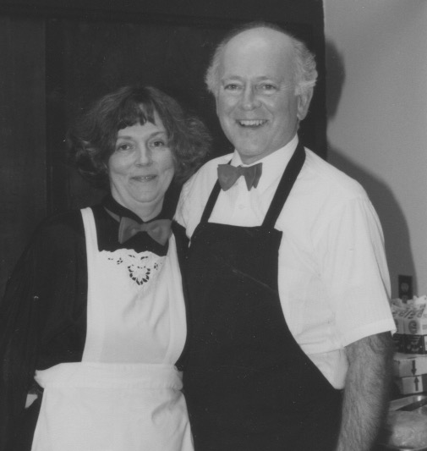

Except it isn't ... Two weeks into the planning excitement, Audrey backs out. We never really know why. Just a simple phone message from her, "I've decided not to do it after all."

We are at the starting gate again, only now without a job for either of us. The brainstorming then jump starts with even more intensity. "What will we do?" "What should we do?" A job search via newspapers, agencies, and people we know, comes up with nothing. I cash in an insurance policy and half of my pension annuities to pay for immediate bills. We spread the word that we are looking for some kind of a new start. We keep our eyes open for possibilities.

The only shimmer of light is from the modest Wednesday evening supper at the little yacht club. I start helping Susan there. The members give us a boost with their enthusiastic praise for the dinners. We keep musing the possibilities..."doing something with food ... other yacht clubs ... churches ... weddings ... funerals ... receptions ... clubs ... unions ... seminars ..." The idea factory is starting to crank up, even to the point of being a dream machine.

So it is that the darkness of desperation provides our motivation to answer the "You're nuts, you know?" comments, with our meek, but determined, "Yes, but... we're going to take the risk and start a catering business. It's the best we can come up with right now, and we're going to give it our best shot." We call it, "Cater To You", until someone has their lawyer complain that it is already the name they are using. So, we back up and add to it. It will be, "Seltzer's Cater To You." This makes it legitimate, and permanent. Then we go through all of the necessary start up regulations, permits, and tax forms.

Since we have no startup money, the "business plan" does 't have to be written down. We agree to do the cooking quietly from our home's little galley kitchen for at least a year. If things go well, we'll think about expanding the operation to our basement.

Aside from well-wishing friends, "who don't really know anyone of influence", we have to start in with cold calls soliciting for potential customers. And so it is on a frigid March Monday morning that I begin acquainting myself with the yellow pages population. I start in calling the 'responsible person' at insurance companies, banks, auto dealerships, associations, unions, and on, and on. About forty calls a day. I note potential future luncheons, seminars, and ask who else might be called or visited who might be thinking about an event, needing some tasty food. Nearly everyone is friendly and encouraging, but there is no specific interest that might lead to a catering job. It takes about one hundred calls to find just one person interested enough for us to send or deliver a sample menu for a planned event. Then there is the process of pricing, waiting for decisions from the proper authorities, and checking out venues.

The first actual event for Seltzer's Cater To You comes in late May. It is a small wedding reception in the MacArthur's basement. They are members of the yacht club. This is followed by a couple of church suppers. Then a training session luncheon for an insurance company. Then a picnic for a health maintenance organization. Then a graduation party. I keep up the calling every day. I pick up leads from happy customers at the various events and follow up. The occasions are all unique, and very gradually increase beyond a trickle. We graduate from our sedan to a station wagon for transport. We purchase equipment, platters, baskets, and generally expand our catering profile.

At the end of the first year we decide we have outgrown our little galley kitchen for food production. We can continue the dreaming. We will stay in the catering business. The relationships with customers and staff are rewarding. The food preparation is creative and challenging. Financially, it is viable. It will work for us. We move the operation to our basement where we build shelves and tables, purchase a used commercial stove, refrigerators, sinks, mixers, a used Dodge van, and lots of other needed equipment.

The yellow pages phone calls and following up on those leads are the main marketing tool for three years. Finally, solicitation for new business has been replaced by the word of mouth recommendations of pleased customers. The echo of, "You're nuts, you know," has been happily replaced with, "You're good, you know!"

THE CHICKEN LITTLE CAKE

"Seltzer's Cater to You" is presenting a June wedding reception in Skaneateles. This fashionable and bucolic resort town is at the head of one of New York's gorgeous finger lakes. The fresh spring day is calling on the flowering crab apple trees and azaleas to 'strut their stuff' in blooming grandeur.

The site of the ceremony is St. Mary's Church, nestled among the flowering trees along the water's edge. The reception is to be in the well-appointed parish hall with its large picture windows all along one side, giving an expansive view of the sparkling blue lake. "Seltzer's Cater To You" has been preparing for the two hundred guests for several days. It is an extensive luncheon menu that would lead to their hoped-for shared comment at the end of the day, 'another triumph!'

The crowning feature is to be the specialty wedding cake. Its tiers alternate with chocolate almond and sour lemon layers. It is labor-intensive to put together. The very rich and dense batters are baked ahead of time. The Italian butter cream icing takes hours to prepare and apply to the moist confection. The butter is whipped at high speed while the hot syrup is introduced drop by drop, so it does not melt the butter. The elaborate frosting is then piped on, using a variety of plain, star, leaf and rose tips, fashioning an elegant basket weave pattern, leaving a space between the tiers for fern and flowers. I can almost hear the admiration from the recipe's originator, Martha Stewart, "Well done, thou good and faithful servant, it looks like you followed the directions this time."

All is in readiness for the showcase wedding and reception. The Seltzer's have hired ten of their friends to help as the staff. They wear their black and white outfits with their signature raspberry colored bow ties. The tables are covered with burgundy cloths and crisp white napkins in a cardinal fold at each place setting. Spring flower arrangements with candles grace each table. The schedule of preparation has come together feverishly and perfectly. The flower bedecked buffet is an elegant sight. Susan and I are nervously proud and pleased.

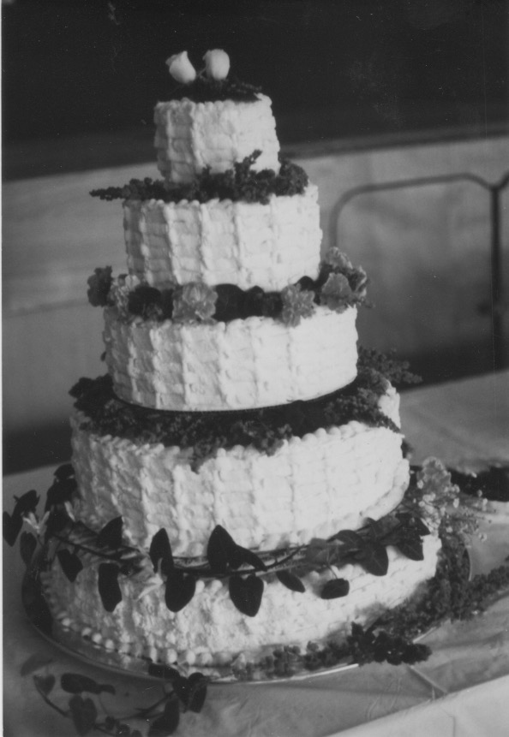

We give the staff their final service instructions, which conclude with, "And be sure to have a good time!" Echoes of the ceremony and its musical flourishes from the sanctuary above resonate into the hall as the last adjustments to the food presentation are made.

I am in the kitchen slicing some extra ham when Cindy Henderson bursts through the doors, screaming, "Paul, the cake...it's falling...come quick!" She might just as well have been Chicken Little screaming, "The sky is falling, the sky is falling!"

I drop my carving knife and bolt into the hall emitting a torrent of expletives that will hopefully not be heard in the sanctuary above. Lohengrin's wedding recessional march is now pealing from the organ. As I race across the dance floor toward the gravity defying tiers of butter cream now aiming for the floor, flashes of what the disaster would look like, and what might be done about it, alternate in my spinning head. Seconds before the lovely basket weave was to tip over, giving in to nature's laws and splatter on the floor, I plunge my ten fingers into three different tiers. I try to think of how to get the cake upright again.

"What has gone wrong?" I am clutching at causes. "Was the cake too heavy for the supports? Did I miss some important details in Martha's directions? Had she warned me?" None of that matters right now. The recessional is concluding upstairs. The guests will be coming through the doors momentarily.

The staff rushes out to see what can be done. Susan quickly surveys the situation and races back to the kitchen to find some extra icing for repairs. I finally get the cake to stay upright again. Looming at me now are ten gaping holes randomly placed in the butter creamed cake layers. What to do about those ugly holes???

FORTUNATELY, Susan appears with a dozen red roses and some fern she had saved for last minute garnishing. With split second dexterity, she breaks the dozen roses from their stems and shoves them into the glaring cavities. She lays the two remaining roses at the base of the cake where the icing has separated. A fern or two and she is done.

Just then, Ted and Clara Crenshaw, the bride's parents, come through the door into the parish hall. They quickly survey the whole scene. The expanse of picture windows showing off the beautiful lake, framed with the pink blooms of the crab apple trees, the meticulously arranged tables with their decorations, and then the sumptuous buffet table waiting to satisfy the appetites of their friends and family. "Just lovely!," exclaimed Clara, and Ted agrees.

Then they walk closer to the cake table. Clara puts her hands to her mouth and sighs, "That is the most gorgeous, the most elegant wedding cake, I have ever seen. And the way you have arranged the roses! How creative and unique. I am so pleased!" Ted agrees, "Thank you so much, it couldn't be more perfect!"

Susan and I, with perspiration beading on our faces, a towel wrapped around my butter cream laden hands, and Susan's hands behind her back holding the rose stems and extra fern, jointly say a quiet, "Thank you. We're so glad you like it."

Clara added, "And you all seem to really be enjoying what you're doing," as she glances at the wait staff taking their places behind the buffet table, with their bodies bent over, and their eyes watering from laughter. Susan and I smile nervously and agree, "Oh, we certainly are!"

A CATERING CAPER

I should have seen it coming. It has been a non-stop, high stress assignment. "Seltzer's Cater To You" is catering a buffet feast for 200 partying guests under a huge white tent nestled in a bucolic setting of willow trees by the quiet Onondaga Lake in Syracuse, N.Y.

Summertime. It is hot and humid for the catering team on each of the five afternoons. We hustle to move food, drink and furnishings into place to be ready for the partying crowds waiting to enjoy their high-priced evenings. The water and power source is 200 yards away from the party at the county park offices. We can't use a truck on the bumpy terrain. It all has to be hauled by hand...and remember, "you have to hurry".

It is a strain, and my body is making it abundantly clear that it is not pleased with this continual call for adrenalin. The battle is on.

My body is yelling, "Stop! I hurt. Listen to me."

But my ego is yelling back, 'You have to keep going. This is the last night of the event. Keep going. Don't stop for water or food. Keep at it. Everyone is having a splendid time and there are lots of kudos for us everywhere. Dinner is almost done."

My body responds, "I don't know if I can make it. I hurt everywhere. I need to get back to the restroom in the park office if I can!"

I have the key to the office and find the washroom. By the time I'm inside the toilet stall my legs and arms are tingling and going numb and limp. "Heart attack!", I think. "Oh my!" Then there is the cold sweat, and nausea and diarrhea and the hot poker pain ramming my lower back. Dizziness.

The questions race through my foggy brain. "Will I pass out? Am I dying? Is this how it's going to happen?" There is no real fright here, but intense curiosity, when I can think at all.

It's getting dark outside. I didn't turn on the lights when I came in. No one knows where I am. I'm alone here. Will anyone notice that I'm gone in the midst of their busyness. How long has it been? How I would love to hear someone call out, "Are you in there Paul?' But the only sound is that of the crickets and locusts starting their summer evensong.

Finally, I hear Susan's voice calling for me in the darkness outside.

I yell, "I'm in here, in here, I need help!" I hear doors rattling as she tries to get entry through various locked entrances. I keep calling out, "In here, in here. Keep trying."

As the restroom door opens, she finds the light switch on the wall and turns it on.

I tell her, "I'm in here, in the stall. I'm really hurting. I might be having a heart attack. I don't know. My arms and legs are numb. I've vomited and have diarrhea. It feels like a hot poker jamming up my back. I can't move."

She looks at me and says, "We didn't know what happened to you or where you were. We kept asking each other when we had last seen you, or if you had said anything about where you were going."

I said, "At first I thought I was just coming to use the washroom, but then the pain got worse and worse. I didn't know what was going on. Once I got into the park office and found the restroom, everything started getting so painful I couldn't move."

With the burning poker pressing me against the toilet stall and perspiration dripping down my face, I said, "You'd better hurry and find a phone and get the rescue squad down here. I don't think any of the offices are open in here. Maybe you'll find a phone at the Salt Museum or someone outside..."

She runs out in a panic trying to think where there might be a phone or someone to help in this now almost deserted dark park. As she runs toward the museum she spots a woman walking along the path ahead . She calls to her for help. It turns out that she is a woman we know from our having catered dinners at the Liverpool Yacht Club, Emma Rickertson. Susan quickly tells her our situation and how scared she is, and how we need to get help. Emma doesn't have a phone, but she happens to be a nurse.

She hears the symptoms and says, "I know it's scary for you, but from what you're saying, it sounds more like it might be a kidney stone attack rather than a heart attack. I don't know for sure of course, but I've seen people writhing in pain, and all the things you're telling me, especially the hot poker up the back, and as painful as it is, I don't think it's life threatening. But we'll find a phone and get the rescue squad here and get Paul to the hospital to find out for sure. Don't worry dear. You go back to him. I'll jump in my car and find a phone and call for help. He's in the park office, you say?"

Susan tells staff at the tents what is going on. She comes back and asks what she can do to help. Nothing has changed for me. She tells me what Emma has said about it maybe not being a heart attack, but kidney stones. I have never heard about kidney stones causing this kind of distress, but I hoped she was right.

After what seems like an interminable wait for the ambulance, I can hear the movement of the rescue personnel making their way through the park office.

Susan calls to them, "We're in here, down the hall, in the washroom." They roll in the stretcher and begin asking questions about what I am feeling.

I quickly rehearse the symptoms and sum up the list with, "Man, I can't move. I'm numb all over, and that burning pain is shooting up my back."

They respond with, "We're going to be right here helping you, and getting you to the hospital." The two of them lift me onto the stretcher as I yell from the pain. Susan has her hand over her mouth as she witnesses the process wide-eyed and follows us into the ambulance. She says her "Thank you's" to Emma for her help and for staying close by.

Once the ambulance is under way my attempt at pain relief comes from digging my heels into the stretcher and pushing hard to get away from the red-hot poker in my back. I hear the roar of the motor and the turning of the wheels. I know we are on our way to the hospital. But I don't hear any siren. I wonder why.

The attendant, with a clipboard in his hand, starts asking me questions: like name, address, phone, doctor, Social Security number...."Wait a minute," I am thinking, "here I am twisting and thrashing in pain, maybe dying, and you want to know my Social security number!" I look up at Susan, bewildered. 'What is going on?' I try to come up with answers for the paramedic, but I'm adding a measure of anger for his lack of understanding of what I am going through. I try to deflect the answering to Susan, but the medic says he needs to hear it from me.

It starts to dawn on me that through these inane questions he is trying to get my mind off the pain, Maybe he knows something that I don't. No siren? No rushing through town traffic? These questions? All I know is that I have never experienced pain like this before and nothing is relieving it, not even digging my heels into the stretcher.

Arriving at the hospital emergency room they move me from the stretcher to a hospital gurney. The triage nurse takes over with the questioning and testing the vital signs. I am wheeled into a hallway and left there, since the emergency room beds are all full. I am given a shot of Demarol for the pain and told that a doctor will be coming soon. Soon becomes a long time. The pain remains intense. I keep digging my heels into the gurney mattress. Another shot of Demarol. It is now almost 11:00 p.m. It has been three hours since I had made my way into the park office restroom with pain as my main companion.

The nurses come by and try to give me assurances. "Just hang in there, the doctor should be coming soon to examine you. It certainly sounds like the kidney stone symptoms to me. I know it's really painful right now but if the stone passes, the pain will go away in a flash." It is small comfort at this point. The poker is still there. It is still penetratingly fiery. It is still shoving me against the wall.

Susan has been back in touch with our catering staff. They have finished the cleanup, loaded the van, and taken it home. They will be coming by the hospital to give her a ride and see what the situation is.

I am still in intense pain, writhing and twisting with pain.

Then, all of a sudden, it is gone! Just as the nurse had predicted. The pain has completely vanished in a moment. Nothing. No more pain after all these hours. What is going on? I release my heels and sink into the gurney sheets, now thoroughly tangled and drenched from my hours of painful sweating.

As my eyes clear, I call to a nurse walking by, "I really think I can get up and move around a bit, maybe even go home when my ride gets here. I'll make an appointment to see my doctor tomorrow. I'm pretty exhausted right now." Such a dramatic turnaround has left me gratefully bewildered for the night. Now I understand what the attending helpers had apparently known all along. As painful as it in the midst of a kidney stone attack, it is not as life threatening as it feels. It often passes on its own somewhere along the way. That's why there was no ambulance siren. That's why there were the distracting questions to divert my attention from the pain. That's why there was the long wait on the gurney in the hospital hallway.

The ensuing doctor's appointment directs me to try to capture the dislodged kidney stone with a urine filter. He further instructs me to always drink lots of water to avoid dehydration, especially in hot weather, and also to avoid driving myself so hard, resting a little, every now and then. This is a catering caper that will not be quickly forgotten.

JUST ONE MORE DAY

Vacations change things. Always a little. Sometimes a lot. Especially in a foreign country. Culture. Cuisine. Sights. People. Language. The unexpected, often serendipitous, and things not mentioned in the travel brochures.

So it is for Susan and me on our trip to Costa Rica in 1988. It is fourteen days of stimulating and satisfying exposure and interaction with a new place and new people. Then there is an added day of an indelible, unexpected adventure as icing on the cake to complete the delightful memories.

There is lots to see and do to delight the senses in Costa Rica. Our first accommodation is the Don Carlos Hotel in the center of San Jose. It is a charming villa for about twenty guests and had been the presidential residence in its earlier days. It has an inviting ambience of lush shrubs, brilliant blooms cascading from the roof tops and doorways, and attendant parrots to amuse. It is intimate enough for guests at their breakfast tables to easily share tales of the prior days' adventures, and to offer what newcomers should not miss.

Among the many delightful options we choose are things like the Arenal Volcano on a rare day without clouds or smoke or fog to obscure the molten lava bubbling in its cavernous bowl below. On another excursion we maneuver our Suzuki four-wheel drive for three hours on an unmarked trail over rocks and crevasses. It is our weekend in the rainforest and its startling natural revelations. We interact with many of the locals along the way, including a tavern owner whose father, from Cornell University, had twenty-five years earlier begun the now flourishing cheese manufacturing industry. We enjoy the established Quaker community and its long term peacemaking influence, including President Arias having received the Nobel Peace Prize in 1986. We walk the pristine white sands of the expansive beaches at Manuel Antonio National Park with a handful of other tourists. The noisy monkeys at the jungle's edge busily gorge themselves on the banana bounty.

We have the privilege of being escorted for three days to both the prominent and the obscure of Costa Rica by Jorge Hernandez, a former graduate student at our home-based Syracuse University. He is researching ways to utilize the abundant coffee bean shells as fertilizer and mulch. He hosts and interprets for us at a sumptuous family dinner in our honor, on their coffee plantation. The father initiated the twenty-five-year-old strawberry industry in Costa Rica.

We spend a memorable day on the cross country "Jungle Train" as it rumbles through the roadless precipices and valleys, providing the only access from the Pacific to the Atlantic coasts. Vendors a

We are deeply moved by the generous attention of a poor native family sitting across from us on the train. At lunch time, they notice that we have not come prepared for lunch on the long train ride. The two small children with big bright eyes and shy smiles come across the aisle offering us two basic baloney and mustard sandwiches they had taken from their paper bag. We have only a small bag of potato chips which we share with them and their parents. It is a not-to-be-forgotten moment of humans connecting, with only the language of the heart to guide and nourish us.

We don't neglect the oft pictured quiet sunset vistas from the pink and purple clothed tables of a gourmet restaurant perched high above the diamond sparkled sea below. Also enjoyed is the meal at the rustic cabin tucked in between farmland hills with the not yet cooked chickens clucking and pecking about under our chairs.

These are among the fascinations stimulating us for our perfect fourteen day stay in Costa Rica. We spend our last day in San Jose in order to be on time for our early morning flight back to Tampa, Florida.

We do not realize that some vivid memories of Costa Rica are yet to appear.

All goes according to plan as the departing day dawns. Our passports are accepted. Our luggage is checked. The flight is on time. We are in the waiting area ready to board the plane when we are informed that the flight to Tampa is full. Susan has a paid-for reservation. She can go. I have a stand-by reservation by virtue of my daughter Linda being a flight attendant, which qualifies her father for a free ride when space is available. It is not on this one. There is no room for stand-by's. I will have to wait for tomorrow's flight to see if there will be room for me then. Oops.

Susan and I hurriedly make the adjustments we can think of that have to be made. We are saying things like, "Let's keep in touch from both ends. Remember to change our accommodations in Tampa. Let Linda know when and where to meet us. Change the return flights to Syracuse. Keep aware of developments about tomorrow's flight."

We say our goodbye's, still trying to put the pieces together, and to feel okay about it all. Susan's plane takes off. My baggage goes with her. The waiting room empties of airline personnel, police, well-wishers, and the other stand by passengers. I am alone with only the distant echoes of other flight announcements to other destinations to keep me company.

With palms still sweaty from the change of events, I rehearse in my mind the priorities for my moves from now on. I don't have to worry about keeping track of my underwear or razor. They are having their free ride to Tampa. I will be in San Jose for at least another day, with only my passport, the clothes on my back, and some money. No other encumbrances. I will catch the bus back to center San Jose, have some breakfast, and then check back into last night's hotel for another day. Simple enough. And then maybe some more walking and sightseeing of the tourist attractions. I wonder if there might be a concert at the National Theatre this evening that I can fit in. It will not be daunting to adjust to this annoying change of plans.

However, there is more to it than that. After a leisurely breakfast at my hotel in San Jose, I saunter over to the registration desk and request a room for another night. I said, "Maybe it can be the room I just vacated earlier." Politely, I am informed that last night's room is not available. And neither is any other. They are full. Another 'oops,' and change of plans. My day now has to start out securing new accommodations instead of sightseeing.

I spend the next hours of the morning going from one hotel to another, and from one B&B to another. I go back to my favorite Don Carlos Hotel. All full. My palms are sweaty again. I am thinking, "What are my narrowing options?"

I am having lunch outside a plaza restaurant and am greeted by a woman from Boston whom we had met at Don Carlos Hotel, and with whom we had shared some travels in the last fourteen days. I tell her of my unresolved accommodation plight. She is still residing at Don Carlos, and half-jokingly says, "You can sleep in the chair in my room as a last resort, if your efforts continue to be fruitless" I half-jokingly thank her. As my search continues into late afternoon, I begin to wonder how that offer might actually work.

Eventually, I walk my way into the seedier commercial regions of San Jose. The streets are crowded with people. The web of utility wires crisscross the streets and corners, almost obscuring the street signs. The curb and cross walk stripes are faded. Trash bins are overloaded. The equatorial heat can use some tropical ocean breezes. I still have no prospects for accommodations. I wonder if the police might have a suggestion. Or maybe a priest in one of these churches I'm passing might know of something.

I am now at the massive central market of San Jose. It sprawls for two blocks with its succession of booths, stands, tables, and umbrellas. They offer a now picked over variety of brightly colored vegetables, fruits, fish, and meats. The vendors are kept busy waving off the flies from the exposed and increasingly 'fragrant' chicken parts.

Just across the heavily trafficked street from the market is a row of small shops. Hanging from the next floor up are neon or painted signs vying for attention with their varied heights and colors. Many of these second-floor advertisements boast a "pension" labeling.

I realize "pension" has something to do with accommodations, perhaps a room or apartment or a boarding place. This series of offerings goes on for two blocks. They all look pretty much the same. Each seems to have a narrow access door squeezed in between the ground level shops.

I come upon one named, "Pension Americana". (Probably especially attractive to the semi prosperous American tastes and ambience). I think, "I'll give it a try. It's six p.m. It's been a long day of no vacancies. I'll just turn this floppy door handle and see what shows up."

I walk into the narrow and dimly lit vestibule. There is a brown wilted plant at the bottom of the stairs. I speculate, "It's probably a rare jungle species struggling to survive the rigors of civilization. (ha)" I brush by it to ascend the unbanistered staircase. A few of the stairs have worn rubber treads, but not all. "For safety's sake," I mused.

At the top of the stairs is a three foot by three-foot landing, with another defunct jungle species in a corner with a rumpled rag rug underfoot. I face two locked, almost painted doors. The door directly in front of me has a 10"x10" square opening covered with a small metal door and hinges. There is a sign in Spanish that I assume says, "Please Knock". I do. Once. Then again. And then again. After about a minute of this I heard the clicking of a metal latch on the other side of the little door opening. The 10"x10" hinged door swings back, revealing two metal bars across the opening. Behind them, a bare twenty-five watt light bulb is hanging from the ceiling of an otherwise dark room.

It gives enough light to show an unshaven face with about two inches left of a well salivated cigar protruding from its mouth. The aroma from the chewed tobacco strands greeted me, along with a rather gruff, "Huh?" Underneath the cigar I can see a red and white striped underwear top. In my best English I try, "Room?"

He is looking at me intensely now, realizing that I am probably not going to rob him. "Si," he responds. This much Spanish I understand. It is the first "Si" since my trek had begun at ten o'clock in the morning. It has been almost eight hours of walking the streets of San Jose, waiting to hear a "Si!" The only relief I feel at the time, given my initial exposure to Pension Americana, is that at least I won't have to sleep in a doorway or on a park bench tonight.

I then manage the next question, "How much?"

His reply, "Dos."

I say, "Two? Two what? Two dollars?"

Again, "Si" is his answer.

I pause, thinking to myself, "You've got to be kidding. Just two dollars to sleep overnight. It's either a really good deal, or this place is even worse than it appears."

I hear another "Huh" from the cigarred concierge on the other side as he starts to push the little metal door shut.

I quickly say, "Okay."

He points to the little ledge under the metal bars indicating that is where I am to place the two dollars. I do so. He scoops up the money and closes the little door. In a moment I hear his rustling around to the back of the second locked door at the top of the landing. He opens it, and hands me the key that will open it. He passes me the towel he is carrying under his left arm. His original gruffness has softened. He is only five feet tall. I think, "His growth is probably stunted from a lifetime of chewing on cigars." He wears ruffled tan trousers with gray smudges, and flip flops for footwear. He motions for me to follow him toward my room.

It is a long and circuitous journey through a labyrinth of barely lit hallways. There are no "exit" signs. I wonder, "How will I ever find my way back and forth, and out of here. What if there is a fire? Oh well, I really need a bed tonight."

At one point on the journey to the bedroom we pause. He points toward a raised platform that has two rusty fifty-gallon drums suspended overhead. They are the water source of our common showers, sinks and toilets just below.

The 'bedroom' turns out to be a 5' x 7' cubicle. The walls go up to about seven feet but are not attached to the ceiling. The whole 'bedroom' area is actually a series of partitions painted a very 'off' white. The individual spaces are only large enough to hold an army size cot, which allows the door (with no lock) to open just enough to get a body inside, before it bumps against the cot. I am wary about the freshness (or not) of the sheets. The frayed olive colored army blanket covers only half of the bed. There is no chair, no chest, no mirror, no pictures. "But ," I think, "at least it is off the streets. And for only two dollars. Who will ever believe that?"

I have to be up at the crack of dawn tomorrow to get to the airport. It leaves me only a short while to have supper, locate the bus stop, and roam the surrounding streets at bit. I make my way back to the Pension Americana. There is now no cigar concierge to greet anyone. My key works in the lock. I am able to eventually wend my way back to 'my place,' having kept track of the various landmarks in the hallway of stacked musty mattresses and piles of empty bottles.

I pause at the common washroom. I have no toothbrush. The towel is in the bedroom. A quick splash, and then to rest my weary bones. I think it's best to sleep in my clothes since I am unsure about the history of the sheets, and the wool blanket covers only half of my body. I think,"I hope I don't have to share my space with too many unseen critters."

I have passed by only a couple of other men in my hallway walks. There are greetings, but obviously I am the only American staying at the Pension Americana.

In spite of my next-door neighbor's erratic snoring, I am tired enough to fall asleep. The only lights available are the bare, low wattage bulbs hanging from the ceiling.

There is a ruckus to awaken me during the night. I can't tell what time it is. The jarring commotion is several cubicles away. It starts with some banging of doors and furniture and bottles. Then there is moaning which grows into screams and shouts from several voices of those who have been aroused. There is a mix of anger and laughter with the screams. Sirens approach from the streets. A gurney is rolled in with more shouts. Brighter lights appear at the scene. Eventually, the noise abates as the ambulance drives away with the ailing person and the exchange of comments from the gathered group subsides. Everyone goes back to their 'bedrooms,' and the community snore begins. Except for me. I stay awake the rest of the night, and am was ready to move out at the crack of dawn.

I gingerly move through the hallways of dead plants and down the entrance stairway. There are two bodies sprawled across the stairs at different levels. They are probably non-patrons who have come in during the night. They reek of alcohol and its effects. I step over them, although they probably will not be much disturbed if I step directly on them.

I am out the street door from the Pension Americana into the welcome freshness of a new morning. There are two others already waiting at the bus stop for the six a.m. pick up. It is a quiet ride through the empty streets of an unawakened San Jose. The sky becomes brighter, but still without the sun at the airport. I take my place in the waiting area for the anticipated flight to Tampa, hoping it will have room for this stand-by passenger today. It does.

As the plane lifts from the runway I rehearse the events of the last twenty-four hours. I smile a lot. I think, "What a neat way to complete a vacation! How many other tourists will have something like this to remember?" Susan is more likely saying, "I don't want something like this to remember!"

I ponder the positive. I consider possible appropriate titles to encapsulate the experience for a later telling. What comes to mind are things like, "Standby for Surprises," "A Bummer Bonus", "Some Negative Nudgings", "Beyond the Brochures," "Completing a Vacation in Style," "Trip Advisor and More," "Making Do," " Fourteen Days Plus One," "How a Perfect Vacation Can Get Even Better".

It's hard to talk about the glories of Costa Rica without including the vivid memories packed into that last day. "Just One More Day" turns out to have a bonus of benefits in spite of appearances. What appears to be a real downer is actually stored in my memory bank as "two bucks, well spent".

LEAF IT TO ME

It seems simple enough. A Sunday afternoon walk. It's fall. It's warm. Most trees have shed their radiant, color filled leaves. Their once brilliant reds, yellows, and oranges are now muted browns, wrinkled and scattered into a thick, soft blanket on the ground. I watch a final display of uniqueness as the last of the leaves are released from their nourishing source. On the way to the ground, some do their spiraling gymnastics of flipping, floating, or drifting side to side. Other are spinning, cartwheeling, and swooshing to the ground.

Their decaying aromas infuse each breath and are accentuated with my every kick and crunch as I stroll along the paths of Oakwood Cemetery in Syracuse, New York. The discarded display of fall's glories from the hundreds of varieties of towering trees covering the hills and valleys of this sprawling hundred-year-old cemetery is especially bountiful. Their job is almost done. They begin their sleep in deep and gentle layers.

There are huge mounds of raked leaves everywhere, basking in the shadows of a receding sun. At the intersection of three cemetery driveways is an eight by twenty-foot mountain of leaves that has been scooped and shoved together by a day loader, waiting for pick up on Monday morning.

Such a huge pile invites more than a passing glance.



I stop and look. Images of my childhood leaf play begin to romp within me. Now at fifty-eight years old, I'm remembering the unencumbered land of growing up days. I'm seeing my friends and me gleefully diving into pile after pile of raked leaves. We squeal with delight as the separate aromas from crinkled leaves press against our faces and waft their fragrances so pleasantly up our nostrils, imprinting their memories on our brains. We just lie here, faces down into the leaves, breathing nature into our deep places. And then, with a bolt, we jump up, rake more leaves back into a big pile and make another run, jump and shout. Or... pick up an armful or two and toss them at each other. Or... for longer play and 'pretends', rake the leaves into rooms of a make-believe house, explaining the floor plan and acting out the activities of each room as we go along. It is a child's delight of fall days.

Now, as adults, such freedoms of play are controlled and subdued. Childlikeness is often negatively labeled childishness. No matter, it is still savored in my silent parts. I can tell from the smile that is curling my lips and wrinkling the sides of my eyes. It's still here. This huge pile of leaves I'm staring at in front of me is a memory waiting to happen.

The unspoken and unconscious motivators are activated and overcoming my inhibitions. There is no one in sight. No voices to be heard. Just a quiet, warm Sunday afternoon. The dying sweetness of this leafy mountain, and the memory it evokes, is calling me to a little reckless abandon, as in bygone days.

I'll do it! Another quick glance in every direction. All clear. My brain calls for more adrenalin. I take a fifty-eight-year-old's version of a long running jump. The legs and feet start. Clomp, clomp, clomp. Faster. Faster. Then lift off. With hands and arms outstretched in a Superman trajectory straight ahead, and, as of old, dive in, head-first. WHOOSH! I land in the soft forgiving leaf pile. No squealing this time, but plenty of internal delight at having crossed the line to enjoy this moment of childlikeness. Now deeply imbedded in it all, I turn myself around in the pile. Such fragrances float around me to stir the treasures of memory and merge them with the ignition of fresh excitement.

I'm thinking, "I'll just bathe myself in them. I'll submerge myself in this leaf mountain of Oakwood Cemetery." The leaves wrap around me. They hold me. They feed me. They relax me. I am covered with leaves. I keep just enough space for my face to show and to breathe. I am snug in nature's leaf wrap.

I have a conversation with myself. "What if someone comes along and sees me. Oh, who cares? Forget it. That's an inhibitor. This is too much fun. I'll savor it awhile. I'll let the sun and the leaves join in warming my body. I'll just inhale deeply and notice the sensory details. I'll just breathe and breathe and breathe...." There is warmth. Stillness. Sweetness. Smiles. Silence.

Then sleep. Deep sleep. Probably forty-five minutes of it. Mmmmm.

Then voices. At first they echo in the dark recesses of my sleep. Not wanting to exit this blissful place, I hold my eyes closed to avoid a rude awakening. I listen a moment.

I hear a distant, "Oh my God! Look, look over there."

"What, what?" is the response from another.

"In the middle of that mound of leaves ... See ?... A face? ... A person? ... Is it alive?...Is it dead? ... It's not moving!"

The voices grow louder with each exclamation. They're getting closer. I'm realizing that there's several people closing in on me. My solitary nap of bliss is done. It's back to reality.

For an instant I wonder, "How shall I play out this game? Shall I keep my eyes closed and let their imaginations take flight, thinking that they have come upon a person strangely left for dead in this mountain of Oakwood's leaves? Should I play at Halloween and jump out at them with a jolt and shout?'

I quickly reason that the least startling extrication would be to open my eyes, smile, and say a simple, "Hi, I just couldn't pass up this pile of leaves as a place for a Sunday nap."

That's what I do. Then I lift myself from the pile and brush off the attached leaves as the group of six walkers intermittently gasp with a mix of laughter and and hands to their mouths. No doubt they continue their walk with comments about the weirdo they have just encountered.

I'm thinking, "Maybe they are also having some thoughts relishing the idea of such rollicking abandon. I know I do".

The Sunday leaf nap event is over, but its imprint and meaning continue. I sense a deep connection. In my sensory absorption of nature's gifts of a leaf's flight, color, fragrance, crunch, warmth, stillness, I am immersed in another of life's thin places, where the consciousness of the heavens mingle with the consciousness of earth.

As I plunge into that huge pile of leaves and sleep in its embrace, my life form mixes with another. Once again, nature teaches me. I teach nature. I am alive in its stillness as I walk home. I smile.

SNAPSHOTS 1

I would like for you to meet my mother. Of course, it is a partial introduction. It is limited by my memory bank, my perspective, and by her undisclosed secrets and dreams. My collage tries to include snapshots of the wealth of her personality as seen in her relationships, causes, beliefs, hobbies, habits, and emotions under the umbrella of love given and received.

Lillian Leona (Daly) Seltzer is born October 6, 1890 and lives her whole life in Washington, D.C. Her father (William Washington Daly) is Irish. Her mother (Margaret Matilda Thour) is German. There are ten children. Eight survive into adulthood. Her father is a dry goods merchant in Center Market. Music fills the rooms and moments of her Lutheran origins

Lillian is a comely 5'2" girl with graceful Grecian features. She grows into a portly, jolly, corseted mother of four boys, and wife of Warren, an architect. Cheery laughter, even giggles, are her constant positive companions, along with the encouraging words for every project. Among the games she loves playing is Chinese checkers. Loves for her are harmonizing with her strong alto voice, even while doing dishes. She uses her piano sight-reading skills to accompany assorted soloists and choral groups, including her own family orchestra.



1915

Her generous bent includes sandwiches for hungry passersby during the days of the Depression and opening her home long term to various relatives in need of shelter. The days of the depression also instill habits of limiting and saving everything from dishwater, to string, lunch bags, and waxed paper, to cutting open toothpaste tubes to get another week's use of them, and of course a close watch on money at every turn. New clothes for the children are always too large so they can "grow into them."

Lillian enjoys vibrant health aside from some neuralgia attacks and appendicitis. According to her it is the weekly use of E-Z tablets and other laxatives that account for her wellbeing. A wide brimmed hat, gloves and long sleeves keep her skin lily white even while gardening.

Formal education stops at grade eight. Her natural bent to assert herself follows her. This is seen in her moments in business school, work at the Census Bureau, selling at her father's market, asking for privileges from congressmen or at a neighbor's swimming pool, or her dealings with hucksters. ("Is it fresh?") and her sales jobs at Hecht's Department Store.

The Women's Christian Temperance Union becomes a major cause for her. She has to reconcile this with her loving father's penchant for bringing home a bucket of beer from the market every day. Her energies outside the home focus on Keller Memorial Lutheran Church, its choir, Sunday School, social groups, and African missionary support. Relationships with her neighbors is not close, following her own oft stated advice to "be friendly to all, intimate with few."

The Busy Bee Club that she organizes and other gatherings for neighborhood children become occasions for passing along the Bible stories and Christian values as well as lots of laughter and advice. There is other advice like, "Marry into good stock." "Waste not , want not." "A laxative a week keeps you in the peak."

Of course, cause number one is raising four boys and running a household in her dream house in Silver Spring, Maryland. She is a dutiful and loving mother, following routines, and inculcating helpful habits in her boys. She can be seen cooking all the comfort food meals. She prepares sandwiches for five every morning, and fixes full breakfasts every day. This includes coaxing eggs into me, while she directs my attention to the birds and trees outside. If a cake doesn't rise she can affirm, "Well, it has good ingredients anyway." Our mother prepares each of her boys to recite or play their instruments on the living room 'stage' whenever relatives or friends stop by.

The four sons all learn and share the household chores every week…making beds, cleaning bathrooms, washing, ironing, sewing, washing dishes, emptying trash, polishing windows and stairs, always with words of encouragement and praise from Lillian.

Lillian knows tears. You can see them when her mother dies or when she plays "Rock of Ages" on the piano, when her two sons go off to war, when one son has to get married early, when her husband is very sick and she doesn't know if he will survive…"What will happen to us?" ... When they argue … when her husband has retired and is home all day long after forty years of being away during the day … and probably quiet tears beyond my seeing.

Joy is apparent as she cares for her canaries, parakeets, and plants. Joy is apparent as she begins each day playing the piano and singing as the family awakens.

Some things never happen for her. She never learns to drive. She never finds her lost diamond engagement ring. She never catches up on reading her stacks of magazines and newspapers. She never gets her dream trip to Cape May, N.J. She never quite gets over her own limited formal education. She tries to advance her sons reputations ahead of time by writing "Doctor" in front of their names on their music and in books. She never gets over her reward and punishment notions about God and the accompanying judgments. She never gets over leaving her weeds and other residue strewn behind her gardening projects. She never relents in giving advice and lecturing her sons about a "better way" for most everything. She never gets over her fear of doctors with scalpels. She lets her own colon tumor grow for ten years, until she bleeds to death internally, with only weakness but no pain.

This is a partial picture of Lillian. She dies at 82, just before Palm Sunday 1973 in Silver Spring. St Luke Church is full for her funeral. Each one there has their own version of Lillian snapshots. They sing about it mightily.

SNAPSHOTS 2

Meet my father, Warren Ray Seltzer. My memories are not complete because they can't include his secrets. But I share some of my images of his life, his intentions, relationships, causes, hobbies, and habits.
He is born April 20, 1891 and lives his whole life in Washington, D.C. His father, Henry Hocker Seltzer, has German origins, and careers of teaching, accounting, and medical doctoring. His mother, Sue Arnold Seltzer, is of English origins and grows up in Pensylvania Dutch country.

Warren has two older brothers: Charles, a teacher, designer, and inventor. Charles spends most of his life in Philadelphia with his wife Edith. She is notable for her shrill soprano voice that turns heads in a church service, and her pet rooster traveling companion. The other brother, Edgar, spends his working life at the U.S. Government Printing Office. His wife, Ruth, supervises the Junior Department at Keller Memorial Lutheran Church Sunday school. She makes wonderful pies. Both brothers are generous in their humor and laughter. Warren is stingy with his smiles but enjoys his own dry wit.
At two years old, Warren has a double hernia, which means he has to wear a truss the rest of his life. His activities are confined to those limitations. There are few sports, no swimming, and no military participation. He is a pretty boy, of slight stature. In his twenties he has a full head of brown wavy hair. In later years this gives way to baldness and comb-overs. In spite of his firm "beer belly," the rest of his body has no fat. He enjoys robust health, walking frequently for pleasure in Woodside Park, Silver Spring, Md., and to meet streetcars and buses on his way to work. These foot excursions allow him to critique the homes under construction in the new subdivision.
A health crisis arises from the stresses of his intense personality in 1952. A perforated ulcer leads to diabetes and stomach cancer. Successful surgery removing his stomach allows him another twenty-five years of vigorous activity. He wears bi-focal glasses, and in later years sometimes chooses to turn on his hearing aids. He has carries free teeth that last a lifetime.

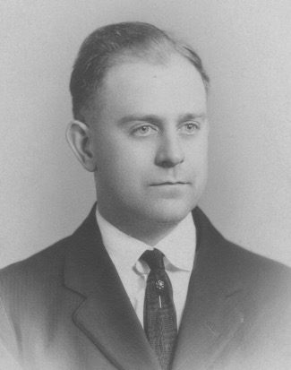

1926
His physical limitations, and the model of his own father, promote his deep appreciation for books and lots of reading. Hard cover books are sacred and held as treasures in the crowded library of his home. There is often five books stacked next to his rocking chair and smoking stand. They satisfy his reading penchant for history, biography, fiction, art, encyclopedia, and Bible interpretation. Most of the time he keeps the wisdom and wealth of his readings to himself.
His creative inclinations lead him to a degree in architecture from Catholic University in Washington, D.C., even though the mathematics requirements are a struggle for him. He uses his designing skills working for the Navy Department and Veterans Affairs Department of the U.S. Government. He also designs post office and hospital buildings, private residences, including his own in Woodside Park, Silver Spring, Maryland. He receives an award for his English Tudor cottage design of 1234 Pinecrest Circle, from the Architectural Design magazine. St. Luke Lutheran Church, Silver Spring, and the communion rail at Keller Memorial Church are among his favorite design projects. He has a two-year unsuccessful entrepreneurial effort in partnership with two other architects as they planned a "triplex" series of house plans, with house parts that could be pre-built, and interchanged, saving customers money.
Music defines much of his enjoyment of life. He has trained as a tenor and fills his life with the pleasures of singing solos, and with choral groups. A visit to his home often includes his vocal offerings. He also studies and plays violin all of his life in church and orchestral groups. This includes his own little family orchestra: piano with his wife Lillian an accomplished accompanist; and his four sons: Philip on cornet, Richard on violin or saxophone, James on clarinet and saxophone, and Paul on trombone. He has fond Washington, D.C. memories of attending the weekly Marine Band concerts under the direction of John Philip Sousa. Later on he regularly takes his family to the various military band concerts at Watergate, Washington Monument, and the Capitol.
There is often a smile of satisfaction from him as he sits in his rocking chair, lightly puffing his pipe or a cigar in front of a blazing fire in the stone fireplace, surrounded by the chestnut paneled living room. He is absorbing the instrumental variations coming from four different rooms as his sons are practicing their weekly lessons. The sons are often called on to stand the fireplace alcove and perform their latest learnings for visitors. Warren regularly listens to radio broadcasts of the New York Philharmonic, the Saturday afternoon Texaco opera productions, Band of America, the Telephone Hour, Longines Symphonette, the Fred Waring Chorus, and many others. He delights in family and friends gathering around the piano, or a summer night on the porch, for a sing-along of popular tunes and hymns.
Warren's emotions are usually guarded within his cloak of introversion and quiet affect. Embarrassing angry outbursts accompany his misfirings in house projects, or when traveling directions aren't accurate.

Simple expressions of affection can be seen when holding Lillian's hand on the porch swing on a summer evening. Quick morning and evening kisses are exchanged among family members. He is rocking me while we gaze at a blazing fire, and I run my hands across his whisker stubble. My third birthday is the occasion for the gift of a bright blue and red toy garage and a kiss. Weekly letters with his brother Charles are regularly exchanged with little variation in the content. Criticisms of others and their ways sprinkle his conversations, revealing stored resentments. He is proudest of his home and family. His discipline of the sons is by way of harsh words, never spanking. Mother does that.
Strangely, he does not speak out against the older sons when they are stealing some lumber from neighbor's homes under construction to build their own huts. He is generous in tipping mechanics and workmen, and sharing his home with relatives who needed housing. He shares tears with Lillian as their older sons, Philip and Richard go off to World War II. The two-star flag is proudly displayed in the front window.
His abundant dreams and creativity find fulfillment in his home and family with all the hobbies and habits this includes. He recounts his larger dream of owning a large farm, having his four sons owning their participating parcel on each corner. Instead, he studies magazines like Farm Journal and Organic Gardening and practices what he learns from them on his quarter acre plot in Woodside Park, Silver Spring, Maryland. There, he squeezes in a dozen fruit and nut trees, a grape arbor, vegetable garden, many varieties of flowering plants, with a large assortment of carefully tended rose and berry bushes. He loves his assortment of fine quality tools. He pours himself into his ongoing house projects: a bell tower, a chicken house, goat stalls, replacing porch posts, a fish pond with an antique pump. A visitor can count on a thorough tour of his home and garden, with accompanying stories for each item.
Warren is appropriately frugal during the 1930 depression days, saving and recycling at every turn. He usually has a dustpan and brush handy for constant clean-up. To earn extra money during the lean income days for architects, he sets up a printing shop in his basement and
turns out stationery, invitations, church programs, and pamphlets. Close by in the basement is his drafting table for non-government designing projects. Other dreaming is stimulated by frequent thumbing of the pages of the Sears, Roebuck catalogues.

There is an 1835 grandfather clock in the living room that clangs every hour through the night.
A cuckoo clock is in the hallway, clucking every hour through the night. There is also the Seth Thomas clock in the library with its quieter gong every hour throughout the night. They all provide a nightly surprise cacophony for unwitting guests. Warren winds them every week.
Guns are present but rarely used. There is an antique squirrel rifle hanging over the living room mantle. A shotgun, 30/30 Winchester rifle, a 22 rifle, and a pellet gun are all stowed along with the quilts in his bedroom closet. There are occasional sharpshooting target practices in the basement, and some skeet shooting excursions. One unsuccessful group squirrel hunting weekend is the limit of gun use. The NRA magazine is skimmed.
Vacations of two weeks per year usually include trips to relatives in Pennsylvania farm country or shared time at the Daly cottage at Colonial Beach, Virginia. A purchase of a runabout boat at age 65 puts him in the world of boat and motor care: caulking, scraping, varnishing, motor repairs, a very bulky life jacket to offset the lack of swimming skills, and fishing attempts…as well as some exciting coastal explorations

The transport through the years to these vacation places relies on an odd assortment of car brands: Essex, Devoe, Lafayette, and Nash. Antiques and their stories are gathered from the Pennsylvania relatives. They have prominent places at 1234. Whenever relatives or friends visit Warren he has lots to offer in his tours of Washington, D.C. He details descriptions of government architecture and historical anecdotes, like "the pigs that used to wander along Constitution Avenue in the old days."
He relishes downing a pint of shucked oysters when he can afford them. The aroma of a whole Lebanon baloney arriving regularly from Palmyra, Pa. pleases everyone, including the postman. Bay rum is his favorite after shave. Paper napkins are re-used. Underwear is of the single piece variety. Suspenders are covered by his vest. There is a gold watch and fob. In later years cupboards reveal the hoarding of various products like toothpaste, or mayonnaise, or bulging canned goods. The attic has bundles of the National Geographic Magazine. His office Christmas party prize of Bellows bourbon from the 1940's is never opened. A beautiful blue leather chair is secretly purchased from Vermont. It incurs Lillian's wrath of "We can't afford it, how could you?"
Politics is a frequent focus at family gatherings, all reflecting deeply engrained Republican, anti-Roosevelt sentiment. Prejudices regarding Jews, Roman Catholics, blacks are revealed in the pride of living in a "restricted" community.
Religion and its accompanying beliefs and practices are a regular part of the Seltzer family scene. Lutheran beliefs, rituals, worship, music, classes, committees, leadership, missionaries, picnics, parties, and their relationships fill their days and conversations. There is grace at meals and spurts of trying morning family devotions. Also remembered are his rants and arguments in the car riding the ten miles home from Keller Memorial Church, in contrast to the 'love' theme of the morning. Married on June 19, 1918, my parents celebrate their 40th and 50th anniversaries with church celebrations, in addition to dinner parties.
An undercurrent of bizarre beliefs surface when Lillian dies from cancer in April 1973. Warren is hysterical for days. When questioned about it, he says he believed that if he lived a good life, raised four sons, made a good home, he would be rewarded…he and Lillian would never die! Suffering and death are a sign of punishment (Job's friends' style). It is the only time it is spoken of.
His diligence for attending to, and completing projects, extends to his retirement days. He has five legal sized yellow sheets filled with things to be done. He wants to avoid the 'rusting out' and dying that his colleagues experience after their retirements. He has the wisdom to voluntarily relinquish driving his car after he hits some bushes when turning into his driveway. He is cared for by friends and church members for five years after Lillian's death.
After living in the house of his dreams for exactly fifty years (1928-1978) he has a month-long stint in a nursing facility which he dislikes because of childish activities like making pot holders or playing bingo. He longs for something more substantive. His last two months alive are pleasant with the familiar surroundings and people at the Lutheran Home in Washington, D.C. He dies there of a stroke November 15, 1978. St. Luke Lutheran Church is full for his funeral. He is interred at the Fort Lincoln Cemetery Mausoleum in Washington, D.C.

MISTER BIG

Let me show you a picture album of my uncle, Adolph Daly, "Mr. Big" to me.

The pictures are expansive, bright, defined and in vivid color. You might even be able to hear them and feel them. Uncle Adolph has an imposing presence you can't miss. All your senses get involved. His stately stature is always center stage.

His voice is big. His laugh is loud and infectious. His gestures are wide and flailing. His dress is impeccable. His hair is always neatly combed. His face is always freshly shaven. His shoes are always shined. His shirts are always starched. His eyes are always animated, He is the "alpha" in his pack of eight brothers and sisters. He has a lively brain. He is the comic. He is the consummate glad-handing-could-have-been-politician type with a quick pleasantry for almost everyone who comes within his range.

As a child I am fortunate to often have been within his range.

Here is some of what you can see with me. He is a hero type. He has been a captain in the US Army in World War I. I don' t remember him telling me any war time stories, but in a book of memories, published by his fighting unit in 1931, there is a story of an occasion when Adolph had been fighting with his machine gunners unit in France. They have taken refuge for the night in a farmhouse. He is late getting back with the unit. There is not room for him to sleep in the farmhouse, so he goes out to the barn to sleep. During the night a German artillery shell makes a direct hit on the farmhouse, killing everyone inside. Only Adolph, sleeping in the barn, is spared.

There is also a very large photograph of him, in his captain's uniform, seated on a camel in front of the Sphynx in Egypt, a copy of which is in every cousin's home. There is also box after box of military memorabilia stored under the Colonial Beach cottage. The cousins look forward to summer vacations when they can wear the gun belts, and play with other parts of the captain's uniform and equipment, look at the maps of foreign lands, and let their imaginations have a wild ride for hours on end.

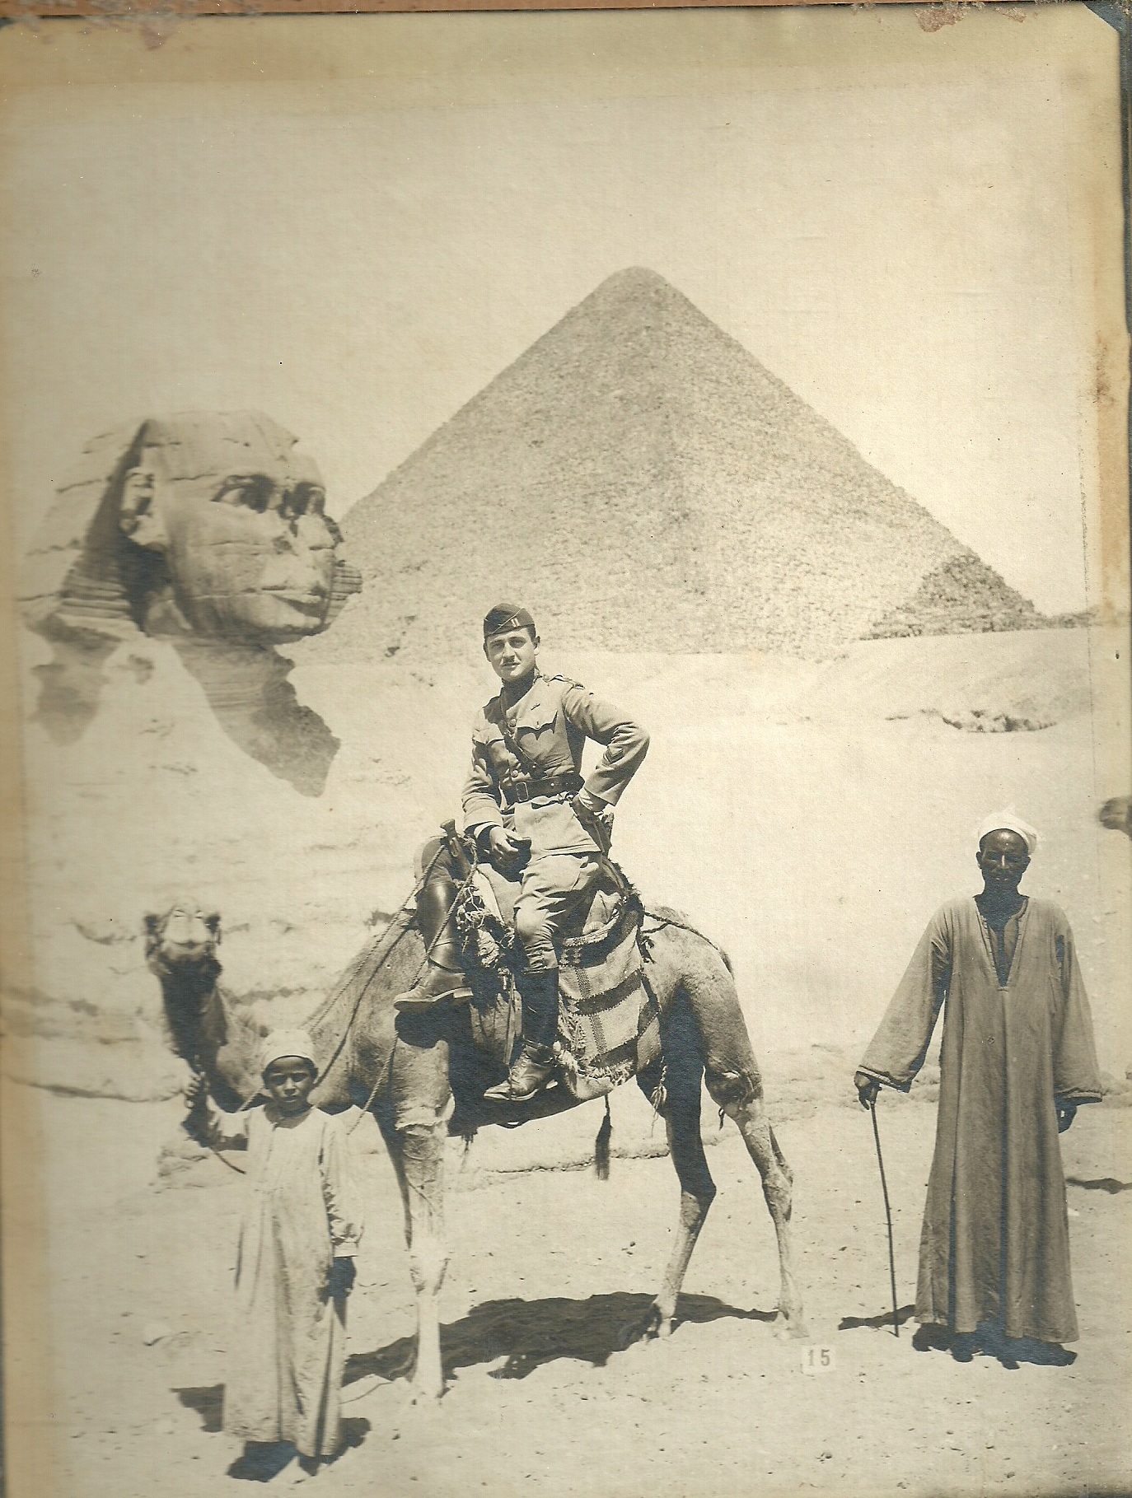

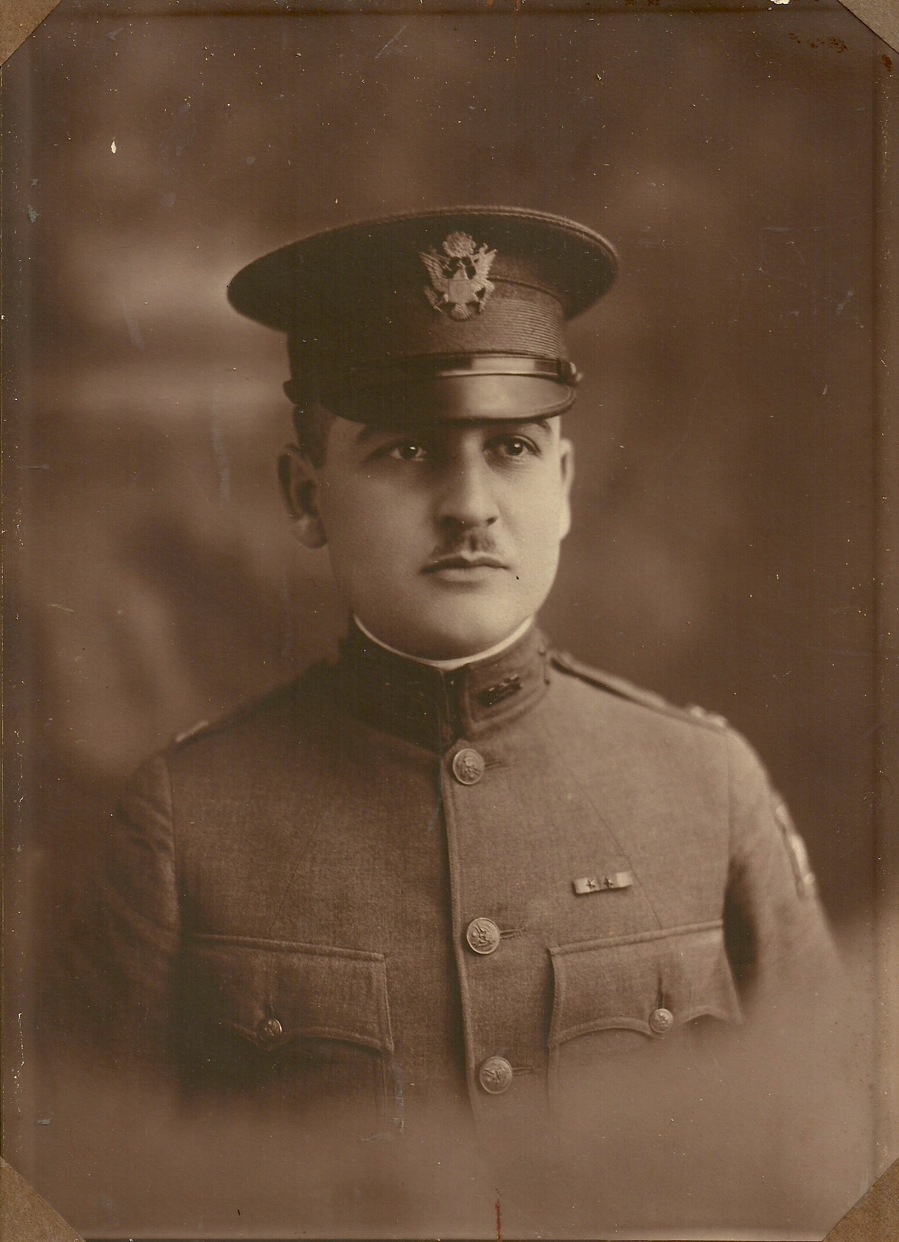

At family holiday events, he is always the turkey carver, the take charge person, and a lead sing-along tenor around the piano. A cigar and a laugh are close by. You never have to inquire about his opinion on anything, especially politics. He loves the Republicans and his friend, J. Edgar Hoover, FBI chief. He has nothing positive to say about the Democrats or President Roosevelt.

He assumes leadership of the family dry goods business at Center Market in Washington, D.C. after his father dies. There is a shadowy nine-month experiment with marriage. This generates much speculation among the relatives. He assumes the role of caretaker of my grandmother when she becomes an invalid. He drives her around in a big black 1936 Buick, with pull-down tasseled shades. (The kind I see in the gangster movies.) They live at 417 9th Street, N.E. in Washington, D.C. with Aunt Mabel and her two daughters. It is the family (20+ aunts, uncles, cousins) gathering place for holidays and Sundays after church. It's just a block away. It is here that the cousins line up next to grandma's bed, which smells of Vicks or lavender, to give her a kiss on the cheek and receive our nickel and mint.

You never find Uncle Adolph in church. But you can often find him at the racetrack in Atlantic City, where he is always just one race away from permanent fame and fortune. I never see him, or any other relative, drink alcohol. I think the lessons from WCTU (Women's Christian Temperance Union) make their mark on the whole family.

Uncle Adolph is hard working. Family is important. He takes charge of the family summer home in Colonial Beach, Virginia. You can often see him cutting the barley grass, white washing and pruning the fruit trees, repairing and painting, cleaning the outhouse, caulking the row boat, frying up a barrel of chicken for a big crowd, chortling while washing the dishes and having a cigar.

You can see him teaching me how to swim and float on my back, holding me, and then letting me go, encouraging me to relax and to keep trying when I gulp too much water. He teaches me how to muscle my way ahead of the crowd when trying to board a Greyhound bus during World War II. Gas is rationed and travel limited, and most everyone has to ride a bus. He laughs at how he can sneak "Chico", his tiny Chihuahua, onto the bus all the time, by hiding him in his coat pocket.

He is overtly generous. A box of caramels, or salt-water taffy, or a crate of Florida oranges, or a quart of oysters, often shows up at the door. In this picture album you can see six of my older cousins gleefully enjoying the weekends he plans for them in Atlantic City. Later on you can see my mother and brother and I on the receiving end of his hospitality in Atlantic City during World War II, when thousands of men from the US Air Force are filling the hotels. They train and march in formations throughout the streets, shouting their cadences, before the evening blackouts quiet the city. I am thrilled, having my first experience staying in a tourist home with starched sheets and eating at Horn and Hardart's Cafeteria. All because of Uncle Adolph.

There is a shadow on his lavish lifestyle. In this picture album you can see the clandestine gatherings and chatter of Uncle Adolph's detractors among his clan. In one scene they are in my family's living room and vocalizing their mutual suspicions that Uncle Adolph is supporting his race track habit, and his flamboyant gift giving, by dipping into the till of the family estate, which he administers for my grandmother. This is in the days of children being seen but not heard. I am curled inside the fireplace cubicle and listening to what they are saying about my Mr. Big, and not liking it one bit. My father calls him a "windbag." It doesn't change my mind. My cap pistol is at my side. In my childlike way of responding to this threatening attack on my hero, I commence shooting off my cap pistol every time they mention Uncle Adolph's name disparagingly. They don't get my passive aggressive message. They tell me to "stop making that noise." When that doesn't work, they send me outside to play.

After my grandmother dies in 1943 you see Uncle Adolph attending to a series of government job assignments. They are often associated with the state department. He has a degree from Harvard's Wharton School of Business. Similar to his racetrack experience, the BIG job always eludes him. In the midst of his unfortunate career adventures he comes to live in our home for a year or so. My father's assessment of his being a "windbag" does not abate.

In 1950 the picture album will show you Uncle Adolph leaving for Okinawa for eighteen months on a government post-war assistance assignment. He loans me his fourteen-year-old 1936 Buick during his absence so that I can commute to Maryland University in my freshman year. I am thrilled. I spend many hours cleaning and shining it, and loving the low rumble of the enormous twelve cylinder engine. Almost everything works. It does belch a fair amount of blue oil smoke, and the brakes need a lot of pumping before achieving a stop. This eventually proves its nemesis with me. At one stop light I don't start pumping the brakes soon enough and I collide with another car. These are the days of no insurance, so I have to pay the other driver for the damage. I spend most of the summer repaying the loan from my father. In addition, the cost to replace the master brake is beyond my means, so the old Buick has to be retired. Uncle Adolph is not pleased to hear this upon his return.

Some years later the picture album takes you to Uncle Adolph's apartment in Miami, Florida. He has retired from government service. He has secured an important job with a TV station as its public relations manager, at least that's what he tells everyone. He still writes often with his usual rambling political diatribes. He recounts his favorite activities there being frequent walks in the park and band concerts.

You can see that Uncle Adolph is still Mr. Big to me when I tout his exploits and personality to my four college buddies while driving to Florida on our semester break. I am expecting his ebullient and hospitable gifts to shine for us, thinking he would want to show us his TV station, and the Miami sights. Not so. He was subdued, polite, perhaps embarrassed. No laughs. No grand gestures. No cigar. No invitations. Our conversation is over in half an hour. I never see Mr. Big again.

You can see a few letters over the years, and a few reports from other cousins who visit him. It turns out that his TV station employment as public relations manager had either been of the "windbag" variety from the beginning, or has been reduced over the years to that of a part time security person, who has access to the station's letterhead for his communications.

One cousin visits Uncle Adolph in the late 1960's and finds his circumstances at the hardship level, with deteriorating health, little contact with even his neighbors and surviving on a small Social Security income. He dies alone in 1973, discovered by his landlord.

On the last page of the Mr. Big photo album, the pictures grow dark and blurred. Uncle Adolph has his brief day in the sun, when everything is bright and clear. He spends his gifts, makes life happen in grand style, and often to the great enjoyment of those around him, including me. Even though the vivid colors and bigness of Uncle Adolph fade in his end times, in my life's pictures with him, he remains "MISTER BIG"!

A SELTZER SAMPLER

On the occasion of the death of James Henry Seltzer, March 6, 2013, I offer a sampling of my memories of him that are stirred. It is my way of celebrating and honoring his uniqueness and value among us. At his death he is eighty-four years old, having been born July 7, 1928.

My earliest memory of James is when I am two years old. It is winter at our home, 1234 Pinecrest Circle, Silver Spring, Maryland. I am wearing my bright red snow suit and hat. We are both playing separately in the yard. The fishpond in the side yard has frozen over. I am trying out how it is to walk on ice. The ice gives way. The visual image etched in my memory bank is of James looking wide eyed at me from the backyard as I am experiencing the shock and fright of going down into the icy water, and probably crying out. He comes running and pulls me out of the pond. He saves my life.

Cousin Virginia, upon hearing of James' death, relates a new little piece about him. He is staying with her family (Aunt Mabel, with cousins Doris and Virginia) during the time our mother is in the hospital giving birth to me. Apparently, he is attired with a Russian type shirt, which causes them to repeatedly tease him and call him 'Ivan.' He thoroughly resents this and lets them know it.

Another early memory for me is when we are sharing a double bed at home. On a cold night we are allowed to say our prayers while kneeling in bed, instead of kneeling on the cold floor. As I am perched with bottoms up, hands folded, and my head into the mattress, my mother has to leave the room. This prompts James to give my bottom a big shove, pushing me over, slamming my head into the headboard, and humiliating my five-year-old frame and delicate disposition. He is also the one to tell me of the non/existence of Santa Claus. Despite all of my protestations, the big man won't be coming down our chimney.

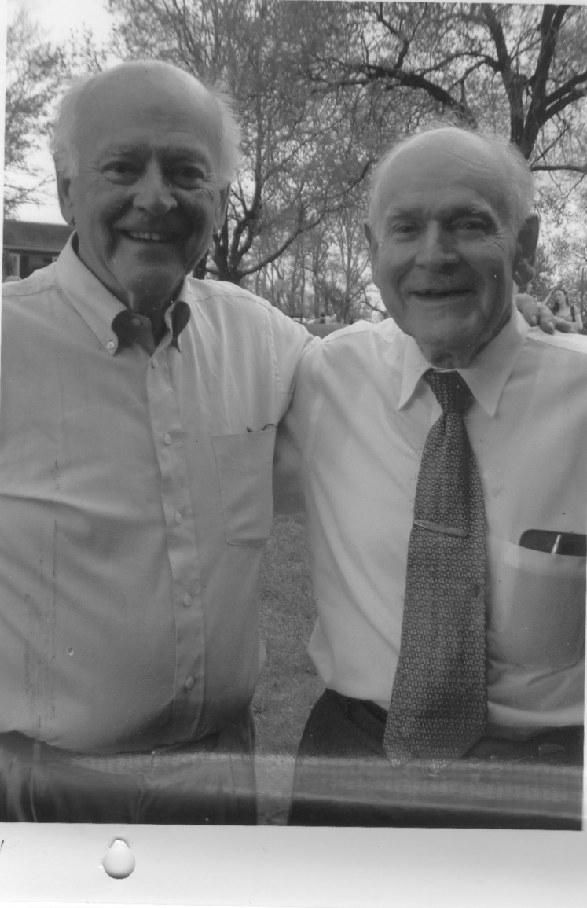
Paul (left) and James.

Being four and a half years younger, I am the "go play with your own friends or by yourself" brother. He is nicknamed 'Spike' by his group of friends, They then understandably nickname me 'Little Spike,' being the tag along little brother.

However, there are numerous times that our interests and energies coincide, and we managed some wonder filled moments together. These delightfully come to mind.

One winter and spring the two of us plan and construct a log cabin in our backyard. (See my "Cabin Fever" story). It provides months of pretend fun under the old cherry tree.

We spend two years (1943-1945) raising Elmer and Elsie, our twin pet goats. They have a stall in the back of the garage and a pen in corner of the yard. They serve as our 'confidants' and friends. They graze the weeds and grass in the Crosby Road field to help us make a clear play area for our baseball and football.

Prior to the goats help we burned the weeds off of the field. Onetime, when the winds are blowing, that burning gets out of our control. The fire department has to be called to assist our slamming the flames with brooms and shovels. In spite of the embarrassment, James and I share a smile through our reddened faces and blackened jeans and shoes.

James seems more of a loner in our neighborhood. His only friends his age are Billy Esche, Jack Whalen, and Charley Weigel. By contrast, I have about twenty to pal around with. But he and his friends have fun. Sometimes they include "Little Spike" in their plans.

One such time is their big idea to create a 'town' of their own. They lay out stringed boundaries in the field where the bank, town hall, church, school and houses are to go. James is the banker. He has watched our father working the full-sized printing press and equipment in our basement. He makes sure he knows how to use it. He designs and manufactures the linoleum blocks to print money for the town. Imaginations are engaged for many months by everyone involved, including me. I am appointed the town messenger, which I think is very important.

James and I follow the family rituals of being assigned and carrying out a host of chores around the house. My father leaves a list on his desk for each of us, naming our tasks for the day. Internally, we take pride in these responsibilities. Mother adds hers whenever the need arises. James and I share things like cleaning bathrooms, sweeping the basement, garage, and porches, painting, running the vacuum, waxing the stairs, washing windows and dishes, picking up the fruit that has dropped to the ground, wringing out and hanging the wash on the clothesline, and sawing wood with the two man saw.

During the World War 2 days we share the victory garden duties. They include the winter days of together catalogue gazing and choosing the vegetables to plant. This is soon followed by the long hot afternoons preparing, tilling, and harvesting the garden through the summer. We also learn to be responsible for cleaning our room and ironing our clothes. There is a full Saturday morning routine of jobs to be done, both with our father, and by ourselves. They are rewarded with enough money (twenty-five cents) for a double feature and an ice cream treat at the Seco Theater in the afternoon.

James and I share frequent explorations of the old Wilson haunted house next to the golf course. With adrenalin at full tilt we hear the sounds and imagine sights that send us running. Sometimes a bedded down homeless man gives us tangible reason to run in fright. Old man Wilson's golf course also provides us with an occasional chance to work for some change. We get a nickel for either a bucket of gathered golf balls or a can of tees. We usually exchange the money for a big orange drink.

Other money-making endeavors include selling the Saturday Evening Post and Ladies Home Journal on a regular door to door route in our neighborhood. All the brothers have done this through the years. We have much to show for our efforts from the Curtis Publishing company. Weekly vouchers for sales accumulate to be exchanged for premiums that last a long time in the Seltzer home. The items include sports equipment like mitts, bats, balls, bobsled, baseball shoes, and ice skates. Even a set of dinner dishes regularly remind each of us of our acquisitions. Mother provides close accounting guidance and encouragement for our enterprise.

James and I also often cooperate in working for neighbors cutting grass and gardening to earn money. We always use the old-fashioned push reel mowers, accompanied by the ever attendant bugs and summer's heat and humidity. Sometimes we even need to use a scythe when the rains keep up too long and the grass grows beyond a mower's ability to cut.

Summertime is delicious. We share some hikes to Sligo Creek with lunches packed for a day's outing. We build a teepee in the backyard. We augment our pretends of cowboys and Indians with cowboy hats, cap guns, and holsters, and rolled up paper labels hanging from the corners of our mouths for cigarettes. Occasionally, we make a trip to Cabin John together on the streetcar for the vast amusement park of Glen Echo with its scary roller coaster, fun house, and dodg'em cars. It reminds us of the fun times at Hershey's Amusement Park when on our family summer vacations to visit Uncle Gus and Violet in Palmyra, Pa. There we breathe in the Seltzer smoked bologna, or go visit Aunt Elsie in Lebanon, in Pennsylvania.

Summer also includes frequent attendance together at the armed services band concerts at the Washington Monument, Capitol or Watergate. Or a crab feast in the backyard. Fourth of July celebrations are important to us. James is big into it. At one point he perseveres in making his own cherry bombs to add to the purchased firecrackers. He wraps the gun powder in layers of tire tape, inserts the fuses, and hangs them to dry on the clothesline. We set up leftover iron water pipes on wheels for cannons. We have our battles. Uncle Charley and Aunt Edith, with her pet rooster, often travel from Philadelphia to be present. It goes on all day. Tin cans being blown into the air. Whole packages of firecracker popping at once. Punk is in the air. Smoke is in the air. The day includes picnics and ends with night time sparklers and ringing ears crowding out conversations.

Summer always includes a week or so at the Daly cottage at Colonial Beach, Va. There are loads of things to do and explore and experiment with there. Uncle Adolph's war memorabilia fill the storage area under the cottage. There is fishing, crabbing, boating, swimming, chores, porch sitting and going 'down front.' (See my "Down Front" story) Early one summer morning the two of us sneak out into rough waters with the Daly rowboat to catch a bunch of perch fish so we can surprise everyone for breakfast. His first catch with a hand line is a squirming green eel. In trying to extricate the swallowed hook and cutting away the eels innards, James takes on a lighter shade of gray/green. Close to being sick we row back to shore. There are corn fritters for breakfast. (See my "Breakfast Plans" story)

Summer also includes trying to get an invitation from our neighbor, Barbara Wolfall, to swim in her pool on a hot and humid day. We can don the boxing gloves and set up the ring ropes between the trees in the yard for some sparring. Or maybe we can sip a cool lemonade on the back porch, play some Monopoly, or put together a puzzle. We keep our sporting equipment and games in the pantry drawers. One drawer for each of us. We also try setting up our tent for an overnight or two in the field behind us, and then fending off the rain water when we don't dig ditches around the perimeter of the tent. James likes to pour over the large collection of National Geographic Magazines, always available at our house, and let his imagination play.

One scary trip to Aunt Elsie's is when a summer downpour causes roads and creeks to flood. Our father tries to drive across the torrent. The car stalls in the middle. Water is rushing in through the doors of the car and rising up to the seats. We ware panicking, thinking we will be washed away. Some bystanders on the shore come to the rescue and tow us out of the raging water.

Saturday night preparations for the next day include each of us shining our shoes, and then a spell of being in the bathtub together to get clean and to have fun spinning around to make lots of suds with the Ivory Soap. (See my "Suds" story")

Sunday trips are to downtown Washington and the rituals for attending Sunday school and church and enjoying the attentions of pastors, teachers, friends and relatives. On holidays at church there is the treat of a box of Hershey kisses. After church the family walks a block to our grandmother Daly's home. She is an invalid in bed for much of the time. The group of cousins lines up at her bedside to give a kiss on her cheek and receive a gift of a nickel and a mint. Then we can run through the house and play until the adults are ready to go home.

James and I share winter fun. It can be on Poston's big front hill with our Flexible Flyer sleds, racing, standing up, going over the bumps and into the creek. Or it can be with the bobsled, earned by older brothers, Rich and Phil, on the big Dale Drive hill. It takes the two of us, plus some buddies to get it back up the hill after a run. We share the mixed winter attire gathered by our mother. We have furry mitts that don't match and hand me down 'mackinaws.'

Palm Sunday, March 1941, is when 18" of snow falls on the Washington, D.C. area. This prevents our family from making the trip to Keller Memorial Lutheran Church at 9th and Maryland Avenue, N.E. for James' Confirmation Service. Instead, we play outside at 1234 building a monstrous snow fort and having fierce snowball battles with all the neighborhood kids joining in.

When inside at home our many shared activities include playing with 'tootsie toys' on the living room rug, with its appropriate design. It looks like streets and city blocks, a whole city for our imagination.

Other favorites include sitting in the dark of the living room watching the blazing fire in the stone fireplace cubicle and listening to the ever-present classical music programs on the radio. Among them are: The Band of America, The New York Symphony, the Bell Telephone Hour, the Longines Symphonette.

If not music, there are the favorite radio shows coming through our new cabineted Philco. We sit right in front of it with our pretzel or Cheezit snacks and dust off the wood grille designs of the speaker case while listening to fifteen minutes of "I Love a Mystery", or "Gangbusters", or "It Pays to be Ignorant", or "Henry Aldrich", or "The Great Gildersleeve" or "Fibber Magee and Molly" or "Duffy"s Tavern". The possibilities go on and on for our delight. When the radio is done we play Animals, Monopoly, Chinese Checkers, or a host of other games stored in the pantry drawer.

Other favorite winter sharings are the Sears and Roebuck catalogues. We do our looking and wishing and listing of our favorites in October. Hopefully, they show up at Christmas. Hours are spent practicing the piano for Mrs. Thompson's recital. There's also the saxophone, or clarinet or trombone, or getting the little family orchestra together to try to make some music. What the music lacks in harmony, it is certain to produce lots of laughs.

James loves guns. We have lots of play around guns together. It is wartime and he has a German army helmet. We have wooden guns, rifles and pistols, and we run about, climbing in and out of the chicken house and playing "guns". His interest in guns develops into having real antique rifles and pistols. Not only does he have them but he uses them in target practice. He makes the ammunition for them, melting lead into bullets and casings for the powder charges. We practice shooting in our basement with our father's twenty-two rifle and pellet guns. James is on the Blair High School rifle team, and in the rifle club. He leaves me behind in this. I just watch him without following. In later years he sells all of his guns and buys a rototiller with the money. It is his version of "turning swords into plowshares".

We have many Halloween adventures together in the neighborhood with our unkindly acts of soaping windows and screens and leaving tipped water buckets at people's door to spill into the house when they open the door. Our mischief extends beyond Halloween. In my last conversation with him he asks if I remember "Our Secret"? I don't. I do remember being scared and hiding in a field with him and his friend, Billy Esche. I remember police car search lights moving over our heads and all around the field. I don't know why. He says we are "on the lam from the police" because we have been going around the neighborhood ringing people's doorbells and then running away. This causes enough upset among the neighbors for the police to be called to find the culprits. They don't catch us. We don't ring anymore doorbells. We never tell this little "secret" to anyone.

I embarrass James one night at the Silver Theater in Silver Spring. The theater is full and watching "A Song to Remember," the life of Frederick Chopin, played by Cornel Wilde. In the dying scene with his tubercular blood dripping on the piano keys and the tune of "Till the End of Time" being played, I am moved to tears, actually, bawling. James tells me to shut up as he cringes from everyone around us looking on. I'm not sure if we ever go to a movie together again.

James often occupies himself by himself. He collects stamps. He diligently disciplines himself to follow the Charles Atlas 'dynamic tension' exercise formula for body building in his teens. Brother Richard has purchased and followed the regimen before him with success. Both of them have the motivational "no sand in your sandwiches at the beach" come to fruition.

He enthusiastically experiments with his chemistry set in the basement. Plumes of smoke belching up the outside basement steps causes our mother considerable concern.

On another occasion, as a teenager, he thinks it will be clever to produce our own home-made root beer. He secures twenty-four, large, clear bottles. We have a capping device. He finds the recipe, buys the yeast, extract, and sugar. He makes the mix, funnels it into the bottles. I watch. Mother watches. He wipes them clean and neatly lines them up on the top shelf of the pantry cupboard to 'cure.' Some weeks later, we are having dinner at the kitchen table and an explosion occurs. It is a bottle of root beer blowing up. We run to see the sweet liquid foaming all over the pantry walls and floor with lots of splintered glass mixed in. In the midst of the clean up another "Blam, blam.' and another two bottles empty and knock over more bottles, which then explode. More cleanup.

Before we are done cleaning up, twenty of the twenty-four bottles have made their mess all over the pantry. The yeast is hyperactive and producing way ahead of the recipe's schedule. We quickly uncap the remaining four bottles, hear their hisses, and see their foaming bubbles drooling down the side. We capture enough of the sweetly fermented brew to enjoy its yeasty bite. There are lots of laughs to accompany the repetition of the story over the years.

At fourteen, James asserts his independent nature, rebels over some contested issue, and runs away from home. He takes his stash of silver dollars, acquired as gifts over the years. (He prefers the 'real money' to the paper stuff). With a small bag of clothing he leaves in a huff one morning, never to return. He makes his way down Georgia Avenue from Silver Spring to Union Station in Washington, D.C. He takes a train to Philadelphia. There he proceeds to look for lodging and maybe a job. He quickly gets rejections on all fronts. His angered ego begins deflating. He has second thoughts about the adventure. He gets back on a train to Washington the same day and returns home. Not much is made of it by our parents. Life goes on.

He follows closely the progress of World War 2, its details, and our involved older brothers and cousins. He is in high school at the time and is proudly part of the government organized 'youth army.' They are uniformed for possible future engagement. He never joins the Boy Scouts. He never has a girlfriend in his growing up years. He is reliable and disciplined as a three year after school employee of Westland Printing Company in Silver Spring. He has his own small printing business, following in our father's footsteps. There are pets in addition to the goats. There are ducks, rabbits, guinea pigs, and a dog or two wandering through. He also does lots of work with our chickens, cleaning the shed, gathering and washing eggs, chopping off heads and plucking feathers to get them ready for Sunday dinners. He gives frequent gifts, e.g., Cesar Franck's Symphony in D Minor to our parents. A Hohner harmonica from Germany for me.

In college years he is more on his own. I watch. He starts at the University of Maryland, following our older brothers, Phil and Rich. He tries pre-med, reaching for the inspiring example of our physician grandfather, whose surgical instruments have been a part of our play times. He is more disciplined than I, but he still does not do well in his first year. Discouraged with himself, he moves to a back-up plan and joins the U.S. Army in 1946. After bouncing around several training options and wrecking a truck as an army truck driver, he lands in an army band, and plays his clarinet for the next five years with his tour in Germany. He travels Europe extensively, taking it all in in his intense style. He tries lots of things as he is growing up and out. He meets Eleanore, his bride to be, and he describes how they take frequent trips together through the Black Forest.

James returns to America in 1952, without Eleanore, on an emergency leave to help out at home with our father's cancer/diabetes/surgery recovery. Eleanore follows six months later.

He re-enters the University of Maryland as an agricultural student with majors in horticulture and poultry husbandry. Unlike his earlier academic trials, he aces every subject. James and I connect once again, as I am also a U of Md. student at that time and living close to James and Eleanore's temporary housing. We both enjoy playing in the marching/concert band, going to ball games, and also the inaugural parade of Dwight Eisenhower in 1953.

Daughter Soraja has the privilege of being born in the back seat of the family 1948 two tone green Nash. James is called by Eleanore from his chemistry exam to race them to the hospital for the birth. It is a difficult trip, having to negotiate through the U. of Maryland Homecoming parade on the way. Soraja is healthy. They all survive. He graduates from college and is offered a job with Perdue Chicken Company near Salisbury, Md.

James is my best man in my first wedding in 1956. Other brothers are also involved in the big "do" with 500 guests. Rich solos on the violin. Phil officiates the ceremony. There are eight bridesmaids and eights groomsmen. James has never done anything like this before and knows little about the proper protocols. Neither do I. I don't know what to tell him. We follow the instructions of others as best we can, and pretend we are comfortable with it all. We smile our knowing smiles.

There are infrequent occasions for James and I to connect after that. Sometimes at family holiday gatherings, or larger clan reunions. He becomes active and a leader in the Jehovah Witnesses organization on Maryland's eastern shore.

For reunions, the Seltzer brothers usually manage to bring our musical instruments out of moth balls and have lots of laughs trying to get into tune and make recognizable music. James has become quite accomplished on his clarinet through his long years of practice in the army bands. We try all kinds of arrangements. When we have two or three days to work at it, we can make some decent sounding music together.

The Seltzer brothers have two significant gatherings in later days. The first is when we meet at 1234 Pinecrest Circle to dispose of its furnishings, after our father dies in November of 1978. Dividing the goods that have accumulated over the fifty years of living in the same house that had been designed and built by our architect father in 1928, is a reason to pour through the many shared memorabilia.

The second brothers meeting is at Richard's Ocean City, N. J. apartment in April 20, 1991. This is the 100th anniversary of our father's birth. We spend the weekend together, walking the board walk and watching the waves. It is a grand opportunity to bring together many missing pieces in our family memories and relationships.

To go beyond this sampling of memories of James, I characterize him as having the gifts of intensity, persistence, discipline, enthusiasm, a generous and ready display of humor and laughter. He has a penchant for experimenting with alternative lifestyles and medicines. He is a purist. He likes growing his own food and grinding his own grains. He is not afraid to go against cultural trends. Employed as a state health inspector for most of his years in Snow Hill and Ocean City, he is aware of what needs fixing. His memories of parents and childhood are laced with expressions of wrongs done to him by his parents, and things of which he didn't approve. But none of these negatives is able to quiet his giant laughter and gentle spirit.

I am glad that we are brothers.

A BROTHER'S BIRTHDAY PARADE

(Born June 5, 1923. Happy 90th Birthday! Richard Warren Seltzer)

Ninety years of life lived and memories stored. They're all here, in your psychic treasure chest. The happy, the sad. The fulfilling, the frustrating. The warm, the chilling. The cherished, the stifled. This is your day to celebrate them all, and savor them all, quietly, with a gentle smile. It's quite a parade.

My entries in your birthday parade are abundant even though I am ten years late getting to your parade route. Perhaps some of my memory nuggets will trigger more of your own.
My earliest image of our connection is in our parents bedroom at #4 Pinecrest Circle, Silver Spring, Md. It is a summer afternoon. You and brother Phil are in charge of me, a three-year-old, getting his nap. The three of us have the old green flowered comforter to share on the floor. I am happy for the attention from my big brothers. So happy, that I am finding any way I can to enjoy the moments of play and banter without succumbing to sleep.

You try several strategies. Things like, "Lie down between us, close your eyes and we'll all go to sleep together." Or, "We'll help you count to ten over and over again." Or, "Stay still and we'll put our arms over you, and you can listen to our breathing." Or, "If you settle down and go to sleep, we'll treat you to a Good Humor when the truck comes around at four." This one can be persuasive.

I remember watching in awe as you and Phil do your time delivering the Saturday Evening Post and Ladies Home Journal for the Curtis Publishing Company. Week after week you accumulate their vouchers which are then traded in for prizes like a bobsled, baseballs, mitts, and shoes, a set of dishes, ice skates and all sorts of goodies. I eagerly take my turn at this treasure trove source later on.



Some people lament having to be the youngest child in a family because they have to make-do with hand-me-downs. I love them. Among them are your green sport coat with the yellow stripe, sports equipment, your adventure hat that I cover with my signs, buttons, and insignia. Most especially, I appreciate being gifted with your racing bike with its curved handlebars. I re-fit the bike several times with new chrome fenders, paint, wheels, and an oversized front basket for the Evening Star deliveries. It serves me well for ten years of growing up in an expanding Woodside Park, traveling to and from school, picking up groceries, and dashing up and down the dirt and gravel roads with my Woodside bike 'posse' of twenty friends.

I have fond memories of sharing Christmas days with you. Our imaginations have field days under the tree with the Lincoln Logs, lead soldiers and the sleek Burlington Zephyr electric train with its aroma of hot oils.

You big brothers usually get along well and shared lots of interests. You take the long trolley ride to downtown Washington, D.C. every Wednesday afternoon for your violin and piano lessons with a very strict Mr. Harrison, who often leaves you upset and in tears with his admonitions. You diligently pursue your musical talents throughout your lives, setting an inspiring example for this younger brother. 1234 Pinecrest is often graced for hours at a time with your practice sounds of violin and saxophone, and Phil's trumpet and piano, to the smiling satisfaction of our parents.

It all develops into a little family orchestra over the years, playing our own renditions of the hymns used in the Keller Memorial Sunday School orchestra and semi-classics from father's Rebew orchestra. At gatherings of family and friends there are usually solos and duets, and group singalongs offered as the evening entertainment.

I remember following your musical dreams beyond our home to the Max Calloway Dance Band, university bands, talent shows, and later on, symphony orchestras and choruses. There are even your melodic delights on the "Sweet Potato," or the bugle, or harmonizing with cousin Doris, accompanied by an ongoing stream of wit and horsing around. It is fun for me to watch and listen.

I am in the background admiring my older brothers and their abundant play. They often double-date. There is Lucille, and Barbara, and badminton, and croquet, and dance events at Hershey Park, and Colonial Beach. One party at 1234 is so lively with swing band music and everyone jitterbugging that our father is worried the living room floor might give way. He intervenes in favor of slower music.

Adventure is always in the foreground for you. I see your excited preparations for your summer pioneer trip to Montana, with our neighbor, Mr. Thomas. Our parents have serious reservations about it all. But you forge ahead. We look forward to your letters recounting the adventures. Upon your return you bring a decorative pillow with "mom" embroidered on it, and a horse's skull you had found while camping out in the wilderness.

You older brothers also have some disagreements, and even one big fight in the kitchen. I don't remember the issue, but I do remember our mother trying to break up a heated physical encounter. It resulted in your getting one big score, leaving an aluminum pot with its bottom caved in, from having been slammed onto Phil's head.

You have a rebel in you. At one point in high school our parents have to make several trips to Blair High School to deal with your behavior with teachers, principal, and finally, Mr. Knight, the superintendent. Your first year at Gettysburg College continues the rabble rousing, even though you are a pre-ministerial son of Keller Memorial Lutheran Church, and a protege of Dr. Samuel Nicolas. With some embarrassment, you transfer to the University of Maryland for your second year, before joining the U.S. Army to help out with World War II.

I see you and Phil coming home from your summer nursery jobs with bodies growing tanner everyday as you sweat in the sun to earn enough money to buy your 1937 black Ford sedan together. (I would have preferred the earlier choice of a 1934 purple Ford convertible).

At some point in your college days, you and Phil are double dating to a Saturday night basketball game at Maryland University, using the family's 1936 gray Lafayette car. I am up early on Sunday morning to deliver The Sunday Star. On leaving the house I smell the pungent after-effects of a fire. Wide-eyed, I look inside the Lafayette. It is all black and charred. Someone in your group of riders had evidently left a lighted cigarette on a seat. Upon leaving the ball game you are greeted with the smoke and flames of a car engulfed. The relational aftermath at home smolders for a long time.

I admire your thorough involvement at the University of Maryland. I look over your shoulder when you are drawing and re-drawing cartoons for the Old Line Magazine, and colorful recreations of the seven dwarfs of Snow White. You are later in theater productions like "Arsenic and Old Lace" as 'Teddy Roosevelt,' bugling the 'charge' into his imaginary battle.

There are some months during the war when you need transportation to and from your army camp to Silver Spring. I'm not sure of the details, but I do remember you convincing our parents to let you use the Lafayette during those months. We make do without a car. The car breaks down on you and there is quite a long stir getting everything sorted out.

For a time in the war you serve as the bugler in 106th Infantry Division. Just before they ship out to Europe's war, you transfer to the University of Pennsylvania in Philadelphia for intensive training in the German language and intelligence warfare tactics. You are saddened when you later hear that your bugler replacement is killed in action.

A vivid memory in our parade here is my having been a part of your wedding on your birthday in 1944 in Philadelphia. It is also D-day in the war activity. All the church bells are ringing throughout the day. You have met Helen, a beautiful secretary, while dancing at the Stage Door Canteen. The ensuing wedding brings my parents and me to join Uncle Charley and Aunt Edith as our family's presence for your wedding. Brother James stays in Silver Spring to tend to the goats and chickens there. The modest ceremony and reception is in the Germantown section of Philly. We all follow your letters and pictures of your honeymoon in the Poconos and thereafter. We learn of your adventures in Officer Training School and the incident of the train leaving the station with infant Ritchie on board, when you were not.

After the war, you and Helen move into 1234 for some months. It is a turbulent time of intense relationships. You and Helen are frequently in heated fights. There is lots of tension for all of us because of ongoing undercurrents, opposing ways of life and expectations.

I am in my rebellious days of eighth grade. You are just out of the military, where discipline is paramount. In an argument with my father I call him "a bastard." It is heard by all in the house. You bolt from your room, grab me by the belt, and shout about the lesson of respect I need to learn as you lift me up the stairs to my room, strip me down, and proceed to beat me to a pulp. I learn that lesson. I also have to admit the source of my two black eyes to my friends at school the next day.

You later move to the Poston's cabin on Pinecrest Circle. The distance and separation give us a better perspective without frequent entanglements. I enjoy babysitting Ritchie at the cabin with a big fire roaring in the stone fireplace. You work part time cleaning St. Luke Church while continuing your college career at Maryland University. You also take over the new Boy Scout Troop #205 at St. Luke Church. I work my way to Senior Patrol Leader under your tutelage.

You write me a memorable six-page letter of advice as I am commencing my college career at Maryland University. It includes lots of helpful, if somewhat overwhelming, tips of how to transition from high school, what to join, how to study, and how to enjoy the process. I follow your advice.

I continue to follow: your evolving career in teaching; life on Viers Mill Road in Rockville; earning your doctorate; and career in education administration in various locations. We connect at frequent family events, but everything is mostly at a distance. I watch your progressions through various job situations. I enjoy your "Schnitzelbank" painting renditions in your Huntington home, and seeing the ways you continue to participate in the arts, music, acting, and modeling. You play your violin for my first wedding in 1956 and serve as best man for my marriage with Susan in Syracuse in 1982.

Concluding the poignant parade with you on this 90th marker, I remember best how music, in its many expressions, has been in your fiber, and in our connections over the years. Most recently, with fondness, I see our afternoon, together with Helen, and your devoted children, Raven, and Ritchie, in the community room of Edelweiss Home. We heartily sing along with lots of the old favorites, and witnessing the way our music, for those moments, trump your usual daily exasperations with communication. It is a treasured moment.

Thank you, dear brother, for this parade of my memories with you. No doubt, your parade is much longer. Continue to enjoy that as well. Happy 90th Birthday!

THE GIGGLE GIFT

I have known Nancy from the beginning of her seventy years. I'm standing in the bright sunshine on the green grass of the Takoma Park Hospital on July 26th, the day after her birth in 1943.

I am looking up to the fourth floor where her mother is holding her newly born up to the window for me to see. I am ten years old, and children are not allowed inside the hospital as visitors. I am now an uncle. Proud, but not sure the role.

Imagine if I had been able to be on that fourth floor, and in that room, on that day, it is likely I might be able to detect some infant level sounds of a giggle coming from Nancy Lee Seltzer. From my perspective of being with Nancy at hundreds of personal and family gatherings over many years, I suspect that her giggler genes are eager to get going from the get-go. Memories highlight happiness. Smiles, giggles and laughter are a dominant presence throughout her life, and ready to be triggered at the slightest provocation. Even in the midst of a crisis or sadness, her giggle gift is waiting in the wings for its expression.

The giggle gift is in her genes. Of course, it usually takes two to get the giggle things unleashed. For Nancy, it seems it is coming from her Grammy early on. They play table games like "Animals" or "Spoons" or "Chinese Checkers." Out of nowhere a giggle session erupts between the two of them, and it continues to the delight of everyone present. Everyone is drawn into the contagion of silliness, partly quizzical as to its source, and partly just enjoying the benefits of a laugh for whatever reason.

The giggle gene expands to include her sister Ruth as she comes of giggle age. The family moves from one venue to another-- Silver Spring, Washington, D.C., Lordstown, Colonial Beach, Camp Luther, Akron, Chincoteague , and Wheeling. The two of them can now be counted on. They find a reason - or not, - at meal time, or game time, or music time, or porch sitting time, or campfire time, to start with a simple little twitter. It grows into a chuckle, and then quick, wide-eyed glances to each other, to signal whether this is another effervescence bubbling unceremoniously from their deep places. Then, in grateful exuberance of heart and lung, there is the rocking back in rhythmic cadence of their bodies. They know that this is one more unique connection for them, as it is and for the rest of those gathered, who again wonder in delight as to what it is all about, and not knowing or wanting, or caring, when it will stop. Nothing more is needed. No reason. Just tear filled, shared laughter. Joy!

So Nancy is walking with us, bearing many gifts. One gift especially, cannot be missed. The giggle gift reveals a profound ingredient at her core. It shows the rest of us that spontaneous outpourings of laughter are the nectar of the gods. She lets us also bathe in hers.

Thank you Nancy Lee and have a very Happy 70th Birthday!

Bathe in our love,

Paul and Susan

HERMAN AND HELOISE

Herman and Heloise are worms. They are discovered under a rock. The rock is in the backyard of 'Under the Eaves B&B,' just outside of Zion National Park in Utah. Six-year-old Azzah, and I, as her Grandpa, find them while trying to think of something interesting to do on a lazy afternoon in April, 2009. Everyone else in our family group is preoccupied with their own pursuits and getting ready to go to dinner.

I say, " You know what, Azzah? I bet if we look under these rocks lining the garden we might be surprised to find some creatures that love the dark."

It seems to pique Azzah's interest for the moment. Together, we start rolling back the soccer ball sized stones separating the garden from the grass.

"Nothing here," she says.

I say, "Let's make sure we look really closely. Let's get down on our hands and knees, and scrape the ground around a bit." Still there is nothing to be seen under several rocks. Then when we turn one more we are excited to see two worms wiggling to get away from the shock of the new bright light, and back into the darkness of the soil. Azzah and I watch them for quite a while.

We lie down on our stomachs and prop up our heads with our hands, our elbows on the ground. It is fascinating. We watch every squirm of the worms.

Their little slimy bodies, half covered with grains of dirt, slithering in different directions, as if to say to each other, "What happened to our quiet little dark and sheltered neighborhood? This bright light is too much! Let's get out of here!"

After a while of intense noticing of these other worldly creatures, I sense their plight and say, "I guess we should put the rock back and let them get back to the darkness they love so much, and where they can get on with their lives there."

"OHHHH, moaned Azzah, just a while longer?," having been quite taken with the newness of these creatures and their little world. Then I say, " Well, okay, why don't we introduce ourselves, and give them a name in case we meet up with them again?" Azzah likes that idea and gets into a little conversation with them.

I suggest, "I'm sure there are lots of things that they would like to know about you. Why not tell them a little about yourself, like your name, where you live, your favorite game, your friends at school, stuff like that?" So she does, with a few prompts from me.

I say to them, "It's so nice to meet you. It looks like you have a very interesting life here. It's hard for us to imagine how it must be to move around in the dark all the time and not be afraid, or always bumping into something. Anyway, we'll let you go for now, but first we're going to give you names so that we will know what to call you when we meet up again. Azzah, how about calling them Herman and Heloise?"

She likes that and says, "Goodbye for now ... Herman and Heloise," with a smile on her face, and a knowing glance at me. We gently lay the rock back in place.

I say, "We can come back every now and then and check on them," Azzah agrees, and takes it on as her personal assignment. We hold hands. "Some lovely new friends, eh?' (I am Canadian).

The rest of the family is ready to go to dinner. Azzah excitedly recounts the backyard adventure, where she and I had met some cute worms under a rock, and named them Herman and Heloise.

She wants to see them again. After dinner she hurries everyone back to the B&B so she can have another 'H &H' look. She and I gingerly pull back the rock to maybe see Herman and Heloise again.

"OH! OH! What the...?" she gasps as she jumps back. There is a mix of confusion, surprise, and delight at what she has now found under the rock where she has been talking to Herman and Heloise just a couple of hours before.

No worms now. In their place are two Hershey chocolate miniatures! What has happened? The wheels are turning in her six-year-old head. Have the worms somehow morphed into chocolate? Of course, she doesn't let the rush of questions prevent her from unwrapping and savoring the Hershey's in short order.

"Amazing", I say. "Let's put the rock back again. You can check it another time until we can get this all figured out". Her questioning delight is quickly spread around into the ears of all the adults. They respond with a mix of knowing smiles, and words of wonder at what has happened. Azzah has much to think and dream about until morning.

At daybreak she is up and out before anyone else. She checks the rock. Squealing, as she runs back inside to her groggy parents, "I don't believe it, Mommy. There is more chocolate under Herman and Heloise's rock." (It is being consumed during her report.) Her parents relish her childish excitement... with smiles. Azzah spends the minutes before breakfast looking under more rocks in the backyard, to assess the extent of this phenomenon. Nothing turns up.

But the news has to be broadcast. She tells her grandparents of the morning's discovery. While breakfasting in the restaurant she moves to neighboring tables to declare the miracle of which she has been a part. She asks if others have experienced the same magic of Zion National Park. Everyone says that they would be sure to check it out where they were staying, and on their way around the park trails to see what can be found.

Everywhere she goes that day she is looking, and with everyone she meets, she strikes up a conversation about the miracle of Zion Park, and her worm friends, Herman and Heloise. The miracle continues off and on under the rock at the B&B and also rocks along the trails of the park, especially when she is tiring of the long walks, and no one wants to carry her,. They wish she would stop her whining.

I would say, "Hey Azzah, we'd better check under some of these rocks, to see how far this thing has spread." Every once in a while, not all the time, and in some very unlikely places, there is evidence of Herman and Heloise. Another chocolate miniature is discovered.

"This is a wonderful place," Azzah sighs. Adults are looking up at the majestic cliffs and rocks and waterfalls and trees and blue skies. Her beauty is being found right under her feet, under a rock or two.

It is all she talks about. At bedtime her father feels she has to have some other reality be a part of her exuberant and expanding fantasy world. He tells her that actually it is probably Grandpa who is hiding those Hershey's under the rocks, just so everyone could have some more fun on the vacation.

Grandpa chimes in. I admit that I have had a part in the scene, "Isn't it fun to get excited, think about, and enjoy?" She doesn't answer either of us but pulls up her bed covers. She closes her eyes. The wheels are turning again in her little head as she processes all of this information.

The next morning she has made her decision about what was true for her. Before everyone was up, she is running back inside, shouting, "Herman and Heloise have been back again and left her more chocolate. Isn't Zion National Park a magical place." And, "Thank you, Grandpa."

The lesson for us in Azzah's story about Herman and Heloise and Hershey's is that you never know what might turn up when you look closely at what is going on in other worlds, even under rocks. There is always more treasure to be discovered. Maybe this is what happened when gold was discovered out west, back in 1849. Perhaps then it was because of some magic performed by earlier relatives of Herman and Heloise.

ODE TO A MIRROR

The most amazing gift...

That I could give you, and you could give me...

There is much to give you.

What can best celebrate your birthing?

That is the gift for which I search.

Shall it be a diamond ring, to assure you that you will never be poor?

Shall it be a mansion, to keep you warm and comfortable?

Shall it be a fence, to protect you from all dangers?

Shall it be a great banquet, to nourish your every appetite?

Shall it be a magnificent painting, to stimulate your creativity?

Shall it be a love letter, to confirm for you our connectedness?

Shall it be a brilliant symphony, to fill your ears with harmony's joys?

Shall it be a photo album, to remind you of your abundance in nature and friends?

Shall it be a cathedral, to point you to your origins and future?

All these, and more, can be sought and treasured.

I will pass them by for now.

I have decided.

The best gift from me to you shall be a MIRROR, clear and detailed.

So that you can see with expanding clarity,

The real you.

The image that reflects your divine core of goodness, truth, and love.

The catalyst that shapes your perspectives and perceptions.

And moves your every step to the next highest version,

Of the greatest vision, you ever had of yourself.

What you see in this mirror is the best gift there is!

MUSIC MAGIC

Music has always been magic for me. There is not a time I can remember when the magic of music has not been close at hand to transform the dancing decibels into my life support system. A sea of melody has always accompanied me. Saturated me. Buoyed me. Propelled me. Nourished me. Quieted me. Enveloped me. Immersed me. Excited me. Its many variations provide the language of relationship, connection, and harmony.

I am never the expert or prodigy. Rather, I am the happy participant. A follower, A striver. An experimenter. A cheerleader and admirer. In the hundreds of images that memory provides, the music and its magic repeats itself. We can retrace parts of this path together.

Early memories from HOME bring back morning wake up calls. From my bed I hear my mother playing her favorites on the piano and singing some hymns. Through the day she sings and whistles encouragements to the canary or parakeet. She plays her recordings of "Teddy Bear's Picnic" or Cesar Franck's Symphony in D Minor. There are other recordings ringing out the familiar big band tunes from my older brother's collection. She sings along with Don McNeal's Breakfast Club on the radio. After dinner, our shared dishwashing is often infused with some harmonies, like Brahm's Lullaby.

Versions of 'surround sound' in my growing up years include my three older brothers practicing instruments from different rooms. Phil is on the piano or trumpet. Rich is doing violin and saxophone. James is clarinet and sax. All the while, I am sitting in my father's lap in the living room rocking chair as he listens with a proud smile stretching his lips after a puff on his pipe.

Every day of the week provides all sorts of music's magic from the radio. There is Saturday afternoon with the Metropolitan Opera and a Milton Cross commentary to assist the imagination with the foreign languages being sung. A wintry Sunday afternoon finds me lying on the sofa, gazing at a blazing fire and letting my psyche play with music of the NY Philharmonic Orchestra concerts. Throughout the week our radio is alive with the Sousa marches on the Band of America, or the classics of The Bell Telephone Hour, or Longine's Symphonette, or Phil Spatanly's All Girl Orchestra.

At home I am hearing my father practicing his violin parts for the Rebew Orchestra, or the Keller Sunday School Orchestra. This is a large popular group which includes professionals from the nearby Marine Band as the first chairs of the sections. I take note of Lester Moreland, a young and handsome trombonist. My parents love to sing, and often practice their church choir parts and solos. Occasionally, they host a party for the choir at our home, and then the fun music never quits, to my delight.

We also have our own little family orchestra. Before I am ready to make music I am gifted with a slender walnut baton from my father, so I can be the 'director.' Sometimes we perform as a group or as soloists for visiting family and friends. A favorite Christmas gift one year is a child's xylophone which occupies me for years. There is more music from the farm bell in the back yard to call us home from play, or a doorbell with multiple chimes.

Singalongs around the piano are regular fare at family gatherings. Extended family musicians like Aunt Mabel on the piano, and her daughter Doris singing. They are always up for a rendition of something. Family nights out often take advantage of the free concerts offered in nearby Washington, D.C. by the Marine, Army, Navy or Air Force Bands at the Capitol, Washington Monument, or Watergate. I hear my older cousins singing and my brother Rich on his "Sweet Potato" (He would try out anything). The bugle is always close at hand for practice or a flag raising by the brothers.

I listen to stories about strict music teachers like Mr. Harrison, who can bring my brothers to tears with his discipline. I hear about my father's exposure to the likes of John Philip Sousa, the march man. Music magic is contagious for me. I can be heard imitating an opera singer with a Palliacci aria from a rowboat in the middle of the Potomac River at Colonial Beach. I think I am alone and far away from listeners until I return to shore and confront a small crowd eyeing me with knowing smiles. Of course, belting out tunes in the shower and whistling along my paper route is my standard operating procedure.

When I venture from my home into my NEIGHBORHOOD of Woodside Park, music continues to hug me as a dear friend. My senses are awash with the pleasantries of music and its magic.

There is Mrs. Parker next door, who, thirty feet away, for at least an hour or two each day, persists at her upright piano with repetitions of Tchaikovsky's Piano Concerto #1 until she has it memorized.

Moving up several musical notches are John and Evelyn Thompson, our neighbors to the rear of our house. They are both accomplished pianists. The two Steinway grand pianos and Hammond Organ they squeeze into their narrow living room attests to their love of music. Their frequent piano solos and duets shower into the neighborhood, delighting everyone, especially during the summer months when all the windows are open.

Mrs. Thompson is my piano teacher for several years, as she is for fourteen of my playmates. She holds recitals in her home for this unique group as soon each of us has memorized two selections. On recital day we students occupy each of the fourteen steps to her second floor. In our starched shirts or skirts, we nervously await our turn. Parents are squeezed into every other available space on the first floor and porch. There is also always be a professional performer, like Glen Carow, to inspire us neophytes in our efforts. I remember him playing Stravinsky's "Fire Dance." At one rapid passage his hands are moving so fast that they're only a blur to my eyes. He puffs me up one time by asking me how I perform a tricky maneuver in Grieg's "To Spring".

In the summer of 1945 Mrs. Thompson somehow persuades us students that it would be fun to see who could spend the most hours practicing. The competition catches on and we find ourselves practicing two to four hours every day. We improve noticeably.

Throughout the years our neighborhood gang has its continuing fun with music. There are ukelele's strumming, with country music being harmonized on back porches and in the basements. Magic, and fun.

My excitement and saturation with music's gifts expands at the various levels of SCHOOL. It starts at ELEMENTARY school with my being selected leader for our kindergarten band at Woodside School. Mrs. Lyons has never heard anything quite like our assemblage of tambourines, triangles, drums and blocks.

A regular part of the school routine are the weekly gatherings in the assembly hall to listen to classical recordings coming from the stage loudspeakers. We are encouraged to let our imaginations conjure up our unique scenarios that might fit the mood and tempo of the music.

Occasionally, a semi-professional performer provides inspiration. There is an amazing 'whistler' who, for a long time, I try to imitate. When back in our separate classrooms, a part of most afternoons finds us with our "America Sings" songbooks open and calling out our favorites where we can all join in a class sing along.

The difficult years of JUNIOR HIGH school are still laced with the pleasantries of music to carry me through. Mrs. Nixon, music teacher, keeps us singing, and taking us on musical field trips. Once we go to the National Theatre in Washington, D.C. where we sit in the last row of the second balcony to see "The Desert Song" and wait at the stage door for cast autographs. There is a day when I help at the International Day festivities at school by playing my recently memorized pieces by Norway's Edvard Grieg, "To Spring" and "Concerto in A" (simplified version). I take ballroom dance lessons. Charles Wickre and I try out a start-up dance band in ninth grade. It has lots of dream power but is short on musical talent at this point.

By HIGH SCHOOL the joys of music's magic has been established. I am ready to set my unique course. Trombone is to be in the picture. Lester Moreland has planted seeds for it being appealing. Our little family orchestra can use a trombone. Montgomery Blair High School is organizing a new marching band and needs trombones. I decide to do it. My first horn is borrowed from a dusty closet somewhere. It reeks of camphor. The slide is so sluggish I slam the mouthpiece against my lips every time I move it. When my parents see that I am going to stay with it, they order me a new one from Sears, & Roebuck. I take lessons from Mr. Clark, a retired trombonist from the Marine Band. I lug the instrument to his home every week and to school every day. There are great musical moments with the band including winning competitions, trips to NYC, high school games, and pep rallies. Don Lindsey and I try out for a trombone duet of "Danny Boy" for the annual Variety Show. We are not chosen.

More musical enjoyment that spices my lifetime comes by way of responding to an invitation from our high school coaches to start a harmonica club. Not much develops with the club, but it is enough of a start to get me practicing a tune or twelve on the back porch swing or on a tree stump near the river. My brother James, serving in the army in Germany, sends me a Hohner chromatic harmonica to spur me on. There has been so much magic and fun through the years playing it and inciting singalongs at every turn at campfires, on buses, trains and planes.

COLLEGE days at the University of Maryland find me being generously nourished and saturated by music, still as amateur and experimenter. The trombone is my ticket to the university marching and concert bands, and then dance bands to pick up few dollars for spending money, travels to bowl games and parades. Singing is added to the mix through choruses and inter fraternity singing competitions and lots of party singalongs. The harmonica is ever ready for a USO show, to help quiet a ferry load of seasick travelers, or just for solitudes' sweetness.

SEMINARY days expand my appreciation of music on all previous fronts by adding the listening to, and participating in, the mystical mysteries of sacred classical choral and organ music. There are lots of trips and performances to give and receive, along with the old-reliables of party and shower singalongs in those four years.

THESE DAYS, the magic of music continues into my adult life. I'm still no expert but rather the enthusiastic amateur in what I might produce from the ivories, trombone, harmonica and vocal cords. I try new things along the way. I take a few lessons. Memorize some new tunes. Try out some jazz and improvisation. Even do some composing for special people and events. Some barbershop quartets. Discover the freedom of 'fake books,' to get me around my halting sight reading. I have a unique, mostly unseen, sunset audience for my trombone serenades from my Edgewater B&B deck. I even toot the oldies now and then from the belfry of the Mahone Bay Centre. In town, at the Father Christmas Festival, I dress up as St. Nicholas (Bishop of Hippo) and give out lots of free hugs for fun in between tromboned Christmas tunes. I love the regular rehearsals and performances of our local swing band. I love the three-part vocal harmonies with Ted and Monty when we entertain at the nursing home. I am so grateful to be on the receiving end of the plethora of music of every stripe right where we live. I bathe in it and love it. I give a little and love it. I still whistle a lot. I still sing in the shower a lot.

There is music in the air, in the soil, in the water, in the sky. When it comes time for me to lie down and continue on, I hope that there will be a tune or two in the celebrations. I will do my best to join in. There will be magic.

MOOD MAKER

When I want to choose a better mood for myself, I probably won't take a pill.

More likely, I will think, hum, whistle, or sing out loud. It will likely be a 1946 song called, "Zip- A-Dee-Doo-Dah". Uncle Remus and Br'er Rabbit introduce me to it in the movie, "Song of the South," It has become my therapeutic mantra. The music is bouncy and memorable. The simple words evoke positive energies that infect and affect the atmosphere.

Here they are. Uncle Remus says to Br'er Rabbit, "Hi, how are you?" Br'er Rabbit perkily responds. "Fine, how are you?" With this cheery start, Uncle Remus says, "Fine!", and bursts into song: "Zip-a-dee-doo-dah, zip-a-dee-a. My, oh my, what a wonderful day! Plenty of sunshine, heading my way. Zip-a-dee-doo-dah, zip- a-dee-a." And then the verse: "Mister bluebird on my shoulder. It's the truth. It's actual. Everything is satisfactual." And he finishes with, "Zip-a-dee-doo-dah, zip-a-dee-a, wonderful feeling, wonderful day!"

I have to wonder why a little ditty like "Zip-adee-doo-dah" so resonates with me in eighth grade and stays with me into adult hood as a mood maker. Imagine with me. I'm a a typical eighth grader in 1946, who has never met the likes of a happy and wise old Uncle Remus before. Like most teenagers I have my share of downers to deal with.

The life questions blast into my comfort zone on a daily basis to shake everything loose and put it all up for grabs. What's right? What's wrong? What's true? What's false? STAY COOL. What might offend her? What might affirm her? STAY COOL. How can I deflect those snide remarks about my haircut or choice of socks? How can I just hide when it comes time for my gym classes and I have to change clothes and take showers with the others, opening up that can of worms of comparing body parts. When will it all just stop? Am I stressed? Am I scared? Am I 'cool' in the midst of all these grade eight exaggerations?

A simple "Zip-a-dee-doo-dah" song is a welcome antidote for me. It has a simple prescription for attitude adjustments. I still value it. I may not be able to change the reality of my circumstances, but I can choose to change my perspective and attitude about how I will experience it, which in itself can often change even the circumstances. At least that has been true for me.

The words and music have been interwoven through so many of my life experiences and relationships. Some people might say that such an approach to the complexities of life is hardly realistic. They will say that it's simplistic. It's airy-fairy. It's pie-in-the-sky, head-in-the-clouds thinking. Could be.

In response, I ask, "What are the alternatives? What are the options?"

Looking at Uncle Remus more closely, I see the wisdom of many profound and subtle insights at work. Through the vehicle of his simple stories and songs he addresses the serious Reconstruction leftovers from the Civil War in the southern states of the USA. His timely old tales deal with the ever present human issues of revenge, anger, sadness, misunderstanding of intention, reverse psychology, communication, resolving conflicts, loneliness, rivalries, heartbreak, separation, comfort, scolding, controversy, and all kinds of human commotion.

He has his fast talking, witty, and lovable Br'er Rabbit friend to help him blend all of this 'real world' stuff slowly into a dream world with its healing of a different perspective. The Bluebird of Happiness, perches on his shoulder as a symbol of cheer, pointing to deeper realities.

Through my years of repeating "Zip-A-Dee-Doo-Dah" in one form or another, the meanings of the mantra have deepened. My personal history, often bewildering and upsetting, is infused and moved toward healing and hope by it. I sing it to myself over and over. I sing it to, and with, my children and grandchildren as we are together in the car, or on a bike, or while pulling a wagon, or when starting a day at breakfast, or getting over an argument, or when looking for another way around a problem, or while on a picnic in a park.

What are the results of a repeated "Zip-A-Dee-Doo-Dah" mindset, versus a more 'realistic' mentality for me? Fundamentally, the "Zip-A-Dee-Doo-Dah" attitude leads to choices that affirm that the universe is friendly, and ever evolving, so that I see that even fire has light in it. It frees me to become more aware of the essential goodness and positive direction of it all.

So if I ever listen to the animals that sing this song, and if I ever take the log-plumed water ride at Disney's Splash Mountain, accompanied by a lilting rendering of "Zip-A-Dee-Doo-Dah" from the loud speakers, I will know it is indeed, another "WONDERFUL DAY!"

A SUNSET DIARY

(Thoughts connected with a photo of Paul Seltzer and his trombone on the Edgewater B&B deck in Mahone Bay, Nova Scotia)

It's summer. It's dusk at Edgewater Bed and Breakfast. It's another gorgeous sunset scene. I am relishing the serenity in Mader's Cove. Awe. Amazement. Gratitude. I stand, silent for a while. I sit, silent for a while. I pace the fifty-foot deck in silence for a while. No sounds. No people. Just quietness below and magnificence above.

The water is still and mirror-like. It reflects the blazing sunset of the sky overhead. The thousands of pink and orange cloud puffs stretch across the western sky and join the pot of gold at the horizon of silhouetted trees. Schooners and power boats dot the cove, secure at their moorings. A heron is perched on the prow of a rowboat. Two ducks paddle back and forth a few feet from the shore. Occasionally, a fish jumps from the water and momentarily ripples the reflections.

An osprey circles high above with his laser-like eyes zeroing in on his potential supper below. A small crowd of feathery sea gulls await the osprey's dive. If he does snatch a fish from the water, they will be in rapid pursuit, trying to tear the fish from the overladen beak of the osprey. The fresh and gentle breeze floats through my nostrils and plays with the leaves of the maple tree at the end of the deck.

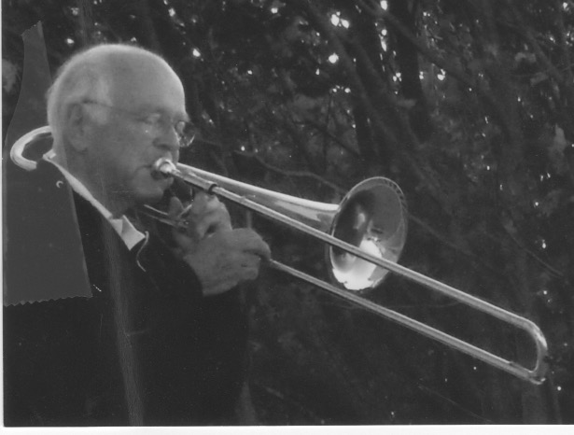

I wonder what I might offer in response to such beauty and peace. From my limited resources I think a quick, "Thank you." Then I go to my music room, pick up the trombone, lubricate the slide for ease of movement, and then move back to the deck scene. There is no one to be seen. It will be a solo in solitude as usual with these daily sunset serenades, or so it seems.

There are a dozen or so memorized, or fake book, big band tunes like: "I'll Be Seeing You", or "Love Is a Many Splendored Thing", or "Tenderly", or "Red Sails in the Sunset", for about twenty minutes, finishing with a rendition of "Taps".

At first, nature's amazements are my only audience. The melodic echoes waft around the water's edge. It is only later and at random meetings that I become aware of how the echoes are reaching the ears of the unseen listeners.

At times the audience becomes visible and up close. The visual images from these musical sunsets of thirteen years serve as a DIARY of soul nourishment. Across Mahone Bay, over the hills, and around the corners, my simple notes, (sometimes sour,) make their way to many ears.

A sampling: There is Patty Sayre's family, out of sight on their wharf or front porch, clapping or phoning a request for "Over the Rainbow." There is Lokman Abdullah, across the Bay and over the ridge at Sleepy Hollow, tending his garden, and phoning, "Paul, how about playing my favorite, 'Summertime'"? There are periodic reports of enjoyment from folks across the Bay like the Butler's, Duncan's, Lutvick's, and Welford's, as they relax on their patios after dinner.

Neighbors Mike and Sheila Mader are entertaining guests on their porch, "We hear you real well and are loving it. Thanks." Helen Cameron, around the corner, often phones her request for "Love Letters in the Sand", for her special dinner guests. "It was my favorite in high school, please", she says.

Others in the audience come into sight and participate in the musical serendipity. There are the tourists from San Francisco, Jim and Holly Cole, dancing together at the end of their wharf to "I Left My Heart in San Francisco". Doris Cook and William, her golden retriever, on his hind legs, stop in the road out front and dance around together. Next door neighbor Gil Mader is a daily listener as he gazes at the waters from his deck, and reflects on his growing up days in that same house. Steve and Cheryl Dyer stroll by. Their dogs, Schooner and Dory, are excitedly yapping and howling at the fanfare.

Power boats and sail boats glide into Mader's Cove and pause to give a shout or blast of approval on their horns. The tour boat takes a pass by. A musical friend from a black schooner moored in the cove, perches himself on the boat's prow and responds with a rendering of "Amazing Grace" on his bagpipes. Wednesday evening's, a dragon boat load of 'Bosom Buddies' (breast cancer survivors), paddles up close to shore to hear a favorite tune or two, and salute with their paddles. Passing cars pause or stop for a longer listen. Our B&B guests return from their dinner in town to relax in the deck chairs, chat, take pictures, and together we play a simple version of "Name That Tune".

After the playing of "Taps" , the trombone is quiet again in Mader's Cove. Evening shadows overtake the waning daylight. Birds find their nests. Crickets exercise their voices. Lights appear in cottage windows. Night is nestling in. The sunset serenade is now just a memory, with only an occasional whistling or humming of a tune somewhere to keep it alive for a moment longer.

SATURDAY'S RABBITS

Last Saturday I start paying more attention to my thoughts. I am thinking about where they might have originated and where they might be taking me. I quickly become aware that it is like chasing rabbits. The thoughts dart into view from nowhere, make a couple of starts to the left and then to the right, and then speed off in an unpredictable direction or nothingness. There doesn't seem to be any sense of where they come from or to where they take me, even if I can follow them.

Neurologists would substitute neurons and electrons firings for what I'm calling rabbits. As they are triggered, apparently randomly and erratically, they can bring to mind thoughts of people and events seventy years ago or imaginings of what might yet happen.

When my wife catches me staring into space, she asks, "What have you been thinking about?" It takes some concentration on my part to identify the thoughts of a particular moment.

A frequent answer from me is, "They are sort of bouncing and dancing around." There has been such a stream of often unrelated, disconnected thoughts jumping in and out and around my awareness. One thought triggers another, and another, and another. Sometimes I can respond with, "But at that precise moment I was thinking about..."

So last Saturday when I intentionally try to be more aware of what I am thinking about, a constant flow pours in, and each new thought brings several more, like a machine gun
spewing out bullets in every direction. Most of them race into oblivion. It is not simple to hold on to momentary thoughts for closer observation. I am trying.

What follows here is what I am able to hold on to as an incomplete version of my brain's rabbit-like activity last Saturday. It's busy.

In the waking moments, when darkness gives way to new light in the sky, I can notice it through the triangle section of the bathroom sky light that I can see while still lying in bed. I notice the droplets of water that have formed on the glass from condensation. I have my wonder moments about the new day. I go through my mental to-do list for the day. I remember scenes from the movie I watched last night. I think about being hungry for some breakfast, and how I had slept better because we had eaten earlier yesterday, and I had done some grazing of smaller amounts through the day. I think this is a better way, as has been advised.

I am pleasantly conscious of the warm, blue sheets that wrap my body under the duvet. I feel my feet and arms gliding over the soft cotton. I smell the pouch of lavender inside my pillow to help speed sleep. When I notice the growing light in the sky my mind jumps to daylight saving time and what it will look like when we lose an hour next month. I get out of bed and walk to my study to look at what time it is on the digital clock. No clock in the bedroom, supposedly to enhance sleep. I always have to take a walk to find the time. While in the study I decide to lie on the floor and put my feet up on the chair seat and go through my little back exercise routine to straighten my vertebrae.

Susan has wakened and is sitting up in bed viewing Facebook entries on her iPad. We talk about the status of the Florida hurricane and the Trump election news and how, if he wins, Marcia and Bill will be moving to Canada, as they say in their latest email. We laugh in amazement at the Facebook video showing a happy dog swinging gleefully on a tree vine he was holding in his mouth. There are routine rapid-fire thoughts about shaving, blood pressure medicines, shower, underwear, grinding coffee beans, pouring in half and half and a teaspoon of sugar, and wonderings about the baked eggs and sausage Susan is making for breakfast. Setting the table and cutting up strawberries all call for passing thoughts.

After breakfast, I see we need more eggs and decide to drive to Sunnybrook Market. I pass the Millett's house on Route 3 and wonder how they are doing. I haven't visited with them for almost two years. They had been so welcoming when we arrived in Mahone Bay seventeen years ago. They had been the first to visit, and Marilyn escorted Susan to a gathering of "The Birthday Club." Soon Dail had been at our door taking me to my first rehearsal with the Mahone Bay Band. I drive by their house often but there is always something else that seems to need doing, and that precludes a visit with them. Sometime I will ...

Cheery Karen is with a German customer at the market. I get the eggs from the fridge and she puts them in a plastic bag. I look at the jelly options and decide to get a jar of the yellow plum jam to take to the Millet's on the way home. Conversations in the market soon make their way to the latest Trump insults, with the German adding his abhorrence at the possibility of a Trump presidency for the world scene. Our joint thought processes result in a cacophony of laughter, ridicule and dismay.

On the lovely drive through Mader's Cove I slow down to check out the status of our former B&B. Apparently no one is home. The flowers in the hanging pots are dried up and the front gardens need weeding. The new contemporary house next door stirs the deluge of negative comments about its inappropriate design and squished in feeling of the new buildings. It's still not completed after two years of work and over a million invested in the re-building.

I wonder if the Millet's will be home. I see the car in the driveway and notice the garden tractor moving along the back hill. I pull in and am greeted by Marilyn with a big hug and our comments about how long it has been. I offer my little gift of yellow plum jam. She says "Thanks very much, I have some wonderful raspberry jam for you that I made from my abundant raspberry patch," and marches toward her open cellar door. Dail approaches and parks his tractor. After we are all seated on the lawn furniture in the open-air garage, our thoughts are free flowing as we share what's new about our health, activities, family status and what's new in town. We recall the shared pleasures of many sing-along sessions, with Marilyn playing on their upright piano, and their cousin Don from Boston on his guitar. He died suddenly two years ago from a heart attack. His ashes are buried on the hill behind us.

Singalong talk prompts Marilyn to recount her story of recently being in a doctor's office in Lunenburg, and a man in his sixties, new to the area, walks in with a guitar. She engages him in conversation, and before long they are singing along with the old-time songs and everyone in the office at the time joining in. Delightful nostalgia-driven thoughts ensue.

Once home I sit on the screened porch, joining Susan. She says, "It's a gorgeous day, we should do something or go somewhere."

I agree. "What do you have in mind?" I am remembering the several times during the summer that we have taken day trips to various parts of Nova Scotia that we have never had a chance to visit while we are busy running our Edgewater B&B. Our visits in those fifteen years are usually in the off-season when most attractions are already closed.

"It's almost noon now, when do you want to go?"

"Now, " she quickly replies.

"Let's try going up Route 10 toward Middleton and coming back by Keji on eight,'" I said. We are on our way in a minute.

It is the perfect day, clear, warm, and the trees in town are just starting to turn. We stop at the Blockhouse intersection to check out the man in the black station wagon who has signs saying he is selling honey crisp apples and culled carrots. Susan has looked at the price of honey crisp apples at the Super Store and they are five dollars a pound. This man's price is five pounds for twelve dollars. We buy a bag and are soon crunching the juicy sweetness of a honey crisp. We are on our way to an afternoon of unfolding of leafy glory.

The brilliant reds, oranges, yellows interspersed with spikes of deep green fir and hemlock finds each curve of the road revealing an ever more astonishing array of beauty. The bright blue sky behind it all seals the perfect setting for thoughts of gratitude and amazement and memories of past experiences of similar glory. There is plenty of time for the thought machinery to remember, to be immersed and to imagine.

Once beyond the verdant farmland from Middleton to Annapolis Royal we find the little German bakery/restaurant nestled in a bright yellow house across from Fort Anne. We think and talk about our last visit to this little charm. They are temporarily overwhelmed with take-out orders. Service to our table is slow. One other couple, tired of waiting, walks out. Finally, the sweet daughter of the owner engages pleasantly with us. They are out of Susan's chosen items of lobster sandwich and squash soup. She substitutes and we settled in for the lengthy wait for the three o'clock lunch. Our thoughts and conversation guess at the status of our lunch, and who among the three owners might be involved in any of the several tasks of doing the take-out orders, minding the bakery line, working in the kitchen or cleaning up. I realize in the process of trying to take note of my thought processes, how crazy and without pattern the neurons fire and the rabbits move in my head.

On the way from Annapolis Royal toward Kejimkujik Park we happen upon a provincial roadside park named Mickey Hill Picnic Park. We turn into the parking lot expecting the usual picnic table and portable toilets nestled in a group of trees. We are happily surprised that it is an expansive area of enormous glacier-age rocks with steps up to the top of the rocks and wooded paths to both a pond and Lamb's Lake, each rimmed with its own version of fall colors. Each step along the paths turns up new marvels of trees growing out of the rocks and the extensive, exposed root systems curled in and around the rocks. There are fallen trees with new saplings appearing out of deadness. Ferns are abundant and thriving on only a bed of pine needles thinly covering the rocks. The aroma of fresh and decaying pine needles pleases our nostrils. We feel we have discovered a mystical forest. Thoughts of amazement present and past are jumping in and out of the brain connections.

Then we drive through Keji Park for its fall display of color and majesty. We share this one with the deer munching on grass on the parkway. (Why don't they eat only the grass at our home instead of our lilies and plants?) We smile as we slowly cruise through Jake's Landing behind a group of fifteen Chinese young people who are unaware of our car behind their leisurely walk as they fill the road like the sheep do in Italy. I resist the temptation to scare them with a blast of the car horn at their backs.

On the final leg of our seven-hour drive through the engaging landscapes of Nova Scotia we pass through Caledonia and notice its nursing home on our right. Thoughts turn to considering if the residents ever have the chance these days to see what we are seeing, and how life is for them and will be for us, sooner than we think. Neurons firing about end times often seep in.

By seven o'clock the sun has left only remnants of light to show off the massive fall trees lining Mahone Bay's Main Street. I keep intentionally rehearsing my plan to think about what I think about on this particular day. As expected, I think about the day and am amazed at what this little experiment at awareness has produced. How busy are the neurons, electrons and rabbits! And, of course, they don't quit once I drift off into sleep. They also provide the crazy mix of images and feelings that make up my dreams and what their mysteries might be unfolding.

My final thoughts rehearse what I have learned from this Saturday's experiment at awareness.
I know that the brain cells or neurons and their synapses are infinite in variety and number. They just don't quit. They are waiting in line in my consciousness to jump in and send their signals. They translate into emotions and feelings affecting bodily functions and health. They often seem to pop out of nowhere with no apparent connection to what synapses preceded them. And yet, while they seem to be random, darting to and fro, I also know that I have some control over which rabbits show up. I can, somewhere in my psyche, decide and choose what my desires, expectations, and intentions are. They influence what shows up in the front of the line.

Take intention for an example. Thought neurons seek out thoughts of similar energy. Like attracts like. Birds of a feather flock together. Thoughts of my intentions are looking for consistency. So, if my intention is to have a positive mindset, then positive neurons will gravitate, congregate, and show up in my mind. I can influence what shows up by my desires, expectations, and intentions. I can willfully choose the people, events, and media that will nourish this. Thoughts will often show up spontaneously, maybe in quiet times, making it seem like I already have the answers and inspiration deep within me. I can say to myself that my mind is filled with inspiring and positive thoughts that help me to spread my wings and fly. Of course, I can choose the opposite as well, and sad, depressing thoughts will show up and fill the cavity.

This Saturday is done. The mysteries and wonders are not. Long live the rabbits!

TAX SALE

My name is Westhaver Beach. Call me Wes for short. I've lived here on Mader's Cove Road, just south of Mahone Bay, Nova Scotia, for a long time. Some will say, since the beginning of time. I've got quite a history here. I can't even bring it all to mind right now. But I do know that its been quite a parade here over the years, with lots of changes. For one thing, I'm looking different. I'm a lot smaller than I used to be when the lighthouse island across from me used to be big enough for a little farm to raise sheep and grow cabbages. Most of that has washed away and my shoreline gets narrower by the year when nor'easters blow in hard, and the waves pound me up to the road. I get re-arranged with every windstorm, but always I'm a bit smaller. The Terns used to love to nest and breed here among my tall weeds. There's not much left for them now.

But I can't get too depressed about all the changes. Even though I can't compete with the big beaches, I do have my modest advantages in this small corner of the world. Folks come here in early morning and get awestruck with a glorious sunrise of orange and pink puffs rippled across the morning horizon. Then there's the end of a warm summer day and they nestle into my sand and sigh at the big round moon rising from the distant waters and glowing over them through the evening hours. They quietly celebrate the manifestations of beauty by soaking up the warm sun, or by splashing in the chilled waters, or by skipping flat stones across the calm ocean, or by singing with neighbors around a campfire with roasted marshmallows and hot dogs. They cherish it all. And so do I.

That's why I am startled one day in January when a pickup truck stops. The driver gets out and plants an 8"x10" sign and post in the sand close to the road. The boldest black lettering spells out 'TAX SALE.' I am curious. The smaller print on this public sign doesn't say where the property is located. It only says that $500 is owing in back taxes since 2008 on this $3500 piece of property. Then it says something about how it could be suitable for a mobile home, and that the tax sale is to be March 4.

Frequently, neighbors take their daily walks along the road next to me. One day a walker glances at the sign. Stops. Moves closer. Takes out her glasses from her pocket, unfolds them and presses the frames over her ears. She squints. Her eyes widen. She looks up and down along the road and along the sand. Then she turns around and briskly walks towards her home.

It isn't long before several other people come to check out the sign. Some are on foot. Some are in cars. Now and then clusters gather and chat intently and feverishly about what might be going on. Apparently, someone has discovered on the county website that the tax sale sign was about me, Westhaver Beach. I am the property in question.

I am imagining all of the telephone activity that must be going on at this point. Shock. Disbelief. "How could this be?" "It's a public beach, isn't it?" "Let's get to the heart of it." "What's going on?" They put the story together that a Francis Smith owns the property. She has owned other property and has lived nearby. She's dead.

The flurry of almost frenzied questions is dominating every neighborhood conversation. "Who's been paying the taxes up until 2008?" "What about the provincial "Beach Act" which is to preserve all beaches as part of the public domain with free access to everyone?"

Mrs. Smith had divided the beach into seven parcels to go with nearby properties. "But what's there to divide, or to tax, or to sell? There's not enough room to ever build anything here, or even put in a mobile home. They'd be under water in any storm, and the high-water mark is right up to, and chipping away at, the road itself." "What if a new owner was to put up a fence?" they are asking. "What if we can no longer sit in the sun, walk our dogs, splash in the water, gaze at the sunrises and moons glowing?" "Something must be done!"

" Maybe we can all chip in and pay the taxes and own it ourselves, or through our Prince's Inlet Neighborhood Association. We probably need some lawyers in on this." Ideas are germinating. The phoning and emailing of officials or anyone who might know or do something continues for days. Lawyers, mayors, councilors, are all digging at discovering what had brought about this turn of events for me, and how it might be remedied.

It eventually seems to be sifting down to that either the county or individuals in the neighborhood association would intervene on tax sale day and then secure me as property for future free public access. There is also talk that all of this surprising attention over me might be a catalyst to put a plan and policy in place to keep other publicly used properties that make life nice, preserved and safe.

Through it all, it makes me feel warm and important inside, even though I have no say in the matter as to who will have the right to own me or use me. I will be here for all of them until that day when the waters finally wash over me and never recede. Then I will be just one more little piece of history rehearsed by the old timers about the good old days, at Westhaver Beach.

MINING GOLD

(Thoughts on Life Writing Classes at Mahone Bay Centre)

It's Thursday morning. There is a story here. In fact, there are hundreds of stories here. All of them have to do with mining our gold. It is our personal and collective adventure of traveling side by side, on parallel tracks, into the mine shaft. We are discovering, releasing, and refining the precious metal at our core.

How does it happen? First, there is our personal inner nudging that there is indeed something of great worth hiding in the dormant recesses of our being. It is waiting to see the light of day. We respond to Ellen's invitation to a Life Writing Course on Thursday mornings. At first blush our reasons are: "I want my children and grandchildren to know something specific about me, who I am, and what my life has been like." We soon become aware that more than that is going on.

When first we gather, before the mining begins, we notice our differences. All we know about each other is what we see. We notice the obvious things, like gender, age, size, countenance, clothes, and body movements. As we get a little closer, we process the greetings and small talk and do some early testing. There are unspoken wonderings, expectations, and trust levels being set. It's all a part of defining our differences.

Then Ellen, our coach and fellow miner, draws us together with a welcome, and announces the plan for the day in the mining process. We quickly move into digging. With our pens and paper serving as our picks and shovels, we start to penetrate the surface. Our brains have been mostly focused on our day to day routines. Now they are called upon to reveal some of their content and capabilities.

It's time for a 'prompt.' A topic is offered by one of us to stimulate the connection between the brain and the pen. We originally call it 'forced writing.' And later, we substitute something gentler, like 'directed writing,' or 'encouragements to writing,' or some such. . We take turns, playfully presenting a wide range of stimuli starters, e.g., "Throwing caution to the wind...", "Vote"...", Pet peeves...", "Breaking rules...", "Beer...", "Candy...", "All I know is...", "Women I have known...", and a host of others.

The instruction from Ellen: "Just put your pen on the paper for five minutes. Make it move. Let come what may from the 'prompt.' Write it down, even if it makes no sense. See what shows up."

We respond with blank stares, furrowed brows, nervous smiles and comments. We think, "Where can I ever go with this?" We put our head in one hand and pen in the other. An attempt is made. Sometimes it is frustrating and unproductive. More often, we are amazed at what comes forth from this prodding of the brain cells. Associations, Tangents. Sadness. Flights of fancy and fun. Even longings surface, like, "How's the handyman looking today?" Once into it, five minutes doesn't leave enough time to finish the thought. We have broken ground with a combination of amazement and satisfaction. We think, "There are possibilities for this mining business."

Going deeply for gold continues when fellow miner/coach Ellen offers soil samples of stories from famous authors, recommends readings, and further tricks of the trade. They can help uncover and describe the gold that is uniquely ours. The objective is to share our stories in a way that another may see, hear, touch, and feel our experience as if they are here with us. This is precious.

Digging deeper, Ellen announces a general category of life experience that could reveal a story for us. We brainstorm topics like: "Decisions", "Jobs", "Disruptions in the family", "School memories", "Childhood memories", and many more. From the golden memory palaces, a long list of possibilities pours forth from each of us. We pick three or four that sound most promising at first glance. We share these preferences with three others. Their observations help us hone in on what might be worth exploring as a developing story with some of our gold dust sprinkled in.

We are one in the searching process. We are unique in what surfaces from the depths of our personal memory banks. We are urged to continue the mining by quickly trying out five different ways of beginning the story. Each five minute "start" uses a different perspective of time, people, themes, and feelings to emphasize. We are shown options for openings and endings. We start to get an idea of what the story might sound like, and where it is going.

We dig more on our own at home. The synapses of our brains become our drilling equipment. We write out a first draft. We embellish the empty spaces. Long forgotten names pop up out of nowhere. We bring our refinements to class.

With three others we 'conference' our stories. We offer suggestions as to what we like, or what is confusing. We find out how it is looking to other eyes. Ellen counsels us on what to look for in a story, e.g., the possibilities of expanded moments, the conflicts, tensions, dialogue, or where to change sentences that are too long, or have too many 'ands' or 'buts.' We re-work the stories from all of this input. We read them aloud to ourselves and to others. We are saturated with this event from long ago. Finally, we choose two of our favorites to include in the class publication.

Through it all, we get glimpses of the treasures of life experiences stored deep inside each of us. The memory snippets are like gold nuggets lifted from the source of solid gold at our core. Personally, we experience the joy of mining the precious metal that is our essence. One remembered nugget uncovers another, and then another. As the mining process evolves we are amazed at what of our uniqueness has filtered to the surface. There are meanings here. The mining and refining of our precious treasures together trumps the differences noticed at our first meeting. We now know, and are known, a little bit more. This is good.

AT LEAST…

AT LEAST I can hide awhile from the punishment coming my way. I am a youngster, probably about six years old, my mother is chasing me for my infraction, whatever it is. I have run from her and the stick (a wooden piece that I have fashioned into a rough representation of a sword for my play) that will eventually make painful contact with my bottom. I am running, running. She is chasing me around the house and yelling at me. I have finally locked myself in the downstairs bathroom.

She is still yelling, "You'd better open this door this minute, if you know what's good for you." I cower and fret, thinking, "How is this all going to end?" But at least for now there is no physical pain to endure. There is lots of psychic pain, and fear of what's coming, sooner or later.

A quick climb out of the bathroom window will put it off a bit longer. I think, "She won't know.
It will be a silent and empty bathroom to greet her when she finds the key to unlock the door.
I will be gone. I will be running down Pinecrest Circle and wondering when and if I should return."

I think, "What 's going to happen when my father gets home? I'm scared and panicky, breathless and sweaty. But AT LEAST for now, there's no pain."

BEER

Beer is a long-time forbidden nectar in my Women's Christian Temperance Union upbringing.
It doesn't seem that tempting. For some adults, it is more than tempting. My mother apologetically tells of her own caring father. He brings home a bucket of beer every evening from the market where he has a dry goods stand. It is okay for him, a loving, gentle, music loving Irishman. But not for her. She is steeped in the Temperance Union and its prohibitions against all forms of alcohol.

It is never in our home during my growing up years. Nice neighbors who easily guzzled, are a target of both puzzlement and derision. My first try daring to share some sips of the evil brew are after a high school pep rally in Sligo Park. It is a now and then thing for me. Of course, there is college and its excesses. Another story…

CANDY

For most people, candy is always enjoyable and a sign of the sweetness that fills life.

Bea Shaw educates me about candy. She is a neighbor and girlfriend for a time in high school. One day she is sick and stays home from school. I take her a box of assorted chocolate candies to cheer her up. She is pleased and grateful.

The next week end I go to her home to pick her up for a date. While waiting for her in the living room, I see the same box of candy on the table.

She calls down from upstairs, "Help yourself to the candy." I thank her and open the box. I pick up the first piece. It looks like it might have a coconut center, one of my favorites. I am about to pop it into my mouth when I notice that the bottom of the piece has been pushed in. I put it back. I look at another, and another. Same thing. All of the candies left in the box have been punched in from the bottom. I have never seen this before. It certainly diminishes its appeal for me. Whenever we pick up a piece of candy at home, we eat it, whether it is our preference or not.

I decide not to satisfy my sweet tooth cravings this evening. I place the top back on the box.

A PONDER POND

Helen stops at her 'ponder pond' most every day on her way home from high school. It isn't an idyllic scene to look at. The pond is mostly backwater and storm drain run off. Cat tails and weeds fill the edges. Entanglements of discarded coffee cups, beer cans, and candy wrappers encourage the stagnant foam dancing on the ripples. There is one stately beech tree left over from another time. Its shiny green leaves form a shapely canopy for the exposed roots that offer Helen a natural seat for her pensive moments.
It isn't a 'smiley' place for her spirit work. But it is a place of solitude needed for all that is raging inside of her. Her list is long and severe. Her home is with her Aunt Lil and her five sisters in the lower east side of Philadelphia. It still looks poor after a century of German immigrants having settled there. The row house is an unpainted gray stucco about fourteen feet wide. Helen doesn't let her dates pick her up at home or have girlfriends drop by. She shares a bedroom with her sisters. She has to make the best of worn and faded hand-me-down clothing. She helps Aunt Lil with the washing and ironing that she does for some income from the wealthy folks on the upper East side. Helen has sad memories of her mother's long sickness and death five years before, when she was ten.
Worst of all is the walk every day on the only road that leads to her school. She has to pass by the county prison of high gray concrete walls topped with steel bars and barbed wire. Her father is inside. He has been there for five years.

Just after her mother died, he had been found guilty of child molestation on several counts, including her younger sister Mildred. For almost a year the whole family had been the focus of wide publicity through the trial and sentencing. It is a persistent and choking dark fog of shame and humiliation that fills every space and thought of her young life. It is resurrected to hammer her every time she has to pass by the prison. It seems that there will be no end to it. It fills her pondering moments as she nestles under the protection of the grand beech tree.
Helen also has her arsenal of gifts. She has her Aunt Lil, who is always offering a sympathetic hug and a quiet smile. She has her five sisters with whom to commiserate. She is pretty and has a bright smile. She has a lilting singing voice. She is intellectually astute. She knows she can never afford to go to college, so she hones her secretarial skills of short-hand and typing. She is learning that she can use her quick mind to manipulate other people according to her wishes. She is clever enough to either lather a person with sweetness, or quickly cut them in pieces with her acid tongue. She is learning how her creative determination and dreams can maybe move her beyond her secrets of shame and defeat. Her fantasies of stardom, wealth, influence, and respectability infuse her pondering this day and will dominate her every move from then on.
Helen looks up at the towering beech branches, sighs, tosses a couple of stones into the languid pond, and make her way on to her home and Aunt Lil.
Helen rehearses the full listing of what is wrong with her life as well as her resolve to get away from it all. Leave it. There has to be a different way… without prisons, and rice and beans, and faded aprons, and unpainted stucco. Aunt Lil's way is not going to be Helen's way, as much as she longs for and often retreats to Aunt Lil's warming fleece.
At ponder pond, for the next two years, before graduating from high school, she becomes determined to hone and use her natural gifts of physical beauty, sharp intellect, secretarial skills, singing voice, subtle perceptions of personalities and their vulnerabilities, to her advantage. She will weave them all together, even subconsciously, to survive …and even thrive. Her antennae are picking up the signals of what her culture requires to have a life different from lower Philadelphia. She can know prestige, prominence, glamour, wealth, stardom, recognition, security, plenty of toys, influence. These will be her drivers. These will provide the silent justifications for the life choices that lay ahead.


The steps and stumbles of those passing seventy-five years are behind her now. At ninety years of age, she looks out over another ponder pond.
She has been wheeled up to the large picture window at the Edelweiss Nursing Home in Boston.
Most of the scene is out of focus for her wandering mind. There is a pond reflecting the dancing diamonds that flicker through her window. There is another gnarled beech tree arching over the water and cat tails dotting its edges. She sees it all through the reflections of herself in the window. Her whitened and disheveled hair surrounds the crisscrossing wrinkles of her face and sinewy arms. Her drooping body is strapped into the wheelchair with a blue bed sheet. The morning sun and its shadows frame her vision of the pond. Her dementia tinged memory catalogue erratically prompts her own seventy-five years of shadows closing in on her fading awareness.
Helen's last days of pondering through her haze now focus on 'what has been' and not 'what can be.' As she nods in and out of consciousness there are the loud and faint voices, the smiles and the tears, the images of people and places, the half-formed questions that have filled her last seventy-five years.
Her high school dreams of prestige, pedigree, recognition, acceptance have been realized…at least partially…outwardly. Leaving East Philadelphia behind, she has discovered family tree threads that lead her to connections with a prominent U.S. senator from Tennessee. The same threads qualify her as a Daughter of the American Revolution with its conventions at Constitution Hall in Washington, D.C. She finds a third cousin who is a movie star in England and from whom she gains some spilled over recognition in the Philadelphia newspapers. Her son and daughter graduate from Yale and Mt. Holyoke. She holds top jobs as an executive secretary. She has modeled, sung solos, and in choruses. She dresses smartly in tailored clothing. She turns eyes. Looking out at the pond, you can see her shadowed smile for these 'ice creams' and a tear for her ongoing unrest at what she thought life should bring…
She has met a handsome young U.S. army private at the Stage Door Canteen. Blossoming with romance they have married on D-day of World War 2. He goes on to become a commissioned officer and spends the war being trained at the University of Pennsylvania in German intelligence tactics. Later, after graduating from college he moves up the ranks of authority and salary as a teacher, principal, dean of Plymouth College and superintendent of schools in Lancaster County. He stays with the U.S. Army Reserve to the rank of colonel. Even though the list of accomplishments expands for both of them, the size of the bank accounts can never keep up. The ever-new purchases of houses, boats, and autos keep them in the poor house mentality with its accompanying stresses and blaming. There is never enough.
Her body shifts in the wheelchair, but the sheet holds her firmly in place. Memory thoughts drift in and out of her foggy brain … It is not enough to ride the coattails of her husband's successes.

She pursues her own creative drives expecting that each new project will jettison her into national fame and fortune. She creates a small business of making lampshades with pressed leaves as designs. Next comes manufacturing jewelry … rings, with family crests. Then there is a glitzy catalogue promoting "after sex" lingerie. When she presents this at a family reunion she loudly tries to persuade family to invest in this catchy fad. "It will bring in thousands for you …" One cousin hustled her twelve year old daughter out of the room, saying, "You don't need to hear this disgusting stuff…!"
There is another financial venture which involved producing and maintaining soda, beer, and snack vending machines at various holes on golf courses. Helen is the assertive salesperson letting everyone know that this is "the biggest innovation of the decade. It's just what the golfers are looking for. With only a $50,000 investment, you can triple it in a year." All of her ventures require substantial outlays of capital which is in short supply for her. Extended family is solicited for financial assistance. It is the only time they ever hear from Helen.
She has never figured it all out, but interwoven in the apparent accomplishments for Helen are the toxic ingredients of an acid tongue and putdowns of others whenever she cannot dominate and control an event or relationship. She often finds herself being separated from churches, neighborhoods, and relatives. Her strident voice and tone repel people from wanting to be in the same car or circle with her. For example, she can see people cringing as she loudly preaches to the Pakastani motel manager about her "What would Jesus do?" bracelet, and how. "Jesus was what he needed, too."

She has wondered why she and her husband were the only ones present for the campfire at a family reunion sing-along. She has the hurting thoughts, "They all love to sing. Why aren't they here?" Repeatedly, her inquiries about the possibility of visiting cousins are rebuffed with: "Sorry, it isn't convenient at this time for you to stop by." There are rare occasions that the nagging and haunting question surfaces from the shadows into consciousness: "Why don't people like me? I don't understand."
In the fading morning light even now her tensed wrinkles reveal a life of bewilderment and fear.
Helen's most painful experiences of her last seventy-five years have been the vicious fights with her husband, in private and in public. From their honeymoon to life at Edelweiss, no one, including her, know when the hair triggers would be tripped. Anytime. Anywhere. But everyone knows, and is in a state of disbelief, from the screaming and swearing they witness between the two of them, without regard to the sensitivities of who else was present.

Their children are spared some of it while away at boarding schools for much of their growing years. But at dinner parties and family reunions, with passengers in their car, at neighborhood barbeques, while attending the symphony, or at ball games…all become mine fields for the spontaneous explosions. Sometimes, consumed in anger, the two of them separate for days.

Because of neighbor complaints they are asked to vacate their apartment in the prestigious Rittenhouse Square buildings. In their final years they are put on separate floors at The Edelweiss Nursing Home so that other residents won't be subjected to their outbursts.

Their only public reflection on the effects of the uncontrolled tongue attacks is an attempt at humor. "We don't know why we're still together either…but the sex after a bout is amazing!"
Now she whimpers repeatedly, "Where is my love? I want my love. I miss my love so much!" There are free flowing tears as the Edelweiss attendant wheels Helen back to her bedroom. The biting self-incriminations from her life review dodge in and out of her semi-consciousness. "Why don't they like me? What can I do?" Her last sleep finally overtakes her as she whispers, "Maybe…different… next time.."
Her ashes are now nested next to her husband's in Arlington National Cemetery, Washington, D.C. There is a ceremony with the full military honors appropriate for a colonel… a horse drawn caisson, a platoon of soldiers in full dress, rifle volleys, an army brass band playing "Nearer My God, to Thee," an unknowing chaplain with his blanket platitudes, "Theirs was a marriage made in heaven." A bugler's mournful 'Taps.'
And, oh yes, their grave is ten yards from a reflecting pond, with cattails around its edges and a gnarly green beech tree providing a canopy… for future pondering?

A JANE DAY

It's morning at Cherrywood Haven. I open my eyes to darkness excepting the sparkling spray of yellow from the night light under the window. There's no light outside the window. It's too early I guess. And the emerging signs of a lighter sky are hemmed in by dark clouds.

But it is morning, right? I'm not sure. I hear the rattling of trays and glasses on the carts as they pass by my door in the common area probably carrying medicines or food to another room or table.

I see the stream of bright light spreading under my door. This must be how morning begins at Cherrywood Haven, my new home. I see the ceiling curtain in the middle of my tiny room is drawn. It still separates me from my new roommate after last night's prickly beginnings.

There had been shouts of "Hey over there, turn down that TV," and "Answer your damn phone, will you?!" I had tried to comply, but I'm deaf in one ear and don't comply fast enough for her. She has reached out of her bed with her cane and yanked the room curtain along its ceiling track to cut us off from any further communication. I wonder for how long, and what else might be in the offing.

Behind me I hear the door open and a cheery, "Another beautiful day comin'. Time to get up and washed and ready for breakfast in an hour. How you doin', hon? You're new here, right. Just last evenin'? Jane, is that right? I'm Tara. Let me know if you need anythin'. You need any help gettin' outta bed or washed up or dressed?"

I'm silent as I watch her busily move around the cramped room, turning on lights, pushing back the curtain, adjusting the window blinds, tossing my roommate's robe over the foot of her bed and keeping glances coming my way to see how I'm doing.

"Soon as you get dressed, put that respirator gadget over your face to get you breathin' better before breakfast."

"Pretty quiet in here. You two know each other yet? Patty, you know Jane?"

We both grunt our assents. "You'll hear the bell when breakfast is ready out there. I'll show you where you can sit, Jane."

I'm praying, Dear God, somewhere far away from Patty so I can digest some of my food, whatever it is."

As she is backing out of the door Tara says, "Anything else hon, I gotta get going?"

I pipe up and say, "Well, yes, I have a friend, Mary, who is here somewhere. I'd like to sit with her if you can arrange it?"

Tara takes it in and replies, "Mary, huh? I'll see what I can do."

Patty and I sit on the sides of our beds in our nightclothes, legs dangling, heads looking left and right, up and down, neither of us wanting to look at each other for fear of what might ensue. We both busy ourselves fussing with the sheets, smoothing out the wrinkled blankets, and fluffing the pillows on our beds. We stretch our feet into the slippers waiting at our bedsides. The silence is pregnant with our unresolved hostility. It is a painful damper on my hopes of a fresh start after my four-month stay at the hospital waiting for this available nursing home bed.

I wonder, What now? So tense. Hard to catch my breath. Have to get that respirator on soon. Hands are shaking. My stomach is not going to be able to handle much breakfast, and yet I need some strength.

I decide to offer a small positive gesture of motioning Patty to use the bathroom before me, without looking her in the face. She moves into the bathroom quickly without a sound or acknowledgement and closes the door. I am grateful for at least momentary relief and the avoidance of confrontation.

I stand and stare at the bed sheets, shaking my head as my fists are planted on the mattress. I am thinking again, as I have been doing so often since Glenna died, Who would have thought that it would all come down to this?? Oh, dear Glenna, I miss you so! We had 41 wonderful years together, didn't we? So much fun! Overnight hiking trips in the rockies with our beautiful border collie Dasher? Lots of laughs. You loved my jokes. Can still see you rocking back and forth and hear your raucous howling. Oh, yes... we had our tears too, hiding in the closet for so long. Your long downhill trip with cancer. Oh dear Glenna, how your body hurt, how we hurt! Here I am at 84, my body going to hell. The "great diminishment" they call it. I guess so! The list keeps growing...advanced COPD, breast cancer, blind in one eye and the other on its way out from detached retinas, pneumonia episodes that keep repeating. Cheesus! Who would have thought! You were my family.

I look left and right and out the window in wonderment. In these precious solitary moments I smooth the bed coverings and fold my bedspread and reach for a tissue to dry my eyes.

Now it's Alice, my dear angel in Regina. Just a neighbor and her husband at first, now my last flicker of a connection. Bless her heart! She has my power of attorney and keeps persistently caring, trying guide me through the maze of financial crises... government regulations... cheating lawyers and supposed friends who pilfered all my money... left me with nothing. Cheesus! Now this! My today. My fresh start in this place so far from familiar foundations... Patty greeting me with shouts to 'answer my damn phone and turn down my TV! Glenna, I wonder if God is punishing me? I just don't know. I don't know. Who would have ever thought ...

I hear Patty flushing the toilet in the bathroom. I wipe another tear. Take a deep breath and stand up straighter.

Come on Jane, you have to get a grip. I know. I know. One step at a time. Baby steps. Get dressed. Put a comb through your hair. Look out the window. It's getting lighter. There's a sunrise going on somewhere. Patty will be opening that bathroom door in a moment. Try a glance in her direction as she comes out. See if there is any possibility for some kind of a truce. See if she is affected positively at all with my move to have her go first...

The bathroom door opens, she turns off the light. I look. She quickly moves out and our eyes meet in a flash. She then gives the door a slight shove backward as if inviting me to take my turn. Her eyes gaze past me toward her bed. But our eyes meet for a second. I see her minimal acknowledgement that I am a person after all, and that perhaps without words we are experiencing the beginnings, not of a normal and longed for friendship, but maybe at least a truce. We remain silent, but it is a bit easier now. My stomach muscles relax a bit. My hands stop shaking.

After the bathroom routines I dress and then attach the respiratory mask meant to loosen my bronchial phlegm and avoid another bout with pneumonia. I sit in my lone armchair and face it toward the window to watch the spreading light of the clouded sky. The breakfast bell rings and I remove the respirator.

I go to my night table to pick up my dentures. I left them here last night, either in a glass of water or wrapped in tissue. The table is empty. Oh no! I grab my cane and look under my bed and chair. I open the drawers of my dresser. I empty my trash can. I check the bathroom shelves. Still no false teeth. Another crisis is brewing.

I say it out loud. "I can't find my teeth. I know I left them on the night table. They're not here. And they're not on the floor or in the trash or in the bathroom."

Patty volunteers, "I haven't seen them. Sorry." It is the first indication of a normal human relationship. I'm very glad for that. But I'm in a panic about my dentures.

Thoughts dart around my brain: Who could have taken them? When? Won't be able to eat. It'll be all porridge, and jello and custards and soup from now on. Can't afford new ones. It'll take ages to get fitted and have them replaced. Sweat droplets emerge on my brow. I retrace the search process... steps...table, floor, trash can, bathroom, drawers...

Without thinking, I call out, "Tara, Tara, help me, help me!"

Tara comes running in response to my panicked pleas. "What is it, hon? What's the matter?" I hurry through the story. She follows the same search steps I had taken.

I don't know, hon. They can't have just walked away."

Patty is standing in the doorway on her way to breakfast. She offers that maybe it had been "that woman in the wheelchair with the red hair, Agnes, I think they call her. She's a bit weird. They say she scoots in and out of rooms in her wheelchair and takes stuff."

My mouth is open in astonishment. "Cheesus," I exclaim.

Tara says, "Oh, I don't think so, hon. Why would she ever take a set of teeth. She couldn't possibly use them or give them to someone else."

I repeat, "Well, they're gone, and I can't eat and I can't afford new ones!"

Tara tries to calm me: "They have to be somewhere. We'll just keep looking everywhere. I'll tell the others to look through all of the trash containers. We'll keep an eye out in the rooms. Meantime, I guess you will be having cream of wheat this morning. You can dunk your toast in your coffee to soften it up. They'll turn up hon,"

Tara seats me at the table with Mary, who greets me with a hug. I tell her what has been going on in my life in the last year we saw each other. We had shared happy times playing Scrabble and putting puzzles together when I had my apartment in the seniors housing in Lakeland. Of course, I include my immediate crisis with the lost dentures in my tales. I am so glad for this bit of normalcy. After a few minutes I look up from my cream of wheat and over at Mary. Her head is on her chest. She has fallen asleep in the middle of breakfast. I motion to Tara as she refills my coffee cup that Mary is out of it.

Tara replied, "Oh yeah, she's a sleepy lady all right. Awake for fifteen minutes and asleep for an hour or two. It's that way for lots of these folks."

I look around. She is right. Half of the tables have women and men in various stages of fog. I think, Oh my God! A year ago Mary and I were laughing over Scrabble and puzzles, and now it's silence and sleep. Look at all of these people. Heads tipped down or sideways. Some drooling. So old, so old. Is this me too? What's going on inside of their heads? Anything? Just numbness? Is it sweet? Is it sour? Surely, they all have memories? Images. What's going on inside of my head? Oh Glenna, I miss you so much!

I touch the napkin to my tearing eyes, pick up my cane and walk back toward my room.

Patty has preceded me. I hear her shouting, "Hey, answer your phone. It's been ringing a dozen times. Don't you hear it? Good Lord! How long is this going to go on?"

I mumble a "Sorry," as I reach across the bed in a rush and grab the phone on the night table before it can jangle another time and further splinter our shaky start.

I finally get the receiver up to my better ear and hear, "Jane. Jane?"

"Yes, yes," I answer.

"It's Alice. Where have you been? I wanted to wish you a happy new start. But you didn't answer. I almost hung up. So, how are you doing on your first day?"

I am relieved that Patty is thoughtful enough to pick up her cane and walk out to the common room so I can talk more privately with Alice.

"Wait a second," I say, "I want to put the phone down and get comfortable on my bed."

I pull the spread over my legs and prop a pillow at my back as I settle in for our talk. I tell her of my first experiences in my new home, with Patty, Mary, Tara, teeth theft, and all the rest. I tell her that I have heard that a ukulele choir is supposed to come to cheer us up tomorrow. I ask her what am I going to do if I have to get new false teeth. I ask how she had made out with Revenue Canada, and the Lakeland police with the lawyer rip offs at the seniors housing, and if we are going to get some financial assistance at Cherrywood.

I always load her up with an expanding list of problems and crises to be resolved. She is my angel. She lives so far away, and for the last ten years has been my caring advocate for so many of my hairy details to be dealt with. She is the light at the end of my tunnel.
.
She tells me everything she is up to on my behalf and also advises me to make more of an effort to meet and be pleasant with people. "Tell them a joke. You're good at that. Everybody likes a joke." She is always encourages me and is direct in her guidance.

She signs off after a half hour with: "We'll get it all together somehow. We'll take each problem one small step at a time and get it straightened out. I'll talk to the Cherrywood nurse about getting you a dentist appointment for dentures if you don't find them. Don't forget you have another appointment Monday for a shot to your retina to see if they can stop your better eye from going blind... Remember what Glenna would probably want you to do. That will help. Love you. Bye."

I close my eyes and drift off for a nap. There is a nudge on my arm. My eyes open to the familiar smiles of Jennifer. She has become my friend from the helping group in Lakeland when I was in the seniors housing and needed a ride to my eye injections.

"Hi Jane." She leans over and gives me a kiss. I am so pleased to see her.

"I brought you your favorite from Tim's, a large iced cappucino."

"Oh," I exclaim, "you are such a dear. You have made my day." I draw the sweet cold coffee up through the straw. "Mmm. So good. Thank you." We have a lovely chat. I tell her my sad tales of woe.

She counsels me, as does Alice, to make the extra effort to keep an eye out for someone beyond the sleepy people who might have common interests.

I always reflect back to her my familiar lines, "Who would have thought my life would come to this...do you think God is punishing to me?"

She assures me, "That's not God's way," and to "think about more of the stuff that makes life have some joy" "I love your jokes. You love your jokes. Everyone loves your jokes. Tell me a joke Jane. Got any for today?"

My funny bone is triggered. I say, "Well as a matter of fact I did hear a good one from that doctor from Newfoundland who was on my hospital floor. Wanna hear it?"

"You bet," Jennifer replies.

"Well, it goes like this. Up in Newfoundland the Pentecostals are big, you know. Lots of 'em. This one Sunday afternoon a whole crowd of the Pentecostals have gathered down by the river for a big baptism. Lots of people gettin' dunked and saved and finding Jesus. And they are all worked up and making lots of noise with their singing and shouting.

The town drunk happens along and wonders what all the excitement is about. He meanders closer until he is right next to the preacher in the water. When the preacher sees him he gets all excited with another salvation prospect at hand. He looks at the drunk and says 'Brother, do you want to find Jesus?' The befuddled drunk responds 'Well, yeah, I guess so.'

'So the preacher pulls him close, grabs his head and shoulders and plunges him into the water. The drunk comes up from the dunking, gasping for breath. The preacher says, 'Well, brother, did you find Jesus?' The drunk, somewhat stupified, says, 'Well, no, I didn't find Jesus.' The preacher, taken aback, says, 'We'll do you again.' He firmly grabs the drunk by the head and shoulders, and again plunges him into the river. He holds him under quite a bit longer this time until the drunk starts writhing and jerking to come up for air. When he is above the water, the preacher repeats his plea, 'Well, now brother, did you find Jesus?' The drunk looks around at all the people watching and tells the preacher, 'Well, no, I didn't find Jesus this time either.'

The preacher is now exasperated. He says to the drunk 'We'll make sure this time.' He grabs him, head and shoulders, throws him under the water, and holds him there. And holds him there. And holds him there. The drunk's arms are flailing and legs are jerking as he tries to get free and come up for air. Finally, the preacher brings the drunk up, choking and gasping. He yells at him, 'For the love of God brother, did you find Jesus?' Still in his apologetic voice, the drunk cries out, 'Well no preacher, I didn't find Jesus. Are you sure this is where he fell in?'"

Jennifer and I rock back and forth in laughter, tears streaming down our cheeks. "See," she rollicks, "I knew you could do it. You are so funny! She leaves me with a hug, still smiling. "I'll see you next Wednesday. I hope you find your teeth. I'll try to pick up some headphones for your TV. Find me another joke Jane. Bye."

So here I am thinking again. My first day at Cherrywood Haven. What's left? Guess it'll be some TV, like always. I'll have to keep the volume way down. I don't know how to get captions on this thing yet. Maybe Tara can help me. Too many remotes. Too many buttons. I get confused. Don't need 'em all.

At dinner Mary nods off again. It's pureed carrots and potatoes and something that's supposed to resemble meat I think. I talk to myself a little more... Maybe I'll take a walk down the hall and then to my room to change my clothes and watch some more TV from bed. I'm thinking the old stuff all over again, and again. My eyes are no good for reading anymore. This all just keeps reminding me that I'm wearing out. I used to have such a sharp memory when I was a paralegal all those years. I could bring up all those rules and remember all those people. No more. I'd be happy right now if I could just remember what I did with my teeth. Getting drowsy earlier tonight. I miss you so, Glenna, ...and Dasher. Oh my. Just memories, lots of memories for now. And the old questions, "Is God punishing me ... who would have thought my life would end up like this. I don't know. I just don't know ... Maybe the gentle night, soon.

JETHRO'S PARADE
Jethro Smalley is jolted awake as his Greyhound bus comes to its first stoplight on the highway outside Las Vegas. The morning's sun streaks its rays into his squinting eyes. He pulls his rolled-up jacket from behind his head and sits up straight, then stretches to the empty seat next to him to let his body know it's time to wake up. He glances around the bus. No one else is stirring. The scene from his window reveals a familiar combination of highway vistas…scattered dirty white houses…with dirtier sheds to accompany them …trash blowing in the streets… a lineup of dust-laden pickup trucks in front of the little houses settled in the shadows of power line towers…two dogs barking at the bus…no grass… no trees… lots of sand. The sun is doing its best to reflect the brightness and promise of a new day.

Jethro has been on the road from his home is Oskaloosa, Kansas, for over twenty hours, with rest stops along the 1300 miles. It is his first time away from his home of 1113 people, with its cornfields and soy fields, and wheat fields. It was all absorbed and loved for his eighteen years with his farmer parents and younger siblings, Emma and Falco. Over the years he had learned to work the farm with the planting and harvesting. He had also done part-time work in Weldan's Pharmacy on weekends. The money earned there has been saved for going on this big adventure after having graduated from high school last month.

He doesn't know how it is all going to work out. It is summer 1971. The Vietnam War is in full swing. Friends from school have already been drafted into the U.S. Army. It's likely that his number will be coming up. His Uncle Malcolm manages an almond-pistachio ranch in Lost Hills, California. Help is needed on the ranch with all sorts of jobs, like painting fences, oiling machinery, harvesting the nuts, and lots of cleaning. Malcom promises Jethro work for at least a year if he wants to try it. Jethro is thrilled with the prospects of the world's parade beyond Oskaloosa.

There is a flurry of goodbye exchanges:

"We love you, Jethro."

"I know, Mom. I love you too."

"Take care now, and careful with your money."

"I will be, Dad."

Falco chimes in, "Give us a call when you get to Uncle Malcolm's. Write us and send some pictures when you can."

Dad adds, "Work hard for him…let us know if you need anything."

Jethro assures, "I will. I will."

He motions for all of them to stand together, "You'll be my first picture with my new graduation gift."

There is more nervous banter as he leaves his family and friends. His mother dabs her handkerchief to her eyes.

The bus revs up and moves out. Wide-eyed, he focuses on the details of the landscape he has never seen. Through Kansas, it is miles and miles of flatlands, green with the fresh shoots of corn, soy and wheat. They give way to the mountains that rise in Colorado. He takes lots of photos of the parade of scenery and people along the way, at the rest stops, and in the bus.

It is all so new. He wants to remember it. He has savings of $271 with him. For safe keeping, following his father's advice, $100 is inside the right shoe. $100 is inside the left shoe. $71 is in his pocket. His mother has packed enough egg salad and ham sandwiches, with fruit and cookies, to carry him through these twenty hours of Greyhound travel. About midway through Colorado, darkness fills the sky and only occasional headlights flash a piece of pavement into view. The drone of the bus, the sweet memories of home, and the unexamined excitement of his future, are all enough to have him smile, roll up his jacket to support his head against the window, and drowse him into sleep for the rest of the night.

This is morning in Las Vegas. He has seen so much about it on TV over the years. All the ads. The electric city. Flashing and rippling colored lights on dancing fountains. Famous entertainers. Enormous theme hotels. The lure of big money wins and losses. The crime. The culture. He takes pictures even at 7:00 a.m. as the bus motor roars from one stop light to another along Fremont Street. It finally rumbles into its slot at the Greyhound Station at 200 Main Street. As other passengers are waking, the driver announces:

"There will be a two-hour layover, leaving for Los Angeles at 9:00 a.m. You will have a new driver. If anyone misses that connection, there will be another chance at 9:00 a.m. tomorrow.
Thanks for traveling with Greyhound. I'll help you with your luggage outside."

Jethro is thinking … Only two hours to see Las Vegas?… I don't know … It's not much time… It looks like there's a lot to see… I probably won't come this way again any time soon … Maybe I'd better get my suitcase out of the bus and store it in a locker in the terminal, in case I don't make it back in time…If I need to, I can call Uncle Malcolm and let him know I'll be late."

He takes some photos of the bus, the driver, and the folks retrieving their luggage. Inside the terminal he spots the lockers and deposits his suitcase. Now it's time to have a look at this famous Las Vegas. He follows the directions guiding him from Main Street, past the Golden Nugget Hotel, with its fancy purple canopy over the entrance, and onto Fremont Street. The massively glitzy 'strip,' its flashing and pulsating lights are still putting on their show at 7:30 a.m. His camera is clicking away at the parade of people. So much is new to his eyes.

The "Hiya honey," friendly women roaming the sidewalks with their long platinum blond hair, stiletto heels, netted stockings, short skirts, and bulbous bosoms bouncing to and fro inside thin silken blouses. He tries not to stare as he fumbles with his camera, appearing to make adjustments. His blushes reveal his sexual arousal and hormonal activity, reminding him of how he felt when paging through the girlie magazines at Weldan's Pharmacy on a quiet Sunday afternoon. Here it is, live!

Some of the unshaven men are not so friendly as they cough and crouch in doorways with newspapers for cover, and others carefully watching the slot players. Even at this hour there are lots of folks in fancy clothes, passing in and out of the guarded doors of enormous hotel casinos with names like Caesar's Palace and Circus Circus, as they dominate the streets and skyways. Squeezed in between the giants are lots of smaller slot machine line ups, fast food restaurants, pawn shops, 'pay-day' loans, hair salons, Traveler's Aid, and a fourteen-foot-wide entrance to a 'gambler's anonymous' gathering spot.

Jethro is approached by a thirtyish man with sunglasses, a flopping pink and purple shirt, offering him a handful of nickels.

"Hey man, here you go, try these out on the slots right here."

Jethro looks bewildered by this offer.

The huckster continues, "Come on young fella, it's free. You look like you're new here. This is the way we do it. We give you ten nickels and show the way to start having some fun on the slots. Just put a nickel in the slot and pull the handle down man."

He is laughing at Jethro now. "Don't be shy. It's not going to bite you. See all those people lined up at those slots. They're making those nickels sing for them. Hear them bells ringin' and people squealing'? They're gettin' loads more nickels coming's' at 'em. They're buildin' up a fortune. You can too. Have some fun with it. Ha, ha."

Jethro is smiling politely, but silent, as he tries to swallow all that is coming at him. He opens his hand and accepts the offer.

There are more chortles, "It's fun man. You can get more nickels from that woman behind the window. It'll cost you this time. Then, if you want, there's a steak breakfast for just two bucks up in that hall behind the slots. Can't beat that deal. Get you ready for a big day on the strip. Ha."

So this is Las Vegas. He is starting to join the parade of lights, nickels, and cacophony of bells, loud music, shouts of "Yes, yes!" from big winners, and "shits!" from big losers, and silence from the dozens of people dutifully pulling the handles of these jangling slot machines of all coin denominations. Some of them are working three and four shiny dispensers at a time. Put in the coin. Pull the handle. Without waiting to see the result, they walk to the next machine and do it all again and again. Without a frown or a smile. Letting the coins pile up when there is a lucky combination. If there is a jackpot for someone in the carpeted aisle, the coins come pouring out. The winner jumps up and down. Folks turn, smile, and go back to their own versions of trying to beat the odds. Some watch, maybe waiting until a user leaves an unproductive machine. That is the time to move in and take over, with the expectation that this machine is 'due.'

There's lots of camera activity for Jethro here. There is a plump, gray-haired woman, probably another tourist. She holds an emptied coffee cup, oil filled with quarters. She is wild-eyed, smiling at her five whirring and beneficent machines. She excitedly yells back and forth to her companion across the aisle. Her other arms keeps pulling the handles and inserting the coins.

Jethro is enticed to take the plunge. The shiny giant sucks up his ten nickels with no return. There is a momentary thought about buying some more but decides that the two-dollar steak breakfast 'sweetener' is the better option for now. He eats. He watches. He buys more film. He takes pictures. He shakes his head in amazement at the scene.

At the next table in the eatery is an old man with a long white beard, white hair poking our from under a soiled hunting cap, red suspenders attached to his wrinkled jeans, topped with a green tee shirt with the printing proclaiming, "Heaven is now!" He is counting and stacking the coins spilling from a small satchel in front of him on the table. He dunks his donut in his coffee and leans in to slurp in the saturated mix. He sees Jethro looking at him. A toothless smile is exposed, and he proudly concludes, "Not a bad take for an early mornin,' You been playin'?"

Jethro smiles, "A little. Enough to lose the ten nickels. Ha. Do you mind if I take a picture of you and your stash?"

With a throaty belch, the old man replies, "Sure, mind you, pictures of me have been known to crack a lens or two. Heh, heh."

He makes a friendly turn on his seat to Jethro and introduces himself, "They call me Walrus. I don't know why. I'm living' in Chloride. it's somethin' of a ghost town, twenty-five miles north of here. I come down most weekends to try my luck. Sometimes it's pretty good. Others not."

Jethro responds, "Well, I'm Jethro Smalley. I'm just stopping over here on my way from Oskaloosa, Kansas, goin' to my uncle's almond ranch in Lost Hills, California. It's my first time here. Actually, it's the first time away from our farm in Oskaloosa. I just graduated from high school. From the looks of things I'll be drafted for the thing in Vietnam pretty soon. Never seen a slot before, or anything like this place."

"It's pretty wild alright. Let me tell ya. You see all kinds. Everyone's greedy to beat the 70/30 odds. You can get caught up in the fever of it all. Little money, big money. Frayed jeans, sleek tuxedos. Dean Martin and Jerry Lewis at Caesar's Palace, or Joey Henshaw at the Big Red. Smiles. Tears. Sometimes a windfall. Often a prison. Oh yeah, it's all here."

Walrus leans in to whisper, "See that fella there, two tables down?"

Jethro nods.

"He came in here an hour ago, swearing' up a storm of 'shits'…shit this, and shit that. Tears streamin' down his face. Tippin' his head back to drink from that pint inside the brown bag after his 'shits.' A hurtin' guy. Probably lost his shirt last night. Tryin' now to figure out what's next, and how to 'splain it to his family at home. I know the feeling'. I been there. Family's gone now. It's just me and my mutt in a trailer outside Chloride. I 'spect there's a trail of us out of this place. I never made it to the tuxedo games or big name shows…just dreamed about it."

Jethro stares in wonderment at Walrus, and then at the shit'man down the aisle. He is pondering this whole scene. There's so much in this parade to take in. All the glitzy stuff. All the people stuff. Where does he fit with it all?

Walrus smiles at Jethro, saying, "I know you're new young fella. But drink it in. Listen to it. It has its own lingo and rules. Just walk up and down under those crystal chandeliers, on that cushy carpet, and see what's goin' on. See if you can figure it out. You'll hear lots of new stuff, a whole new language, like 'barber pole.' That's when there's more than one color or denomination in a pile of chips. Or 'capping,' when you cheat the tables by adding extra chips on top of an original bet once the game has begun. You get that? Ha, ha."

"Yeah, I guess."

"There's a million of 'em. What is it when you hear somebody talking about 'cracking' the nut.' Any idea?"

"Nope."

"Well, it'll probably be a casino manager talking' 'bout his net profits after expenses. Or, if you hear him sayin' someone is 'down to the felt,' it means he's pointin' at someone's who broke or busted. And when you hear a manager complainin,' he'll call a customer a 'flea' because he is a very irritatin' player. Get the idea?"

"I guess so."

"Well, I could go on all day, but I'll quit with a big one.
'Scampi capper.' Any idea?"

"Not a clue."

"That, my friend, is a gambler who is making outlandish claims about his win percentages and expectations."

Walrus wraps up his teaching session with, "Yeah, it's a strange world, a crazy world man. It's the only world for a lot of us…Sure, take another picture, lots of pictures, so you'll remember."

He gathers his stash of coins into his satchel and says, "Well, it's nice to met ya…Jethro…was it? I gotta get back to Chloride and my mutt. Good luck, and I hope they don't catch up to ya for the mess in Vietnam."

"Thanks, Walrus. I'm glad we met."

Walrus pulls his jeans into place, gives a slight wave of his forearm, and with his toothless smile disappears into the passing crowd on Fremont Street.

It's too late to get back to the terminal for the bus to L.A. Jethro calls Uncle Malcolm with the news. He spends the whole day and night walking the main streets and the side streets of Las Vegas. The glitter and the noise never quit. What are people thinking?

He pockets lots more nickels from the many small arcades along the way…enough to buy him lunch, supper, corn dogs, and ice creams. He wanders through Circus Circus and notices the hefty, tuxedoed men guarding the big steel-clad doors hiding the high stakes gaming areas for the tuxedoed clients. He observes lots of surveillance stares from the dealers and strolling supervisors.

Jethro sees the 'shit man' again, twice. He takes pictures. The man still has his bagged bottle in one hand. Once, he is leaving the Traveler's Aid office. Then, he is opening the door to the Gambler's Anonymous place on Fremont Street. Jethro thinks about him often.

The crowds on the streets and in the joints during the day become surging masses of people as the night skies darken. The pulsing flood of dancing lights allow electricity to take over and provide its substitutes for brightness.

Jethro is close to 'parade' overload and fatigue. At 3:00 a.m. he makes his way back to the Greyhound terminal on Main Street. He retrieves his luggage from the locker. It becomes his pillow on a terminal bench, along with the jacket under his head. Sleep comes quickly. The early morning hours are punctuated with the public address system announcing departures. He is ready for his 9:00 a.m. bus ride of six hours to Los Angeles, and then a 150-mile connection north to Lost Hills and his uncle. He sleeps a lot. He remembers a lot…sees them all again…hears them all again…the people and places in his Las Vegas parade.

EXTRAS

A HYMN FOR EARTH DAY -- SHINE MYSTERY!
Our eyes are veiled, but yet we see
God's glory so oft revealed;
A ray of sun, a blade of grass, a bird in flight,
Soft moonbeams light, emblazoned sky,
Cosmos expands, atoms divide, sweet butterfly
Sing alleluia, shout alleluia,
Love's whole creation, shine mystery!
Expose it more to us each day,
We shall ever expectant be,
The joy of eyes, and ears delight;
The sounds beyond, an inner sight,
The mystic harmonies of love,
Connected hearts and souls entwine.
Sing alleluia, shout alleluia,
Love's whole creation, shine mystery!

Prepare our hearts, affix our gaze,
Compassion fill our miseries;
Let wounded hearts melt with our own,
Reveal our union long since won,
Let us receive and then respond,
With Love's mysteries held deep within.
Sing alleluia, shout alleluia ,
Love's whole creation, shine mystery.
Sing alleluia, shout alleluia,
Love's whole creation, shine mystery!

HEAVEN POSTPONED

They both hear it. The sirens of the gods are screaming across their emotional skyways.

They answer "yes" to the allurements. Separately they navigate life's jagged rocks in their paths, arriving a quietly scintillating pond secluded among the gently billowing willows. There are abundant low hanging sweet fruits oozing their tempting nectar. They taste. The siren's enticements are coming true.

Heaven is pregnant here.

They eye each other as they show-off in the sparkling spring. Splashing. Sometimes floating. Sometimes propelling dolphin like, undulating through the waters. A laugh. A squeal. They churn a trail of bubbles as their bodies dizzily absorb the honey of this heaven. Urges within serve as magnets to pull them closer. They do the mating dance as fingertips slide alongside for a moment's spark. Hair strands glide around an ankle. The curves of the calves and shoulders are lightly caressed. Touches and tickles titillate the hungry skin. Shared smiles of anticipated pleasure promise more excitements. Imaginings whirl into gratifying harmonies. What could be better?

Heaven is birthing here.

Every body part is on alert and engaged in the teasing, the testing, the enfolding, the clutching, the improvising, the pulling, the stroking. The brain seems absent as the bodies entangle. The potent qualms about desirability are being smothered with the rapid tingling of the spine and toes. Fully enmeshed, their bodies are now swirling in the vortex of ecstasy. At the end of the glistening pond they are fully joined and being swept through the surging whirlpool to the turbulent rapids of sexual bliss. Together they are tossed to and fro, in and out, up and down, through the heaving froth. In their orgasmic blur they exclaim primal moans, piercing shrieks of laughter, and shouts of delight. They see the bulging blue veins throbbing on their necks. They feel the fingernails scraping plump flesh across their backs...ahh...just as the sirens had promised.

And then, with faces tightly squinched, limbs straining, there is a final heaving, pulsating explosion as piercing shouts herald the release from every pore. Their bodies have offered up their treasure trove of pleasure. They collapse together for the tastings of the sweet after glow. Her breasts press into his chest. They are awash in the sweat and juices of love making. The rapid thumping of their hearts begins its decline. Crimson hickies rise in the shoulder shallows. Droplets of perspiration trickle down their backs.

Heaven is spent here.

Quietness surrounds their interlocked limbs. Heads start to clear. Sleep beckons. What more could the sirens of the gods have to offer? From their inner recesses rises the sense that one thing more is needful. For a few passing seconds their heavenly longings are looking for expression. Before they separate to replenish their physical energies, their lips part with smiles of pleasure and hope. Their eyes meet and stare for an eternal instant. Their four white globular organs peer behind these windows. They are like searchlights into the hidden reaches where the soul might dwell. Signals race through their synapses, searching for the precious combination of elixirs that will give permission to unlock the necessary words from their heart places: "I LOVE YOU." It is not to be found in the look. It cannot be said aloud. There is nothing to alchemize the joys of physical joining into soul joining. The penetrating gaze into heaven's home is empty. In that instant of poignant awareness they hear the whispers of regrets echoing in their world.

Verbally, they share assurances of their marvelous love making adventure. Their bodies slide apart. They hold hands as they fall asleep with the unspoken knowings that ...

Heaven is postponed. They will listen for the sirens again.

ALBUM OF SELTZER FAMILY PHOTOS



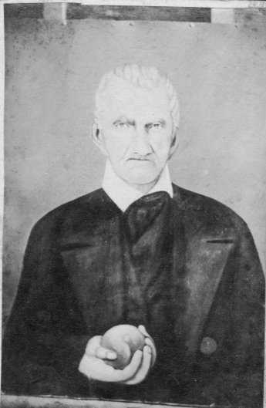

Martin Hocker, father of my paternal great-grandmother, Anna.

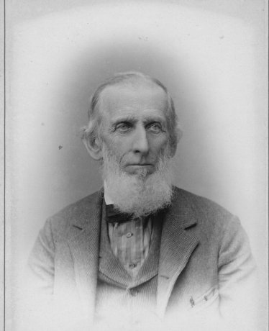

My paternal great-grandfather, Henry Uhland Seltzer

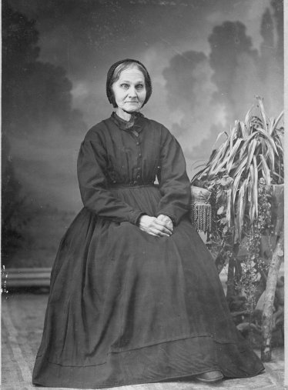

My paternal great-grandmother Anna Hocker Seltzer (second wife of Henry Uhland Seltzer and daughter of Martin Hocker)

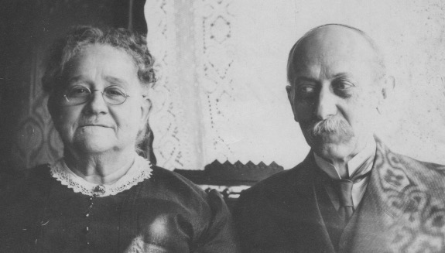

My paternal grandparents, Henry Hocker Seltzer and Sue Arnold Seltzer

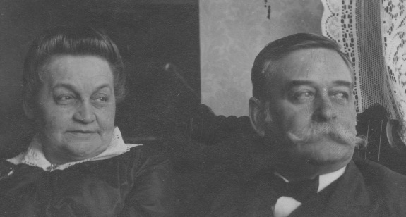

My maternal grandparents, William Washington Daly and Margaret Thour Daly

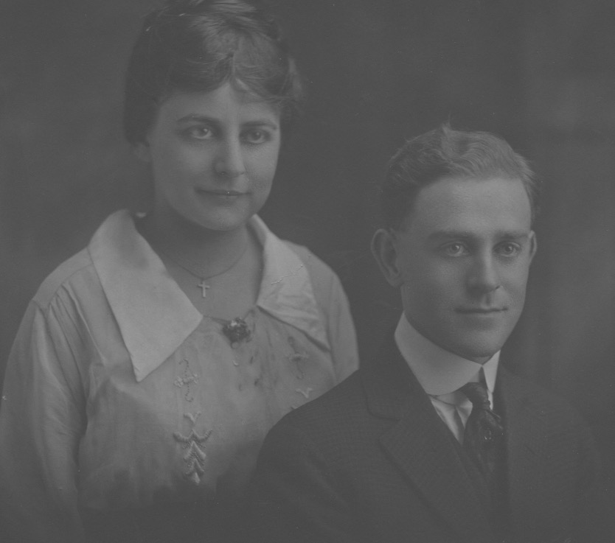

My parents Warren Ray Seltzer and Lillian Daly Seltzer

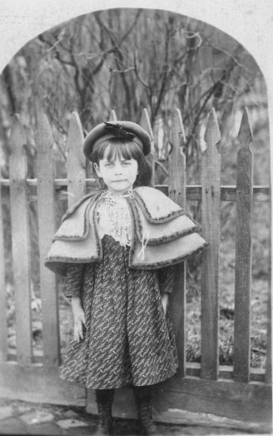

My mother, Lillian Daly Seltzer

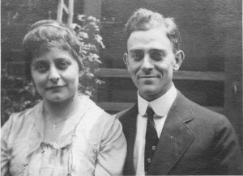

My parents on their wedding day, June 19, 1918.

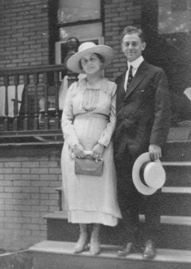

My parents on their wedding trip to Philadelphia, June 1919.

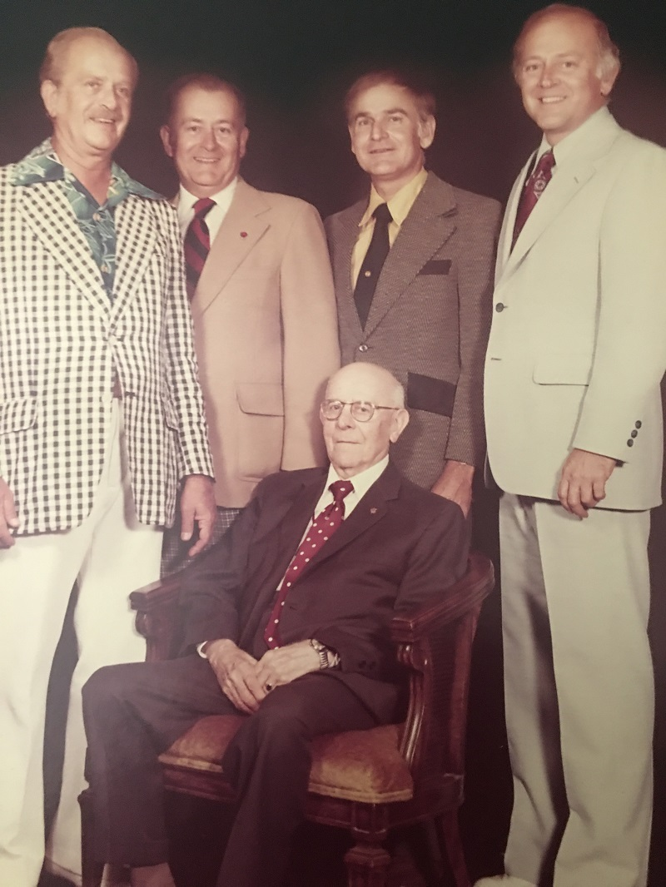

The Seltzer Brothers, summer 1978. Charles Philip Seltzer age 57, Richard Warren Seltzer age 55, James Henry Seltzer age 50, John Paul Seltzer age 45, and their father Warren Ray Seltzer, age 87, a few months before he died.

MUSIC AND POEMS WRITTEN FOR SPECIAL OCCASIONS

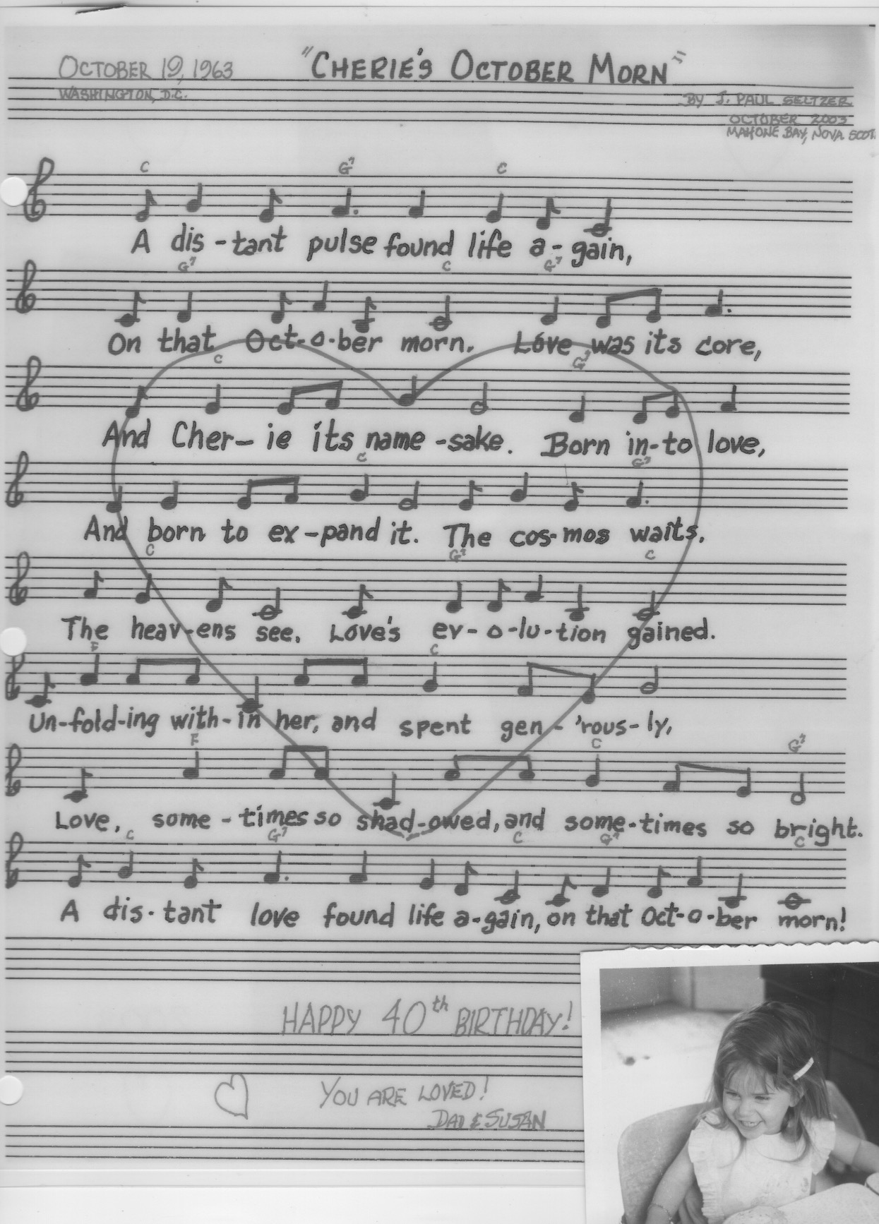

"October Morn," written by Paul for daughter Cherie

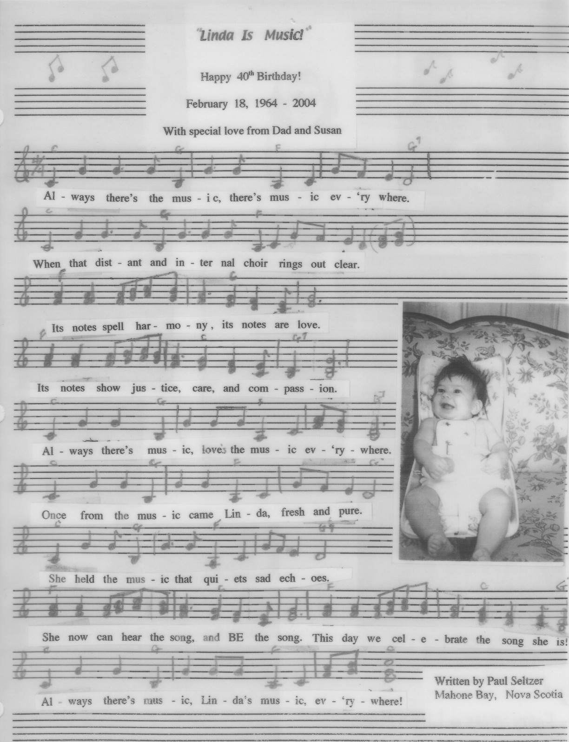

"Linda Is Music," written by Paul for daughter Linda.

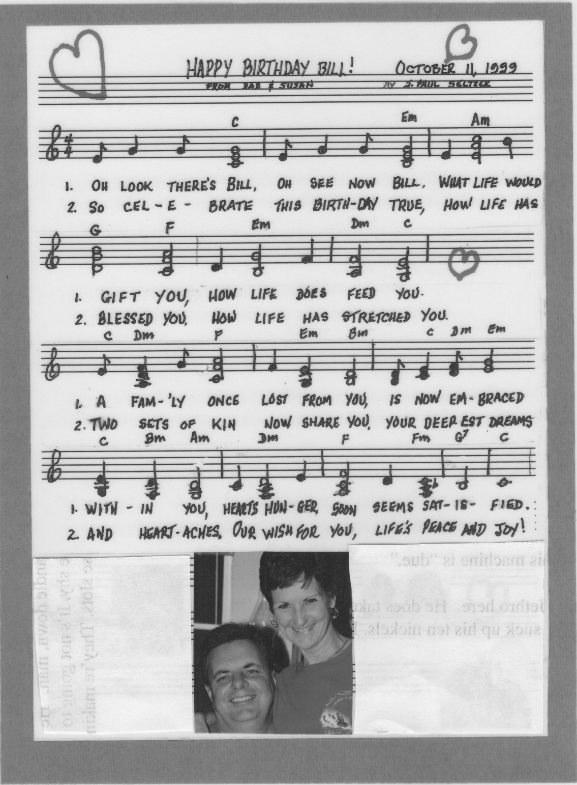

“Happy Birthday Bill,” written by Paul for son Bill.

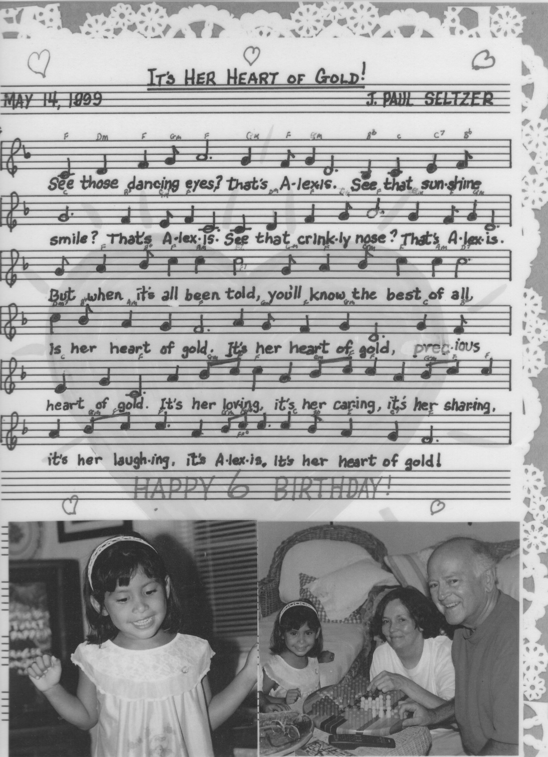

"It’s Her Heart of Gold." written by Paul for granddaughter Alexis

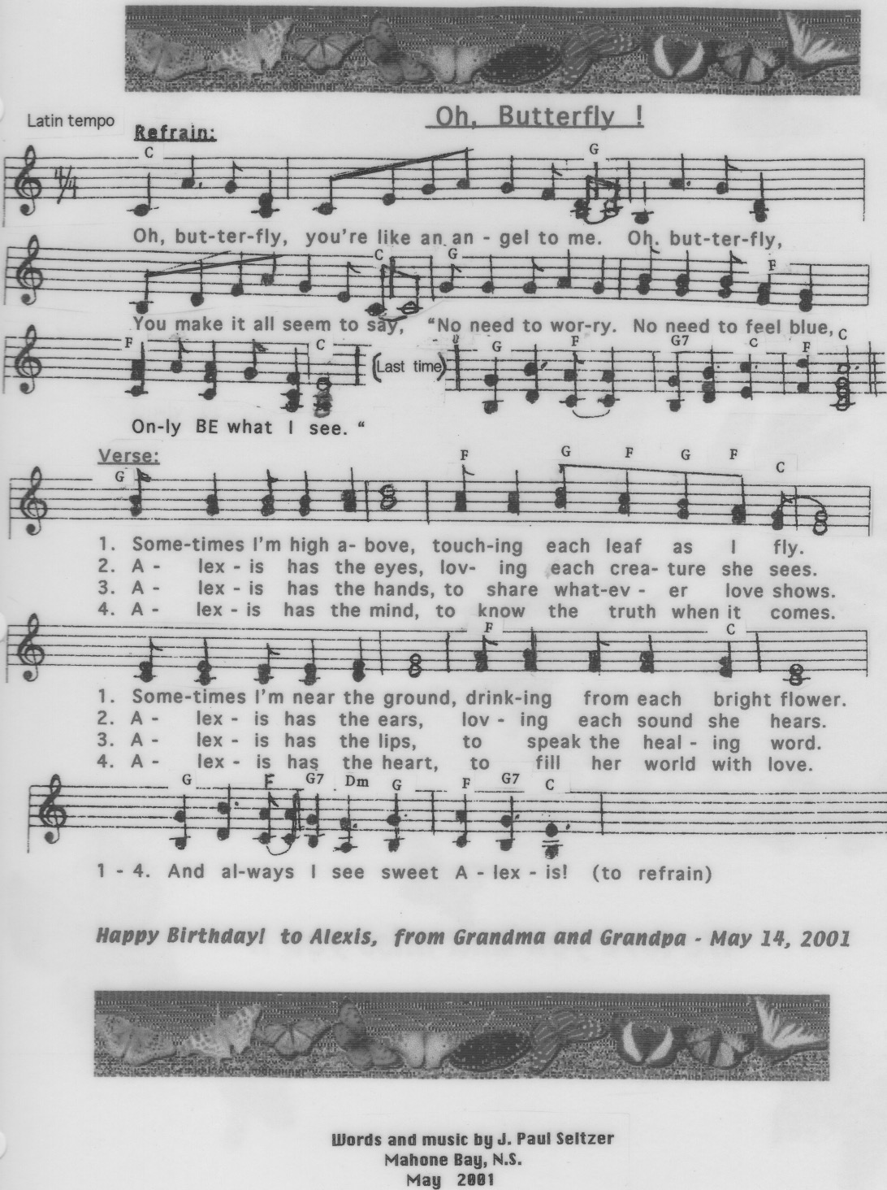

"Oh Butterfly," written by Paul for granddaughter Alexis

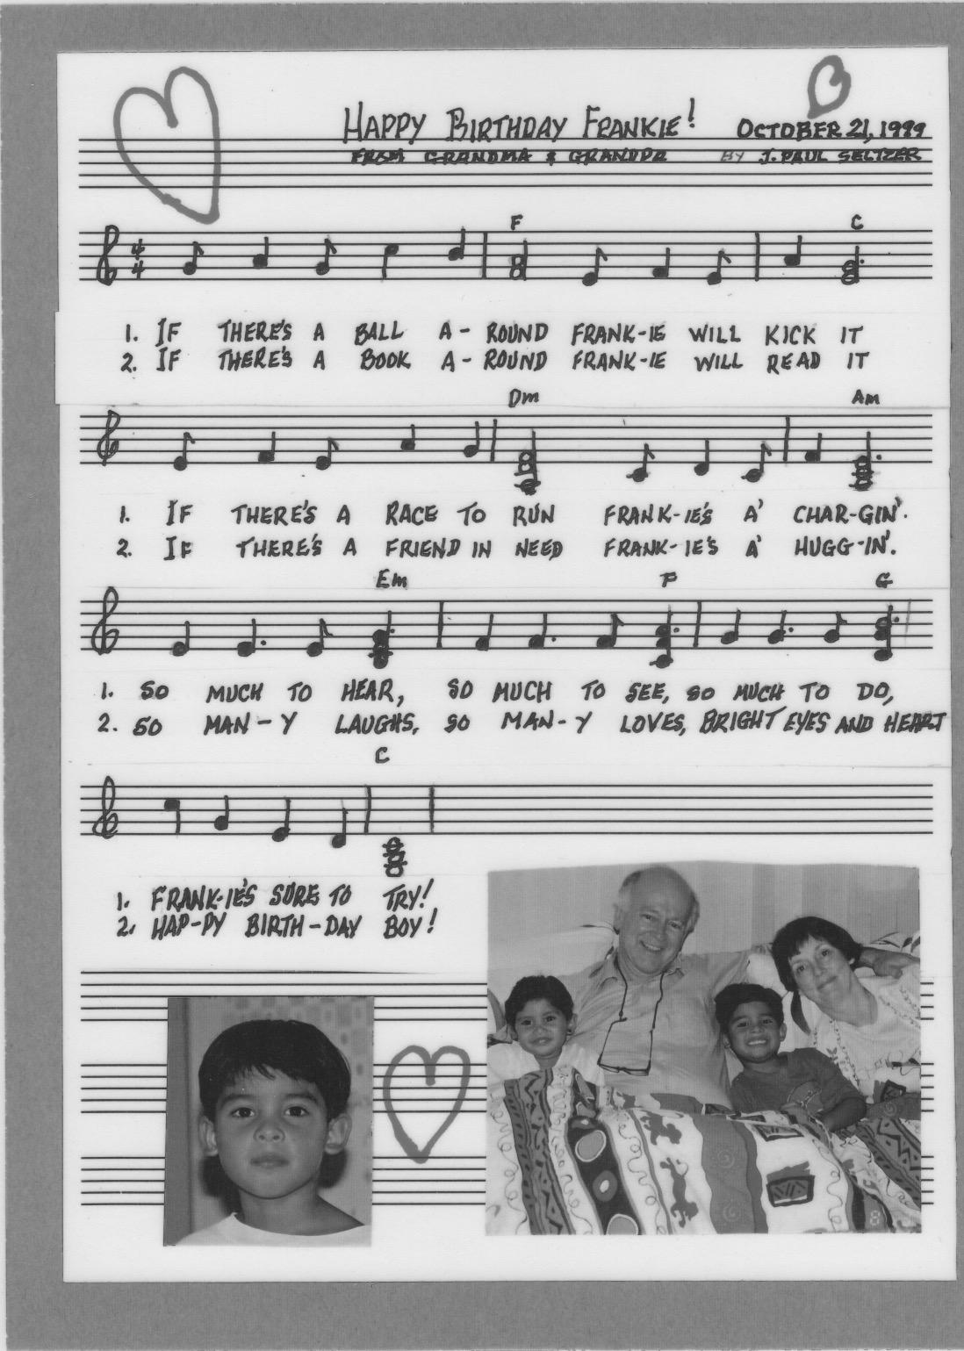

"Happy Birthday Frankie," written by Paul for grandson Frankie.

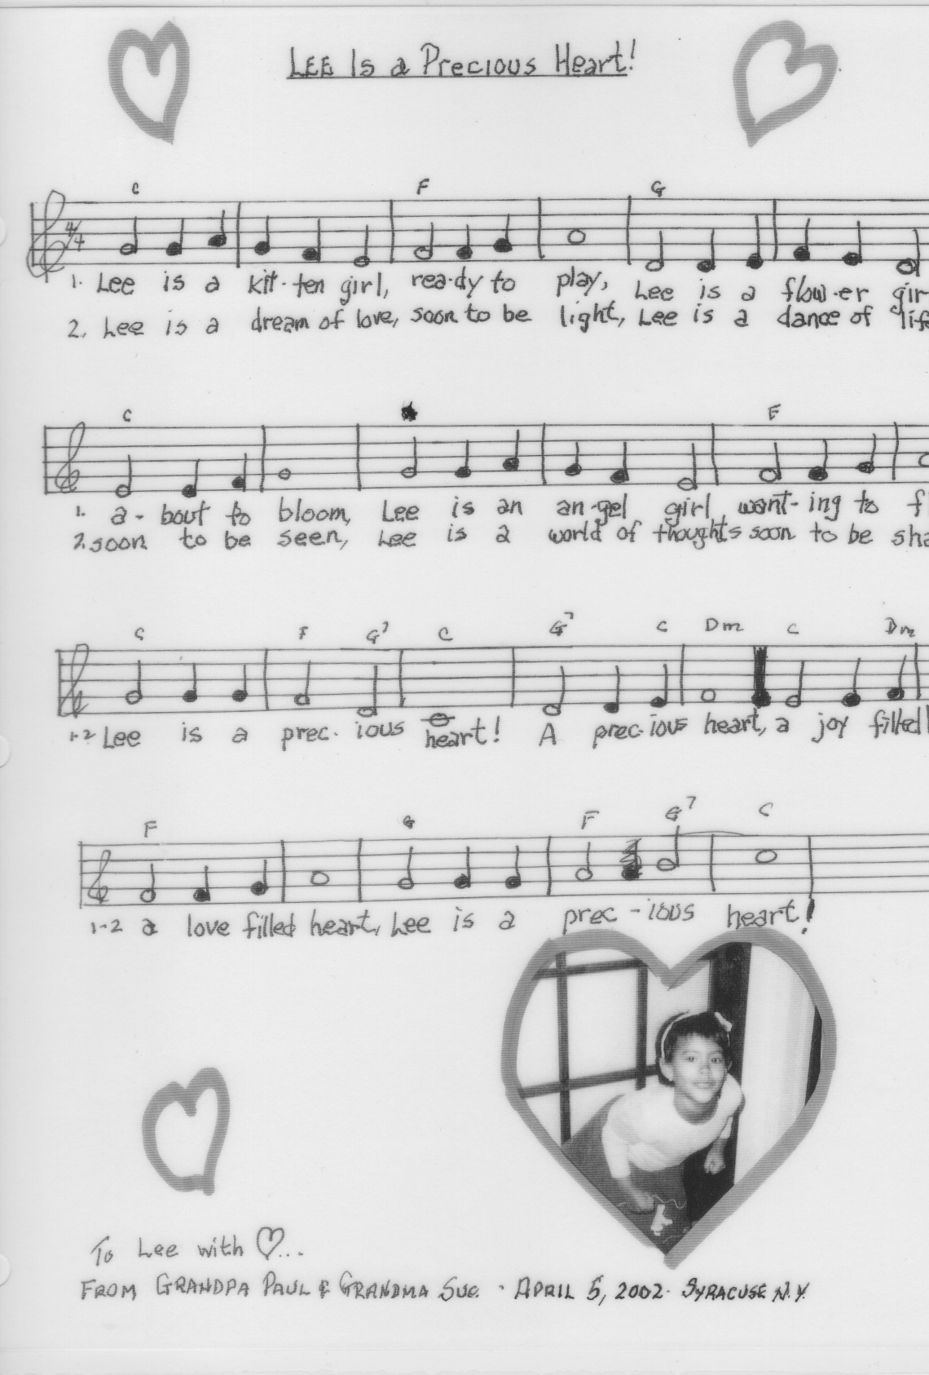

"Lee Is a Precious Heart," written by Paul for granddaughter Lee.

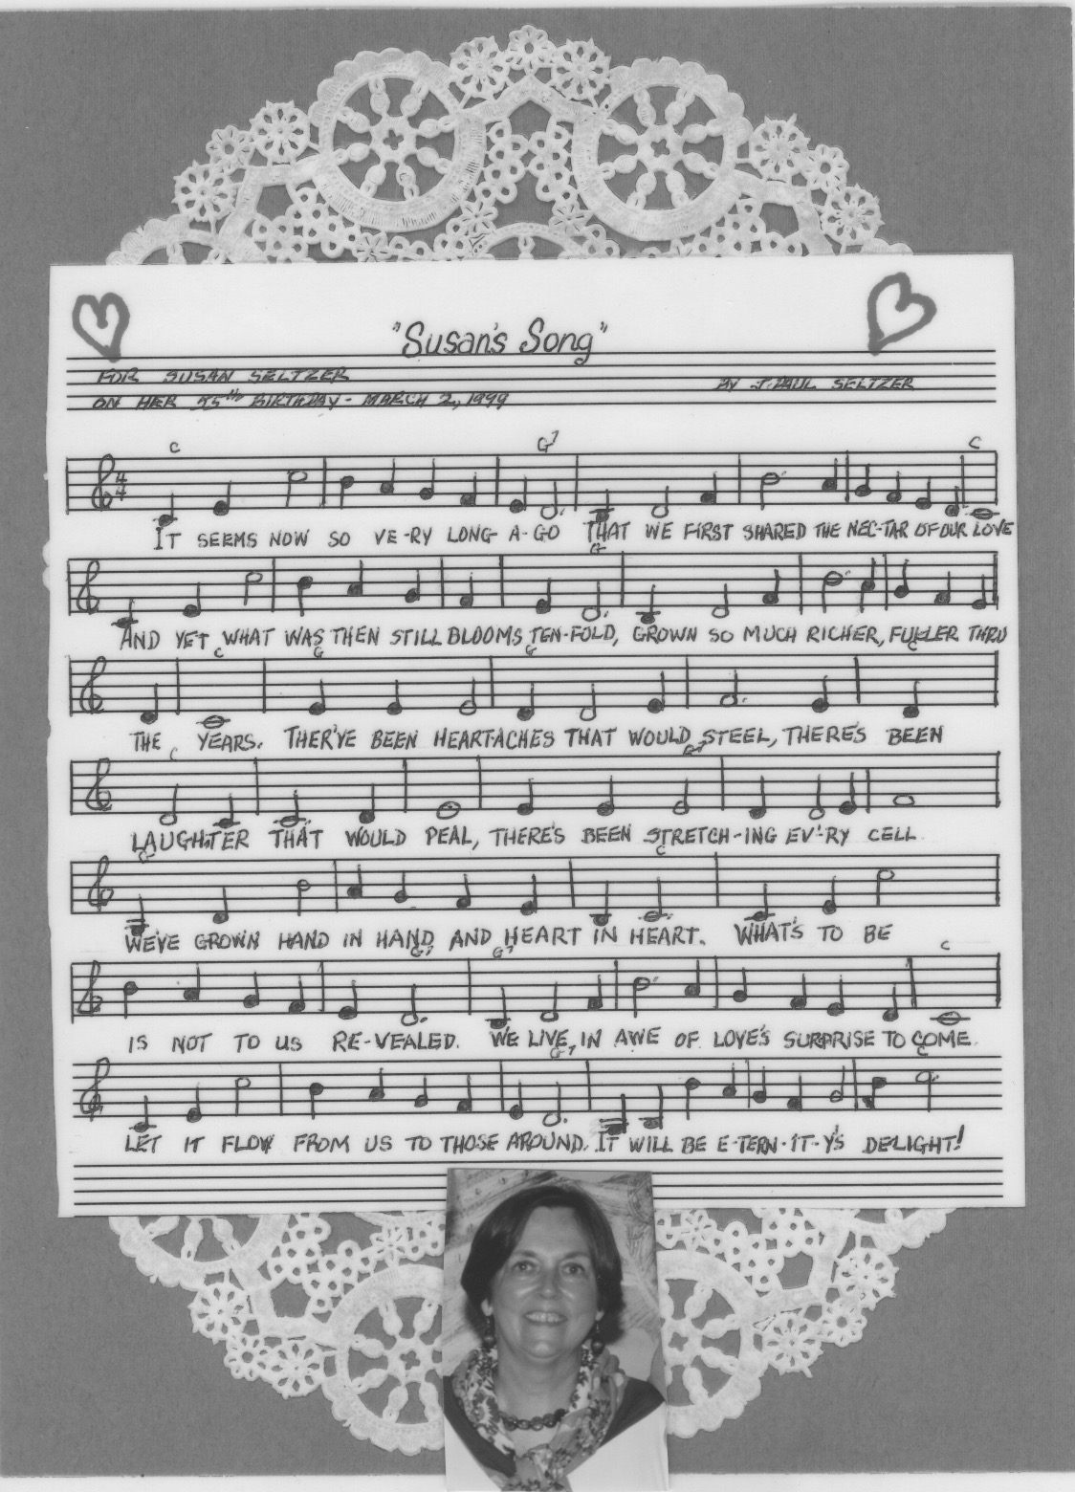

"Susan’s Song," written by Paul for his wife Susan.



"Susan's Journey Prayer," by Paul for his wife Susan

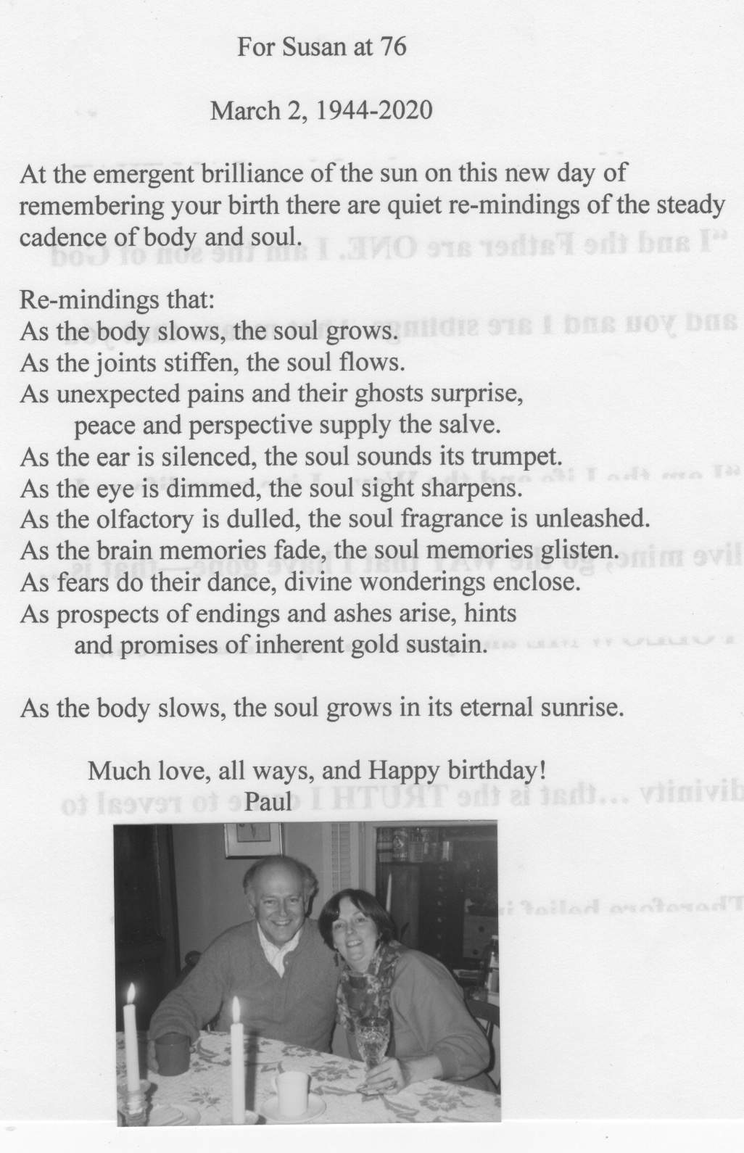

"Susan at 76," by Paul for his wife Susan

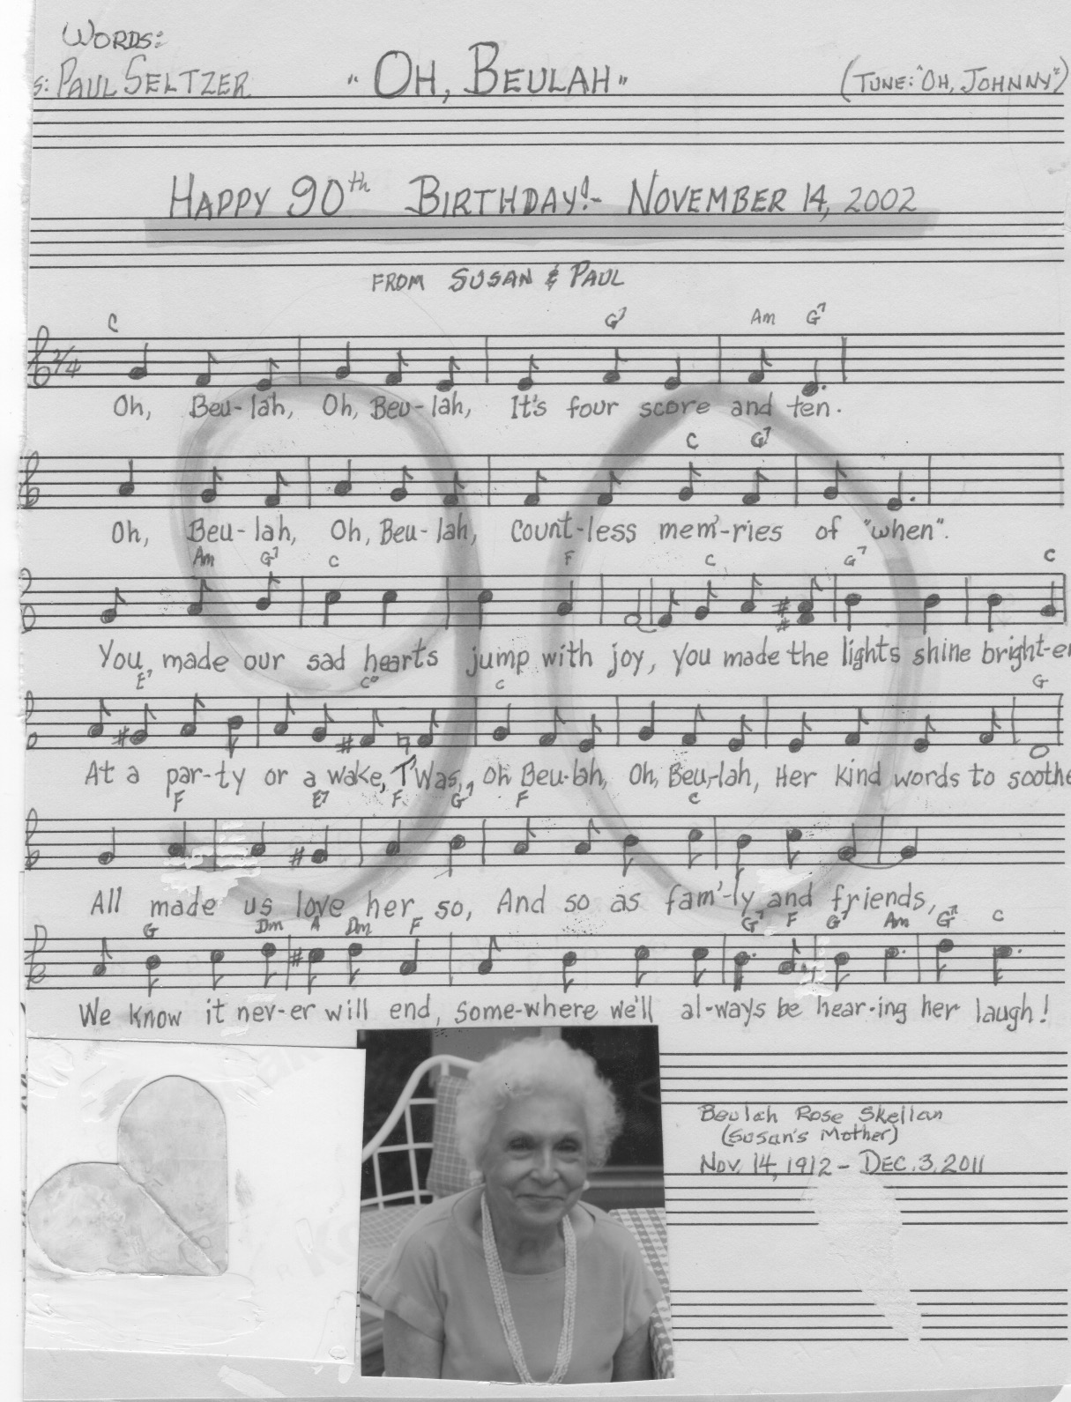

"Oh Beulah!" by Paul for his mother-in-law Beulah.

THE DALY CLAN REUNION SONG

Colonial Beach, Virginia
August 1, 1998

TUNE: “This Land Is Your Land.”
WORDS: Paul Seltzer

REFRAIN: This clan is your clan, this clan is my clan,
We call it Daly, and we’re cousins gathered,
To stir our memories and tell our stories
Of laughter, tears and dreams gone by.

Verse 1: And though now distant, our roots still draw us,
To come together, just one more time,
And remember how we shared our life here.
We’ve fed our souls from year to year. REFRAIN

Verse 2: In harmony sweet we sang our songs here.
We bought from hucksters and shared our meals here.
We smelled the coffee and picked the fruit trees.
We’ve fed our souls from year to year. REFRAIN

Verse 3: We’ve heard the rain pound the old tin roof here.
We slumbered deeply ‘neath the weeping willow.
We brought our friends here, and played ‘down front’ here.
We’ve fed our souls from year to year. REFRAIN

Verse 4: We thank our forbears’ for their loving wisdom
To build this cottage on the old Potomac.
We’ve watched the sunrise and fished these waters.
We’ve fed our souls from year to year. REFRAIN

Verse 5: Our aunts and uncles we well remember,
How their love and laughter enriched our lives so.
We thank the dear Lord they dwell within us.
They fed our souls from year to year. REFRAIN



"Shine Mystery" by Paul for Earth Day 1998.

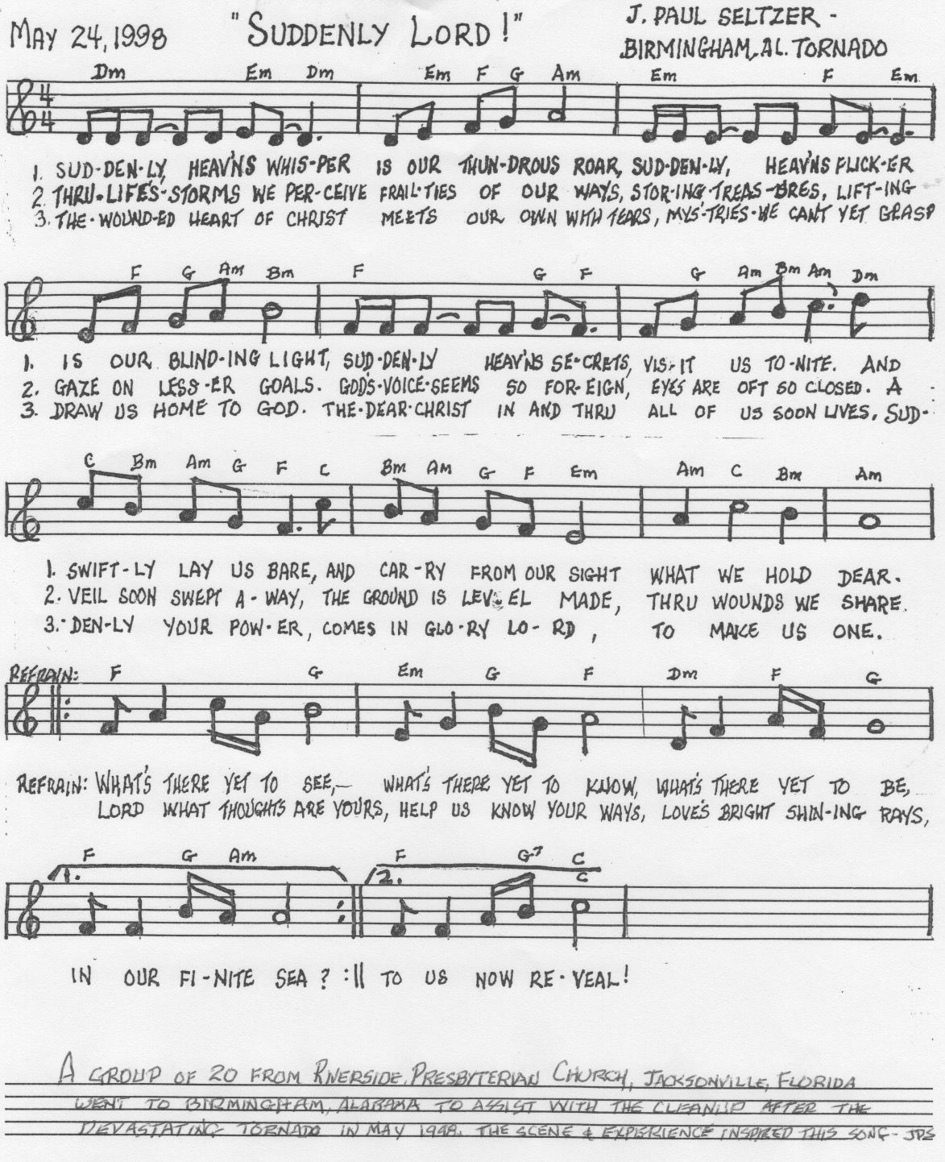

"Suddenly Lord!" by Paul, 1998.



"Christ is a Name for Love" by Paul, 2019

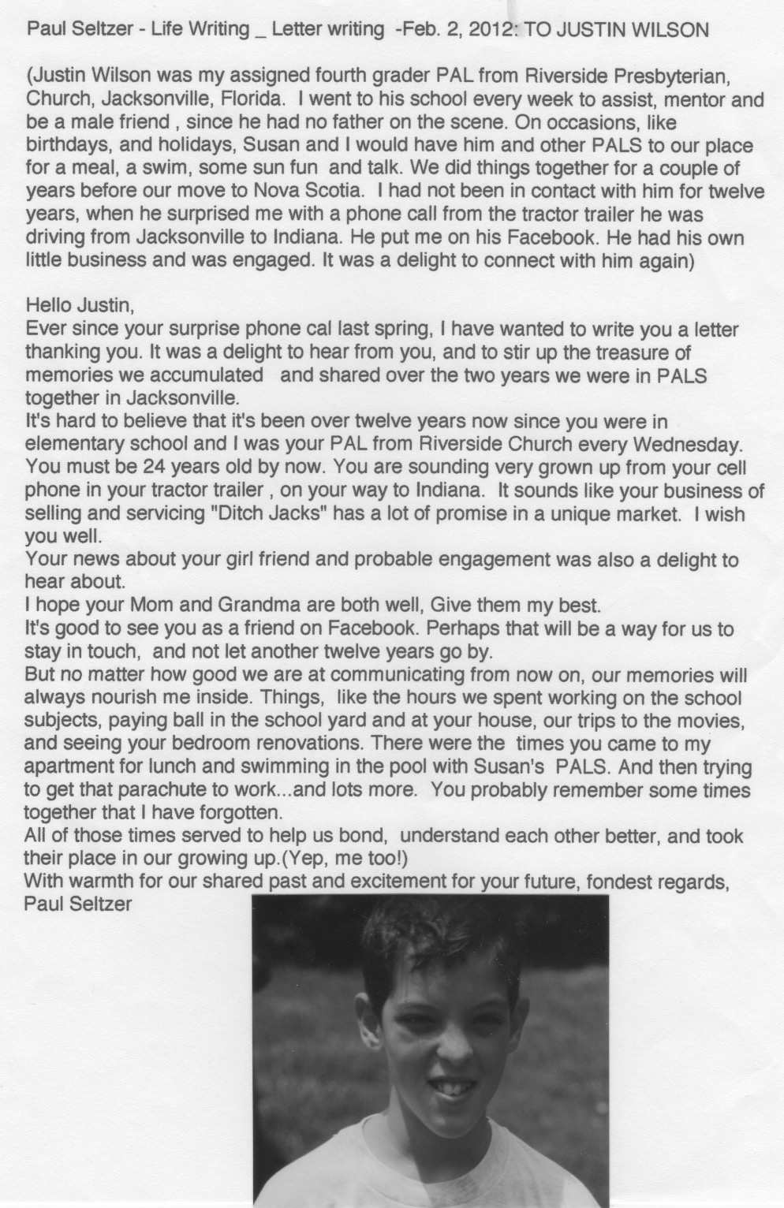

Life Lessons from a young friend in Jacksonville, Florida

SELTZER GENEALOGY

complete genealogy online at http://www.seltzerbooks.com/gen/seltzer/seltzergenealogy.html

Charles Philip Seltzer (1921-2008)

Richard Warren Seltzer (1923-2014), his autobiography is online at http://www.seltzerbooks.com/lifeandtimes.html and http://www.seltzerbooks.com/lifeandtimes2.html

James Henry Seltzer (1928-2013)

John Paul Seltzer (1932- ), the author of this book
Children of
Warren Ray Seltzer (April 20, 1891 Washington, DC - April 13, 1978, Washington, DC) architect, md. June 19, 1918 Lillian Leona Daly (Oct. 6, 1890 - April 15, 1973)
Newspaper notice of his death:
Warren Seltzer, Retired Architect for Government
Warren Ray Seltzer, 87, a retired government architect, died Wednesday at the National Lutheran Home in Washington after a stroke.
He worked for the Navy's bureau of Docks and Yards, and after World War II, the Veterans Administration for 40 years before retiring in 1966.
Mr. Seltzer was a native of Washington and graduate of McKinley Tech High School. He earned a degree in architecture at Catholic University.
A resident of Silver Spring for 50 years, he had been active in the senior fellowship, Sunday school and choir at St. Luke Lutheran Church in Silver Spring since 1942.
His wife, the former Lillian Daly, died in 1973.
He is survived by four sons, the Rev. C. Philip of Marshallville, Ohio, Dr. Richard W. of Columbia, Pa., James H. of Snow Hill, Md., and the Rev. Dr. J. Paul of Syracuse, NY; 12 grandchildren, and six great-grandchildren.
Warren's siblings (by mother Susan) =
Charles W. Seltzer (1880- )
Edgar Arnold Seltzer (1884- ), daughter = Olive
children of:
Henry Hocker Seltzer (Aug. 28, 1856 - Aug. 7 1925), physician, md. (1) 1877 Susan Arnold (April 1859 - Dec. 1916), daughter of Peter Arnold md. (2) Oct. 18, 1918 Sarah L. Behm (1856-). Henry and Susan both buried in Washington, DC.
His autobiography = "Henry Hocker Seltzer, Pennsylvania Dutch Teacher, Civil Servant and Physician - Memories of 1856-1915"
as web page http://www.seltzerbooks.com/hocker.html
as pdf page http://www.seltzerbooks.com/hockercomplete.pdf
He grew up on a farm near Belle Grove, Pennsylvania. Pennsylvania Dutch was spoken in the home. English was his second language, putting him at a disadvantage when he went to school, but he became very bookish, proud of his educational accomplishments. For 10 years, he taught in one-room schoolhouses in Pennsyvanian Dutch farm country. At times, he handled, alone, as many as 65 students ranging in age from 5 to 21, and for a wage of $33/month. He had to deal with the vagaries of rural schools, with behavior problems and parents who had little respect for book learning, and arbitrary decisions of county-level school administration. During corn-husking sometimes only 3-5 students would show up. He traveled by train to Kansas in 1878, and almost settled there. Later, le got a civil service bookkeeping job with the US Treasury Dept and wrote a bookkeeping text book for farmers. And, at the age of 40, he got an M.D. degree from what later became George Washington University. He practiced medicine very little, having gotten the degree mainly to prove that he could.
half-siblings of Henry Hocker Seltzer
children of Henry Uhland Seltzer and Barbara Smith Seltzer
John P. Seltzer (1851-1922)
Martin Seltzer (1852-1934)
James M. Seltzer (1854-1855)
Elizabeth E. Seltzer (1859-1934)
Benjamin F. Seltzer (1861-1949)
Charles Augustus Seltzer (Uncle Gus) (1864-1965), daughter = Violet
Harvey L. Seltzer (1866-1936)
Henry Hocker Seltzer is the son of
Henry Uhland Seltzer (June 15 June, 1824 - Nov. 25, 1897; md. Anna Hocker (May 10, 1827 - Jan. 10, 1914) Hocker Family
Henry Uhland Seltzer = son of
Philip Seltzer (stone mason, also cultivated a small farm which he owned) ( Dec. 6, 1772 - April 19, 1847) died of tuberculosis, buried in the Reformed cemetery at Annville, PA; md. March 25, 1800 Maria Uhland (Aug. 10, 1784 - Feb. 25, 1860) died of cancer, buried Lutheran cemetery at Bellegrove, PA.
Philip Seltzer's siblings =
Anna Maria Seltzer (1771- )
Abraham L. Seltzer (1773-1863)
Jacob Seltzer (1776-1846)
Barbara (1777-1875)
Michael Seltzer (1780-1863)
John Seltzer (1783-1856)
John George Seltzer (1813-1899)
children of:
Johann Michael Seltzer (March 23, 1740 Lutheran, Parchim, Mecklenburg-Vorpommern, Germany - 1815 Mount Zion, Lebanon, Pennsylvania) md. Barbara Gasser (1748 - ). Michael arrived in Philadelphia with his father in 1752. He served in the American Revolution. His descendants qualify for membership in the Sons of the American Revolution and in the Daughters of the American Revolution.
Michael was buried in the cemetery at Zoar's Lutheran Church, Mt. Zion, Lebanon County, PA (tombstone made of native sandstone worn by the elements and illegible in 1937; per handwritten notes by Richard Seltzer, Sr., this tombstone no longer existed in 1975).
Barbara Gasser was daughter of Jacob Gasser of Helidelberg Township near Schaefferstown, Lebanon County, where he owned and cultivated 38 acres which he purchased form the Penn agents in 1735) reportedly buried in Jonestown, Lebanon County. Children: i Anna Maria ii Philip iii Jacob iv Michael Jr. v John vi Barbara
Michael and Barbara Seltzer probably established their first home in or near Schaeferstown, where their first child was born and baptized in St. Luke's Lutheran Church, of which they were members in 1771.
Michael signed the Oath of Allegiance to the American Colonies in 1778 and served as a soldier of the third class in Company 7 of the 9th Battalion of Lancaster County in 1781, under Captain Bradley and Lieutenant Adam Mark. [per handwritten notes by Richard Seltzer, Sr., spelled "Michel Selcer" on the muster roll.]
He paid a tax of eight pounds (English money) on 150 acres of land which he owned in Bethel township in 1782. Bethel township and Heidelberg township were both then in Lancaster County. When Dauphin County was created from Lancaster in 1785, Michael Seltzer and his brother Christian, both residents of Bethel township were among those who protested about Middletown becoming the county seat of Dauphin County.
On May 5, 1789, Michael and his wife Barbara purchased 166 acres of land from Archibald Sloan for 560 pounds. This was part of a larger tract granted to Samuel Sloan by the Proprietaries of Pennsylvania, on November 26, 1748. (Samuel was Chibald's uncle). This tract lies directly north of the bridge that spans the Swatara Creek at what is know as the Water Works, north of Annville, PA. On this tract, Michael Seltzer erected a house and barn. A stone in the upper part of the house has this inscription "M.S. 1802". Cross the bridge across Swatara Creek at Water Works, the farm lies on the left side of the road. Go down the lane to the creek. Here is the house, shaded by trees.
This tract is recorded in Book G., Volume 1, Page 307 in the Recorders Office, Dauphin County Court House, Harrisburg, PA, as follows: "Beginning at a F____ thence by land of Robert Young, North 50 degrees, East 174 perches, thence by land of Peter Gingrich, South 113 perches, thence by same East 18 and two tenth perches, thence by same South one and one-half degrees and 169 perches, thence down Swatara Creek 2786 perches to place of beginning."
Johann Michael's siblings =
Georg Christian
Johann Jacob
Johann Phillip
Maria Eva
children of
(Johann or Hans) Jacob Seltzer (Feb. 15, 1711 - 1772) md. 1733 Anna Maria Welsen ( - 1769)
Immigrant. Cooper and farmer. Arrived in Pennsylvania 1752 with Wife Anna Maria Welsin; Daughter Maria Eva; Son Johann Michael; Son Johann Philipp; Son Georg Christian; Son Johann Jacob. Source: BURGERT, ANNETTE KUNSELMAN. Eighteenth Century Emigrants from German-Speaking Lands to North America. Publications of the Pennsylvania German Society, 16/19. Birdsboro, PA: The Pennsylvania German Society. Vol. 1: The Northern Kraichgau. 1983. 461p., page 341. Shown in Passenger and Immigration Lists Index, 1500s-1900s at Ancestry.com
(Johann) Jacob = son of
Wyerich Seltzer (1661 Michelfeld, Amberg-Sulzbach, Byern, Gemany - 1742 Michelfeld, Amberg-Sulzbach, Byern, Germany) md. 1683 Michelfeld, Ostalbkris, Baden-Wuerttemberg, Germany Anna Catherina Neff (1666 Michelfeld, Ostalbkreis, Baden-Wuerttemberg, Germany - 1759 Michelfeld, Heidelberg, Baden-Wuerttemberg, Germany) The Neff Family
Wyerich = son of
Erasmus Seltzer (1640, Michelfeld, Amberg-Sulzbach, Bayern, Germany - 1703, Michelfeld, Germany) md. 1658 Michelfeld, Amberg-Sulzbach, Bayern, Germany Margaretha Donner (Dec. 27, 1638 Sundgau, Germany - June 26, 1667 Michelfeld, Amberg-Sulzbach, Bayern, Germany)
Erasmus = son of
Georg Seltzer (1604 Michelfeld, Amberg-Sulzbach, Bayern, Germany - Nov. 22, 1669, Michelfled, Amberg-Sulzbach, Bayern, Germany) md. 1662 Michelfeld, Germany Anna Baur (1605 Germany - 1654 Laimen, Baden-Wuerttemberg, Germany)
Georg = son of
Ulrich Seltzer (1572 Michelfeld, Amberg-Sulzbach, Bayern, Germany - 1607 Michelfeld, Heidelberg, Baden-Wuerttemberg, Germany) md. 1600 Michelfeld, Amberg-Sulzbach, Bayern, Germany Margaretha (1576 - )

DALY GENEALOGY
Lillian Leona Daly (Oct. 6, 1890 - April 15, 1973 md. June 19, 1918 Warren Ray Seltzer (April 20, 1891 Washington, DC - April 13, 1978, Washington, DC) architect
her siblings =
John Milton (6) Daly died at 94 years old
Mabel May (6) Daly b. 18 January 1888, d. August 1947; md. Wood
Harry Wesley (6) Daly b. 29 September 1883, d. 27 June 1959
William Washington (6) Daly, Jr. (6) b. 7 September 1884, d. 10 July 1938
Edwin Earl (6) Daly b. 1889, d. 1973
Adolph A. (6) Daly b. 29 January 1895, d. 1 March 1973
Margaret Adele (6) Daly b. 20 January 1897, d. 27 May 1995 (98 years); md. Miller
Amy A. (6) Daly b. 6 October 1885, d. 14 April 1888
Edna E. (6) Daly b. 17 November 1886, d. 8 July 1888
children of
William Washington Daly, Sr. md. Margaret Matilda Thour.
son of
John Michael Daly b. 23 May 1830 in Dublin, Ireland, d. 4 February 1904 in Norfolk, VA; md. (1) Amanda Baker of Philadelphia (b. 20 October 1835 in Philadelphia, d. 1884) daughter of Thomas Baker and ___ Lauderbach, granddaughter of Mary Lauderbach md. (2) Mary Quinen.
his siblings =
John died young
James b. 21 September 1826 in Dublin
Alice b. 28 October 1828 in Kilbeggan
Jane b. 5 October 1833 in Kilbeggan
Agnes b. 7 June 1835 in Dublin
William b. April 3 (year?) died young
Thomas b. 18 September 1839 in Philadelphia md. Sept. 19, 1860 Carolline M. Wilson, children = Harry, Athalia, Kerfoot; granddaughter Mary Violet Daly MacFarland (1904-2002), her daughter = Mrs. Bruce Wilson
Mary Jane died young
Margaret died young
William Hudson b. 11 July 1842 in Indiana County
Patrick died young
Mary Ellen b. 29 June 1848 in Wilmington, Delaware
children of
Thomas Daly (Feb. 20, 1792 - 1858) at the Gibsonton distillery near Charleroi, PA md. 18 June 1822 in St. Paul's Catholic Church, Arran Quay, Dublin, by Rev. Gormley, Mary Maher.
his siblings =
Catharine Daly b. 7 March 1791, died young
Thomas Daly b. 20 February 1792,
Jane Daly b. 24 July 1793,
James Daly b. 3 December 1794, died young
Alice Daly b. 16 December 1797, d. September 1811.
children of
John Daly d. 22 May 1806; md. Alice Wheeler 25 June 1789.
son of
Patrick (1) Daly, b. 13 May 1724, Athlone, Ireland
____________________

Published by Seltzer Books
established in 1974, as B&R Samizdat Express
offering over 14,000 books
feedback welcome: seltzer@seltzerbooks.com

